
DA Software Solutions (Pvt.) Limited.
#76, Pagoda Road, Nugegoda. Sri Lanka.
E-mail: dumindu@dassonline.com
Phone: +94 114 941 921, +94 773 435 429

Client Name/Address
Date : 1st Nov 2011
Our Reference : DASS /INV
Invoice Number : TI 270

Mr.Imdad Nagub,
Manager IT,
Citizen Development Bank

INVOICE
Description
Pawn - Brokering Management” Software Solution

Particulars | Amount (LKR)
Quotation Dated 15th Oct 2011 | 68,000.00
Total Invoice Amount | 68,000.00

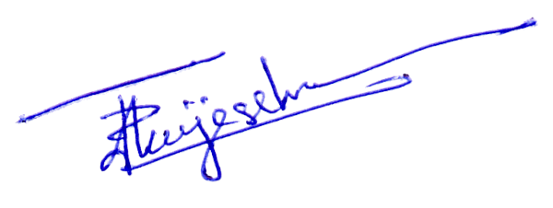
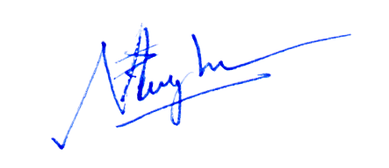

Prepared by: ………………………………. Authorized by: ……………………..................

