Server Configuration

Feature Description
Processor | Intel® Xeon® 3.0 Core GHz (320 GB SATA model
Memory | 4 GB (4 x 1 GB) or more
Network Controller | Embedded NC105i PCIe Gigabit Ethernet Server Adapter
Expansion Slots | - Full-height, half-length 32bit/33MHz PCI at 3.3V slot  - Full-height, half-length PCIe x1 slot (x8 connector)  - Full-height, full-length PCIe x1 slot (x8 connector)  - Full-height, full-length PCIe x8 slot (occupied by Smart Array E200/128MB controller on 1 TB SATA, 2 TB SATA, And 584 GB SAS models)  (1) Lights-out 100c option slot
Management | Microsoft Management Console (MMC)-based user interface  Remote system management via Remote Desktop or Telnet (Optional) HP Lights-Out 100c Remote Management Card
Operating System | Microsoft Windows Server 2003 Release 2, Workgroup x32 Edition (320 GB SATA model), Raid 5
Hard Disk Capacity | 180GB Or More
Form Factor | Micro ATX Tower

Client PC Features

Feature | Description
Processor | Dual Core Intel Pentium 2.0 GHz or Higher
Memory | 1 GB or more

System Architecture

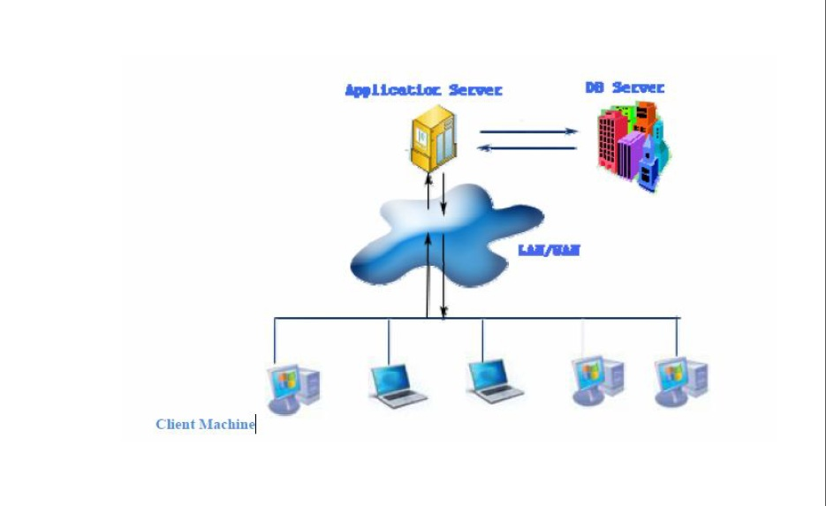
System Performance

Feature Description
Number of Contract 30,000
Number of Branch 15
Number of Users (Concurrent) 100
Network Band Width 100MBps
Facility Inquiry Speed 1 per second

FinSoft Development Architecture

Oracle 10g Data Base
Microsoft Visual Studio 2005 Development Tool
Crystal Report Reporting Framework





