USER REQUIREMENTS

The Bidder should provide the following in the specified order in Section 4 of the proposal/bid document.

Provide detail information of the proposed solution as per document enclosed. Please note that marking should be carried out in the following manner; The Remarks column should be used to explain or provide detail information.

DESCRIPTION | REMARKS
Rating - 5 | If the User requirement is met 100% as defined in the RFP without any work around method.
Rating - 4 | If the User requirement is met 75% as defined in the RFP without any work around method. Define the number of hours required for the modification and cost in US$ in the Remarks column, in order to provide 100% functionality as defined.
Rating - 3 | If the User requirement is met 50% as defined in the RFP without any work around method. Define the number of hours required for the modification and cost in US$ in the Remarks column, in order to provide 100% functionality as defined.
Rating - 2 | If the User requirement is met 25% as defined in the RFP without any work around method. Define the number of hours required for the modification and cost in US$ in the Remarks column, in order to provide 100% functionality as defined.
Rating - 1 | If the User requirement is met as a Work around method defined in the RFP. Define the number of hours required for the modification and cost in US$ in the Remarks column, in order to provide 100% functionality as defined.
Rating - 0 | If the User requirement is not met as a defined in the RFP and modifications are required. Define the number of hours required for the modification and costs in US$ in the Remarks column.

The NBL rating is as follows:
1 = critical; 2 = essential; 3 = nice to have

FOREIGN CURRENCY BANKING UNIT (FCBU)
Ref : | User requirements | NBL Priority | Bidder’s Rating | Bidder’s Remarks
 | PLEASE NOTE THAT THE IMPLEMENTATION OF FCBU & DBU SHOULD CONFORM TO THE SCOPE DEFINED BELOW AS IT IS UNIQUE TO SRI LANKA.  Foreign Currency Banking Unit (FCBU) is a separate unit from the Domestic Banking Unit (DBU) the main difference is in the Accounting concept where the base currency differs from one to another.  In FCBU the Base currency is USD, whilst in DBU it is LKR, the system should treat the DBU and the FCBU units as two different entities.  FCBU must hold its balances in USD (and in other foreign currencies) and not in LKR. It should not hold balances in LKR and automatically convert to USD for reporting/viewing purposes.  The products available in DBU and FCBU are the same including the mechanism of how it behaves.  There are different guidelines governing these two units by the Regulatory authorities, which amounts to the criteria of account opening and maintenance, these criteria should be available in the system in order to control the aspect of maintenance.  The reporting to Local authorities and the Statutory audits also differs from one another.  Operationally the FCBU clients could have a DBU account as well; The FCBU accounts will be maintained in Foreign currency whilst the DBU could have both Foreign Currency and Local currency and the system should provide facility to fund the Domestic Unit via transferring funds from FCBU.  The Forex positions need to be maintained separately but for information purposes a consolidated position is required.  In the Case of Facility granting certain clients who are having accounts in both these units should be monitored as a global picture i.e. Consolidated exposure in any different currency defined by the user.  The interface to the units should enable to allocate costs to each unit on a periodic basis. This is similar to Cost center allocation since the DBU will take account of all the cost.  The interbranch (FCBU and DBU) postings should seamlessly flow, updating the Forex positions automatically. | 1 | 3 or 4 or 5 | This requirement requires detailed study. From the discussion we had during the POC, it seems the best way forward is to set up the FCBU as a company within T24.
 | Functionality
 | Classifying and storing recorded Data
 | Concept of Handling multiple currencies  All transactions are recorded in the currency of the transaction  All transactions are also recorded in the Base currency equivalents  The sum of all balances in Base currency equivalents is always kept zero (Sum between Debits and Credits)  Currency-positions should be presented by the position reporting mechanism. | 1 | 5 | Supported by T24. T24 is a multi-currency system by design and supports multi currencies in terms of transactions and accounting. All currencies to be used are defined in the Currency table with currency code, number of decimal places, quotation rules, delivery days…  For all the deals/contracts booked as foreign currencies, the system automatically converted them into base currency for GL purpose.
 | Recording Transactions in Multiple Currencies in DBU  Example:  Customer buys USD for current account pays from his EUR current account  Amount USD 100 USD/EUR Cross Rate =1.65 1 USD = 90 LKR and 1 EUR = 54.5454  Posting in traditional Multiple currency system  Debit Position account USD USD 100  Credit Current a/c Customer USD 100  Credit Equivalent A/C USD LKR 9,000  And:  Debit Current a/c Customer EUR 165  Credit Position Account EUR EUR 165  Debit Equivalent Account EUR LKR 9,000  In Recording of the transaction above in an automated system we expect the automatic Position Management once we do only the below entries.  Debit Current a/c Customer EUR 165  Credit Current a/c Customer USD 100  The data entry screens are required to be tailored to perform the transactions of the above nature by only specifying the amount wish to be transferred and only specifying the target currency.  Eg: As per the above example, Once the teller inputs customers USD account number and Credit of USD 100 and the EUR currency as the Debit currency, system automatically should calculate the Debit result using applicable rates. In this instance may be the cross rate (decision is up to the bank) or the buying rate of the EUR and the selling rate of the USD. | 1 | 5 | Supported by T24 through the submenu of Buy/Sell Cross Currency. The relevant exchange rate is automatically defaulted from the exchange rate table maintained in T24 which can be updated periodically.  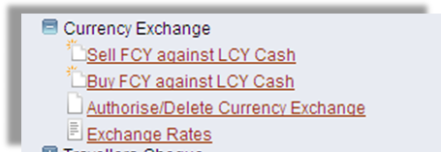  Figure 1. Currency Exchange
 | Revaluation Process  To measure the effects of movements in market rates (e.g. forex rates) on the bank’s profitability.  To produce financial statements in the bank's reporting or base currency in accordance with GAAP | 1 | 5 | Supported by T24. Revaluation process in T24 adopts generally accepted industry standard. Rates used for valuation, be they FX spot and forward rates or money market interest rates are stored in the respective Currency table, forward rates table and basic interest table. The rates can be updated either manually or via market data feed.  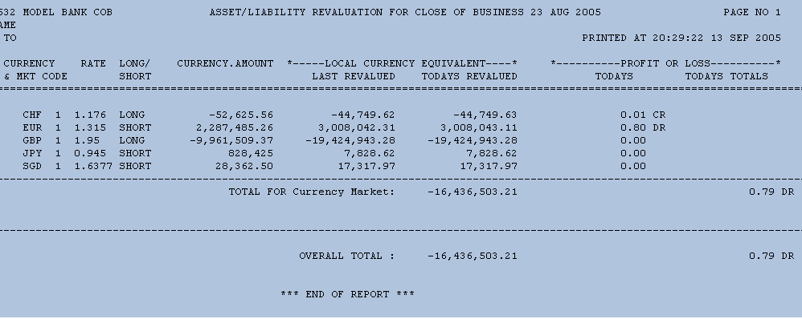  Figure 2. Asset/Liability Revaluation Report
 | Normal Revaluation  Exchange result  Position result  Against spot middle rate  Daily  Forward revaluation  Against applicable forward rate  Daily  Daily Revaluation example  Day 0 – closing rate : 90.00 LKR/USD  Outstanding: +10,600  Account Balance Equivalent  01USD 100.00Dt 9,000.00Dt  02USD 2,000.00Cr 180,000.00Cr  03USD 12,500.00Dt 1,125,000.00Dt  04LKR 954,000.00Cr 954,000.00Cr  P&L  05LKR 0.00 0.00 Transitory Memo  06LKR 0.00 0.00  Day 1 – closing rate : 90.10 LKR/USD Outstanding: +10,600  Account Balance Equivalent Adjustment  Posting  01USD 100.00Dt 9,010.00Dt 10.00Dt 0.00  02USD 2,000.00Cr 180,200.00Cr 200.00Cr 0.00  03USD 12,500.00Dt 1,126,250.00Dt 1,250.00Dt 0.00  04LKR 954,000.00Cr 954,000.00Cr 0.00 0.00  P&L  05LKR 1,060.00Cr 1,060.00Cr 0 1,060.00Cr  Transitory Memo  06LKR 0.00 0.00 1,060.00Cr 1,060.00Ct  Day 2 – closing rate : 90.05 LKR/USD  Outstanding: +10,600  Account Balance Equivalent Adjustment Posting  01USD 100.00Dt 9,005.00Dt 5.00Cr 0.00  02USD 2,000.00Cr 180,100.00Cr 200.00Dt 0.00  03USD 12,500.00Dt 1,125,625.00Dt 625.00Cr 0.00  04LKR 954,000.00Cr 954,000.00Cr 0.00 0.00  P&L  05LKR 630.00Cr 630.00Cr 0 430.00Dt  Transitory Memo  06LKR 0.00 0.00 430.Dt 430.00Cr  Forward Revaluation Example  Contract Details:  Contract Date 11/OCT/1995  Value Date 01/NOV/1995  Purchase Amount USD 100,000.00  Sale Amount HKD 780,300.00  Contract Rate 7.803  Equivalent in Local Currency HKD 780,300.00  Purchase Spot Rate 7.80  Sale Spot Rate 1.00 | 1 | 5 | Supported by T24. T24 provides a Revaluation designer table which provides a choice of different types of revaluation methods.
 | Today’s Closing Rates:  Closing Rates: USD/HKD Process Date 11/OCT/1995  Spot Middle Rate 7.810  Points 1 week 0.001 Pips unit 0.001  Points 2 weeks 0.003  Points 3 weeks 0.007  Points 1 month 0.011  Points 2 months 0.018 | 1 | 5 | Supported by T24 Currency tables.
 | Interpolation of forward rate:  Spot Date 13/OCT/1995 2 weeks 27/OCT/1995  3 weeks 03/NOV/1995  Period 27/OCT/1995 – 03/NOV/195 = 7 days (period)  27/OCT/1995 – 01/NOV/195 = 5 days (contract in period)  Forward rate:  7.810+0.003+(0.007-0.003)*5/7=7.8158571 | 1 | 5 | Supported by T24 Straight Line Revaluation method.
 | Calculation of foreign exchange forward revaluation result:  Exchange Result (7.81-7.80)*100,000 = +1,000.00  Forward Result (0.0058571-0.003)*100,000 = + 285.00  Total Result (7.8158571-7.803)*100,000 = +1,285.00  Exchange Result = result of movement in exchange rates Forward Result = result of changing forward points  First the results of the previous day should be reversed, after which the total revaluation result will be booked to the balance sheet through a transitory item versus P&L posting. | 1 | 5 | Handled by using the I/O choice in the FX Revaluation Parameter.

