USER REQUIREMENTS

The Bidder should provide the following in the specified order in Section 4 of the proposal/bid document.

Provide detail information of the proposed solution as per document enclosed. Please note that marking should be carried out in the following manner; The Remarks column should be used to explain or provide detail information.

DESCRIPTION | REMARKS
Rating - 5 | If the User requirement is met 100% as defined in the RFP without any work around method.
Rating - 4 | If the User requirement is met 75% as defined in the RFP without any work around method. Define the number of hours required for the modification and cost in US$ in the Remarks column, in order to provide 100% functionality as defined.
Rating - 3 | If the User requirement is met 50% as defined in the RFP without any work around method. Define the number of hours required for the modification and cost in US$ in the Remarks column, in order to provide 100% functionality as defined.
Rating - 2 | If the User requirement is met 25% as defined in the RFP without any work around method. Define the number of hours required for the modification and cost in US$ in the Remarks column, in order to provide 100% functionality as defined.
Rating - 1 | If the User requirement is met as a Work around method defined in the RFP. Define the number of hours required for the modification and cost in US$ in the Remarks column, in order to provide 100% functionality as defined.
Rating - 0 | If the User requirement is not met as a defined in the RFP and modifications are required. Define the number of hours required for the modification and costs in US$ in the Remarks column.

The NBL rating is as follows:
1 = critical; 2 = essential; 3 = nice to have

SWIFT
Ref : | User requirements | NBL Priority | Bidder’s Rating | Bidder’s Remarks
 | Security & Controls
 | Facility for session authentication with SWIFT (e.g. Swift Alliance Access server). | 1 | 5 | Fully supported. T24 provides a standard out-of-the-box interface for interfacing to SWIFT. The interface handles both incoming and outgoing SWIFT messages. Uploading and downloading of SWIFT messages is automated
 | Facility for defining a secure communicating partner, by defining the communicating partners (Swift server) MAC Address/ IP Address. | 1 | 5 | Fully supported. T24 provides a standard out-of-the-box interface for interfacing to SWIFT. The interface handles both incoming and outgoing SWIFT messages. Uploading and downloading of SWIFT messages is automated
 | Facility to define limits and exceptions on automatic processing by way of pre defined tables. (e.g. If an incoming payment exceeds USD 10,000 it should be diverted to a separate outstanding message queue and processed through verification & authorisation levels defined) | 1 | 5 | Supported by T24.
 | Facility to define verification and authorisation levels, for processes requiring manual intervention for incoming messages. | 1 | 5 | T24 has a feature to let the bank to decide which function needs to have authorization, which function doesn't need or automatically authorized. Even every function can have different authorization level for different user, it can be setup in screen designer facility  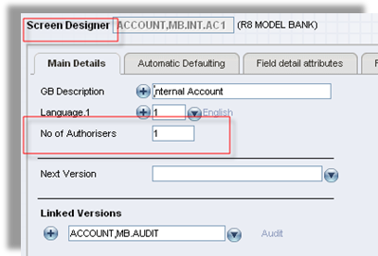  Figure 1. Setting number of authorizer
 | Facility to define data entry, verification and authorisation levels, for outgoing payments. | 1 | 5 | Please refer to the explanation above.
 | Facility to identify possible duplicate outgoing instructions by comparing the instruction details of to be sent with those already sent and queued to be sent.  In matching such instructions, a user defined combination of the following details, for each instruction type, shall be compared: Sending of duplicate needs to initiated manually  Correspondent details;  Counter party details;  Ordering party details;  Beneficiary details;  Currencies;  Exchange rates;  Amounts;  Value dates. | 1 | 5 | Supported by T24 Duplication functionality.
 | Facility for unauthenticated messages to be diverted to a separate queue and should be available for processing once released by a authorised user (authorised users can be defined and changed) | 1 | 5 | Supported by T24
 | Swift Compatibility
 | The interface should be capable of online integration with Swift Alliance Access 4.1 for Windows NT. | 1 | 5 | Fully supported. T24 provides a standard out-of-the-box interface for interfacing to SWIFT. The interface handles both incoming and outgoing SWIFT messages. Uploading and downloading of SWIFT messages is automated
 | The Interface should also be capable of integrating with future swift message standard releases (November 2002) and new Swift version releases e.g. Swift Alliance Access ver 5 | 1 | 5 | This is fully supported. Temenos provides enhancements on T24 for addressing SWIFT requirement changes, and the same is made available to our clients as part of our maintenance contract.
 | Features
 | Facility to archive and clear completed messages (Automated monthly purging) | 1 | 5 | Supported by T24. The audit trail details are always stored as part of the data record itself. So, it is available online till the time the data record is actually purged / archived.
 | Facility to stop & start the interface when necessary | 1 | 5 | Supported by T24.  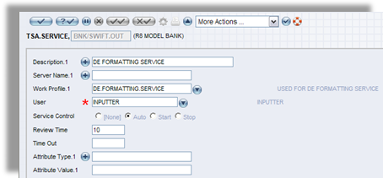  Figure 2. TSA.SERVICE
 | Facility for manual intervention (menu driven) to troubleshoot problem messages |  | 5 | Supported by T24 or SWIFT
 | Facility to support straight through processing. The following is a example of a transaction which should be supported:  Receipt of incoming payment at NDB Bank in Colombo, Sri Lanka, from BANK 2 in New York, U.S.A. with instructions to pay Customer 1 at BANK 3 in Kandy, Sri Lanka. The payment should be automatically processed without any intervention at all in the following manner:  Authentication  Check pre predefined tables for limits and exceptions on automatic processing  Converted to local currency (option of not converting)  Bank 1 charges deducted (Our charges) (option of no charges)  Reconverted to original currency  Outward message created for payment to BANK 3 with Customer 1 as beneficiary and message sent to swift, with details of original amount and deducted charges  The above type of transaction should be processed using message codes / user tables/ authentication (freely definable including currency exceptions, Limits on amounts & Beneficiaries). | 1 | 5 | Supported by T24 Funds Transfer (Payments) module.
 | Facility for incoming messages which cannot be processed automatically, to be diverted to a outstanding message queue for the appropriate department to process. | 1 | 5 | Supported by T24.
 | Facility for the user to manually route outstanding messages to the appropriate user | 1 | 5 | Outstanding messages will be routed to appropriate user based on his or her processing rights.
 | Facility to process and clear outstanding messages applying user selected entries (e.g. change of a/c no for incorrect a/c no) to the following modules :  General Banking Module  Treasury Operations Module (Inclusive of back office reconciliation)  Trade module  Retail Banking Module  Nostro Reconciliation module | 1 | 5 | Supported by T24.
 | Facility to clear outstanding messages by transferring these messages to the archive without any further action. | 1 | 5 | Supported by T24.
 | Facility to automatically generate outgoing messages to swift through the use of Product codes / user tables (freely definable including authorisation levels (option of STP), message types, currency & amounts). | 1 | 5 | Supported by T24 Delivery module.
 | Facility to create templates per product for outgoing message content. | 1 | 5 | T24 includes standard message templates. We are assuming that the format of these templates meet the requirements of NDB. If not, then NDB can use T24 message format designer (included in the Delivery module) to modify them.
 | Letter of credit related product transactions should generate MT 700 series message types | 1 | 5 | The T24 Delivery module supports all standard SWIFT Messages/Print Messages.  The message delivery mechanism in T24 is a flexible and soft parameterized option to define messages associated with each transaction / process cycle.
 | Documentary Credit related product transactions should generate MT 400 series message types | 1 | 5 | Please refer to the explanation above.
 | Financial product transactions should generate  MT 100,103,110,111,199,202, 299 & 999 message types | 1 | 5 | The T24 Delivery module supports all standard SWIFT Messages/Print Messages.
 | Facility to support generation of customer statements through the following message type MT 940,942 & 950 | 1 | 5 | The T24 Delivery module supports all standard SWIFT Messages/Print Messages.
 | Treasury & Money Market related product transactions should generate MT 202,210,300 & 320 message types | 1 | 5 | Please refer to the explanation above.
 | Reports
 | The ability to generate status & log reports, these reports should include the following message details, creator, verifier, authorisor, date & time of each transaction process, message type, related product type, amount, currency, beneficiary, sender & correspondent bank details. | 1 | 5 | A Bank user can utilize either T24 Enquiry designer or T24 Report Designer to construct a report. The report can be in the form of online enquiries (i.e. using T24 Enquiry designer) or in the form of hardcopy reports produced during a Close of Business. In addition, T24 Enquiry designer includes a wizard function to guide a user to design simple enquiries.  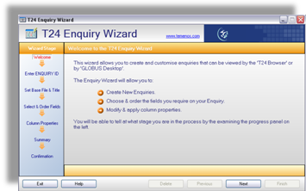  Figure 3. T24 Enquiry Wizard to guide users in designing enquiries
 | Facility to generate daily report of non-delivered messages (to swift) & problem messages. This report should contain a description for rejection. | 1 | 5 | Please refer to the explanation above.
 | Facility to generate a audit trail on system interface changes this report should contain the following details  Changes done by whom  Date & Time of change  What was changed | 1 | 5 | Supported by T24.  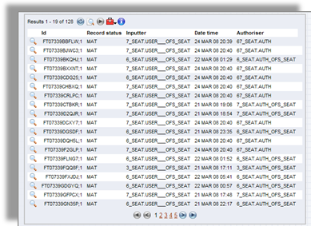  Figure 4. History file
 | The system shall warn management of possible duplicate emissions for outgoing messages and shall highlight these in a separate audit trail. | 1 | 5 | Supported by T24.
 | Facility to generate MIS reports on message volumes and transaction types ( freely definable) | 1 | 5 | Supported by T24 MIS module.  A Bank user can utilize either T24 Enquiry designer or T24 Report Designer to construct a report. The report can be in the form of online enquiries (i.e. using T24 Enquiry designer) or in the form of hardcopy reports produced during a Close of Business. In addition, T24 Enquiry designer includes a wizard function to guide a user to design simple enquiries. (Please refer to 25 above for Figure of the Enquiry Wizard).
 | Online Inquiry
 | Facility to inquire daily incoming & outgoing messages | 1 | 5 | Supported by T24.  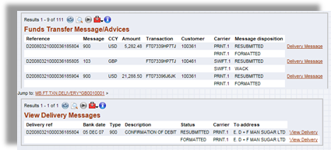  Figure 5. View FT Advices/Messages
 | Facility to inquire on messages not processed automatically | 1 | 5 | Supported by T24 by enquiry on the appropriate message queue.
 | Facility to inquire on messages requiring manual intervention | 1 | 5 | Supported by T24 by enquiry on the appropriate message queue.
 | Facility to inquire on messages pending for Authorisation & Verification | 1 | 5 | Supported by T24.  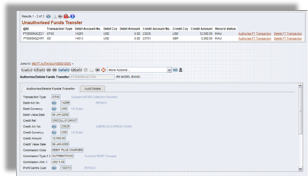  Figure 6. Authorise/Delete FT Transactions

