USER REQUIREMENTS

The Bidder should provide the following in the specified order in Section 4 of the proposal/bid document.

Provide detail information of the proposed solution as per document enclosed. Please note that marking should be carried out in the following manner; The Remarks column should be used to explain or provide detail information.

DESCRIPTION | REMARKS
Rating - 5 | If the User requirement is met 100% as defined in the RFP without any work around method.
Rating - 4 | If the User requirement is met 75% as defined in the RFP without any work around method. Define the number of hours required for the modification and cost in US$ in the Remarks column, in order to provide 100% functionality as defined.
Rating - 3 | If the User requirement is met 50% as defined in the RFP without any work around method. Define the number of hours required for the modification and cost in US$ in the Remarks column, in order to provide 100% functionality as defined.
Rating - 2 | If the User requirement is met 25% as defined in the RFP without any work around method. Define the number of hours required for the modification and cost in US$ in the Remarks column, in order to provide 100% functionality as defined.
Rating - 1 | If the User requirement is met as a Work around method defined in the RFP. Define the number of hours required for the modification and cost in US$ in the Remarks column, in order to provide 100% functionality as defined.
Rating - 0 | If the User requirement is not met as a defined in the RFP and modifications are required. Define the number of hours required for the modification and costs in US$ in the Remarks column.

The NBL rating is as follows:
1 = critical; 2 = essential; 3 = nice to have

SECURITY
Ref : | User requirements | NBL Priority | Bidder’s Rating | Bidder’s Remarks
 | SYSTEM SECURITY
 | Objective  Ensure Protection against unauthorized access  Restricted access to confidential information  Ensuring Accuracy of Data. Defining User Access to  Sub systems to be Centralized. | 1 | 5 | Supported by T24.
 | User Identification
 | User ID:  User ID should be alpha numeric ranging form 04 to 15 and this should be captured in Audit trails.  User Name:  User Name field should be in alpha form and Min and Max of the field (Max 50 characters) and this should be shown in the screens not the user ID.  EPF No:  There should be a field to capture the EPF No to user profile  NIC No:  There should be a field to capture NIC No to user profile  Email Address:  There should be a field to capture the email address of the user and it should be shown in first login screen and also it should be directed to designated user group (Admin) when they request reset password.  Attached :  User ID attached Department and or sub department if head office, and when it is branch, attached branch and or sub branch can be able to map with user ID. Department/Branch fields are mandatory and Sub branch and sub department field also be there when required.  User Access :  Access capturing for user ID need to be performed here by granting User Role/s, User Group/s or User Template/s etc.  User Profile Modification:  User profile should not be allowed modify if the user is logged into the system and System Admin should be able to force logout the user and do the modification when required. The modification should include change all the changes in user profile except User ID and same user ID can be use anywhere within the bank. Also after the profile modification, the user should be notified the changes done to his/her profile at the very first login. Also there should be an option to view profile history.  Vacation Period:  If user goes on vacation or System Admin is required to block the account, the system should facilitate to full fill this need with real time updates and after the defined vacation, the user should be able to login to the system without Sys admin interaction. | 1 | 5 | It is fully supported by the T24 Security Management System.  Each user has a User Profile in T24, which contains a unique user identifier, password, language and authorised activities within the system. Once a user signs on to T24, the SMS checks each activity against the profile to determine validity; unacceptable actions are prevented and recorded  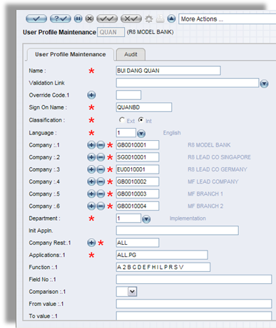  Figure 1. User Profile Maintenance  For detail which is not available in standard version of T24, system provide local fields for user to define detail which the bank need to maintain (Other fields may be added as local fields using the Local Reference - Database Designer tool).
 | User should be able to categorized under predefined user groups, attached functions along with respective Branch/Sub Branch and Dept if head office Users. | 1 | 5 | Supported by T24 SMS module.
 | Facility for the chief security officer (and at least one alternate) to delegate to lower level security officers, the authority to set security parameters within the authority level. Authority level can be able to change when required.(i.e. Branch System admin) | 1 | 5 | Supported by T24 SMS module.
 | Generates reminders and forces the Users to change password after a predefined interval from the date of last-changed. (Security Officer to define the no. of days for the password expiry) Security alert should be notified to security officer/s when it is exceeded the last date defined for each user(Very next working day) | 1 | 5 | Supported by T24 SMS module.  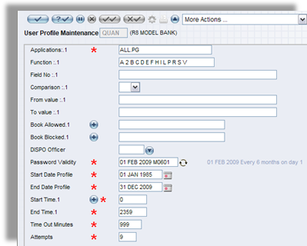  Figure 2. User Profile
 | Provides an on-line, real-time facility for the system administrator to: -  Define the security and privacy of information  Add and remove users in the system  Change the security profile of users.  Also to see all the users login to the system across the bank and facility to select selected branch/sub branch, dept if head office form central location.  Check the critical functions(pre- defined) by each user, Date, Branch/Sub Branch, Department/Unit | 1 | 5 | Supported by T24 SMS module.
 | Able to control security profiles of users at various levels of authorized officers apart from the security administrator.(i.e. Security Officer) Only to logout and user profile enable option is to be given to Branch Authorizer group and all the changes they do has to be notified to System Admin on daily basis. | 1 | 5 | Supported by T24 SMS module.
 | A special log of security officer activities that can’t be deleted even by him/herself.  User creation/Modification/ deactivation/PW reset and user group/template changed on daily basis. | 1 | 5 | Supported by T24 SMS module.  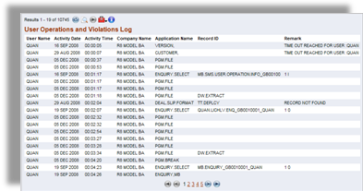  Figure 3. User Operations and Violations Log
 | Access Controls |  | 5 | Supported by T24 SMS module.
 | Able to define an expiry date for User Ids. User ID should be min 04 and Max 15 characters. | 1 | 5 | Supported by T24 SMS module.  (Please refer to the above response No. 4 for illustration of the User Profile).
 | Provides automatic logoff of User ID after a certain time period and it can be defined by system admin. | 1 | 5 | Supported by T24 SMS module.
 | Displays “Last Signed on” upon sign-on and it should be captured to user management report(grid format) | 1 | 5 | Supported by T24 SMS module.  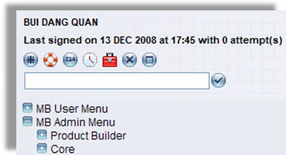  Figure 4. Last Signed on
 | Prevents passwords from being viewed or printed by any user. | 1 | 5 | Supported by T24 SMS module.
 | Able to disable screen echo when password is keyed (i.e. do not display password). | 1 | 5 | Supported by T24 SMS module.
 | Provides password encryption within the application. | 1 | 5 | Supported by T24 SMS module.
 | Provides for password length ranging from 06 to 15 characters.  Password parameters can be able to define by the bank i.e. Alpha numeric, case sensitive and the combination of alpha numeric characters and min and max of the combination + special characters | 1 | 5 | Supported by T24 SMS module.
 | Controls to be incorporated when creating passwords.  Eg; Provides alphanumeric characters in password.  *Password to contain combination of Characters  (Upper case, lower case) & numeric and special characters.  Immediate previous passwords cannot be re-used for defined time and ensures that new passwords must be different from the last x passwords (x > 20) and this can be able to defined by the bank. | 1 | 5 | Supported by T24 SMS module.  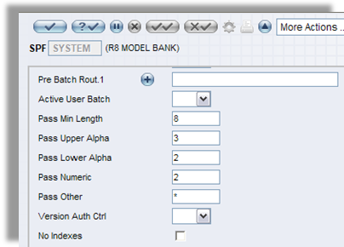  Figure 5. Password Validation
 | Able to change password on-line and when required. | 1 | 5 | Supported by T24 SMS module.
 | Able to set maximum number of password attempts and be able to define by the bank. | 1 | 5 | Supported by T24 SMS module.
 | Forces change of password at regular intervals (e.g. 30 days). | 1 | 5 | Supported by T24 SMS module.
 | Provides warning message to user, prior to required password change date (e.g. 10 days). | 1 | 5 | Supported by T24 SMS module.
 | Logs all changes to passwords and profile changes. | 1 | 5 | Supported by T24 SMS module.
 | Disables a user after a number of consecutive “log-on” failures and should be able to define this by system admin and such attempts to be notified to system admin when exceeded the defined attempts. | 1 | 5 | Supported by T24 SMS module.
 | Able to interface application access with the system access | 1 | 5 | Supported by T24 SMS module.
 | Ability to restrict Dual Access. (I.e. to grant Dual Access on prior approval) and even if any user profile is granted both input and authorize access with approval cannot be able to authorize his/her own transaction. | 1 | 5 | Supported by T24 SMS module.
 | Ability to have different levels of access within a system. Restrictions should apply to locations, functions, transactions, screens, fields on screens, etc. and also be able to restrict / allow system screens. | 1 | 5 | Supported by T24 SMS module.
 | Ability to restrict access to certain types of accounts (eg. Employees’ accounts) and devices (eg. Terminal id). | 1 | 5 | For all Users the information and facilities which may be accessed are specified at 4 levels: COMPANY; APPLICATION (and VERSION), FUNCTION and FIELD so that it is possible to specify precisely which records, belonging to which company, may be accessed and what may be done with them.
 | Ability to “lock” the workstation without having to sign off to prevent any access to the workstation.  Ability to automatically deactivate a user ID that is not used after a number of days and this can be able to define by the bank. | 1 | 5 | Ability to “lock” the workstation can be done by system administrator outside T24.  Ability to automatically deactivate a user ID that is not used after a number of days can be developed subject to Change Management procedures followed during project implementation.
 | Provide access control over print spools | 1 | 5 | Supported by T24 SMS module.
 | The User ID authorized to update/modify/delete and or view data is defined in password authorization tables. These tables should be secured against unauthorized access with additional password protection and data encryption. | 1 | 5 | Supported by T24 SMS module and Database security.
 | Access to the system utility especially through command line is restricted. | 1 | 5 | Supported by T24 SMS module.
 | Facility to warn when assigning functions which cannot be performed by the same person (un-combinable) & assign same on prior approval. | 1 | 5 | Supported by T24 SMS module through Override Message.
 | The commonly used system values for Users to remain as default values when creating/adding users & facility to change values where necessary. | 1 | 5 | Supported by T24 SMS module.
 | System Controls
 | Activates security system automatically upon reboot and cannot be deactivated except by authorized Security Administrator. | 1 | 5 | Supported by T24 SMS module.
 | Encrypts the security database, password and data across data communication media. | 1 | 5 | Supported by T24 SMS module and Database security.
 | Restricts the access of storage device/user-catalog for users. | 1 | 5 | This can be done by system administrator outside T24.
 | Integrates sign-on across different products/platforms when required. | 1 | 4 | Supported through customization.
 | Classifies access to System resources into different category of access rights which should include Read only right, Update right, Execute right, print right etc. | 1 | 5 | Supported by T24 SMS module.
 | Provides automatic time-out cut off of terminals not used by operators for predefined period of time. | 1 | 5 | Supported by T24 SMS module.
 | Provides the ability to restrict certain operators to log-on during nominated hours on specified days i.e. according to predefined calendar profile as stated above. | 1 | 5 | Supported by T24 SMS module.
 | Transactions also may be restricted by amount, by product as well as by type of transaction. | 1 | 5 | Supported by T24 SMS module.
 | Provides for the control of the distribution of reports in relation to the right to see. | 1 | 5 | Supported by T24 SMS module.
 | Ability to assign protection rights on different classes of users for the same resource. | 1 | 5 | Supported by T24 SMS module.
 | Provides an alarm to warn higher authority if security is violated. | 1 | 5 | Supported by T24 SMS module.
 | System Monitoring
 | Registers any attempts (successful and unsuccessful) to access restricted resources codes identifying the operator, terminal, date and time and notified system admin immediately. | 1 | 5 | Supported by T24 SMS module.
 | Maintains a log of log-on, log-off and security violations and system failure also off line transaction taken place in such period. | 1 | 5 | Supported by T24 SMS module.
 | Able to produce reports, which show all allowable accesses for users including systems, locations and access level, transaction done per day by product wise/amount wise/transaction wise in the system. | 1 | 5 | A Bank user can utilize either T24 Enquiry designer or T24 Report Designer to construct a report. The report can be in the form of online enquiries (i.e. using T24 Enquiry designer) or in the form of hardcopy reports produced during a Close of Business. In addition, T24 Enquiry designer includes a wizard function to guide a user to design simple enquiries.
 | Able to produce a variety of Audit Reports giving details of sensitive transactions, including date, time, User ID, old and new values for changes. | 1 | 5 | Please refer to the explanation above.
 | Facilitates availability of a complete audit trail for tracking transactions through the system showing who entered the transactions, who authorized the transactions, when they were entered and at which terminal. | 1 | 5 | Supported by T24 SMS module.  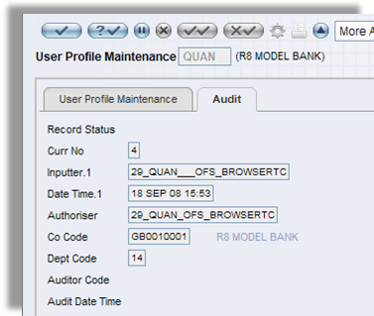  Figure 6. Audit
 | Provides on-line availability of the audit trail for a specified period of time before being archived. | 1 | 5 | Supported by T24 SMS module.
 | Able to produce Access Control Report which shows all unauthorized or irregular access to systems including date, time, User ID, location workstation ID and any sensitive transactions (eg. Password rejected, user not allowed in system, job submitted to update master file). | 1 | 5 | T24 provided a standard enquiry. We are assuming that the format of this enquiry meet the requirements of NDB Bank. If not, then NDB Bank can use T24 Enquiry and Report designer tools to modify them.  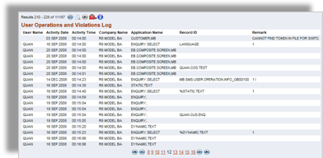  Figure 7. User Operations and Violations Log
 | Able to define frequency, types and details of exception reports. | 1 | 4 | Supported by T24 with minor customization.
 | The logs (e.g. for computer access and attempted access violations) cannot be tampered or altered without leaving an audit trail. | 1 | 5 | Supported by T24 SMS module.
 | Able to display/print password override report immediately and also patch updates (anytime during the day) | 1 |  | Require more clarification to respond more accurately.
 | Facilitate embedded audit module that collect pre-defined information into a special computer file that can be examined/monitored continuously by the auditor. | 1 | 5 | A Bank user can utilize either T24 Enquiry designer or T24 Report Designer to construct a report and export to text or excel file for this purpose.
 | Facility to print Access logs of defined Users.  (Security Officer/Administrator to define users) | 1 | 5 | Supported by T24 SMS module.
 | Reports (Print / View / Save in grid format)  Administration Reports can be able to obtain for a given period.  User Profiles  User Profile deviations  Special Users  Password reset times  Unsuccessful attempts  Logged in time per day and accumulation.  System down time while logged in.  No of transaction by user /by branch/ by product wise per day  Single level/ dual level transaction per day by branch wise  User per Special Authority  Functions per User  User per Application / Function  Users and Functions expiring within X days  Users / Functions – Un-combinable  Audit Reporting  Access Logs  User profile creations / deactivations for a given time period  Users not logging to the system for a given period  Set up Reports;  Application Standard Values  Available Functions  Un-combinable Functions  Application Object Authorities  Objects per Application  Special User Authorities  Objects and Authorized Users / Group Profile  Security Violations | 1 | 5 | T24 provides two powerful designer tools (Enquiry Designer and Report Designer) to enable Bank to define reports. In addition, T24 includes standard enquiry and report templates which Bank can use to construct its own report/enquiries in a relatively short time frame  The reports and enquiries produced can be printed or viewed or saved in HTML, XML or CSV (grid format) depending on the initial design structure.  In addition, T24 includes numerous standard reports and enquiries which can be utilized as user reports or as templates for new report or enquiry construction.

