

ModularFour Solutions (Pvt.) Limited.
#472, Kohalvila road, Gonawala, Kelaniya, Sri Lanka.
E-mail: mahinda@modular4.com
Phone: +94 112 918 458, +94 772 317 666

Client Name/Address
Date : 14th Aug 2014
Our Reference : M4/INV
Invoice Number : M4INV14000003
PO No. :
Mr. DA Software Solutions

INVOICE
Description
MBSL Maintenance Cost
Particulars | Amount (LKR)
Cost of Annual Maintenance Cost | 31,500.00
Invoice Total | 31,500.00

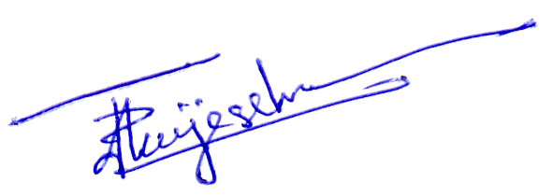

Prepared by:  Authorized by:

