Modular4 Solutions (Pvt) Limited.

#112/7, Vauxhall Street, Colombo 02. Sri Lanka.
E-mail: info@modular4.com
mahinda@modular4.com
Phone: +94773435429, +94772317666
28th April 2010,
Mr. Zihan Zakeriya,
Financial Controller,
Bioextract Pvt Ltd,
# 11,
SDS Jayasinghe MW,
Kalubowila,
Dehiwala.

Dear Sir,

QUOTATION for Net Work Solution

First and foremost, thank you very much for your interest in Modular4 Solutions (Pvt) Ltd. With reference to your inquiry on the above Network solution, we are pleased to submit herewith our revised price quotation for your kind consideration.

Pricing Summary

Description | Qty. | Rate  (Rs.) | Price (Rs.)
4U Rack | 1` | 8,000 | 8,000
24 Port Patch Panel (with 1 Year Warranty) | 2 | 8,000 | 16,000
24 Port Switch (with 1 Year Warranty) | 2 | 15,000 | 30,000
Data Point | 32 | 1,800 | 57,600
Voice Point | 27 | 1,600 | 43,200
Labor Cost | 5 | 4000 | 20,000

Total Price for the Solution Rs. 174,800/-

Conduit Layout plane

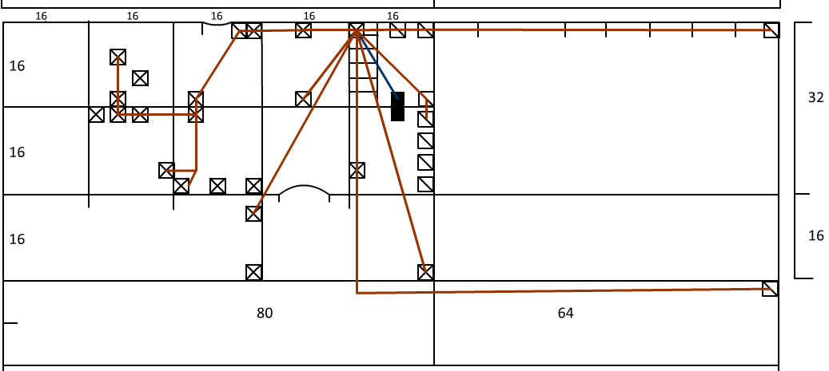

Terms & Conditions

- All Data Points will be tested by team before handed over to the customer, voice point testing will be completed after customer has provided with PBX system.

- This proposed solution only covers physical connectivity among client nodes; hence any security threat from viruses, hackers or adult content neither filtering nor restrictions to access network resource will not be covered. Client is advised with a security solution to minimize above threats.

- Our team should be given with access to the building/rooms when necessary during the installation period and if required thereafter.

We hope this pricing proposal would meet your requirements. Should you need any further clarifications, please feel free to contact us.

Thank You,
Yours sincerely,

D.J. Wijesekera
Director Business Development

