

ModularFour Solutions (Pvt.) Limited.
#472, Kohalvila road, Gonawala, Kelaniya, Sri Lanka.
E-mail: mahinda@modular4.com
Phone: +94 112 918 458, +94 772 317 666

Client Name/Address
Date : 11th Dec 2014
Our Reference : M4/INV
Invoice Number : M4INV14000007
PO No. :
Mr. Susantha Fernando
Chairman,
No. 40/12 A,
Park Road,
Colombo 5.

INVOICE
Description
Configure New Router and Repair two PCs
Particulars | Amount (LKR)
Cost of “Configure New Router and Repair two PCs “ | 10,000.00
Invoice Total | 10,000.00

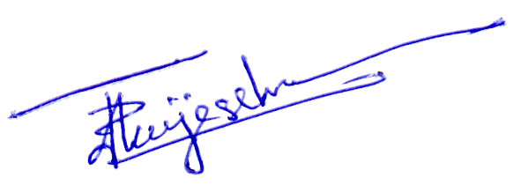

Prepared by:  Authorized by:

