

ModularFour Solutions (Pvt.) Limited.
#472, Kohalvila road, Gonawala, Kelaniya, Sri Lanka.
E-mail: mahinda@modular4.com
Phone: +94 112 918 458, +94 772 317 666

Client Name/Address
Date : 1st June 2015
Our Reference : M4/INV
Invoice Number : M4INV15000005
PO No. :
Mr. Susantha Fernando
Chairman,
No. 40/12 A,
Park Road,
Colombo 5.

INVOICE
Description
Pawning SW Maintanence
Particulars | Amount (LKR)
Cost of “Pawning SW Maintanence”  Annual Maintenance Cost | 99,000.00
Invoice Total | 99,000.00

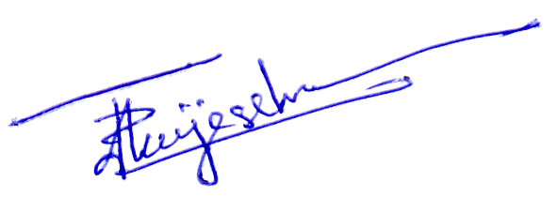

Prepared by:  Authorized by:

