
Modular4 Solutions (Pvt.) Limited.
#472, Kohalwila Rd, Gonalwala, Kelaniya, Sri Lanka.
E-mail: mahinda@modular4.com
Phone: +94 112918458, +94772317666,+94716825707

13th Dec 2014

Mr. Susantha Fernando Proposal No: M4PO14000007
Chairman
No. 40/12 A,
Park Road,
Colombo 5.

Dear Sir,

QUOTATION for the Proposed Network and Configuration

Bare minimum network
Description
ADSL Router supply & configuration
10 network point installation with 6 Access point installation and configuration

Finical Considerations of the proposed network solution

Description | Qty | Unit Price | Total Price
24 port Switch | 1 | 15,000 | 15,000
24 port patch panel | 1 | 6,500 | 6,500
Access points | 6 | 8,000 | 48,000
2 U Rack | 1 | 5,000 | 5,000
utp patch code | 15 | 125 | 1,875
ADSL router With Firewall & Filtering | 1 | 8,000 | 8,000
Simax Cable (400m) | 5 | 4,000 | 20,000
Casings | 30 | 350 | 10,500
Face plates | 10 | 500 | 5,000
Node Termination | 20 | 1,500 | 30,000
Network Configuration | 1 | 50,000 | 50,000
Total Cost |  |  | 199,875

Secure captive portal system
Provides Hotel customers with access to internet with a given username and password to be expired on their departures which can be given on their arrival by reception.

Description | Qty | Unit Price | Total Price
Dell 121 server Hardware | 1 | 250,000 | 250,000
CSTech Captive Portal system | 1 | 350,000 | 350,000
Concurrent Client license | 10 | 2,000 | 20,000
Total Cost |  |  | 620,000

Optional: pre-paid card system and post billing plans excluded on this proposal.

Maintenance Agreement
Description | Total
Total solution maintenances annually | 25% of the proposed solution

Network topology
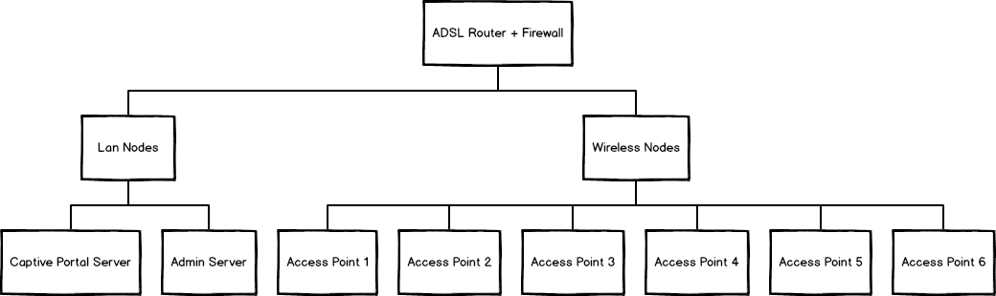

Maintenance Service Agreement

Coverage
It is a must that network solutions to be continues monitor and look for loop holes that can interrupt business process, which will cause huge lost for the company.

Also, in case of a break down to avoid business lost We CSTech here by recommend Client follow this agreement for fulfill their uninterrupted services to the customers.

Below we have mentioned the services provided by our agreement for your consideration.

- For any brake down in the existing setup, Our Company will guarantee that system will restore within 24 hours from the break down time. This will be done by our company will maintain a separate backup resources at their premises and restore it with existing resources for any breakdowns. (Please keep in mind that this service is not provided on Saturdays and Sundays, If any breakdown reported on those days will restores in following Monday.)

- For Servers, adding new business rules & calibrating on new rules for the firewall solution will be free of charge, as requested by the client or by us for future enchantments of the solution. (for advanced rules our company will charge additional)

- However for total re-configure of existing firewalls with new configurations of the new database server and calibrating both new databases server with new firewall configurations to work optimized with protecting the new database server from malicious attacks from hackers & other intruders will cost in a different proposal as our company decides.

- A technical person will visit the client premises regular (monthly) basis to provide services to Linux firewall solution for any problem on this solution.

- This agreement only target services to components mentioned in this design only.

Terms and Conditions

- We assume that customers PCs are in proper working order and free of bugs/viruses. If not cost of rectifying such problems will charge additionally from the customer.

- We shall not be responsible for any damages to the software/hardware unless it occurs due to the negligence of our company personnel.

- Personnel from our company should be given access to the building/rooms when necessary during the installation period and if required thereafter.

- Scope of the project is not to be extended without prior permit from our company management. Fixed requirement set is defined to be followed when projects initiated.

- Any service requested will be separately charged to the Customer, such as bug fixing, new requirement, new installation etc. These charges are taken as support charges and will be depend on our company management.

- All rights for solution are reserved by our company. Hence, Exposing of this document to our competitors or implementation of the described solution may lead to legal issues. Hence our company have all authority to offend the customer or taken the issue to courts.

- Please Sign-off this document if you have met the necessary satisfaction level and provide a copy for our company personal to kick off the project. After sign-off this document any changes will be charged additionally as a new requirement or requirement change.

- Our company will sign a maintenance service agreement with Client Ltd of before commotion of the project. (Please refer the section 2)

- If incase of our company decided to abandon the agreement, our company will expose all design, implementation and configuration documents related to this solution and provides hands on training to a Technical Personal @ your Stuff to continue the solution after our company expose the solution.

Proposal Validity
This proposal is valid for a period of one (01) month.

Payment Terms & Other Charges
Application System Charges for each Module
Hardware Cost Should be Pay Up-Front
Installation and Configuration Charges will be After Done the Job
Cheques should be draft to “ModularFour Solution Pvt Ltd.”

We hope this pricing proposal would meet your requirements. Should you need any further clarifications, please feel free to contact us.

Thank You,
Yours sincerely,


J.M Madhujith Jayakody
Director Project Development

