LuckyHomes Pvt Ltd


Implement of Legal Process

Version 1.0

30-MAR-2016

ModularFour Solution Pvt Ltd.



Revision History

Date | Description | Author | Comments
30-03-2016 | Initial Version | ModularFour

Document Approval

The following Software Requirements Specification has been accepted and approved by the following:
Signature | Printed Name | Title | Date

Table of Contents

Revision History ii
Document Approval ii
1. Introduction 1
1.1 Purpose 1
1.2 Scope 1
1.3 Definitions, Acronyms, and Abbreviations 1
1.4 References 1
1.5 Overview 1
2. General Description 1
2.1 Product Perspective 1
2.2 Product Functions 1
2.3 User Characteristics 1
2.4 General Constraints 4
2.5 Assumptions and Dependencies 4
3. Specific Requirements 4

1. Introduction

1.1 Purpose
LuckyHomes has requested a further development on the existing FinSoft application to support their Legal Process.

1.2 Scope
Normal Closure
Early Settlement

1.3 Definitions, Acronyms, and Abbreviations
N/A

1.4 References

Annexure I - Stamp duty details

Annexure II - Stamp duty payment details

Annexure III – Finance Request Form

1.5 Overview
Introducing Legal Process for Block Final Payment

2. General Description
N/A

2.1 Product Perspective
EP, RealEstate

2.2 Product Functions
Proposed procedure for Stamp & Legal Fees to the Modular Four System
Step 1
Legal fees can be taken only for settled contract and contract status must be changed as “Closed”.

Step 2
Receipting of Legal and Stamp fees for the closed contract – Standard Receipt

Step 3
Stand duty request should be made by Legal Division via system and request form should be generated through system. Annexure 1

Step 4
Standard payment should be arranged against the payment request.

Step 5
Stamp duty release should be updated to the system by Finance Division

Step 6
Bank acknowledgment should be updated to the system by Legal Division.

Step 7
Deed submission date to the Land Registry should be updated by the Legal Division.

Step 8
Registered deed received date should be updated by the Legal Division.

Step 9
Deed handed over date and receiver’s name should be updated to the system by Legal Division.

Acknowledgement SLIP

2.3 User Characteristics
Parameter Definition For Legal and Stamp Duty
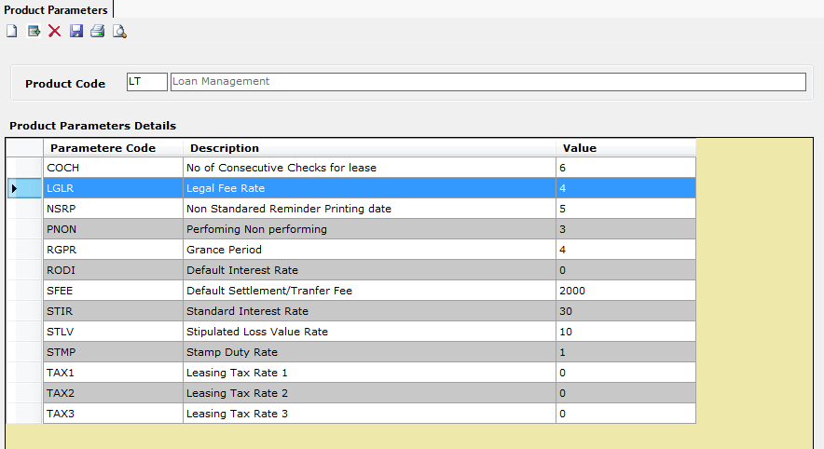

Figure 1.1

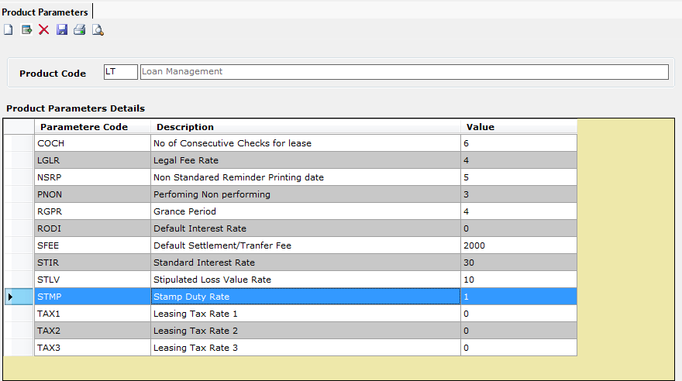

Figure 1.2

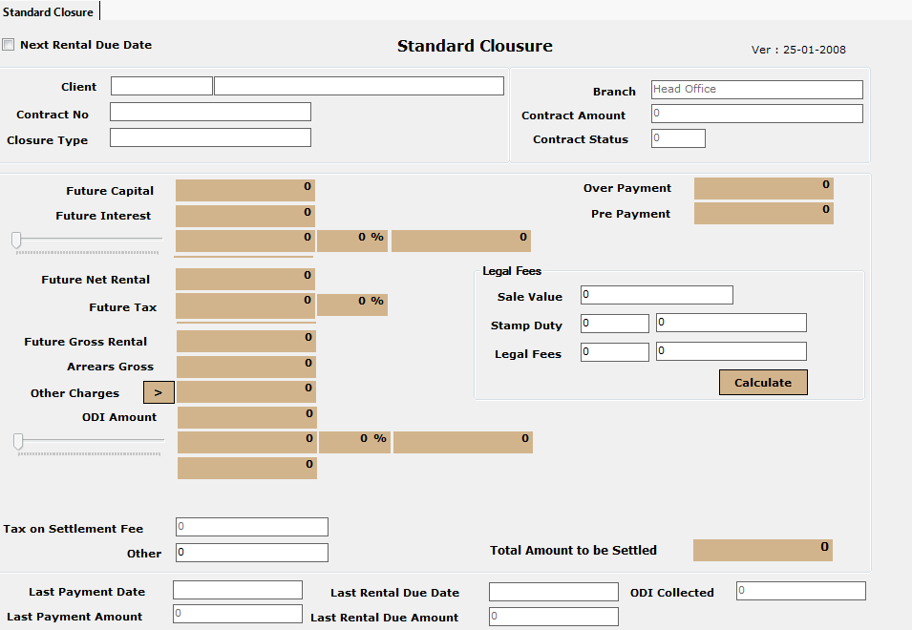
Figure 1.3

2.4 General Constraints
N/A

2.5 Assumptions and Dependencies
N/A

3. Specific Requirements

Functional specification:

Stakeholders:
Head of Loan Department (LuckyHomes), Head Of Accounts Department (LuckyHomes),
Head of IT (LuckyHomes), Head of Process (Modular4), Director Projects (Modular4)

Annexure I

Lucky Homes (Pvt) Ltd

Stamp duty details as of : xxxxxxxxxxxxx
Printed :
Printed Time :
Project | Lot No | Client Name | Date of Fully Settled | SD Payment Date | SD Request Date | SD Released  Date | Bank Acknowledge Date | Date of Deed Sent to L/R | Date of Deed Received from L/R | Deed Hand over Date | Deed Hand Over to
Branch Name :
Printed Date :

Required criteria option
- Project Wise
- Pending hand over deeds

Annexure II

Lucky Homes (Pvt) Ltd

Stamp duty payment details as of : xxxxxxxxxxxxx
Printed :
Printed Time :
Branch Name :
Printed Date :

Project | Lot No | Client Name | Sale Value Rs. | Legal Fees Rs. | Stamp Duty Received | Stamp Duty Payment
Total

Required criteria option
- Project Wise

Annexure II

Lucky Homes (Pvt) Ltd
Instructions For Depositing Stamp Duty To The Credit Of Provincial Council
LEGAL DEPARTMENT
Deed No | : | ………………………………………………….. |  |  |  | Name of Project |  |  | : | ………………………………………………
Date | : | ………………………………………………….. |  |  |  | Plan No. |  |  | : | ………………………………………………
Stamp Duty Rs. | : | ………………………………………………….. |  |  |  | Lot No. |  |  | : | ………………………………………………
 |  |  |  |  |  | Situation of Land |  |  | : | ………………………………………………
 |  |  |  |  |  | District |  |  | : | ………………………………………………
 |  | Name of the Grantor |  |  | : | ………………………………………………………………………………..
 |  | Address |  |  | : | ………………………………………………………………………………..
 |  |  |  |  |  | ………………………………………………………………………………..
 |  | Name of Grantee |  |  | : | ………………………………………………………………………………..
 |  | Address |  |  | : | ………………………………………………………………………………..
 |  |  |  |  |  | ………………………………………………………………………………..
 |  | Name & Address of the Notary |  |  | : | ………………………………………………………………………………..
 |  |  |  |  |  | ………………………………………………………………………………..
 |  |  |  |  |  | ………………………………………………………………………………..
Prepared By |  |  | : | ……………………………………………. |  | Authorized By |  |  | : | ……………………………………………..
CONFIRMATION - REAL ESTATE & FINANCE DEPARTMENT
System Reference
Real Estate No :………………………………………

Easy Payment No :………………………………………..

Client Name |  |  | : | ……………………………………………………………………..
Receipt No. & Date |  |  | : | ……………………………………………………………………..
Amount Received |  |  | : | ……………………………………………………………………..
Checked By |  |  | : | ……………………………………………. |  | Checked By |  |  | : | ……………………………………………..
 |  |  |  | Real Estate Division |  |  |  |  |  | Finance Division
 | …………………………….. |  |  |  |  |  |  |  |  | ………………………………..
 | Recommended By |  |  |  |  |  |  |  |  | Approved By
PAYMENT DETAILS AND ACKNOWLEDGEMENT
Amount Paid | : | …………………………………. |  |  |  | Date |  |  | : | …………………………
Cheque No | : | …………………………………. |  |  |  | Voucher No. |  |  | : | ………………………………..
Name | : | ……………………………………………………………………..
Signature | : | ……………………………………………………………………..

Annexure IV

Acknowledgement SLIP

