

ModularFour Solutions (Pvt.) Limited.
#427, Kohalwila Road, Gonawala, Kelaniya, Sri Lanka.
E-mail: mahinda@modular4.com
Phone: +94 112 918 458, +94 772 317 666

Client Name/Address
Date : 16th November 2015
Our Reference : M4/INV
Invoice Number : M4INV15000007
PO No. :
Mr. M H Wasantha
Accountant
Lucky Homes (Pvt) Ltd.
No. 145/1A, High Level Road,
Pannipitiya, Sri Lanka.

INVOICE
Description
FinSoft Software Solution (Real Estate, Easy Payment, General Ledger)
Particulars | Amount (LKR)
Cost of Maintenance for period of 01/11/2015 – 30/04/2016 | 250,000.00
Invoice Total | 250,000.00

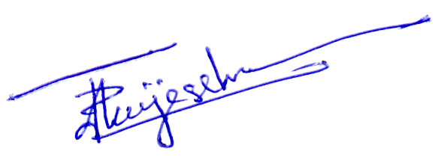


Prepared by: ………………………………. Authorized by: ……………………..................

