
DA Software Solutions (Pvt.) Limited.
#76, Pagoda Road, Nugegoda. Sri Lanka.
E-mail: dumindu@dassonline.com
Phone: +94 114 941 921, +94 773 435 429

Client Name/Address
Date : 01st January 2012
Our Reference : DASS /INV
Invoice Number : DAINV12000274
MBSL Savings Bank
#2, Deal Place,
Colombo 3.

INVOICE
Description
“Pawn - Brokering Management” Software Solution

Particulars | Amount (LKR)
Cost of “Pawn - Brokering Management” Software Solution Maintenance for 2012 January 1st to 2012 June 30th | 26,250.00
Invoice Total | 26,250.00

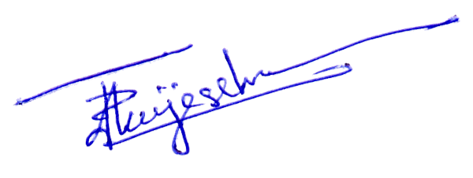
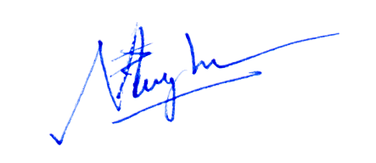

Prepared by: ………………………………. Authorized by: ……………………..................

