
Modular4 Solutions (Pvt.) Limited.
#76, Pagoda Road, Nugegoda. Sri Lanka.
E-mail: dumindu@modular4.com
Phone: +94 114941921, +94773435429

Server Configuration

Feature | Description
Processor | Cod core Intel Pentium 3.0 GHz (320 GB SATA model
Memory | 4 GB (4 x 1 GB) or more
Network Controller | Embedded NC105i PCIe Gigabit Ethernet Server Adapter
Expansion Slots | - (1) Full-height, half-length 32-bit/33MHz PCI at 3.3V slot  - (1) Full-height, half-length PCIe x1 slot (x8 connector)  - (1) Full-height, full-length PCIe x1 slot (x8 connector)  - (1) Full-height, full-length PCIe x8 slot (occupied by Smart Array E200/128MB controller on 1 TB SATA, 2 TB SATA, and 584 GB SAS models)  (1) Lights-out 100c option slot
Management | - Microsoft Management Console (MMC)-based user interface  - Remote system management via Remote Desktop or Telnet  (Optional) HP Lights-Out 100c Remote Management Card
Operating System | Microsoft Windows Server 2003 Release 2, Workgroup x32 Edition (320 GB SATA model)
Form Factor | Micro ATX Tower

Client PC Features

Feature | Description
Processor | Dual Core Intel Pentium 2.0 GHz or Higher
Memory | 1 GB or more

System Architecture

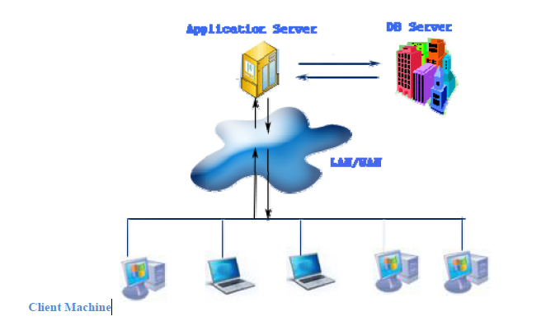

System Performance

Feature | Description
Number of Contract | 30,000
Number of Branch | 15
Number of Users (Concurrent) | 100
Network Band Width | 100MBps
Facility Inquiry Speed | 1 per second

