

ModularFour Solutions (Pvt.) Limited.
#472, Kohalvila road, Gonawala, Kelaniya, Sri Lanka.
E-mail: mahinda@modular4.com
Phone: +94 112 918 458, +94 772 317 666

Client Name/Address
Date : 11th Dec 2014
Invoice Number : M4INV14000006
PO No. : M4PO14000004
Mr. Manjula Suraweera
GM,
People's Realty Ltd.
No.16 ,
Byrde Place , Colombo 06.

INVOICE
Description
Balance Upload and Source Modification – 50%
Particulars | Amount (LKR)
Cost of “Balance Upload and Source Modification – 50%” | 63,000.00
Invoice Total | 63,000.00

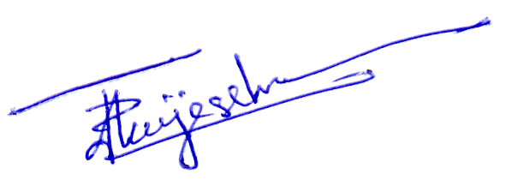

Prepared by:  Authorized by:

