
Modular4 Solutions (Pvt.) Limited.
#76, Pagoda Road, Nugegoda. Sri Lanka.
E-mail: dumindu@modular4.com
Phone: +94 114941921, +94773435429

27th March 2012

Mr. Anuranga Indrajith Handaragam
Head of IT,
People’s Merchant Bank,
#21, Nawam Mawatha,
Colombo 02.

Dear Sir,

QUOTATION for Several Modifications in Pawn Management Software Solution

First and foremost, thank you very much for your interest in Modular4 Solutions (Pvt) Ltd. With reference to your inquiry on the above software solution, we are pleased to submit herewith our revised p rice quotation for your kind consideration.

Pricing Summary

 |  | Man Hours | Rs.
1. | Remove the ID Validation for Admin Users | 4h | 7,200.00
Cost of software Modification Rs. 7,200.00

Total cost of software Modification Rs. 7,200.00

Currency of Offer
All prices are in Sri Lankan Rupees.

Proposal Validity
This proposal is valid for a period of Six (06) month.

Payment Terms & Other Charges

Application System Charges for each Module
50% - on confirmation of the quotation
50% - on implementation of the modifications

We hope this pricing proposal would meet your requirements. Should you need any further clarifications, please feel free to contact us.

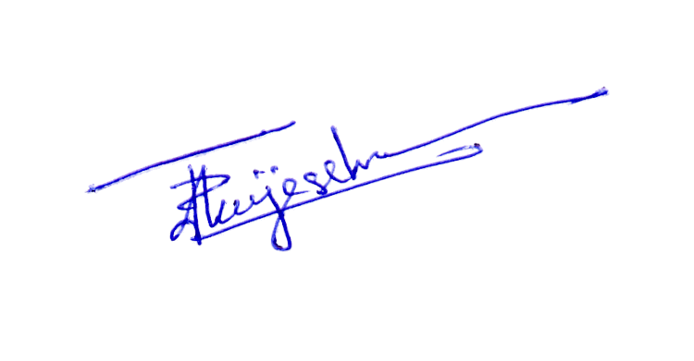
Thank You,
Yours sincerely,

D. Janeendranath Wijesekera
Director Business Development

