

ModularFour Solutions (Pvt.) Limited.
#427, Kohalwila Road, Gonawala, Kelaniya, Sri Lanka.
E-mail: mahinda@modular4.com
Phone: +94 112 918 458, +94 772 317 666

Client Name/Address
Date : 04th Dec 2015
Our Reference : M4/INV
Invoice Number : M4INV15000012
PO No. :
Mr. Anuranga Indrajith Handaragam Proposal No: M4P
Head of IT,

People’s Merchant Bank,

#21, Nawam Mawatha,

Colombo 02.

INVOICE
Description
Maintenance For Pawning System
Particulars | Amount (LKR)
Payment of Maintenance for the Period of 2015-2016 | 112,882.56
Invoice Total | 112,882.56

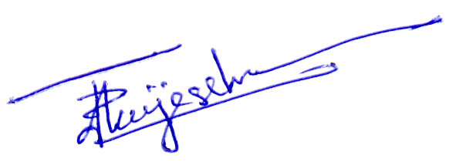


Prepared by: ……………………… Authorized by: …………..................

