Mr. Niluksha
Sew Gunasekara Pawn Brokers

Pawn Brokering Solution
Proposed Financial Suite

Prepared For: Sew Gunasekara Pawn Brokers

Prepared By: Modular4

Proposal Date: 29/09/2014

Description

Pawn Brokering Solution is a comprehensive, user-friendly package consisting of the following components:
Product Categorization
Cartage Categorization
Fund Management
Reminder Module
Chart of Accounts
Petty Cash
Journal Entries
Financial Statement etc..
This has been designed for ease-of-use, being menu-driven with consistent structures across all of the application. The database provides shared access to the information while ensuring complete integrity of the data.
Pawn Brokering Solution provides many convenient reporting features, tailored to the roles of your decision. Also it is an application that optimizes the processes of exchanging documents between enterprises and managing documents within an organization by capturing and reading electronic copies – and eliminating the need for manual data entry.

Proposal Number: M4PO14000003
Table of Contents

Project Purpose and Business Problem 3
Our Solution 3
Implementation Plan 4
Application and Software License 6
Financial Estimates 7
About Modular4 8

Project Purpose and Business Problem
Finance software should provide users with an online environment within which they can maintain Customer records, Ticket details, Referential documents, with minimum data redundancy & greater security. And improve employee performance and productivity by integrating business processes and data across the organization
Also it should provide the reports, graphs as per the state regulation and market trends.
Finally it should help with MIS reporting for better decision making.

Our Solution

Pawn Brokering Solution offers the chance to capture of data easily and accurately, facilitate processes, and generate data that is easily accessed and intuitive. It saves time and effort not having to duplicate the posting of transactions. Also enables you to master the data needed to make fast, sound decisions while conducting business.
Pawn Brokering Solution supports capture of data easily and accurately, facilitates processes, and generates data that is easily accessed and intuitive. The robustness of the product protects the business from internal and external fraudulent activity. Pawn Brokering Solution simplifies the adherence to regulatory mandates and results in significant savings and provides protection against litigation.

Benefits of using our solution
Common Client Concept
Pawn Brokering Solution maintains Customers, Auctioneer and the Officers of the system in a method where each can play either role at any given time, which reduces data duplication. And the National Identity Card Number is mandatory in the system & it is validated as per the Central Bank regulations.

Information Centre
Pawn Brokering Solution has an inbuilt report module with MIS reports, supporting better decision making, which can be customized as per user requirements

Implementation Plan

High Level Project Plan
Master data keying (by Customer ) 30 Days
Fine Tuning and Implementing 15 Days

Software Agreement
The Software Agreement to be signed with “Modular4 Solutions (Pvt) Ltd.”

Software Warranty
This software solution carries a warranty period of Twelve (12) Months from the date of User acceptance test (UAT).

Software Maintenance
Maintenance services shall be provided under a maintenance agreement to be signed after the warranty period expires. The standard annual maintenance charges would be fifteen percent (15%) on the product price plus the subsequent cost of modifications.

Software Maintenance
Upfront 100% maintenance fees for a period of one year at the signing of the maintenance contract.
During such annual maintenance MODULAR4 shall rectify all software related faults, defects and malfunctions free of charge.

Additional Software Modifications
All additional software modification charges will be quoted after a detailed system study. The development of the modifications would begin once a written confirmation is given by the client.

Modification Charges
50% - on confirmation of the quotation
50% - on implementation of the modifications

Updates/New Modules
Customers under maintenance service agreement are entitled to free Application Updates within the same version, database, operating system, and application language (subject to application customizations done at the client’s site) of the modules purchased.
Other additional/new modules/new version upgrades would be available at a very special discounted price to your company.

Purchase Order & the Payments
Purchase Order and the payments to be issued to “Modular4 Solutions (Pvt) Ltd.”

Application and Software License

Oracle
Java 1.6

System Architecture
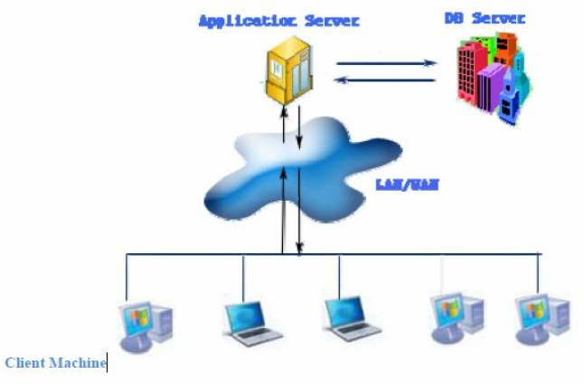
System Performance

Feature Description
Number of Contract 30,000
Number of Branch 15
Number of Users (Concurrent) 100
Network Band Width 100MBps
Facility Inquiry Speed 1 per second

Pawn Brokering Development Architecture
ORACLE Data Base
Java 1.6
Jasper Reporting Framework




Financial Estimates

Pricing Summary

Cost of the Pawn Brokering Software Module | 815,000.00
Cost of the General Ledger Software Module | 725,000.00
Cost of the General Ledger Software Module | 350,000.00
Total Price | 1,890,000.00

Note:
** MODULAR4 will sell the source code to the client five (5) times of the Software value on unlimited user license, if client needs.
** Unlimited user license will be provided for each module.
**

Currency of Offer
All prices are in Sri Lankan Rupees.

Proposal Validity
This proposal is valid for a period of one (01) month.

Payment Terms
50% - on Acceptance of Proposal
50% - on Live Run

Training
User training will be done at site during implementation.
About Modular4

Modular4 has delivered cost effective and high-quality software solutions for a wide range of industries and domains. We work together to deliver the ultimate in customer satisfaction while also helping each business or company achieves their unique needs.
Our competence and experience ensures that we deliver excellent services and products to our customers.
At Modular4 we are proud of our high quality standards. These standards allow us to provide our customers with reliable software applications, regardless of complexity.

Contact Us
Dumindu Wijesekara Mahinda Jayakody
0773435429 072317666 / 0716825707
dumindu@modular4.com mahinda@modular4.com
Web Site : www.modular4.com

Our Clients
Client | User reference | Solution Provided
People’s Merchant Business PLC | Anuranga Indrajith  Manager IT | “Pawn – Brokering” Software Solution
Citizen Development Bank | Mr. Imdaad Nagiub  Senior Manager IT | “Pawn – Brokering” Software Solution
MBSL Savings Bank | Mr. Dushmantha Weerathunga  Manager IT | “Pawn – Brokering” Software Solution
Lake House Printers & Publishers | Mr. Rasika Karandawa | Online Bank Cheque Book Ordering and Cheque Printing (MICR)  Cheque return Notice Printing with Lanka Clearance Process data
City Bank | Mr. Sumeda Karunarathne  Product Manager | Post Dated Cheque management Software
Ideal Property | Mr. Peter Jayalath  Owner | Real Estate management Software
K.G.S Spear Parts | Mr. Sajeewa Ekanayaka  Product Manager | Inventory Solution
Lucky Homes | Mr. Dinesh Kuruwita | Finsoft Total Solution
Global Trust Pvt Ltd | Sheno Jayasekara  Manager IT | “Pawn – Brokering” Software Solution

Confidentiality
All material, prices and other information provided in this proposal and other supporting documents, annexure, CD-ROMs, diskettes etc. should not be disclosed to any 3rd party without written consent.

We hope this pricing proposal would meet your requirements. Should you need any further clarifications, please feel free to contact us.


Thank You,
Yours sincerely,

D. Janeendranath Wijesekera
Director Marketing
Modular4 Solutions

Server Pricing

Feature Description
Processor | Intel® Xeon® 3.0 Core GHz (320 GB SATA model)
Memory | 4 GB (4 x 1 GB) or more
Network Controller | Embedded NC105i PCIe Gigabit Ethernet Server Adapter
Operating System | Microsoft Windows Server 2003 Release 2, Workgroup x32 Edition (320 GB SATA model), Raid 5
Hard Disk Capacity | 1TB Or More
Server Price | Rs. 500,000.00

