Sales Quotation No: MEVA/__/__/__/__/__/_____ | Sales Quotation Date: DD/MM/YYYY

Buyer Name & Details | : | <company> | <country>  Contact person: <name>  Mobile No : <ph>  Email address : <email>
Vehicle with Armoring Detail/s | : | <vehicle category>
Price (in US$) –  As per clause II below | : | <as approved>

<armouring level> BASED ON
<vehicle model>

<Hero Image>

Pictures are for illustrations purpose only
II. Vehicles Prices and Specifications Breakdown

VEHICLES PRICES AND SPECIFICATIONS BREAKDOWN |  |  | PRICING, USD
NO | ITEM DESCRIPTION | QTY | UNIT PRICE | TOTAL
B | Armor Specifications
C | Warranty Package
E | Delivery point/Freight Charges:

IV. Payment Terms and Condition

- In accordance to ANNEX (D) in RFP FCM 24-5.
- Bank Details

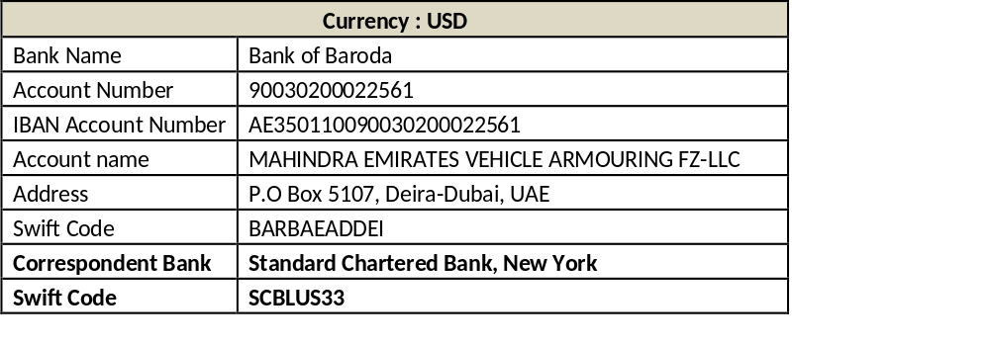
VI. Shipping Documents for Export related Requirements:

(Buyer shall be responsible for procuring the Shipping Documents)
- End User Certificate from the End User in the prescribed format
- No Objection Certificate from Consulate/Embassy of Importing country in UAE in the prescribed format.
- Importing country consulate in UAE attested trade license or passport copy of the buyer.
- And any other requirement as per the local law.
- MEVA will not take any responsibility for shipment unless the End User Certificate is provided by the End User on the company letter head duly signed and stamped, NOC is provided by Embassy/Consulate and MOFA export license is issued.

General Process Involved:
- Client to get the End User Certificate which strictly need to mention the vehicle details with Engine/Chassis number (To be provided by MEVA)
- The End User Certificate to be sent to Consulate/Embassy of Importing country in
- UAE with one to MEVA
- Embassy/Consulate to issue the NO OBJECTION CERTIFICATE (English and Arabic) to Ministry of Foreign Affairs, Dubai.
- Ministry of Foreign Affairs, Dubai to issue the Export clearance letter.
- CID Inspection and Custom Formalities
- Movement of vehicle from Plant to Sea Port
- Shipment.
TERMS | DESCRIPTION | DETAILS
Proposal Period | From the date of the issuance of Proposal | 60 Days
Pre-Delivery Inspection | Upon the request of Client | @ Client cost
Pre-Fabrication Inspection | Upon the request of Client | @ Client cost
Liability and Damage | Liability of the seller shall be limited to the Warranty terms as specified in clause V
Storage Fees | From the date of notification of completion of vehicle to the date of shipment | @ US$ 50 per vehicle per day
Non-Refund/Non cancellation | Once the proposal is signed by buyer and seller, the amount is Non-Refundable, and proposal cannot be cancelled | Amount is Non-Refundable, upon signature by both parties
Force Majeure | Seller shall not be responsible for any failure to ship or any delay in shipment of the Goods or  any part thereof, which may arise from  a) Acts of GOD  b) Fires,  c) Explosions,  d) Strikes, Riots,  e) Civil commotions, Mobilizations,  f) Threat or existence of war, blockades, embargoes, requisition of vessels, epidemics,  g) Acts of the Authorities or of any other causes beyond the reasonable control of the Seller.  h) changes in local, regional or international law  If affected by such, the Seller should inform the Buyer of the same.
Payment Failure | Failure to pay full amount from 15 days of notification. | 2% of the outstanding will be billed every month end till full amount is paid
Any amendment |  | To be notified in writing/mail
VIII. CONFIDENTIALITY AND NON-DISCLOSURE

This sales proposal or contract is between M/s Mahindra Emirates Vehicle Armouring FZ LLC and the intended buyer/respective organisation. Information contained in this proposal is of commercial value to each party and shall not be shared or disclosed with/to any third party without the consent of the party and other than for the performance of the contract. The party disclosing information may suffer penalty by the other party for such unauthorized disclosure.
IX. DISPUTE AND GOVERNING LAW
Any mutually unsettled dispute shall be settled as per UAE laws in UAE courts having appropriate jurisdiction to hear the case.
X. TERMINATION

  - This sales contract can be terminated by either party by giving a letter in writing to other communicated vide Email to the Email address mentioned in this agreement.
  - If the buyer terminates the contract on any ground, including non-performance of his obligation, advance paid to the seller is not refundable.
  - If the buyer is not able to get approval for the import of goods described in the contract, the contract shall be terminated on account of the non-performance of the buyer’s obligation and the advance paid to the seller shall be non-refundable.
  - If the seller terminates the contract for reasons attributable to the seller, then advance paid by the buyer is to be reimbursed in full. In such case the buyer shall have no right or claim whatsoever against the seller except for the full refund of any advance amount paid.

AS WITNESS the hands of the Parties or their respective representatives on the date hereof.

For and on behalf of  Mahindra Emirates  Vehicle Armouring  Signature ______________  Name:  Mobile No.: +971 …………………………………………….  Email Address: ………… | For and on behalf of  Buyer’s  Signature ______________  Name:  Mobile No.: …………………………………………….  Email Address: …………

