**User Manual:**

**Shattered Rails**

**04/17/24**

Ankith Goutham

Mahin Haque

Jayanth Nama

Lilac Sabri

Table of Contents

Application Features 2

Registration 3

Email Verification 3

Login 4

Forgot Username 5

Forgot Password 6

Profile Page 6

Edit Profile 7

Change Current Password 8

Side Games 8

User Interface Customization 10

Adjust Text Speech 11

Text to Speech 11

Branching Paths in Shattered Rails 1 11

Combat in Shattered Rails 1 12

Autosave in Shattered Rails 1 13

Progress Completion Bar in Shattered Rails 1 13

Combat in Shattered Rails 2 13

Pause Text 13

Restart Game 14

Help Page 14

Step-By-Step Guide 16

How to Register 16

How to Login 16

How to Play Shattered Rails 1 17

How to Play Shattered Rails 2 17

How to Customize User Interface 17

How to View the Help Page 18

How to View the Profile Page 18

How to Change the Logged in User’s Profile Information 18

How to Change Your Password 19

How to Use Forgot Password 19

How to Use Forgot Username 19

Explanations 20

Selecting Difficulty 20

Selecting a Class to Play 20

Decision Making 20

Battle Mechanics 20

Endings Explained 20

# **Application Features**

## **Registration**

The registration feature allows for users to create an account with the Shattered Rails application giving them access to both Shattered Rails 1: Shattered Inceptions and Shattered Rails 2: The Requiem of Shattering. Additionally, you will be able to view your profile where you can edit your profile and change your current password.

Registration requires four fields of information being email, username, password, and confirm password. A valid email is required to register as the user will need to verify their email before they can login.

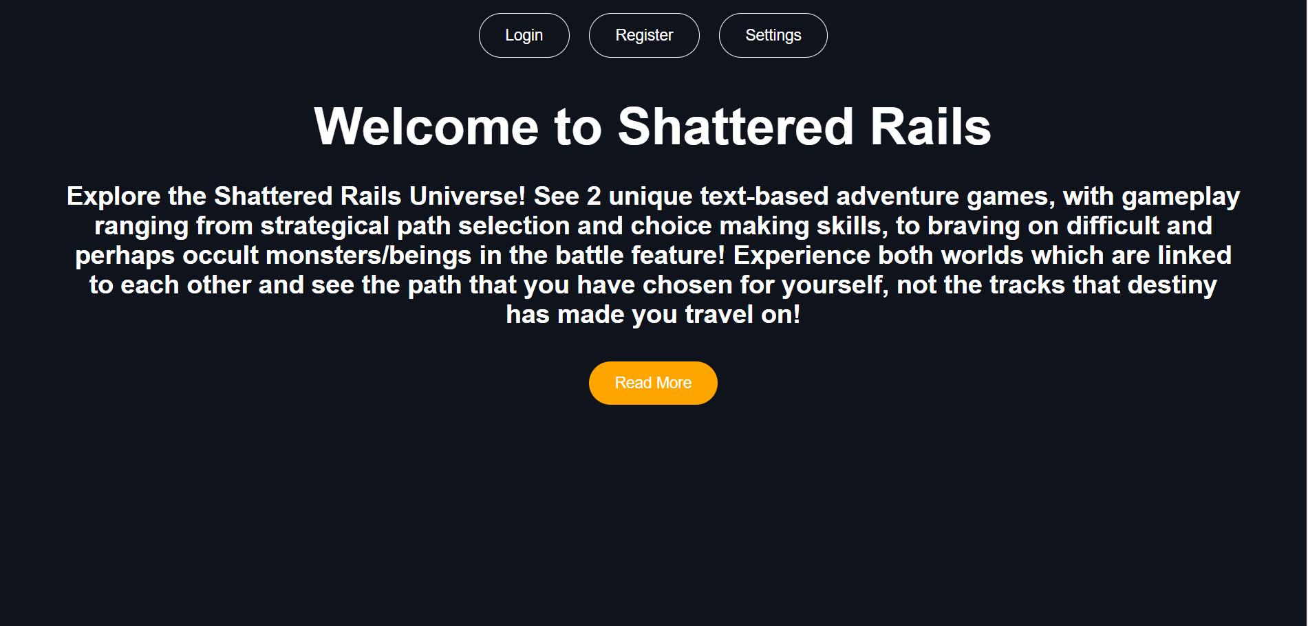

## **Email Verification**

The user will be required to verify their email after registration. The next figure shows the screen you are taken to after registering an account and the figure after shows an example of what the verification email will look like.

## **Login**

The login page will allow the user to login to Shattered Rails after registering for an account and verifying their email address. It will take the username and password as the input.

## **Forgot Username**

The Forgot Username will allow the user to retrieve their username for their account based on the email address associated with the account.

## **Forgot Password**

The Forgot Password will allow users to retrieve their password for their account based on the email address associated with the account.

## **Profile Page**

The profile page allows the logged in user to view their accounts information and make changes to it if necessary. When clicking on the “Profile” button in the nav bar in other pages it will lead to the profile page with the “Edit Profile” being the default destination. On the left of the page there is a side bar, with two options being Edit Profile and Edit Password. A delete profile button is included if the user no longer wants to be associated with Shattered Rails.

## **Edit Profile**

Edit Profile is the default when coming to the profile page. It allows the user to change their name, email address, username, or any combination of the three. Once the user changes their information, they will click on the green update button to save the changes.

## **Change Current Password**

In the profile page, the user can change their current password on their account by filling out the three fields “Current Password”, “New Password”, and “Confirm New Password”. The current password must be correct and the new password and confirm password have to match before you can change the password.

## **Side Games**

Throughout the Shattered Rails application, there will be side games that the user can play on their own or with two players depending on the game. These games have no effect on the other games and vice versa.

The first game on the home page is Tic Tac Toe that is played with two players. The first player is “x” and the second player is “o”. The player wins by getting their respective symbol three times in a row vertically, horizontally, or diagonally.

The next game is Rock, Papers, Scissors on the game selection page. The user must be logged in to access this game. This game is played against an AI opponent where the user chooses either “Rock”, “Paper”, or “Scissors”. The user wins by picking the right move. Rock beats scissors, paper beats rocks, and scissors beats paper.

The final three games are located on the help page. The user must be logged in to access these games. The first game is “Odd or Even?” where the user must guess if the randomly generated number is going to be odd or even. The second game is “Above or Below Five?” where the user has to guess if the randomly generated number is going to be above or below 5. The final game on this page is “Flip a Coin!” where the user has to guess if the coin flip results in heads or tails.

## **User Interface Customization**

User Interface customization is available in most pages allowing you adjust aspects like text color and text size. Shattered Rails 1 and Shattered Rails 2 offer more customization than the customization on other pages. To access the customization, you click on the Settings button in the navigation bar which will open a popup with all the customization options.

The first aspect the user can customize is the text on the page. Some of the things that can be done include adjusting line spacing, the font color, the font family, making the text bold, making the text bigger/smaller, underlining the text, italicizing the text, and aligning the text in the left/center/right.

The user can also customize the color on the page. This includes customizing the color of the text, the color of the background, and the color of the terminal in Shattered Rails 1 and Shattered Rails 2.

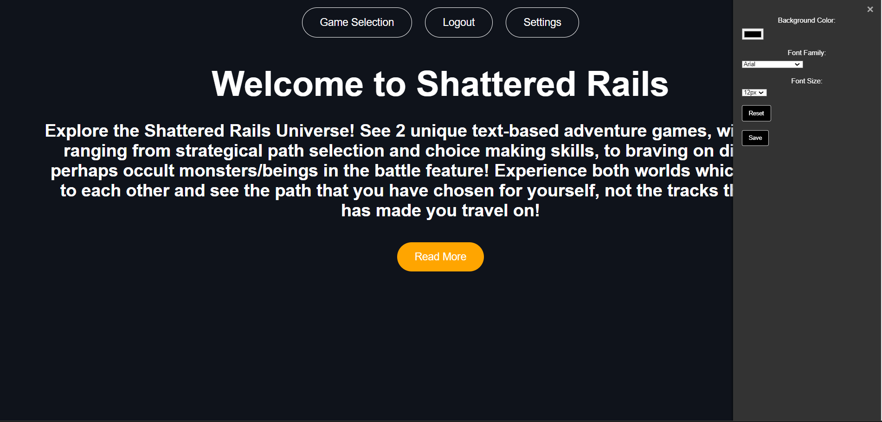

## **Adjust Text Speech**

The adjust text speech function is available in Shattered Rails 1 and Shattered Rails 2. It is accessed by clicking on the “Settings” in the navigation bar. This will adjust the flow of text in the terminal where the text for the game is outputted. The speed of the text can speed up or slow down depending on user preference.

## **Text to Speech**

The text to speech function enables a voice that reads off what is being printed out in the terminal and is available in Shattered Rails 1 and Shattered Rails 2. The feature is off by default and can be turned on by clicking on the “Settings” icon in the navigation bar.

## **Branching Paths in Shattered Rails 1**

Shattered Rails 1 offers a branching storyline where the user will have a unique ending based on the decisions they made throughout the game. In the figure below, it shows the decisions the user can take in the form of dynamically generated buttons at the bottom after the story text has been fully printed out. Each button will lead to a new path where the user can make another decision with another set of choices.

The figure after the next one shows the tree diagram of all the possible branches the user can visit. The different endings can be categorized into three different types of endings being good endings, bad endings, and secret endings.

## **Combat in Shattered Rails 1**

Combat in Shattered Rails 1 is simple designed for people new to the test-based adventure genre. The two types of commands the user can do when in a combat scenario are attack and stay still. Attack will deal a randomized amount of damage to the enemy and the goal is to defeat the enemy without dying. Attack damage from the user and the enemy is dependent on the difficulty the user selects in the beginning. Health of both the user and enemy is also dependent on difficulty.

## **Autosave in Shattered Rails 1**

Shattered Rails 1 provides an autosave feature that works in the background. The game will keep track of where the user currently in the game and store the save state in the database. If the user were to leave the page or logout and return back to Shattered Rails 1 then they will start back on where they left off in the story.

## **Progress Completion Bar in Shattered Rails 1**

Shattered Rails has a progress completion feature where the game keeps track of all the paths that the user has visited. As the user visits more paths in the game the percentage will increase, and the green bar will increase. Visiting a path that you have already visited will not increment the progress and will be ignored. The game completion is stored in the database and will be saved if the user were to leave the page and return.

## **Combat in Shattered Rails 2**

Combat in Shattered Rails 2 has been expanded on from Shattered Rails 1. Attack and Stay Still are returning commands from the first game with the same functionalities. Defend allows the user to defend which will either defend half of the enemy's damage or completely avoid the enemies damage. Spell is a different type of attack that uses Magic Points (MP) resource. The run command allows the user to run away from battle and select another boss to fight. Persuade has the chance to defeat the enemy instantly without fighting the opponent, however this can fail and make the enemy stronger instead.

Battle commands statistics can be affected depending on whichever class you pick in the beginning of the game. Some classes have more MP while, others have greater chances to dodge attacks, and some do more damage with the regular attack.



## **Pause Text**

Pause text is a feature included in both Shattered Rails 1 and Shattered Rails 2. It is enabled and disabled via a button below the terminal. Pause text will stop the flow of text in the terminal and resume when clicked on again.

## **Restart Game**

Restart game is a feature included in both Shattered Rails 1 and Shattered Rails 2. It is enabled and disabled via a button below the terminal. It will restart the game from the beginning. For Shattered Rails 1, it will start from after selecting the difficulty at the beginning of the story and for Shattered Rails 2 it will start at the boss fight select.

## **Help Page**

The help page shows information regarding how to play the game and information about the text-based adventure genre. It can be accessed from Shattered Rails 1 and Shattered Rails 2.

At the top of the page, it shows all the possible branches a user can visit depending on the choices they make. The endings are categorized into good endings, bad endings, and secret endings. The chart is color coded for readability and the legend explaining the meaning of the colors.

In the middle of the page, it explains all tips and how to use features in paragraph format.

The bottom of the page offers three side games that can be played with no effect on the main two games. These games can be played with one or two people depending on the game.

# **Step-By-Step Guide**

## **How to Register**

Staring from the home page:

1. Click on the “Register” button on the top navigation bar.
2. In the middle box, enter a valid email address that you have access to in “Email” field. You may need to use a different email address if the email address is already associated with another existing account.
3. Enter a username for your account in the “Username” field. You may have to retype a new one if the current username is taken.
4. Type in a password in the “Password” field. The password must be at least 8 characters long, contain at least 1 capital letter, and include at least 1 special character (!,@,#,$,%,^,&,(,)).
5. Retype the password in the “Confirm Password” field exactly how you wrote in the “Password” field.
6. Click the “register” button, you will be taken to a page asking you to confirm your email address.
7. Login to the email address you provided during registration, and you will receive an email from shatteredrails@gmail com with a link. Click on the link and your email address will be verified and will be taken to the login page. You will now be able to login in to Shattered Rails with the username and password you created during registration.



## **How to Login**

Starting from the home page:

1. Ensure you have already registered for Shattered Rails.
2. Click on the “Login” button in the navigation bar located in the top of the page.
3. In the “Username” field, enter the username for your account.
4. In the “Password” field, enter the password associated with your account.
5. If the credentials are correct, you will be taken to the game selection page and logged in. If the credentials are incorrect ensure you are typing the correct username and password.
6. If you are having trouble, the “Forgot Password" and “Forgot Username” buttons will help retrieve forgotten credentials.



## **How to Play Shattered Rails 1**

Starting from the home page:

1. Ensure an account has already been created for Shattered Rails.
2. Login to Shattered Rails.
3. Click on the yellow box on the left side of page titled Shattered Rails: Shattered Inceptions which will take you to the start page.
4. Click on the “Start Mission” button when you are ready to play the game.
5. You are now on the Shattered Rails 1 game page.

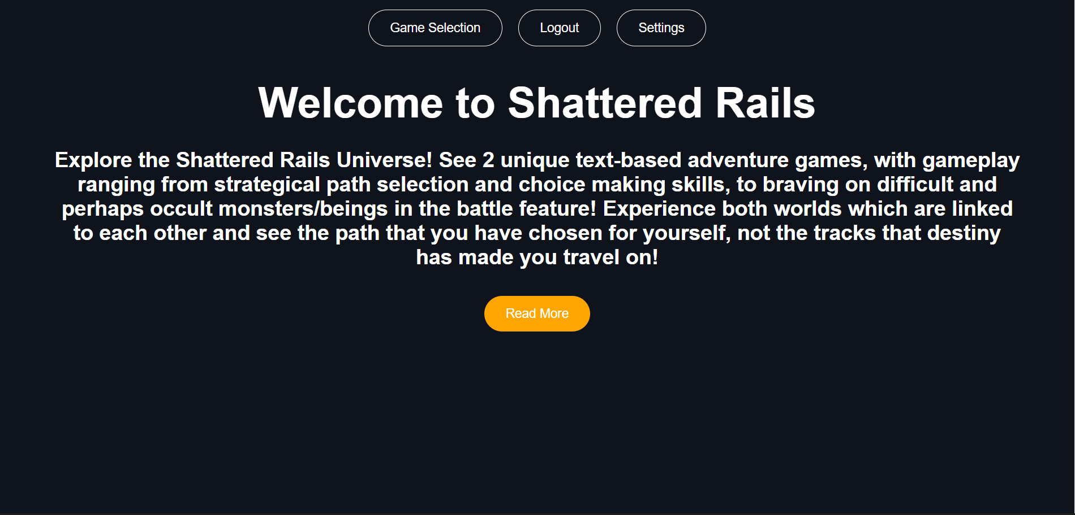

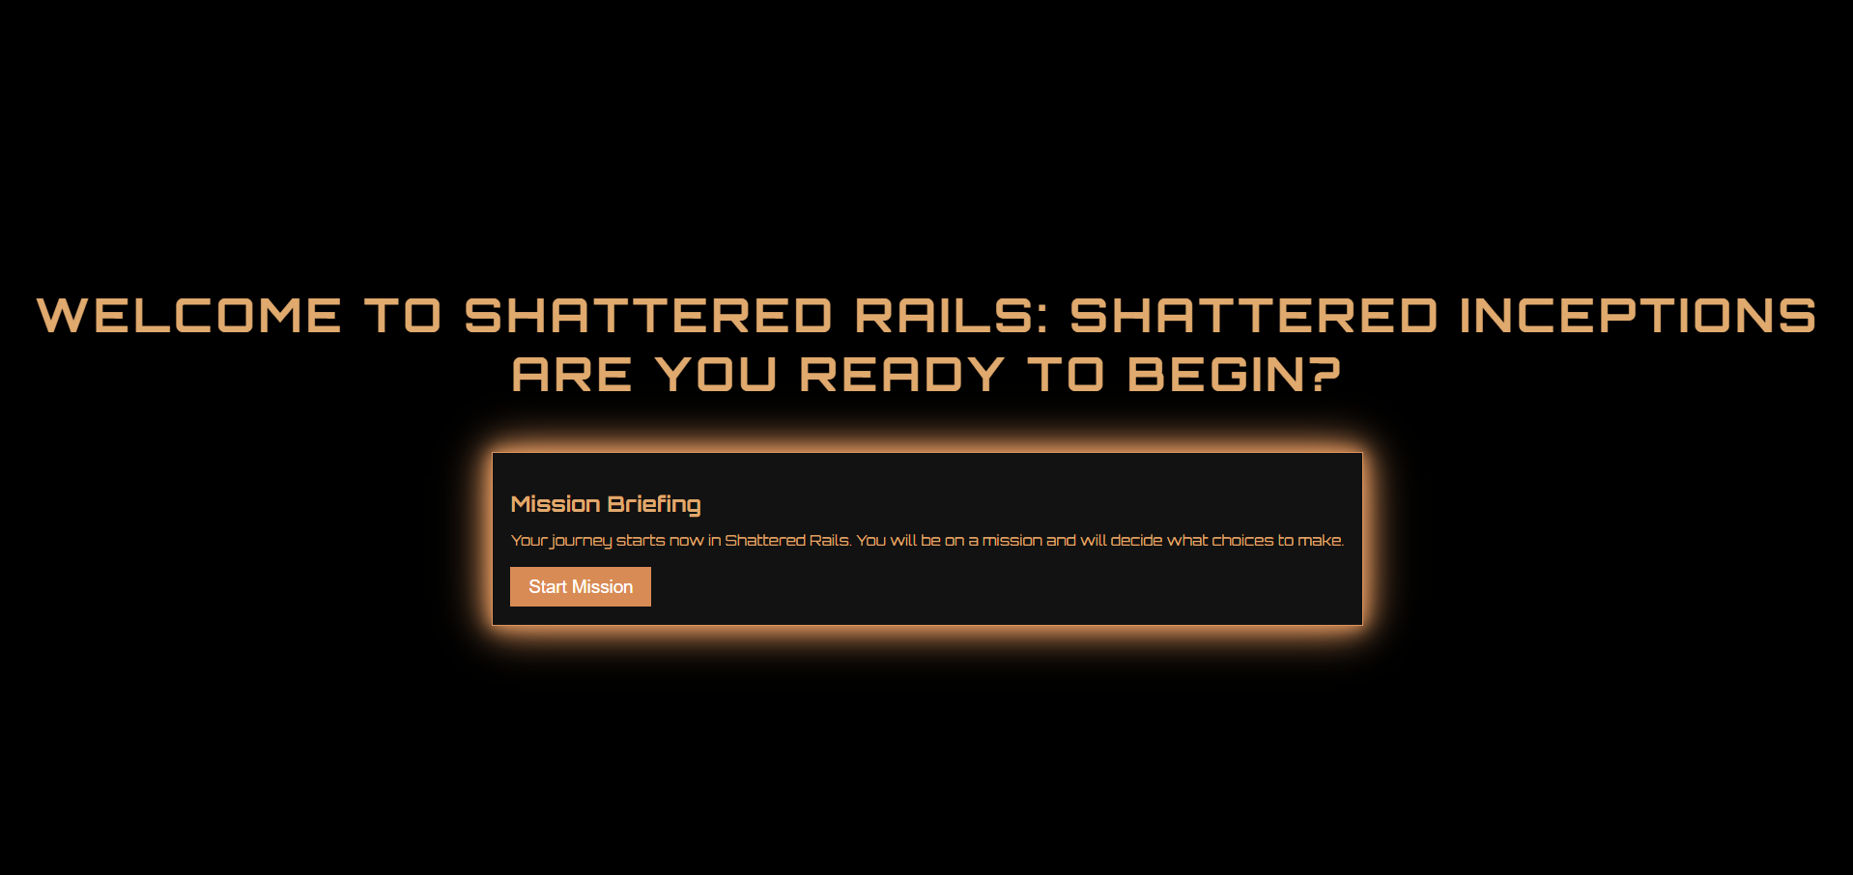

## **How to Play Shattered Rails 2**

Starting from the home page:

1. Ensure an account has already been created for Shattered Rails.
2. Login to Shattered Rails.
3. Click on the blue box on the right side of page titled Shattered Rails: Requiem of Shattering which will take you to the start page.
4. Click on the “Start Mission” button when you are ready to play the game.
5. You are now on the Shattered Rails 2 game page.

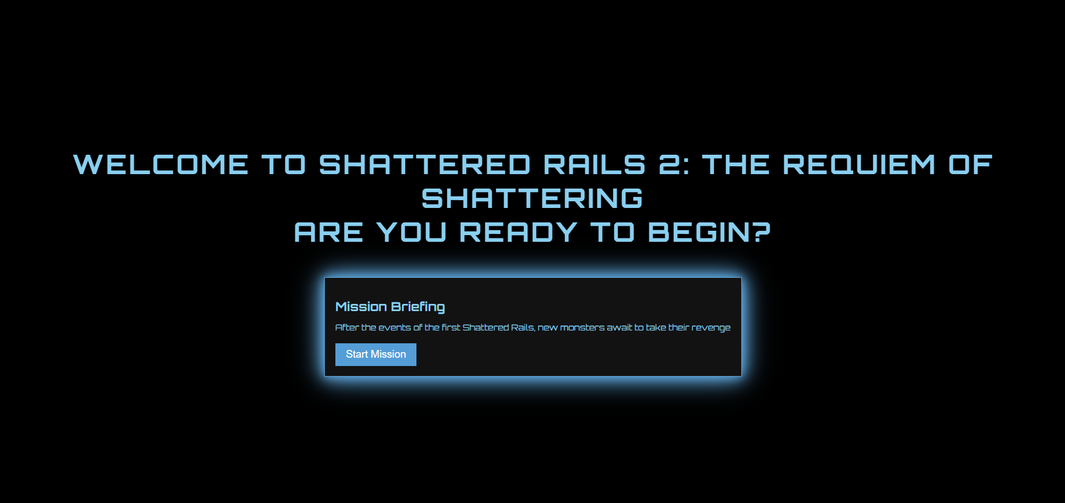

## **How to Customize User Interface**

Customizing the user interface is done through the “Settings” button where clicking on it will open a popup with various customization options. The “Settings” button is located on many pages including Home, Register, Login, Game Selection, Profile, Game 1, and Game 2. Game 1 and Game 2 offers more robust customization options.

1. Ensure you are on a page where the “Settings” button is available. The list of pages is mentioned above.
2. Click on the “Settings” button and customize text, color on the screen, text speed, text to speech, or any combination of the options.
3. Click on the “Settings” button again to close the popup window to apply the changes.

## **How to View the Help Page**

Starting from the home page:

1. Ensure an account has already been created for Shattered Rails.
2. Login to Shattered Rails.
3. Click on either the Shattered Rails: Shattered Inceptions button or Shattered Rails: Requiem of Shattering button taking you to the start pages of game 1 and game 2 respectively.
4. Click on the “Start Mission” button.
5. You will now be on Shattered Rails 1 or Shattered Rails 2 game page depending on your choice in step 3.
6. Click on the orange “Help” button located on the bottom right of the screen.
7. You will be taken to the help page.

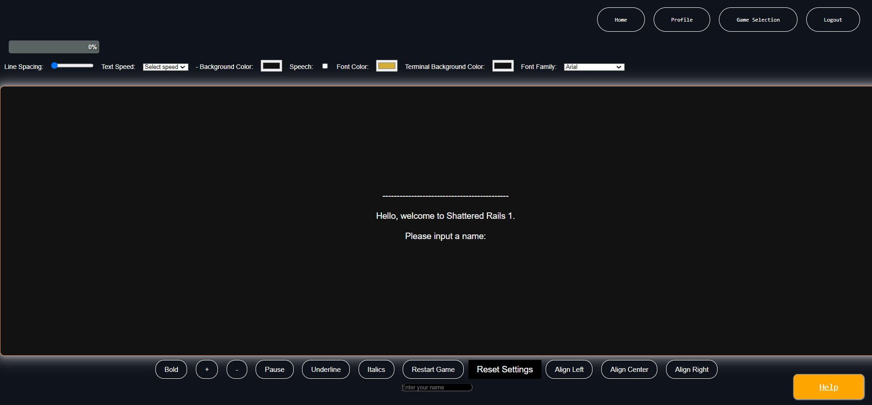

## **How to View the Profile Page**

Starting from the home page:

1. Ensure an account has already been created for Shattered Rails.
2. Login to Shattered Rails.
3. Click on the “Profile” button on the navigation bar located on top.
4. You will be redirected to the profile page.

Note: The profile page can only be accessed by logged in users only. Once logged in the “Profile” button will be available in the navigation bar located on every page until the user logs out.

## **How to Change the Logged in User’s Profile Information**

Starting from the home page:

1. Ensure an account has already been created for Shattered Rails.
2. Login to Shattered Rails.
3. Click on the “Profile” button on the navigation bar located on top.
4. You will be redirected to the profile page.
5. There are two options in the left sidebar. Edit Profile will always be the default when first navigating to the profile page.
6. There are three fields the user can modify being “Name”, “Email”, and “Username”. You do not have to update all three, you may choose to update one or two fields. Type in the new information in one or more fields and click the green “Update” button. If the new email is already taken, then an error message will appear, and you will have to type a different email address. If the new username is already an existing username, an error message will be displayed, and you will have to type in a new username.
7. The profile information has been successfully updated in the database. After updating the username, the user will remain logged in.

## **How to Change Your Password**

Starting from the home page:

1. Ensure an account has already been created for Shattered Rails.
2. Login to Shattered Rails.
3. Click on the “Profile” button on the navigation bar located on top.
4. You will be redirected to the profile page.
5. There are two options in the left sidebar. Edit Profile will always be the default when first navigating to the profile page.
6. Click on the “Edit Password” option in the left side bar to be taken to the form to update the password.
7. There will be three fields in the form being “Current Password”, “New Password”, and “Confirm New Password”. All three fields must be filled out before you can click the green “Update” button. If the current password field does not match the password stored in the database for the associated account, then an error message will be displayed and will have to try again. If the new password and confirm new password fields don’t match then an error message will be displayed and will have to try again.
8. Once successfully updated, you will be able to login with the new credentials while the old ones will no longer work. After updating the password, the user will remain logged in.

## **How to Use Forgot Password**

Starting from the home page:

1. Ensure an account has already been created for Shattered Rails.
2. Click on the “Login” button on the navigation bar on the top of the page.
3. Click on the “Forgot Password" button.
4. Type in your email for your account in the field.
5. Check the email you typed and click on the link to reset the password.
6. Type the new password in the “New Password” field and retype the password in the “Confirm Password” field. If the new password and confirm password field don’t match an error will display and you will have to try again.
7. Click on the “Reset Password” button.
8. Your password has successfully been changed and can now login with the new password and username. The old password will no longer be functional.

## **How to Use Forgot Username**

Starting from the home page:

1. Ensure an account has already been created for Shattered Rails.
2. Click on the “Login” button on the navigation bar on the top of the page.
3. Click on the “Forgot Username" button.
4. Type your email associated with the account in the field.
5. An email will be sent to the email address with the username associated with the account.
6. You can use the username and password to login.

# **Explanations**

## **Selecting Difficulty**

Selecting the difficulty in the beginning of the game will dictate how difficult your experience in the game will be. Selecting difficulty will affect the player's health and the enemy’s health with your health decreasing and the enemy’s health increasing as the difficulty increases. Enemies will also do more damage as the difficulty increases. Easy will provide the simplest gameplay experience while hard will be more difficult in combat scenarios. Both games offer difficulty selection in the beginning of the game.

## **Selecting a Class to Play**

Selecting a class to play as is offered in Shattered Rails 2. Each class has its own unique set benefits and drawbacks. The Knight class offers the base stats providing a balanced experience. The berserker class offers more health points (HP) for the player but has less of a chance to evade attacks. The thief has a greater chance to evade compared to other classes but has less HP. The magician offers more Magic Points (MP) to be able to use more spells but has the least amount of health.

## **Decision Making**

In Shattered Rails 1 and to a lesser extent Shattered Rails 2 users will be prompted with choices after some story has been printed out. Selecting a choice will advance through the game leading to another scenario where you will have to pick from a set of options or a battle scenario. Options can also be dialogue options where the story asks the user a question and you are given a set of answers to choose from.

## **Battle Mechanics**

Battle mechanics are offered in Shattered Rails 1 and is expanded on in Shattered Rails 2. The figure below shows the battle mechanics from Shattered Rails 2. Shattered Rails 1 only offers the Attack and Stay still options during a fight.

In Shattered Rails 2, the attack command damage is based on the class you choose and requires no resources. The defend attack has a chance to either block 50% of the incoming damage from the enemy’s next attack or to completely evade the attack taking no damage. The chance of evasion is affected by the class you select in the beginning. The stay still command replenishes 5MP each time it is called but leaves the user vulnerable to enemy attacks. It caps out at 10MP for every class other than Magician who has 20 MP as the max. Spell casts a magic attack and uses a certain amount of MP. MP is a limited resource, and spells can no longer be used if it is fully depleted. The run command makes the user run away from battle and go back to the boss select screen. Persuade command gives you the chance to use charisma to avoid conflict, via 3 different options, handle with empathy/let’s not fight/negotiate. However, if the persuasion fails the battle will continue.

In Shattered Rails 1, Attack and Stay are the only commands and function similarly to Shattered Rails 2.



## **Endings Explained**

Shattered Rails offers a branching storyline with 16 endings for the user to see. The endings can be categorized as good endings, bad endings, and secret endings. The endings will be tracked by the progress bar on the top left of the game page.

