**Title:** Introduction to portable charger circuits for electronic appliances and uninterruptible power supply.

**Introduction:** The aim of this experiment is to know the basic structure of portable charger and uninterruptible power supply, to get familiar with the working principle of portable charger and uninterruptable power supply and to know the usage of these two devices.

**Theory and methodologies:**

**Battery Chargers:** A battery charger, or recharger, is a device used to put energy into a secondary cell or [rechargeable battery](https://en.wikipedia.org/wiki/Rechargeable_battery) by forcing an [electric current](https://en.wikipedia.org/wiki/Electric_current) through it.

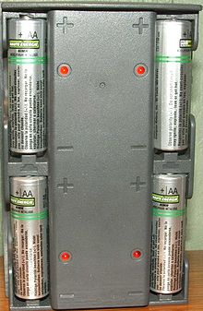

Fig : Battery Charger

A battery charger is basically a DC power supply source. Initially a transformer is used to step down the AC mains input voltage to the required level as per the rating of the transformer. A bridge rectifier configuration is used to rectify the low voltage AC into DC and is further smoothed by a high value electrolytic capacitor. Zener diodes are also used to clip-off over the certain voltage level. This DC is fed to an electronic regulator circuit which regulates the voltage into a constant level and is applied to the battery under charge, where the energy is stored through an internal process of chemical reaction. The most commonly used regulator ICs have four digit names starting with “**78”** for positive voltage levels and “**79”** for negative voltage levels. Sometimes simple transistorized regulators are used as they are easy to construct and cheaper, but they have low efficiency due to losses in transistors. In automatic battery chargers a voltage sensor circuit is incorporated to sense the voltage of the battery under charge. The charger is automatically switched off when the battery voltage reaches the required optimum level.

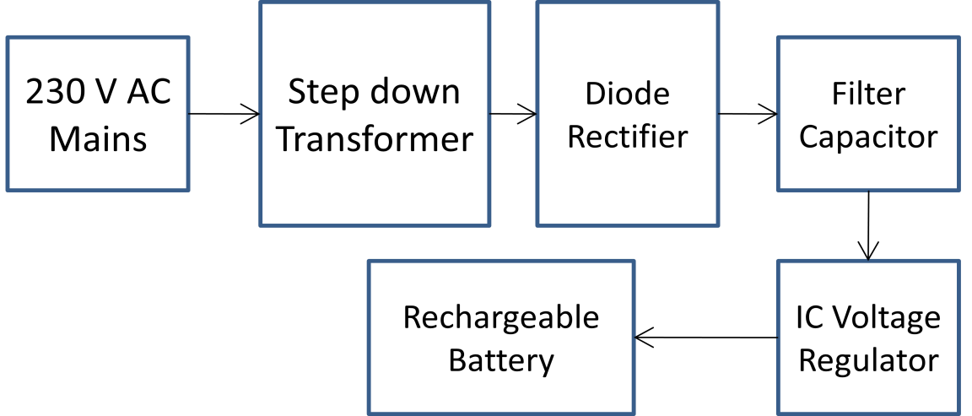

Fig : Block diagram of a basic battery charger used in electronic appliances.

**Power Banks:**

The power bank has a switch to turn on the output and charge a mobile device. The status LEDs indicate the amount of charge left in the power bank and also indicate charging/discharging operation. A Micro USB connector is used to connect the charging source to charge the internal battery. The power bank can either be connected to a PC/Laptop or to the main supply to charge the battery. A USB-A connector is used to connect the mobile device for charging.

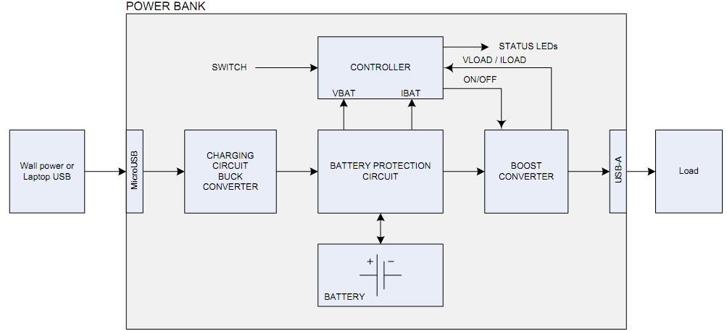

Fig : Block diagram of a basic power bank.

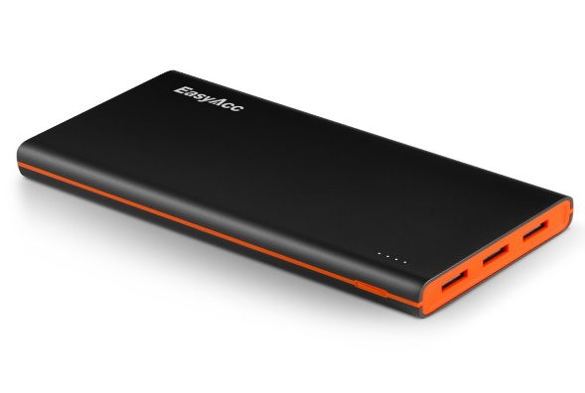

Fig : Power Bank

The input voltage from the Micro-USB connector is fed to a charge controller. This usually is a

buck converter that converts the 5V input voltage into either a constant current or constant voltage

to charge the Lithium Ion battery. The boost converter converts the battery voltage – which can range from 3.0V to 4.2V – to 5V which is used to charge the external mobile devices. A microcontroller performs control functions like turning on the boost converter when the switch is pressed, measuring the battery voltage and controlling the LEDs to indicate state of charge and turn off the boost converter when the external mobile device stops drawing current.

**-**

**Uninterruptible Power Supply:**

A UPS generally consists of a rectifier, battery charger, a battery bank and inverter circuit which converts the commercial ac input into dc suitable for input to the battery bank and the inverter. The rectifier should have its input protected and should be capable of supplying power to the inverter when the commercial supply is either slightly below the normal voltage or slightly above. There are three distinct types of uninterrupted power supplies, namely, (£) on-line UPS (ii) off-line UPS, and (Hi) electronic generators. In the on-line UPS, whether the mains power is on or off, the battery operated inverter is on all the time and supplies the ac output voltage. When the mains power supply goes off, the UPS will be on only until the battery gets discharged. When the main power resumes, the battery will get charged again. In off-line UPS and electronic genera-tors, ther inverter is off when the mains power is present and the output voltage derived directly from the mains is the same as the mains supply voltage. The inverter turns on only when the mains supply goes off.

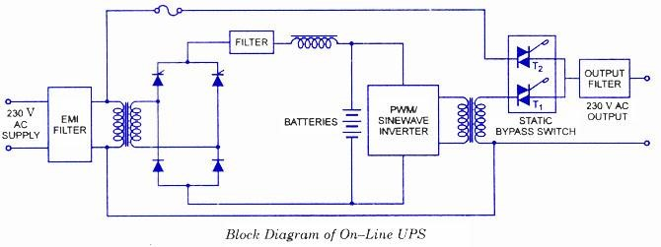

Fig : Block diagram of an on-line UPS.

In case of On-line UPS, the battery operated inverter works continuously whether the mains supply is present or not. Triac T1 is on for all the times while Triac T2 has been provided to bypass the UPS inverter, only when a fault develops in the UPS inverter. When the mains supply fails, the UPS supplies power only until the batteries get dis-charged. However, once the mains power resumes, the batteries will get charged again. The switching times of these supplies is considered to be zero. Usually sealed maintenance free batteries are used and the running time of the inverter is low (approximately 10 to 30 minutes).

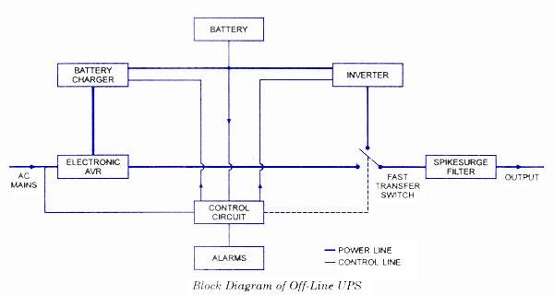

Fig : Block diagram of an off-line UPS.

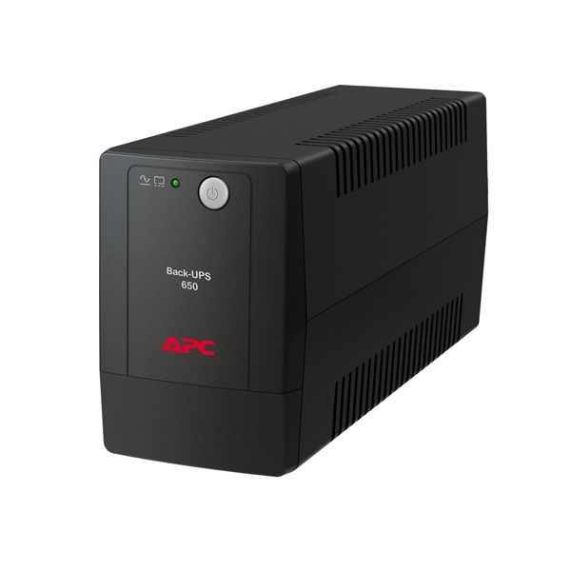

Fig : UPS

In the case of Off-Line UPS, the inverter is off when the mains power is on and the output voltage is derived directly from the mains. The inverter turns on only when the mains supply fails. Its switching time is less than 5 ms. These UPS are generally used with PCs or computers or other appliances where a small duration (5 ms or less) interruption in power supply can be tolerated. Usually, sealed batteries or lead-acid batteries are used. The running time of these supplies is also low (about 10 to 30 minutes).

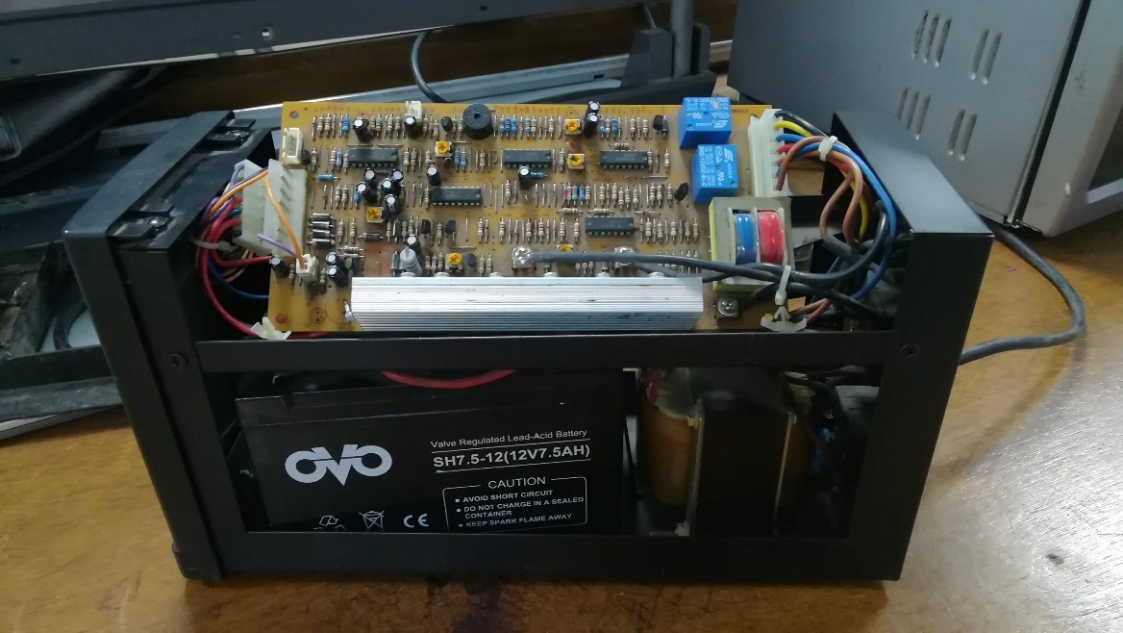

Battery

Transformer

Heat Sink

Transformer

PCB

Fig : A UPS

**Questions/Answers:**

* Why the filter capacitor is necessary in a charger circuit? Describe different types of voltage regulators which can be used in chargers.

**Ans:** In power supplies, capacitors are used to smooth (filter) the pulsating DC output after rectification so that a nearly constant DC voltage is supplied to the load. The pulsating output of the rectifiers has an average DC value and an AC portion that is called ripple voltage. Filter capacitors reduce the amount of ripple voltage to a level that is acceptable.

There are two types of voltage regulators used in charger: Step Up and Step Down.

Step-up: generate a regulated output voltage that is higher than the input voltage.

Step-down: reduce an input voltage to a lower, regulated voltage much more efficiently

* Describe the operation of the Buck and Boost regulator topology in a power bank. What is the relation between ripple current and inductor size in these chopper?

**Ans:** The Buck-Boost provides a regulated DC output voltage from either an AC or a DC input. The Buck converter produces a DC output in a range from 0V to just less than the input voltage. The boost converter will produce an output voltage ranging from the same voltage as the input, to a level much higher than the input.

* What are the static devices that can be used as switches in a UPS? Explain

**Ans:** Static devices like UJT, SCR, TRIAC, DIAC etc. are used in UPS. Because these switch works in a very efficient and reliable manner, monitoring both the power supply sources. As soon as it senses that one of the source is about to break, or is failing to provide the required power, instantaneously it switches to the alternate of backup source kept.

**Discussion:**

In this experiment basic knowledge about portable charger circuits for electronic appliances and uninterruptible power supply was learned by both practically and theoretically. Practically ups and portable charger circuits were observed for understanding the working principle of it. Finally the experiment was finished by summarizing all the learning of the experiment.

**Conclusion:**

The experiment is successful as the goal of the experiment is achieved. For future application the learning of the experiment will provide a useful resource.

**References:**

1. Lab manual: Lab-6 (Electrical-Shop), American International University Bangladesh.
2. <http://engineering.electrical-equipment.org/panel-building/static-transfer-switch.html>
3. <https://www.pololu.com/category/133/step-up-step-down-voltage-regulators>
4. https://www.cnet.com/news/led-local-dimming-explained/ [accessed on 13-02-18]
5. <http://blog.coppelltvrepair.com/2011/03/how-to-uninstall-6871qyh053b-and.html>