**Result Management System**

**Himu Hinu (210201011), Mahin Reza (210201016), Mammar Tajwor(210201024),MD Fahmid Faisal (210201030)**

**Course Code:** CSE 2206

**Course Title:** Database Management System Sessional

**Semister:** Winter 2023

**Department of Computer Science and Engineering, Bangladesh Army University of Science and Technology (BAUST)**

**Introduction:**

RESULT MANAGEMENT SYSTEM is a web based application designed and engineered for primary schools that need to manage results across multiple class’s students that need to track, manage and report results. This application can run on any kind of operating system and browser.

This document aims at defining overall software requirement for RESULT MANAGEMENT SYSTEM. Efforts have been made to define the requirements exhaustively and accurately.

**Problem Definition:**

In traditional way of managing result can be tough. The problems it faces mainly are:

1. Lost of data due to keeping record in traditional paper
2. Miscalculations during calculating total result, grade etc.
3. Data corruption
4. Hard for students to access result whenever they need
5. Editing previously mistaken data

We can solve these problems easily by including database and a user friendly interface. The improvements over manual result managements will be:

1. Less chance to loose data permanently
2. Lesser chance of data corruption
3. Easy to manage and edit data of the students
4. Students can see their results whenever they want

**Available Applications:**

1. **Student Result Management System:** This type of RMS is used to manage student results for various examinations, such as tests, quizzes, and assignments. It typically includes features such as student registration, exam creation, result calculation, and report generation.
2. **Employee Performance Management System:** This type of RMS is used to manage employee performance and provide feedback. It typically includes features such as goal setting, performance reviews, and rewards management.
3. **Learning Management System:** This type of RMS is used to manage online learning courses and track student progress. It typically includes features such as course creation, enrollment management, assignment submission, and grading.
4. **Project Management System:** This type of RMS is used to track project progress and identify potential risks. It typically includes features such as task creation, resource allocation, and reporting.

**Stakeholders:**

1. **Students:** Students are the primary users of a result management system. They need to be able to access their results easily and securely, and they need to be able to understand and use the results to make informed decisions about their education.
2. **Teachers and lecturers:** Teachers and lecturers use the result management system to record and track student progress. They also use the results to inform their teaching and assessment methods.
3. **Examiners:** Examiners are responsible for developing and marking assessments. They need to be able to enter the results of assessments into the system accurately and efficiently.
4. **School administrators:** School administrators use the result management system to track student performance and to identify areas where additional support may be needed. They also use the results to produce reports for parents and other stakeholders.

**Issues Encountered:**

1. **Data entry errors:** Data entry errors can occur at any stage of the result management process, from the recording of student marks to the calculation of final grades. These errors can lead to inaccurate results and can cause significant problems for students.
2. **Inaccurate results:** Inaccurate results can also be caused by errors in the calculation of grades, or by problems with the software system itself. Inaccurate results can have a serious impact on students' academic careers and can also damage the reputation of the institution.
3. **System downtime:** System downtime can occur for a number of reasons, such as hardware failures, software bugs, or power outages. When the system is down, users cannot access their results or perform other essential tasks. This can be disruptive for students and teachers alike.
4. **Difficulty accessing results:** Students and other users should be able to access their results easily and securely. However, some result management systems can be difficult to use or may not be compatible with all devices. This can make it difficult for students to get the information they need.

**System Architecture:**

1. **Front-end:** The front-end is the user interface of the system. It allows users to access the system and perform tasks such as viewing results, entering grades, and generating reports. The front-end can be implemented using a variety of web technologies, such as HTML, CSS, and Bootstrap 5.
2. **Back-end:** The back-end is the server-side component of the system. It is responsible for storing and managing data, processing requests from the front-end, and generating reports. The back-end can be implemented using a variety of programming languages and frameworks,mysqli,bootstrap 5.
3. **Database:** The database stores all of the data for the RMS, such as student information, assessment results, and grades. The database can be a relational database management system (RDBMS) such as MySQL, PostgreSQL, or Oracle, or it can be a non-relational database such as MongoDB or Cassandra.
4. **Application programming interfaces (APIs):** APIs allow the RMS to communicate with other systems, such as student information systems and learning management systems. This allows the RMS to integrate with other systems and to share data.

**Database Design:**

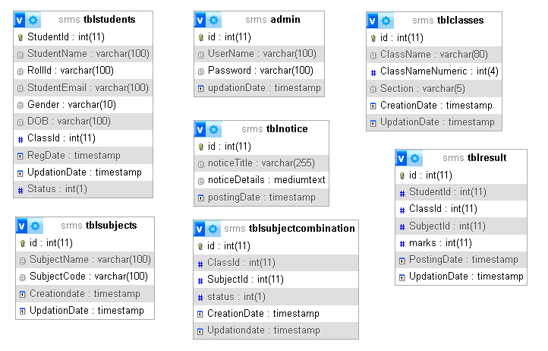

**Database Schema**

**Table:** “result” for result management

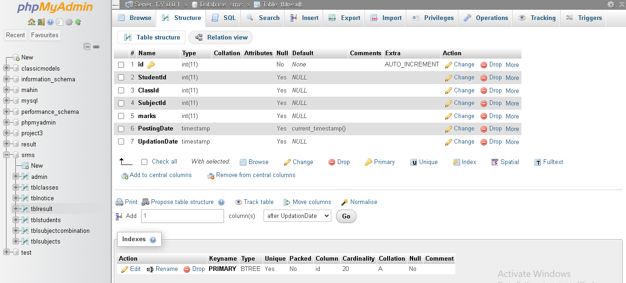

**Fig:** 1

**Tools & Technologies:**

1. All the languages we have used in this project:
2. PHP
3. HTML
4. CSS
5. Bootstrap 5
6. JavaScript
7. MYSQL
8. Software we have used:

* XAMPP
* Visual Studio Code
* Sublime Text

**Implementation:**

Homepage:

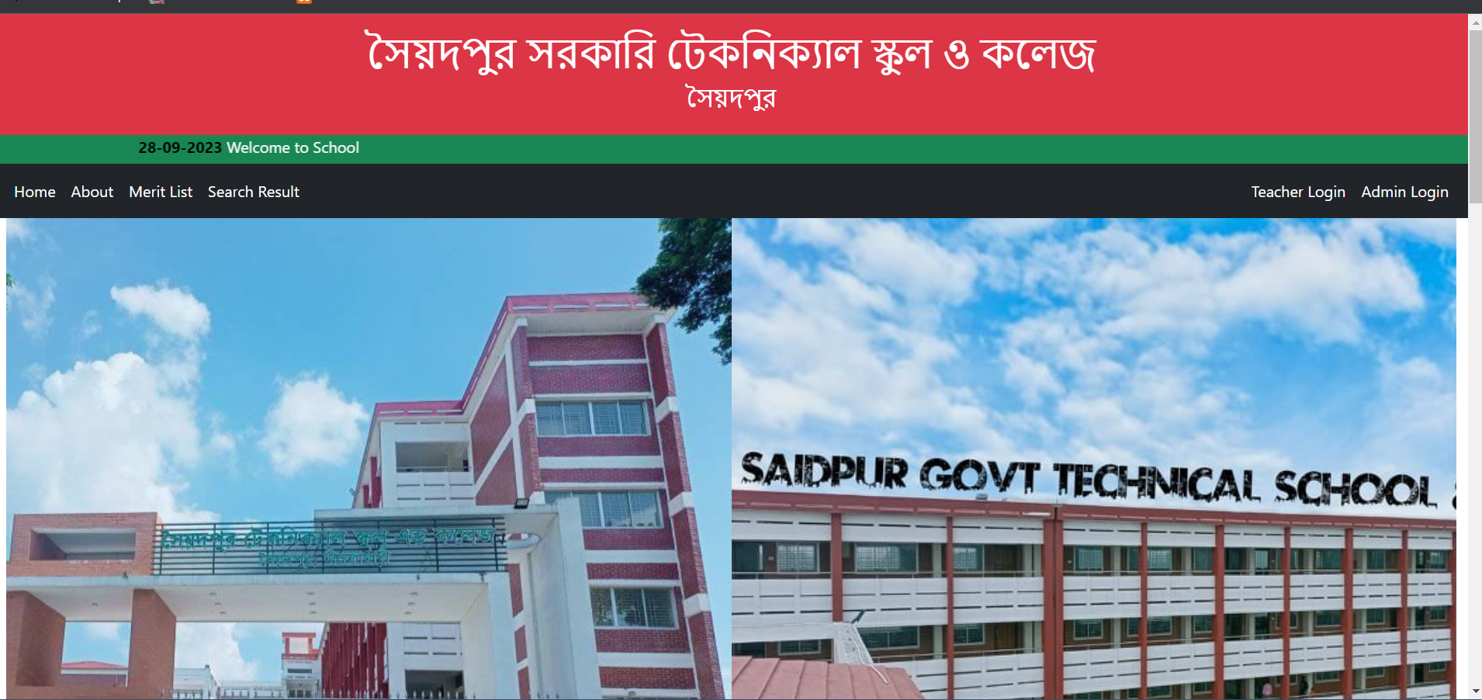

**Fig: 2**

Merit List: (Select a class)

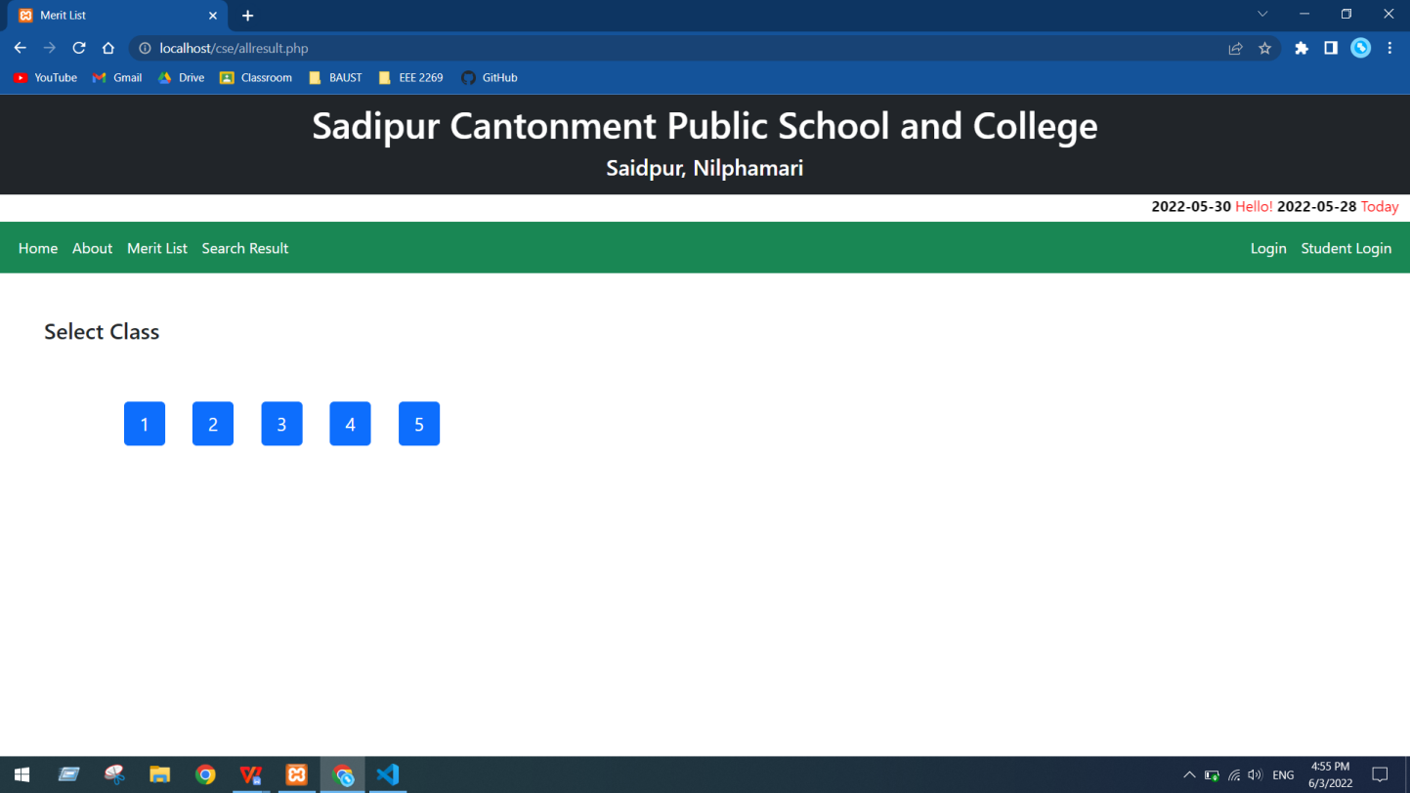

**Fig: 3**

Search Result:

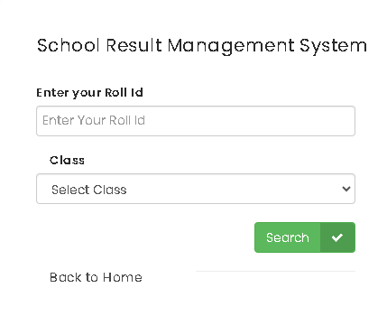

**Fig: 4**

Search Result: (Shows individual result)

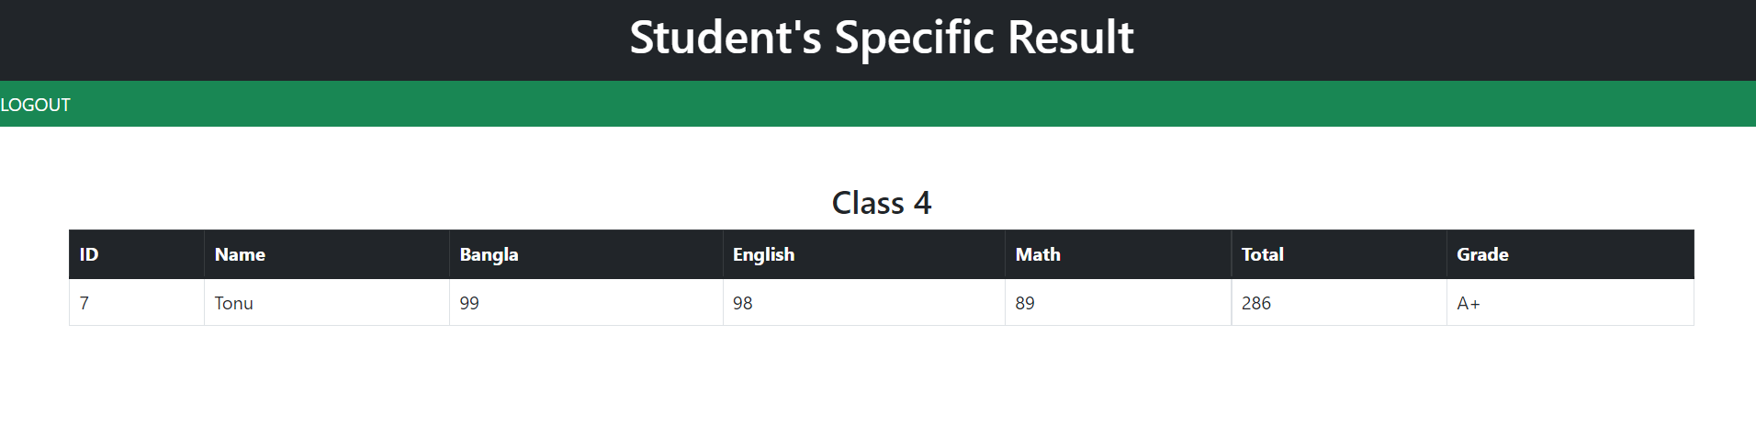

**Fig: 5**

Admin:(Dashboard)

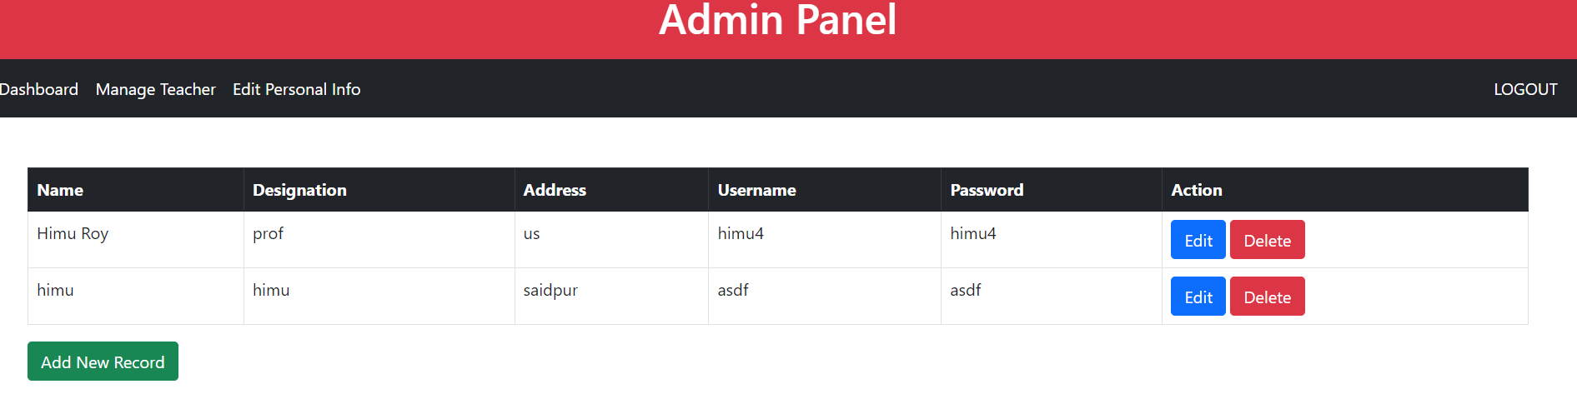

**Fig: 6**

Result: **(**Add new record)

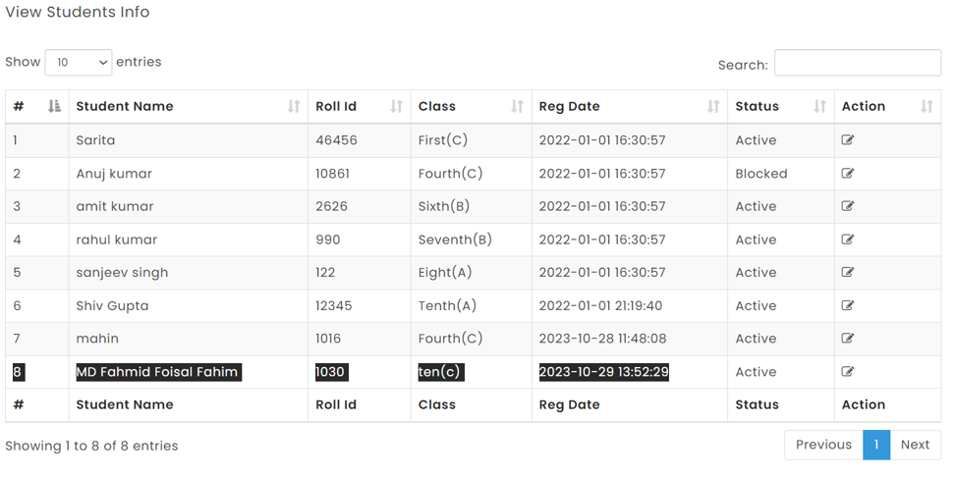

**Fig: 7**

**Result:** Edit student info:

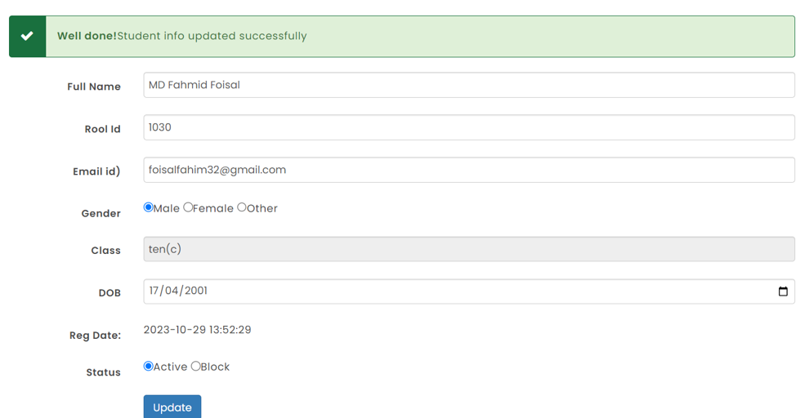

**Fig: 8**

**Admin:** (Edit notice)

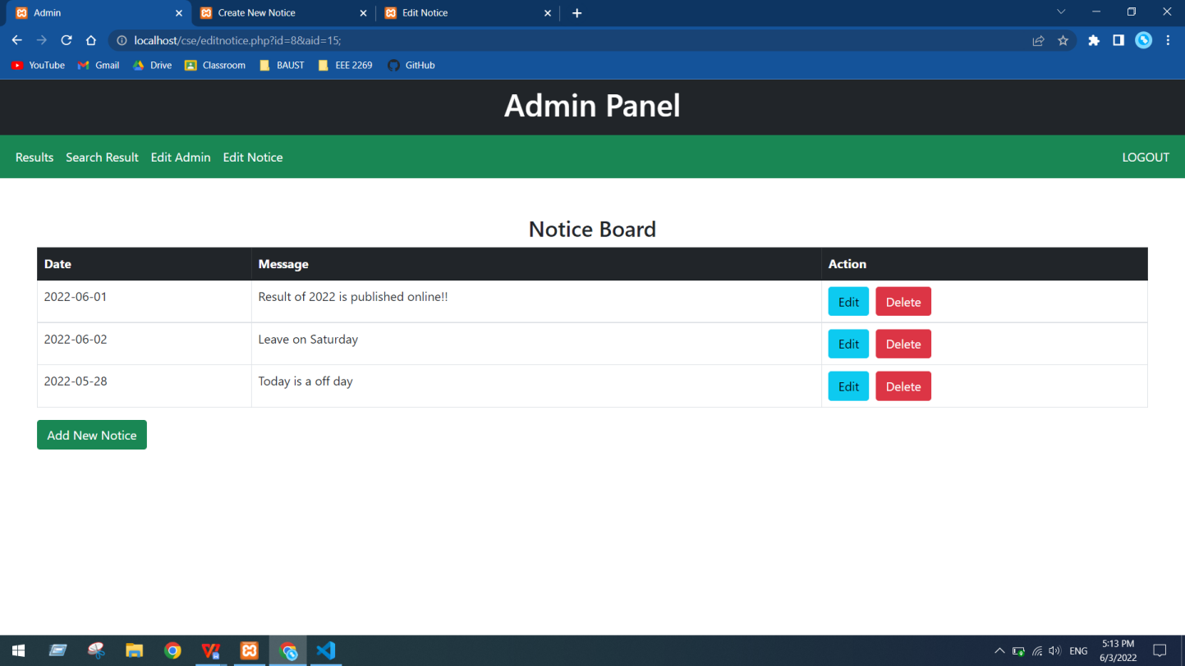

**Fig: 9**

**Student Dashboard:** Shows detailed result of specific student

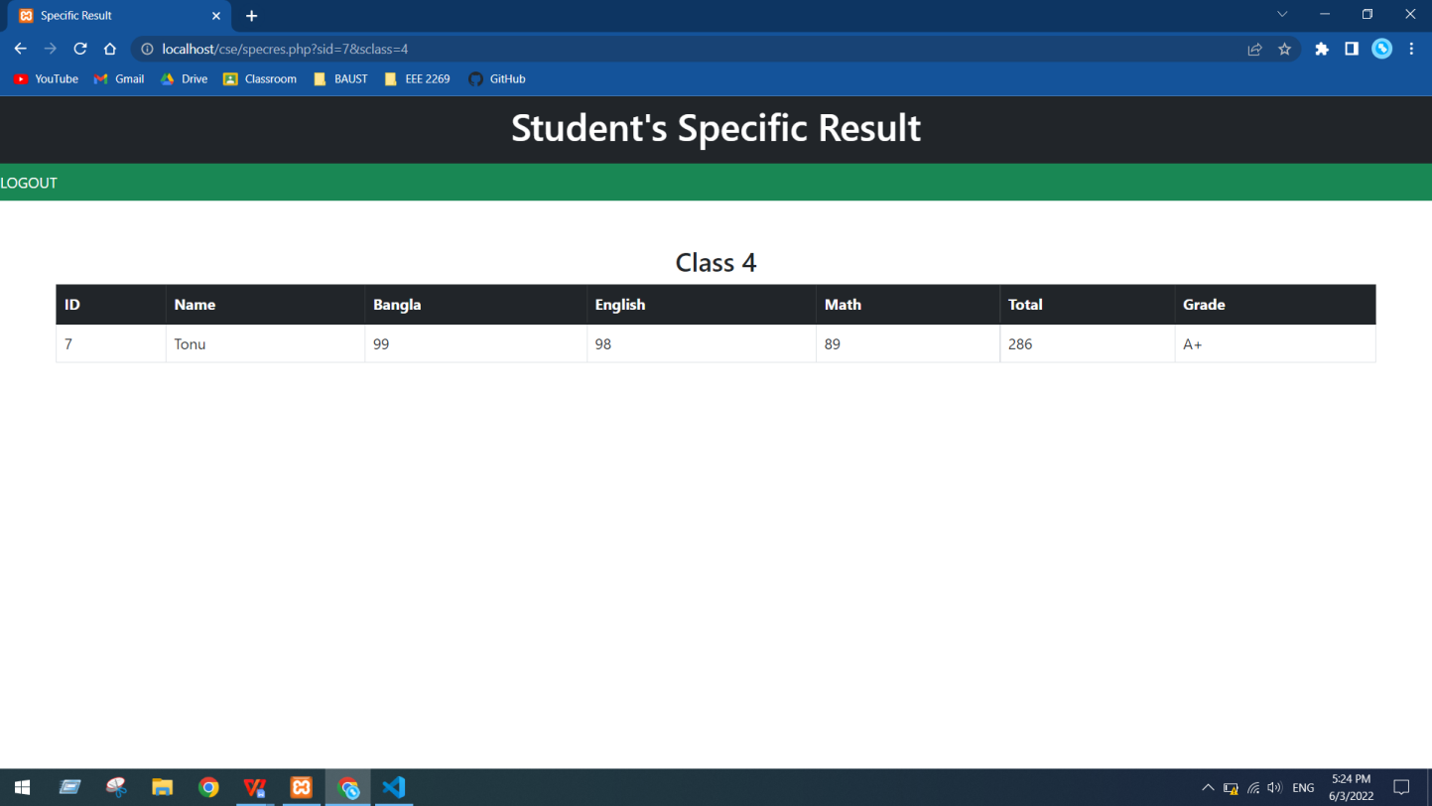

**Fig: 10**

**Conclusion:**

The project was done to implement Web-Based Student Result Management System . The purpose was to automate the result management system that includes creation of result, edit wrong data and showing student’s results using a computerized system. A well-defined, efficient, controlled and managed information system or software based on web technology storing, processing and providing information through the internet.

And the objectives were achieved by following a process model such as system analysis, design and system implementation. The system analysis was composed of two activities, requirement determination and structuring.

**Limitations:**

**Cost:** Developing and implementing an RMS can be expensive. This can be a barrier for smaller institutions or for institutions in developing countries.

**Complexity:** RMS can be complex to develop and maintain. This requires the involvement of skilled and experienced software developers.

**Security:** RMS contain sensitive student data. It is important to ensure that the system is secure and that data is protected from unauthorized access.

**Integration:** RMS need to be integrated with other systems, such as student information systems and learning management systems. This can be a complex and time-consuming process.

**References:**www.google.com, www.mysqltutorial.org, www.youtube.com, www.w3schools.com, [www.tutorialspoint.com](http://www.tutorialspoint.com), [www.codeacademy.com](http://www.codeacademy.com), [www.researchgate.net](https://www.researchgate.net).

**Appendix:**

Attainment of Complex Engineering Problem (CP)

|  |  |  |  |
| --- | --- | --- | --- |
| **S.L.** | **CP No.** | **Attainment** | **Remarks** |
| 1. | P1: Depth of Knowledge Required | Yes | K3 (Engineering Fundamentals): Require knowledge of database design (Sec. 7). |
| K4 (Engineering Specialization): Require Knowledge of Bootstrap (Sec. 8). |
| K5 (Design): Flow Chart of Methodology shows solution design of the problem (Sec. 6). |
| K6 (Technology): XAMPP server, PHP, MySQL, Bootstrap, etc. (Sec. 8). |
| K8 (Research): Studied related application to find limitation (Sec. 3). |
| 2. | P2: Range of Conflicting Requirements | No | Agriculture (Agriculture Management Sec. 1), Web technologies (PHP, MySQL, Bootstrap, etc Sec. 8), Database Management System (Sec. 7). |
| 3. | P3: Depth of Analysis Required | Yes |  |
| 4. | P4: Familiarity of Issues | No | Working with Agriculture domain as a CSE student (Sec. 1). |
| 5. | P5: Extent of Applicable Codes | Yes | Use Waterfall software development model (Sec. 6). |
| 6. | P6: Extent of Stakeholder Involvement and Conflicting Requirements | No | Involves farmers, workers, customers and admin (Sec. 4) |
| 7. | P7: Interdependence | Yes | Involve login, product management, fertilizer management, plantation management, etc (Sec. 9). |

Mapping of Complex Engineering Activities (CA)

|  |  |  |  |
| --- | --- | --- | --- |
| **S.L.** | **CA No.** | **Attainment** | **Remarks** |
| 1. | A1: Range of resources | No | Involves farmers, workers, customers and admin, Computer Engineers, Technologies: PHP, MySQL, MVC, Bootstrap, Laravel, etc. (Sec. 4 and Sec. 8). |
| 2. | A2: Level of interaction | Yes | Solve problem arises from various conflicting and other issues (Sec. 5). |
| 3. | A3: Innovation | No |  |
| 4. | A4: Consequences for Society and the Environment | Yes | Provides knowledge, tools and technologies for overall farming (from plantation to product selling) which will increase productivity and profitability (Sec. 10). |
| 5. | A5: Familiarity | No |  |