For NS3:

Packet size = 256, Throughput = 126.22

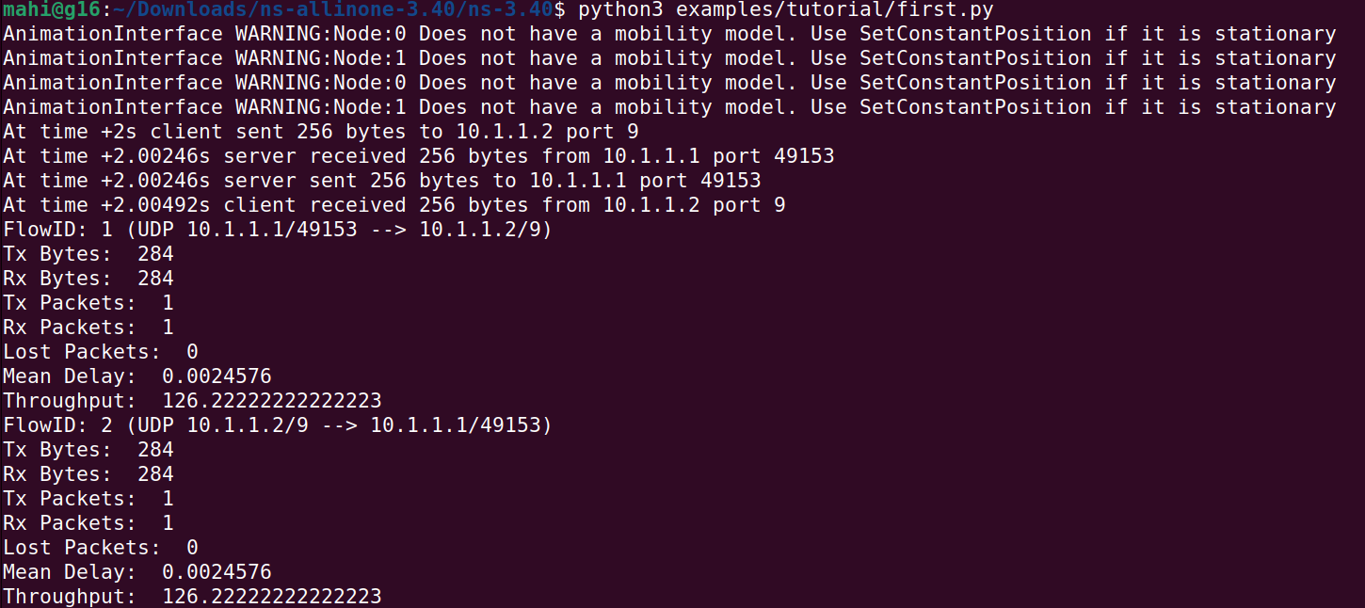

Packet size = 2048, Throughput = 922.66

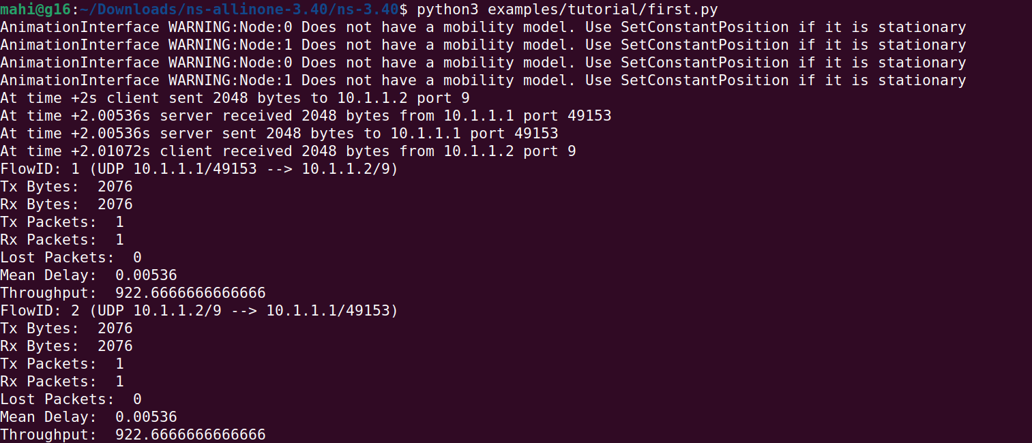

Packet size = 1024, Throughput = 467.55

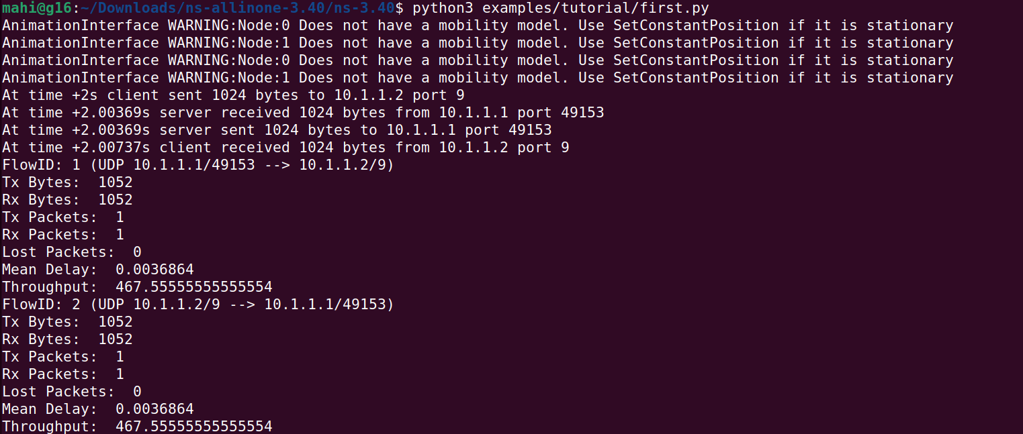

Packet size = 512, Throughput = 240.0

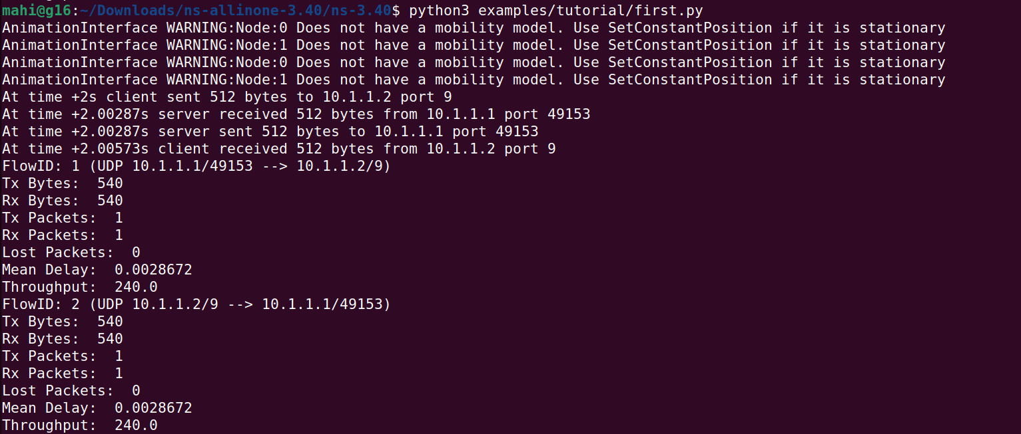

Packet size = 128, Throughput = 69.33

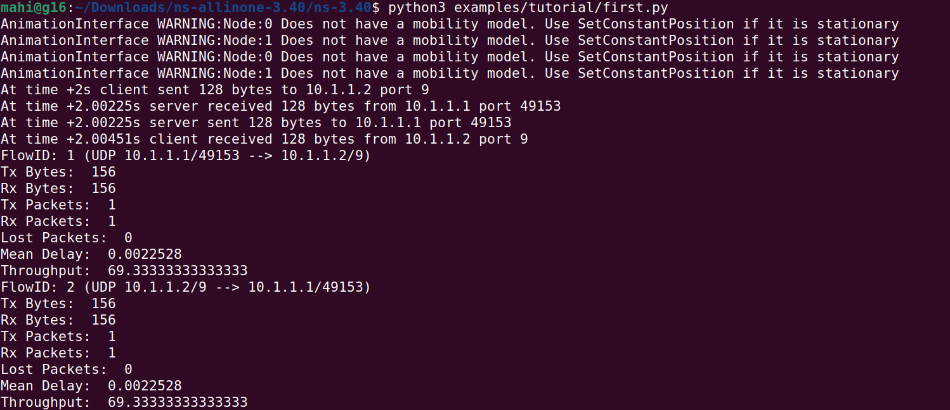

**Packet size v/s throughput graph**

|  |  |
| --- | --- |
| Packet Size | Throughput |
| 128 | 69.33 |
| 256 | 126.22 |
| 512 | 240.0 |
| 1024 | 467.55 |
| 2048 | 922.66 |

**Graph:**

Here the points make a straight line that means Throughput is directly proportional to Data size, if we increase the Data size then the throughput will also increase. As a result, data packets with larger size will be able to use larger bandwidth of Data Link Layer.