**layer protocols headers for a request packet:**



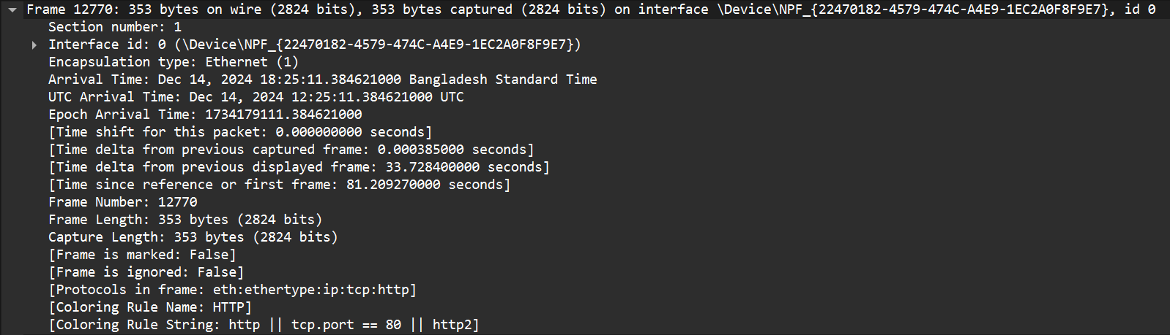

Here, in this Physical Layer, the protocol HTTP packet is seen including information the frame length is 353 bytes, with a TCP port 80. Furthermore, the packet's arrival time, frame number (12770), and timing details are also provided.

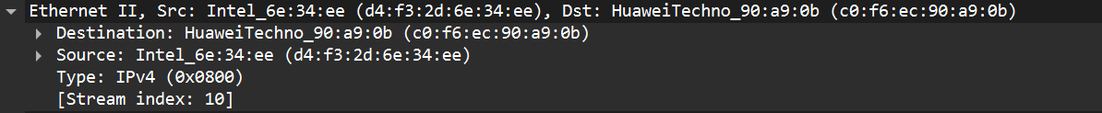

Here, Data Link Layer contains MAC addresses for both the sender and the recipient. The source MAC address (c0:f6:ec:90:a9:0b) identifies the network interface of the sender and the destination MAC address (d4:f3:2d:6e:34:ee) specifies the intended recipient's network interface. Moreover, it contains the protocol used “IPv4”.

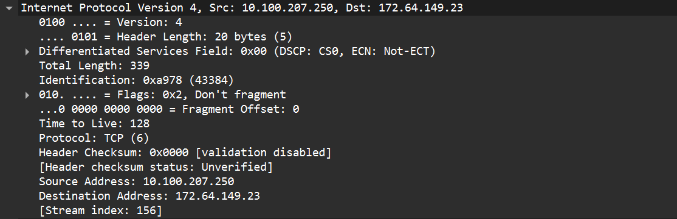

Here in this network layer, it contains the source and destination IP addresses to identify the sender and recipient of the packet across protocols. The IP address of the sender is 10.100.207.250 and the IP address of the recipient is 172.64.149.23. The TCP protocol is used here, and checksum is also seen.

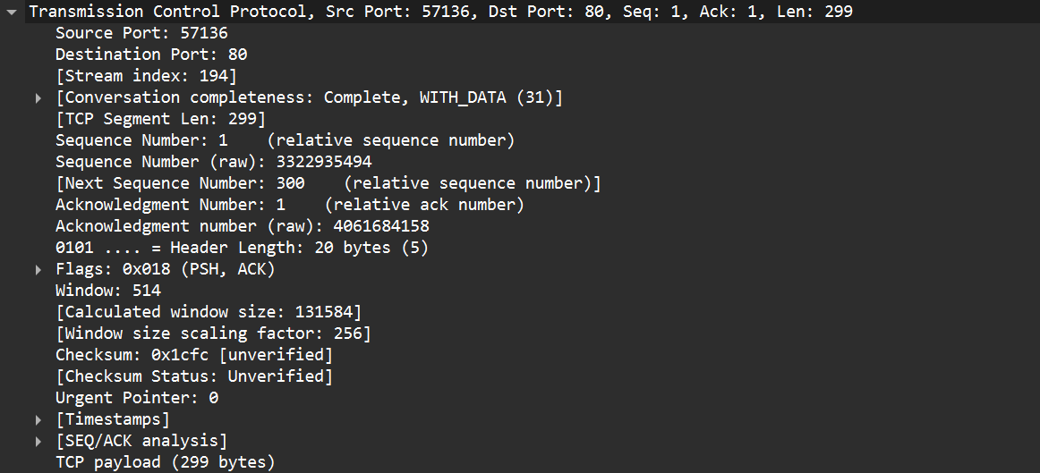

Here in Transport layer, the Source Port 57136 and Destination port 80 are seen. This helps to identify the specific application/service on each host in receiving end. Additionally, it includes sequence numbers, acknowledgment numbers, window size, checksum, and various flags (SYN, ACK).

Here in Application layer, GET method (SectigoRSADomainValidationSecureServerCA.crt) from the host crt.sectigo.com. Moreover, the User-Agent, Accept-Encoding, and Accept-Language, specifying client details are also seen. From here we understand the full URI of the request is: <http://crt.sectigo.com/SectigoRSADomainValidationSecureServerCA.crt>.

**5 layer protocols headers for a response packet:**

Here, in this Physical Layer, the protocol HTTP packet is seen including information the frame length is 655 bytes, with a TCP port 80. Furthermore, the packet's arrival time, frame number (12778), and timing details are also provided.



Here, Data Link Layer contains MAC addresses for both the sender and the recipient. The source MAC address (c0:f6:ec:90:a9:0b) identifies the network interface of the sender and the destination MAC address (d4:f3:2d:6e:34:ee) specifies the intended recipient's network interface. Moreover, it contains the protocol used “IPv4”.

Here in this network layer, it contains the source and destination IP addresses to identify the sender and recipient of the packet across protocols. The IP address of the sender is 10.100.207.250 and the IP address of the recipient is 172.64.149.23. The TCP protocol is used here, and checksum is also seen.

Here in Transport layer, the Source Port 80 and Destination port 57136 are seen. This helps to identify the specific application/service on each host in receiving end. Additionally, it includes sequence numbers, acknowledgment numbers, window size, checksum, and various flags (SYN, ACK).

Here in application Layer, we see HTTP response with a 200 OK status, indicating establishing transmission. The response also includes content type (application/pkix-cert), size (1559 bytes), caching headers, and server details (Cloudflare).