**High-Resolution Document Image Reconstruction from Video**

Now-a-days smart phones are equipped with good quality cameras and all peoples give preference to smart phones to digitized their document compare to cam scanner as with smart phones we can take picture from walls or from any location but quality of smart phones pictures will reduce when we take large size of picture and to solve this issues author describing concept to reconstruct high resolution document image from smart phones. In propose work author is asking to move smart phone camera across large size picture and then use high intensity pixels to replace weak intensity pixels while reconstructing document image.

In the proposed method we find the location of each frame in the document and we use a sharpness criterion to select the highest possible quality for each region of the document among all available frames. To evaluate performance of propose work author is using SMARTDOC 2017 dataset. This dataset contains document videos and ground truth image (exact document image) and has given video and image location with document top, left, bottom and right coordinates.

In propose work implementation we will take input video with coordinates and ground truth image and then extract frame from video and from frame we capture document image by giving coordinates and this process is called as homographic matrix calculation or image warped. After performing image warped we will calculate warped image similarity with ground truth image and the warped with high similarity will be considered as high resolution document image. Homographic will replace weak intensity pixels with high intensity pixels.

All sample datasets are saved inside folder called ‘smartdoc17-dataset-sample’. Below screen showing sample data from dataset folder

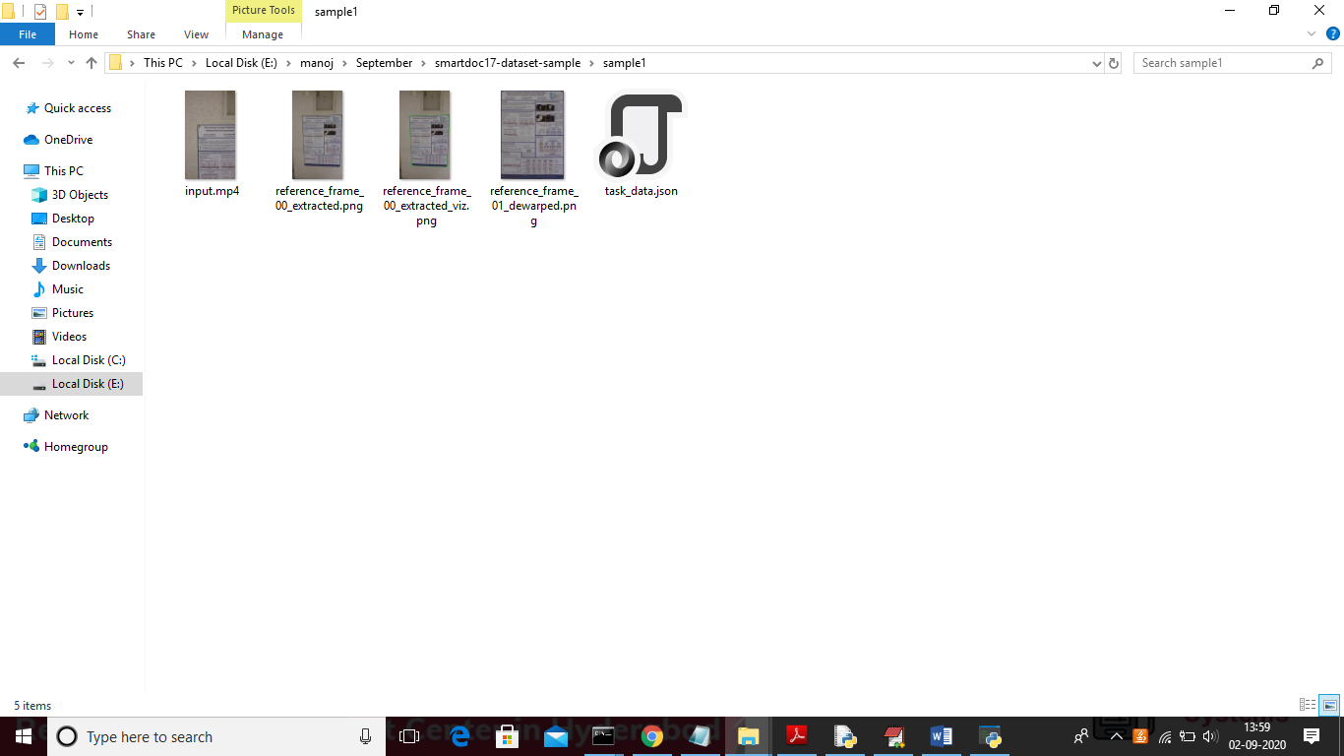

In above screen we can see input.MP4 video file with ground truth dewarped image with JSON file

Screen shots.

To run project double click on run.bat file to get below screen

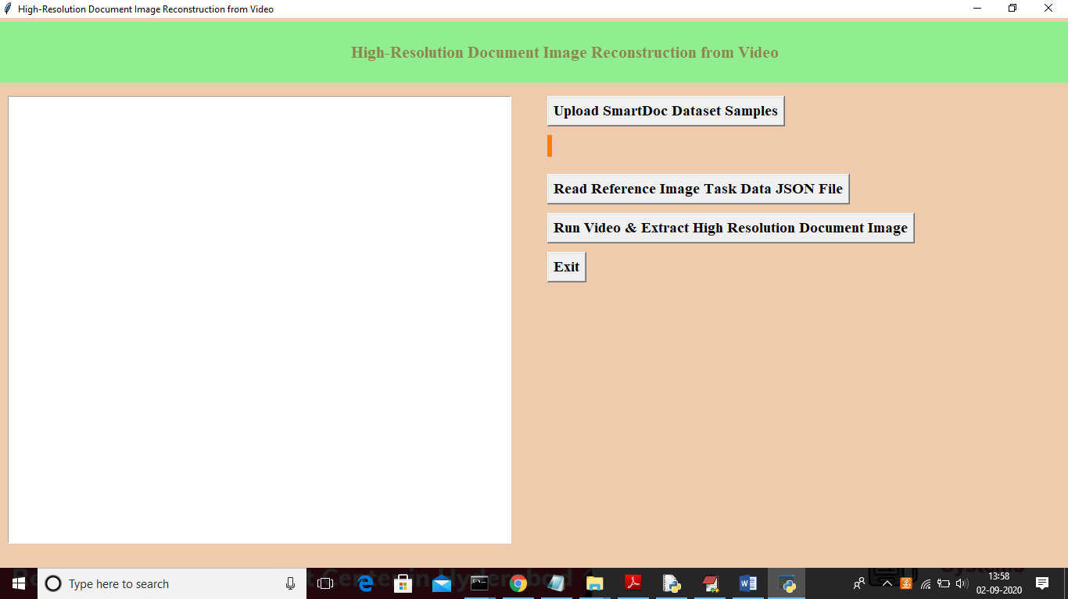

In above screen click on ‘Upload SmartDoc Dataset Samples’ button to upload samples

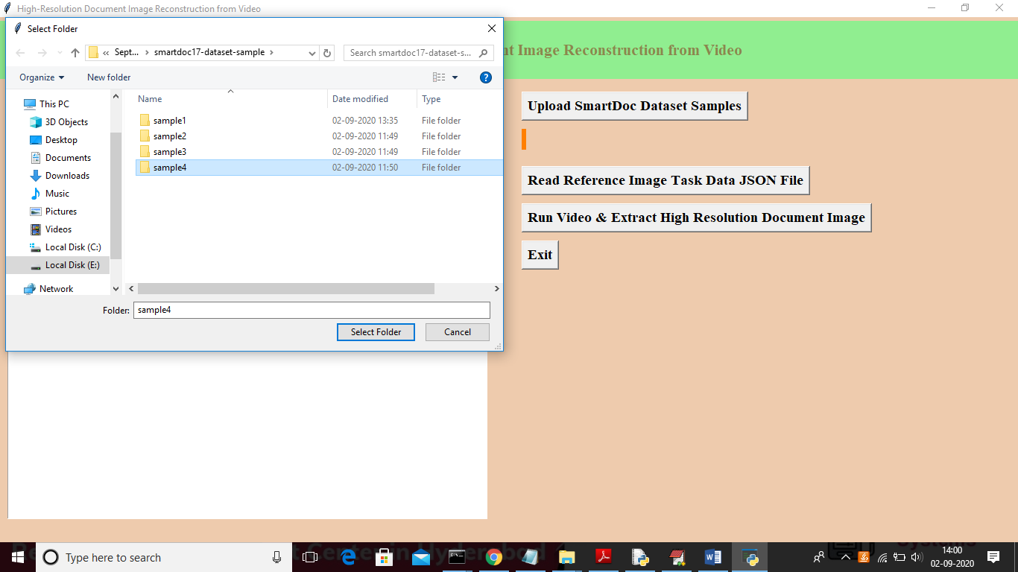

In above screen I am uploading ‘sample4’ folder which contains video and other files and this is small size video will get output after running 350 frames and other samples contains more than 1500 frames so to get output other sample may take time. After uploading dataset will get below screen

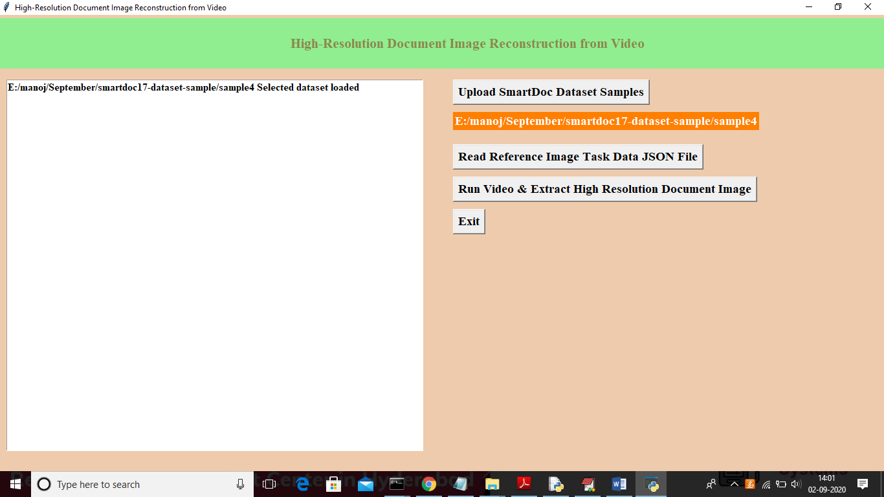

Now click on ‘Second button’ from above screen to read video details from sample uploaded folder

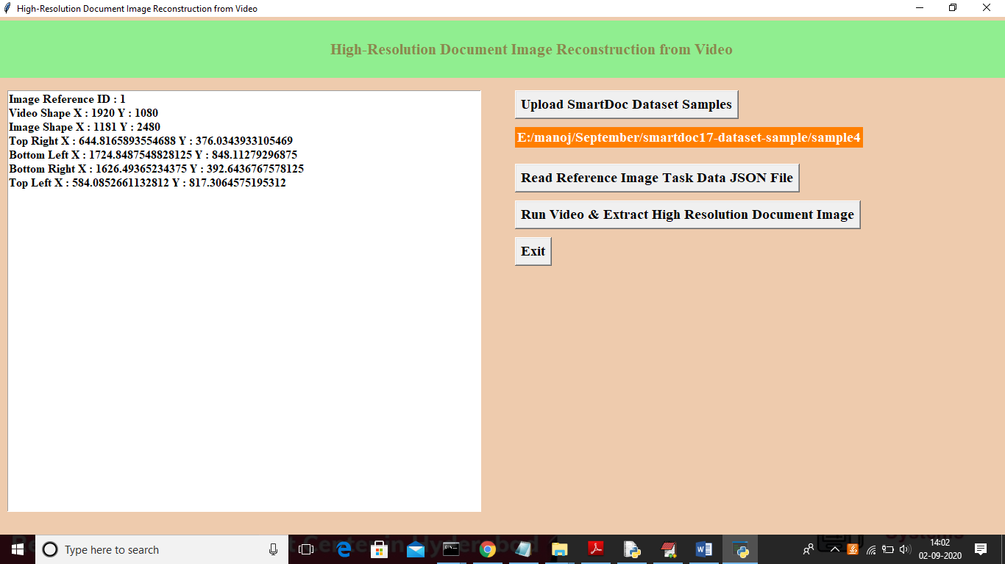

In above screen we can see video reference id with video and image size and with coordinates details and now click on ‘Run Video & Extract High Resolution Document Image’ button to play video and to get high resolution image

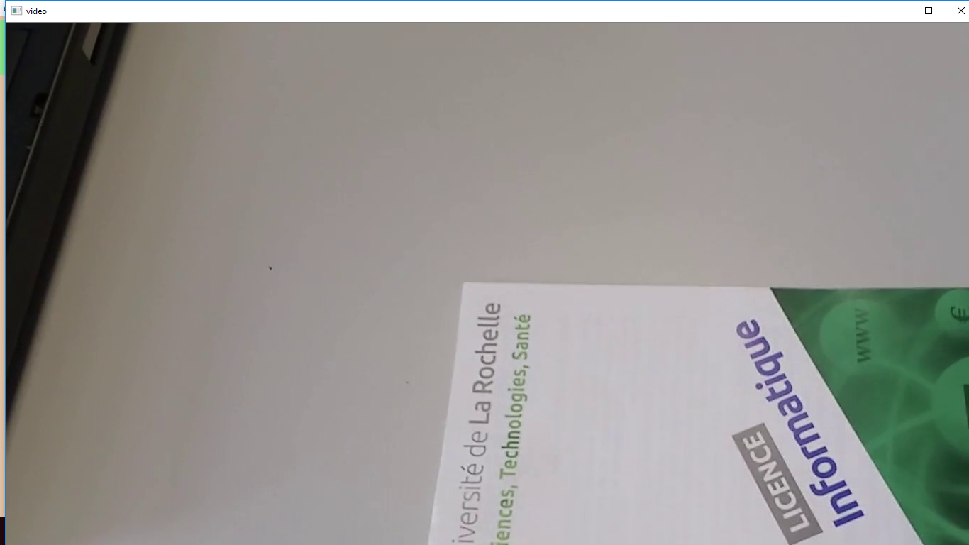

In above screen we can see video started playing and while running u can see video is playing. Below is another frame

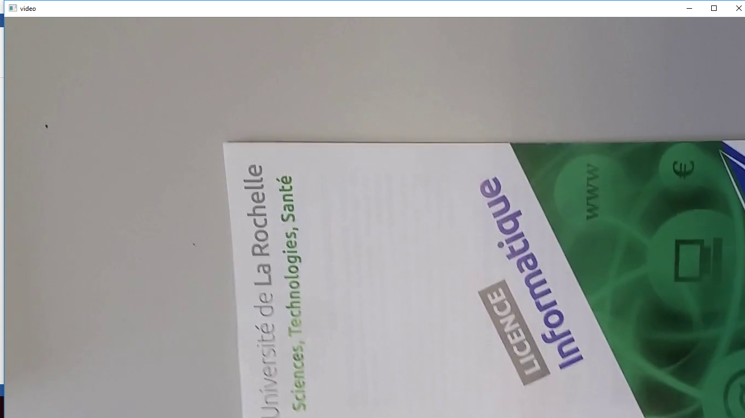

In below black console we can see frame no with similarity score with ground truth image

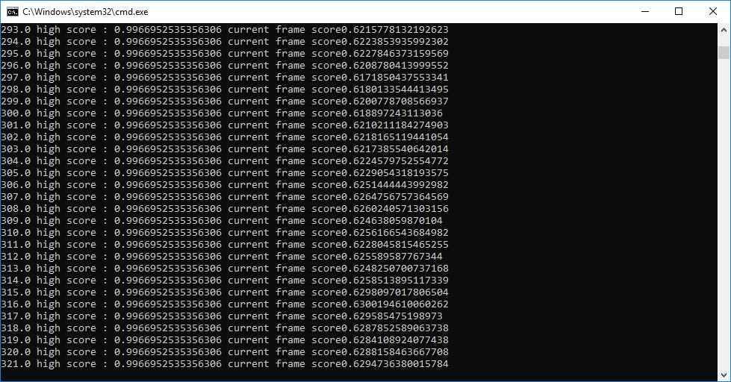

In above screen we can see first value is frame no and second value is highest similarity found frame and third value is current frame similarity

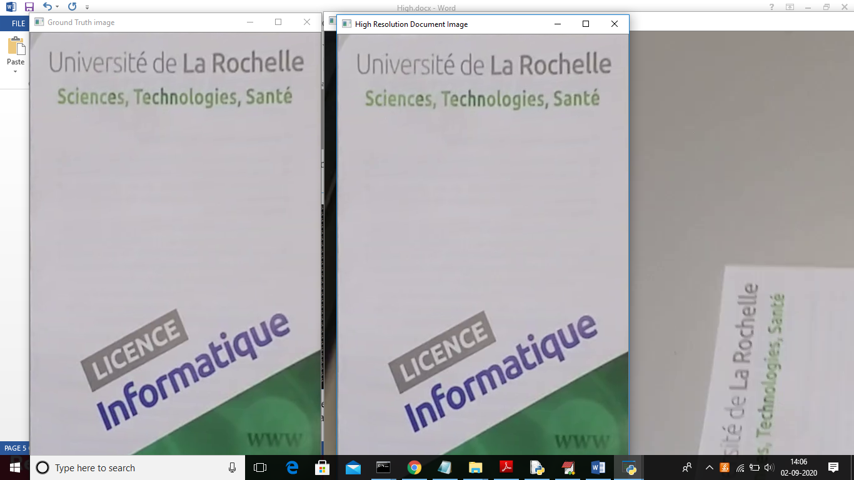

In above screen first image is the ground truth image and second image is the high resolution image extracted from video and background third image is the reference video image from which we extracted high resolution image.

Similarly you can upload other samples and get output