High-Level Design (HLD)
Saudagar AI: Voice-led demand and procurement intelligence for kirana stores
Document status | Submission-ready
Version | 1.0 | 19 July 2026
Prepared for | Saudagar AI prototype review

Purpose statement
Saudagar AI converts informal customer interactions into a structured demand signal and context-aware procurement guidance. This HLD defines the solution boundary, target architecture, agent responsibilities, data flows, security posture, and future evolution. It is intentionally technology-aware but remains focused on system decisions rather than code-level mechanics.

1. Business Objective
Enable kirana-store operators to recognise unmet demand, reduce preventable stock-outs, and make more timely replenishment decisions without asking them to maintain complex manual records.
Objective | Outcome indicator | Design response
Capture implicit demand | Customer requests become auditable events | Voice/text intake and structured extraction
Improve availability | Recurring stock-outs are surfaced | Per-shop demand aggregation and prioritisation
Improve order timing | Seasonal/contextual drivers influence replenishment | Business-intelligence enrichment and agent reasoning
Keep the workflow simple | Owner can review actions in a mobile UI | Flutter dashboard with real-time Firestore reads

2. Scope and Principles
- In scope: Hindi/Hinglish or text demand capture, product canonicalisation, demand analytics, contextual recommendations, catalogue management, and feedback capture.
- Out of scope for the current prototype: payment, supplier ordering, inventory-system write-back, identity/onboarding, and autonomous procurement execution.
- The backend is the trusted write path. The client may consume approved Firestore projections but does not execute state transitions directly.
- The agent system is assistive: recommendations are presented for shopkeeper review, not automatically sent to suppliers.

3. Logical Architecture
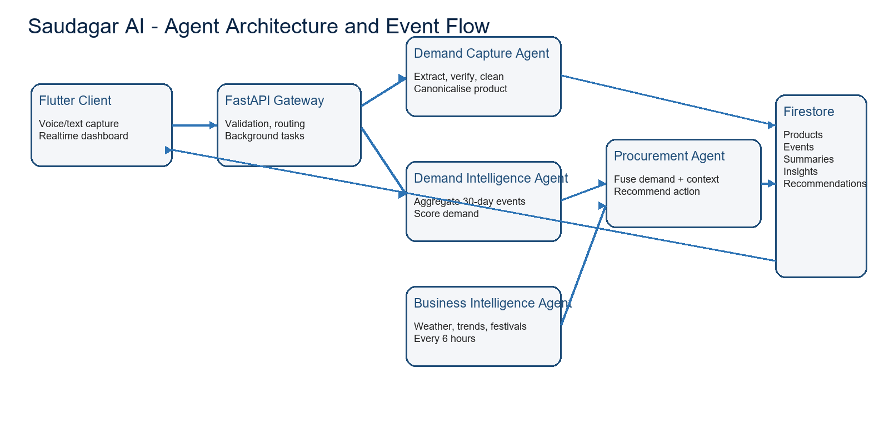
Figure 1. Logical agent architecture. The core pipeline responds to a demand event; business context is refreshed independently and consumed by procurement reasoning.

4. Agent Architecture
Agent | Trigger | Responsibility | Primary output
Demand Capture | POST /capture-demand or /upload-audio | Extract, verify, clean and canonicalise one or more demand events | demand_events
Demand Intelligence | Background task after capture | Aggregate recent per-shop events into frequencies, stock-out counts and demand scores | demand_summary/{shop_id}
Business Intelligence | Startup then 6-hour scheduler | Refresh weather, trends and festival context | business_insights/latest
Procurement | After summary update | Combine demand summary and business context into ranked guidance | recommendations/{shop_id}

5. End-to-End Flow
- The shopkeeper records audio or provides a transcript in the Flutter client. Audio is transcribed server-side before the demand workflow starts.
- FastAPI validates the request and invokes the Demand Capture pipeline. The pipeline uses model-based extraction and verification, cleans product phrases, and reconciles them with the live catalogue.
- The canonical demand event is persisted. A background task derives recent demand metrics for the shop.
- The Procurement Agent combines the summary with the latest seasonal and market context to generate a prioritised recommendation set.
- Firestore’s real-time capability makes summaries, insights and recommendations available to the client dashboard.

6. Data Architecture
Firestore is the operational datastore. Events are immutable-in-principle capture records; summaries and recommendations are replaceable projections keyed by shop. The products catalogue supplies canonical names and aliases. Feedback forms a separately auditable loop for evaluating recommendation usefulness.
Data domain | Key | Retention / mutability posture
Product catalogue | Product document | Managed reference data; aliases evolve with curation
Demand events | Generated document ID | Append-only audit signal; timestamped by backend
Demand summary | shop_id | Recomputed projection from recent events
Business insights | latest | Time-sensitive singleton refreshed on schedule
Recommendations | shop_id | Latest advisory projection; human review expected
Feedback | Generated document ID | Append-only evaluation record

7. Security and Trust Boundaries
- Service credentials and model/API keys are held only by the FastAPI runtime; they are never distributed with the Flutter client.
- The client is designed for read-only realtime consumption of approved Firestore collections. Backend services own writes and validation.
- Input is validated through Pydantic contracts; model outputs are verified and canonicalised before persistence.
- Production deployment must replace prototype CORS wildcard settings with an explicit frontend allow-list and apply least-privilege Firestore rules.

8. Reliability, Observability and Risks
Risk | Current mitigation | Planned hardening
Model uncertainty | Independent verification and transcript-grounding checks | Quality metrics, fallback review queue and prompt regression suite
External API failure | Error handling and local mock Firestore | Timeouts, retries, circuit breaking and durable queues
Duplicate/background work | Simple prototype task triggering | Idempotency keys and event-driven workers
Sensitive data | Server-side secret isolation | Data minimisation, retention policy and consent controls

9. Future Scope
- Integrate supplier catalogues, order drafts and inventory-system reconciliation while preserving explicit shopkeeper approval.
- Introduce multilingual capture quality measurement, per-store catalogues, and active-learning alias confirmation.
- Move scheduled and post-event work to durable cloud jobs/queues for horizontal scaling and retry control.
- Add role-based access, tenancy isolation, audit dashboards, model evaluation, and operational SLIs/SLOs.
- Use feedback to evaluate recommendation acceptance and calibrate ranking policies without allowing uncontrolled autonomous ordering.

10. Acceptance Summary
The HLD is satisfied when a reviewer can trace the path from customer request to a persisted demand event, derived shop-level analytics, contextual recommendation, and visible client result; understand each agent’s authority; and identify the controls required for production hardening.

