A Project Report On

**Xerox Shops**

**Submitted By:**

Mahipal Chavda (Exam No : 53)

**Guided By:**

Dr. Vinod Desai

**Submitted To:**

Post Graduate of Computer Science And

Technology Department

Sardar Patel University Vallabh Vidhyanagar,Anand

2022-2023

**Post Graduate Department of Computer Science and Technology**

**Sardar Patel University**

**Vallabh Vidyanagar**

**CERTIFICATE**

This is to certify that **MahipalSinh Kanaksinh Chavada** of MCA IV semester has worked on the project entitled “**Xerox Shops**” satisfactory towards the partial fulfillment of the degree of Master of Computer Science and Applications during the final semester at the Post Graduate Department of Computer Science and Technology, Sardar Patel University, Vallabh Vidyanagar, Gujarat, India.

Date of Submission

1st May, 2023

**Internal Project Guide Head of the Department**

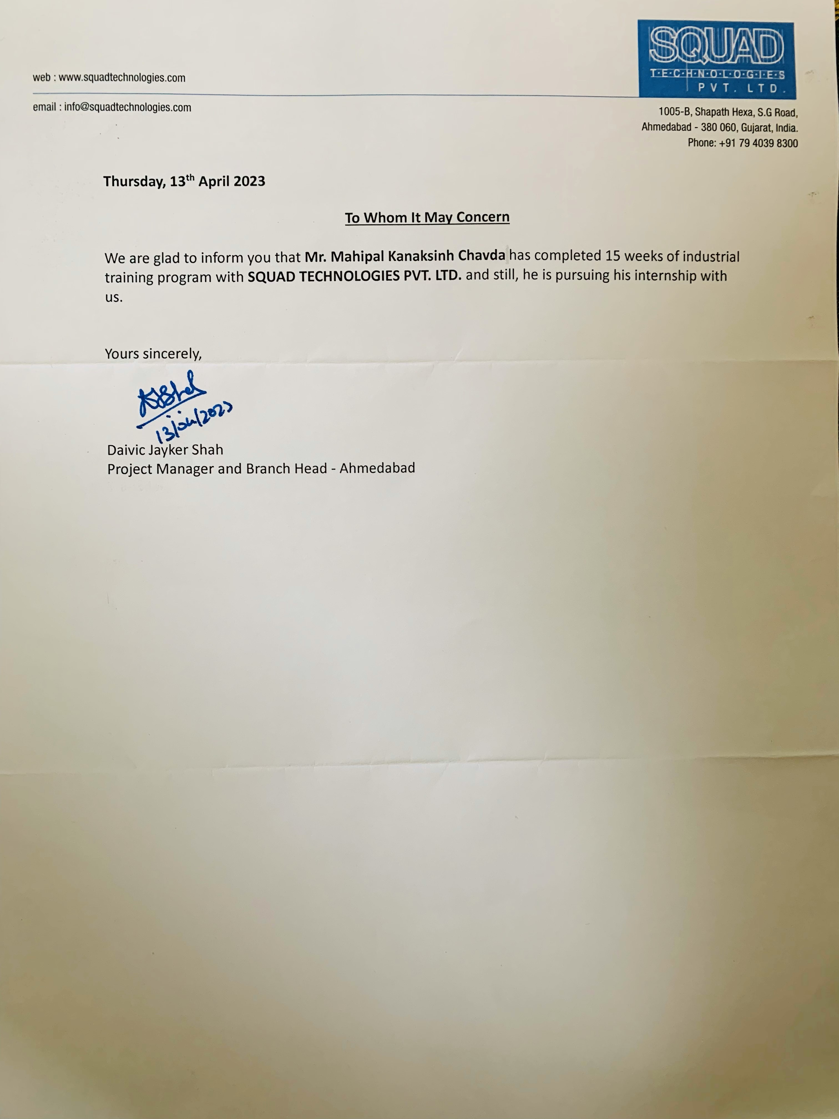

**Acknowledgement**

Knowledge in itself is a continuous process. At this moment of our substantial enhancement, we rarely find words to express our gratitude towards those who were constantly involved with us.

The completion of any inter disciplinary project depends upon coordination, cooperation and combined efforts of several resources of knowledge, creativity, skill, energy and time. The work being accomplished now, we feel our sincerest urge to recall and knowledge through these lines, trying our best to give full credit wherever it deserves.

We would like to thank our project guide **Mrs. Jesal Desai** and Internal project guide **Dr. Vinod Desai** who advised and gave us moral support through the duration of our project. Without their constant encouragement we could not have been able to achieve what we have.

It’s our good fortune that we had support and well wishes of many. We are thankful to all and those names which have been forgotten to acknowledge here but contributions have not gone unnoticed.

With Sincere Regards,

**MahipalSinh Chavda**

**Table of Contents**

|  |  |  |  |
| --- | --- | --- | --- |
| **Sr. No** |  | **Subject** | **Page Number** |
| **1** |  | **Project Profile** | **6-7** |
| **2** |  | **Introduction** | **8-15** |
| **3** |  | **Introduction to tools & technologies** | **16-28** |
| **4** |  | **System Study** | **29** |
|  |  | Existing System | **30** |
|  |  | Proposed System | **30** |
|  |  | Scope of the Proposed System | **30** |
|  |  | Aim and Objective of the Proposed System | **31** |
|  |  | Feasibility Study | **32** |
|  |  | Operational Feasibility | **32** |
|  |  | Technical Feasibility | **32** |
|  |  | Economical Feasibility | **32** |
| **5** |  | **System Analysis** | **33** |
|  | **1.** | Requirements Specification (along with System Modules) | **34-37** |
|  | **2.** | Use Case Diagram | **38** |
|  | **3.** | Activity Diagram | **39-40** |
| **6** |  | **System Design** | **41** |
|  | **1.** | Data Dictionary | **42-36** |
|  | **2.** | Screen Layouts | **47-60** |
|  | **3.** | Reports | **61** |
| **7** |  | **System Testing** | **62** |
|  | **1.** | Testing Strategies | **63** |
|  | **2.** | Test Cases | **64-66** |
| **8** |  | Future Enhancement | **67-68** |
| **9** |  | Bibliography/References | **69-70** |

1.Project Profile

* **Project Profile**

**Project Name:** Xerox Shops

**Type of Application:** Web Based Application

**Project Description:** Xerox shop is web application. Our application will allow people to select xerox shop near your area. And then you can upload your document which you want to be printed. You just need to select date and pay half of payment. Your print will be ready before your given deadline**.**

**Team Size:** 3 Members

**Front End: Bootstrap 4.5, CSS 3,**

**Back End: C# 8.0, Sql Server 15.0**

**Tools used:** Microsoft visual studio 2019, Sql server management tool

# 2.Introduction

* + **2.1 DEPARTMENT PROFILE**

**POST GRADUATE DEPARTMENT OF COMPUTER**

**SCIENECE AND TECHNOLOGY**

**SARDAR PATEL UNIVERSITY**

**VALLABH VIDHYANAGAR**



**History**

The Department of Computer Science was established in the year 1986 as an institution offering postgraduate course in Computer Science. The computing facility, however, was introduced at the **Sardar Patel University** somewhere in 1973-74 at the University's computer center with an IBM 1620, a second-generation mainframe computer. The University started one-year Post Graduate Diploma in Computer Applications (PGDCA) course in the academic year 1975, Master of Computer Applications (MCA) in the year 1986, M.Sc. (Computer Science) in 1988, M.Sc. (Bioinformatics) in 2004, M.Phil. (Computer Science) in the year 2008. Ph.D. (Computer Science) in 1990 and Ph.D. (Bioinformatics) in 2011. Besides these programs, The University also started offering computer related short- term programs from time to time. The computing resources were also used by different postgraduate departments of the University for their Research Work. The institute took lead in establishing links with

national and international institutes. The department started a CSI chapter (CSI the Computer Society of India is a national professional body having links with various professional bodies in India and abroad) in 1985-86. Various workshops, seminars had symposia have been organized under CSI banner so far, which have strengthened both the teaching and research activities of the department.

In the year 1988, Late **Shree Gordhan bhai Hathi Bhai Patel** donated money to the University for a separate building of the Post Graduate Department of Computer Science. The department was also recognized by the UGC to provide technical training to personnel at various levels of academia and administration. Several PC based systems had been installed and major research work was carried out in the areas of CAI (Computer Aided Instruction), KBS (Knowledge Based Systems) and DSS (Decision Support Systems). In 1992, the M.Sc. in Computer Science program was terminated and intake of the MCA program was increased from 30 to 40. Three faculty members were selected on the basis of merit for the CICC-Japan training in the years 1992, 1994, and 1995.

Early 2000 was the time when vast technological changes took place in the IT industry all over the worlds. The department could meet the technological requirements through support from the UGC, AICTE and various bodies of the state. A networked laboratory was established at the department, providing state-of-the-art facilities, the intake to MCA was increased to 100 by introducing self- financed seats in the year 2000, and a separate self- financed batch of MCA was started. The department was recognized and offered ’Refresher Courses in Computer Science’ for the Computer Science faculty members in India by the University Grants Commission. In the year 2002, a special **MCA** program was introduced for providing lateral entry into the second year to computer science graduates. In a short span, the department grew to the extent that a new building was required. With one more generous donation from Late Shree Gordhanbhai Hathibhai Patel, grants from the UGC and he state government and the department's internal sources, a new building was inaugurating on July 22nd, 2002 by H.D.H Pujya Pramukh Swami Maharaj.

The name of the department was then changed to **Patel Post Graduate Department of Computer Science and Technology** in the year 2002, subsequently, new powerful servers and several workstations were added to the laboratory and electives for bioinformatics and wireless networks were added to the syllabus. The M.Sc. (Bioinformatics) program under the UGC Innovative Program scheme was introduced in the year 2005.

* + **2.2 Company Profile :**



**Company Name :** Squad Technologies Pvt. Ltd.

**Website :** [**https://squadtechnologies.com/**](https://squadtechnologies.com/)

**Company Overview :**

* Squad technologies Pvt. Ltd. Is about software and web technology development firm that takes the long view of team-building and business success. They have the broader perspective about their products and they believe on building the whole group as the Indian representative in the services and products they are providing. The company puts their clients as the top most priority and make sure that no matter, what they can deliver the requirement which they have been asked for.
* In India our company had been started their services since 2000 and from then we are providing our services internationally in the best way possible.
* We have 1000+ clients globally which are the one who proves that we are providing them one of the best technological helps.
* We have delivered more than 5000 projects on time with the great accuracy as well as on the budget .
* Our team has 200+ qualified tech as well as the marketing professionals, who are trying to give their best.

**Services :**

* [UX/ UI Design](https://www.squadtechnologies.com/services/#uxuidesign)
* [Website Development](https://www.squadtechnologies.com/services/#websitedevelopment)
* [DevOps](https://www.squadtechnologies.com/services/#devops)
* [IT Consultancy](https://www.squadtechnologies.com/services/#itconsultancy)
* [Marketing](https://www.squadtechnologies.com/services/#marketing)
* [QA Services](https://www.squadtechnologies.com/services/#qaservices)
* [AI/ML](https://www.squadtechnologies.com/services/#aimlartificialintelligencemachinelearning)
* [IoT](https://www.squadtechnologies.com/services/#iot)
* [Mobile Apps](https://www.squadtechnologies.com/services/#mobileapps)

**Technologies:**

|  |  |  |  |  |  |
| --- | --- | --- | --- | --- | --- |
| Android | Flutter | Kotlin | Firebase | React Native | Node.js |
| Vue.js | React.js | PostgreSQL | SQL | MongoDB | .Net |
| Adobe XD | Figma | InVision | Google Cloud | PHP | Laravel  etc. |

3.Introduction to tools & Technologies

* **3.1 Introduction to Tools**
* **Front End Tool:**



**Microsoft visual studio:** The Microsoft Visual Studio is a Microsoft-based Integrated Development Area (IDE). It is used to build software, websites, web applications, web services and mobile apps. Visual Studio uses the Windows API, Windows Shape, Windows Print Foundation, Windows Store, and Microsoft Silverlight development systems from Microsoft. The code can be both native and controlled.

Visual Studio includes a code editor supporting IntelliSense (the code completion component) as well as code refactoring. The integrated debugger works both as a source-level debugger and a machine-level debugger. Other built-in tools include a code profiler, designer for building GUI applications, web designer, class designer, and database schema designer.

It accepts plug-ins that expand the functionality at almost every level—including adding support for source control systems (like Subversion and Git) and adding new toolsets like editors and visual designers for domain-specific languages or toolsets for other aspects of the software development lifecycle (like the Azure DevOps client: Team Explorer).



* **Back End Tool:**

**Sql server management tool**: SQL Server Management Studio (SSMS) is a software application first launched with Microsoft SQL Server 2005 that is used for configuring, managing, and administering all components within Microsoft SQL Server. It is the successor to the Enterprise Manager in SQL 2000 or before. The tool includes both script editors and graphical tools which work with objects and features of the server.

A central feature of SSMS is the Object Explorer, which allows the user to browse, select, and act upon any of the objects within the server.

It also shipped a separate Express edition that could be freely downloaded, however recent versions of SSMS are fully capable of connecting to and manage any SQL Server Express instance. Microsoft also incorporated backwards compatibility for older versions of SQL Server thus allowing a newer version of SSMS to connect to older versions of SQL Server instances. It also comes with Microsoft SQL Server Express 2012, or users can download it separately.

* **3.2 Introduction to Technologies**

1. **Html**



HTML, which stands for Hypertext Markup Language, is a programming language that is used to create web pages. It allows you to add text, images, videos, links, and other content to a webpage, and it provides the structure and formatting needed to make a webpage easy to read and navigate.

HTML is a markup language, which means that it uses tags to define the structure and content of a webpage. A tag is a piece of code that begins with a less-than symbol (<) and ends with a greater-than symbol (>). Tags are used to create different types of HTML elements, such as headings, paragraphs, lists, images, and links.

HTML documents are made up of two main parts: the head and the body. The head contains information about the document, such as the title and metadata, while the body contains the actual content of the document.

To create an HTML document, you will need a text editor, such as Notepad or Sublime Text. You can then start by creating a basic HTML structure with the `<!DOCTYPE html>` declaration, followed by the `<html>` element. Inside the `html` element, you will have a `head` element and a `body` element.

HTML is a foundational technology for the web and is essential for creating web pages and web applications. By learning HTML, you will gain the skills to create and publish your own web content, and you will be able to contribute to the creation of web-based projects.

1. **CSS**



CSS, or Cascading Style Sheets, is a style sheet language used to define the visual appearance of a web page written in HTML or XML. CSS allows you to separate the content of a web page from its presentation, making it easier to create and maintain consistent styling across multiple web pages.

CSS syntax consists of three main components: selectors, properties, and values. Selectors are used to target HTML elements, while properties and values are used to define the appearance of those elements.

**Here's a breakdown of the CSS syntax:**

- **Selectors:** A selector is used to target HTML elements that you want to style. Selectors can target elements by their tag name, class, or ID. For example, you can target all `p` elements with the selector `p`, or you can target a specific element with the ID `#myelement`.

- **Properties:** A property is a characteristic of an HTML element that you want to style. Properties can include things like font size, color, background, and margin. Each property has a specific name, such as `color` or `font-size`.

**- Values**: A value is the specific setting that you want to apply to a property. Values can include things like color names (e.g. `red`), numeric values (e.g. `12px`), or keywords (e.g. `bold`).

1. **JavaScript**



JavaScript is a programming language that is primarily used to add interactivity and dynamic behavior to web pages. It is a client-side scripting language, which means that it runs in a web browser and is executed on the user's computer.

JavaScript allows you to add logic and functionality to web pages, such as form validation, user interface effects, and dynamic content. It can also be used to manipulate HTML elements and CSS styles on a page, making it a powerful tool for web development.

JavaScript syntax is similar to other programming languages, such as C++ and Java. It consists of variables, operators, control structures, functions, and objects.

**Here's a brief overview of some of the key concepts in JavaScript:**

**- Variables**: Variables are used to store data, such as strings, numbers, and boolean values. Variables can be declared using the `var`, `let`, or `const` keywords.

**- Operators:** Operators are used to perform operations on variables and values, such as arithmetic operations (+, -, *, /) or comparison operations (==, !=, <, >).

- **Control structures:** Control structures, such as if/else statements and loops, are used to control the flow of the program and execute code based on certain conditions.

**- Functions:** Functions are reusable blocks of code that perform a specific task. They can take input parameters and return output values.

- **Objects:** Objects are collections of related data and functions, and they can be used to represent real-world entities, such as a person or a car.

JavaScript can be included in an HTML document using the `<script>` tag, which allows you to add JavaScript code directly to a web page.

Here's an example of a simple JavaScript function that displays an alert message:

```

function showAlert() {

alert("Hello, world!");

}

```

Overall, JavaScript is an essential tool for web development, and it provides a powerful way to add interactivity and dynamic behavior to web pages. By learning JavaScript, you can create more engaging and interactive web pages that provide a better user experience for your visitors.

1. **jQuery**



jQuery is a JavaScript library that simplifies HTML document manipulation, event handling, and animation. It is a lightweight and fast library that makes it easy to add dynamic behavior to web pages.

jQuery allows you to write less code and achieve more, by providing a simple and consistent API for working with HTML elements, CSS styles, and events. It also provides a wide range of plugins and extensions that extend its functionality and make it easy to work with other JavaScript libraries and frameworks.

jQuery syntax is based on CSS selectors, which makes it easy to target HTML elements and apply changes to their properties. It also provides a range of methods and functions that make it easy to work with HTML elements and attributes.

**Here are some of the key concepts in jQuery:**

**- Selectors**: jQuery selectors are similar to CSS selectors, and allow you to select one or more HTML elements based on their tag name, class, ID, or other attributes.

**- Methods:** jQuery methods are used to perform actions on selected HTML elements, such as setting their CSS styles, modifying their content, or adding event handlers.

**- Events:** jQuery provides a wide range of events that can be used to respond to user interactions, such as clicking a button or submitting a form.

**- Effects:** jQuery provides a range of built-in effects that can be used to animate HTML elements and create dynamic user interfaces.

jQuery can be included in an HTML document using the `<script>` tag, and it can be used in conjunction with other JavaScript libraries and frameworks. It is widely used in web development, and is a popular choice for adding dynamic behavior and interactivity to web pages.

Overall, jQuery provides a powerful and intuitive way to work with HTML elements and create dynamic web pages. By learning jQuery, you can improve your productivity and create more engaging and interactive web applications.

1. **C#**



C# is a modern, object-oriented programming language developed by Microsoft. It is designed to be simple, efficient, and secure, and is widely used for developing desktop applications, web applications, and games

C# syntax is similar to other C-style programming languages, such as Java and C++. It supports a wide range of programming constructs, including variables, operators, control structures, functions, and classes.

**Here are some of the key concepts in C#:**

**- Variables:** Variables are used to store data, such as numbers, strings, and boolean values. They can be declared using different data types, such as int, float, and string.

**- Operators:** Operators are used to perform operations on variables and values, such as arithmetic operations (+, -, *, /) or comparison operations (==, !=, <, >)

**- Control structures:** Control structures, such as if/else statements and loops, are used to control the flow of the program and execute code based on certain conditions.

**- Functions:** Functions are reusable blocks of code that perform a specific task. They can take input parameters and return output values.

**- Classes:** Classes are used to define objects that represent real-world entities, such as a car or a customer. They contain data members and member functions, which define the properties and behaviors of the object.

C# can be used with different development environments, such as Visual Studio, and it can be used to develop different types of applications, including desktop applications, web applications, and games. It also supports different programming paradigms, such as procedural programming, object-oriented programming, and functional programming.

Overall, C# is a powerful and versatile programming language that is widely used in the software industry. By learning C#, you can develop a wide range of applications and improve your career opportunities in the field of software development.

4.System Study

**4.1 Existing System:**

* The existing application will look more attractive and it will be the more user friendly.
* It has more useful features.
* The data will be more secure.

**4.2 Proposed System:**

* In our application user as well as shopkeeper has to register themselves to get access in our system.
* Users need to upload their document and date.
* Shopkeeper will get notification that user has ordered their prints through mail as well as in our application.
* User will get message that ordered has completed

**4.3 Scope of the Proposed System:**

* Keep data safe
* We have one file manager so that user as well as shopkeeper can check the file in future
* User as well as shopkeeper can check order history.
* Order wise file management.
* Reduce billing Paper work.

**4.4 Aim and Objective of the Proposed System:**

**AIM:** User can set online order to print their xerox on time without any difficulty.

**Objective of proposed system:**

* Now a days there is so much chaos at xerox shops.
* At last point of time students need printout of their college work to submit.
* Many of time they cannot submit on time due to work load of xerox shop.
* We came up with a solution
* Students can login to our application
* They can select xerox shops near their respective area.
* After selection of shop they can place order by uploading their document and selecting due date on which they wanted to get printouts.
* Users must need to pay 50% of their amount.
* Shopkeeper will get notification.
* Shopkeeper will download the document and complete the order.

**4.5 Feasibility Study:**

The main objective of the feasibility study is to test the Technical,

Operational and Economical feasibility for adding new modules and debugging

old running system. All system is feasible if they are unlimited resources and

infinite time.

* Operational Feasibility
* Technical Feasibility
* Economical Feasibility

**4.5.1 Operational Feasibility:**

|  |  |
| --- | --- |
| **Customer** | **Shop** |
| Register | Register |
| Find Shops by cities | Add types of Xeroxes |
| Check the pricing of shops | View order |
| Place documents to shopkeeper for printing | Download & print the documents |
| View files | View orders which have pending payment |
| Check History | View Feedback |
| Give Feedback | Check History |

**4.5.2 Technical Feasibility:**

(Minimum)

* Processor : Pentium 4- 2.4 GHZ
* Hard disk : 10 GB (Free)
* Ram : 2GB
* Front End : visual Studio
* Middle Ware : Visual Studio
* Back End : MY- SQL
* Tools used : Microsoft office Visio 2007

**4.5.3 Economical Feasibility:**

* As per budget

5.System Analysis

**5.1 System Requirement**

**Requirement Specification:**

* **Actors:**
  + **Customer**
  + **Shopkeeper**
* **System Module:**
  + **Customer**
    - Register
    - Login
    - Find Shops by cities
    - Pricing of shops
    - Place documents to shopkeeper for printing
    - View files
    - Check History
    - Feedback
  + **Shopkeeper**
    - Register
    - Login
    - Add types of Xeroxes
    - View order
    - Download & print the documents
    - View orders which have pending payment
    - View Feedback
    - Check History
* **Register:** Customer & Shopkeeper both have to register first in all register fields if anything is missing then proper message will be displayed. If everything is okay then both have to verify their account by entering PIN that will be in email inbox. If pin is wrong then again correct or empty then message will be displayed otherwise, they are redirected to login screen.
* **Login:** Customer & Shopkeeper both have to login first if email id was incorrect then message will be displayed ‘user is not registered’ and if password was wrong then message will be displayed ‘invalid password’ and if email & password is correct respective dashboard will be displayed.
* **Find Shop (Customer):** After logging into system customer can first redirected to Shops module in this module customer have to select particular city after selecting city customer can see shops that are available in that city.
* **Pricing of shop (Customer):** After selecting shop customer will redirected to Shop Pricingpage here customer can find that which type of xeroxes shop is offering and if customer wants to print documents then customer can place order by clicking on particular xerox type.
* **Place documents (Customer):** After selecting xerox type customer redirected to Place Orderin this page customer have to choose their documents that he/she wants to print. If the selected files have ‘.doc’ or ‘.docx’ or ‘.pdf’ format then and then only system will allow to perform next task otherwise error message will be displayed. If documents are correct then customer can see total price and pages. If customer wants to add more file then he/she can add.

After selecting documents customer have to select pickup date if pickup date not today’s date or tomorrow’s date then proper error message will be displayed. If customer wants to write something with order, then customer can write in description box and customer can place the order.

* **Payment (Customer):** After placing order customer will be redirected to payment page here customer have 4 options to pay half amount of the bill. If everything is okay then order will place otherwise order will cancel automatically and proper message will be displayed.
* **Invoice (Customer):** After paying half amount customer will be redirected to invoice page here customer can see the bill of order and customer can download.
* **Files (Customer):** In this module customer can find files that customer has selected for printing and customer can view and download the files.
* **History (Customer):** In this module all completed order will be displayed here and customer can check files by order wise also.
* **Feedback (Customer):** In this module customer can submit their feedback to shops that customer has ordered once.
* **Types of Xerox (Shop):** In this module shopkeeper can add, delete and edit particular Xerox Type. For adding xerox type shopkeeper must have to add name, price and description of xerox type. If everything is okay then xerox type will be added and proper message will be displayed. And if any error occurs then also proper message will be displayed.
* **View order (Shop):** In this module shopkeeper can find orders which shopkeeper has to complete. For completing any order shopkeeper has to view order files. After viewing order shopkeeper will print the documents and shopkeeper has to update order to completed.
* **Orders with pending payment (Shop):** In this module shopkeeper will find orders that are completed but customer has not taken the printouts. When customer will come and pickup their printouts and paying remaining amount the shopkeeper can update order by clicking received payment button.
* **View Feedback (Shop):** In this module shopkeeper can see the feedbacks that are submitted by customers.
* **History (Shop):** In this module fully completed orders will be displayed.

**5.2 Use case Diagram**



**5.3 Activity Diagram:**

**Shop :**



**User :**



6.System Design

**6.1 Data Dictionary**

**1) City :**

|  |  |  |  |
| --- | --- | --- | --- |
| CITY | | | |
| Field Name | **Type** | **Size** | **Constant** |
| CITYID | INT | - | PRIMARY KEY |
| CITYNAME | VARCHAR | 50 | NOT NULL |
| PINCODE | VARCHAR | 6 | NOT NULL |

**2) Customer :**

|  |  |  |  |
| --- | --- | --- | --- |
| CUSTOMER | | | |
| Field Name | **Type** | **Size** | **Constant** |
| CUSTOMERID | INT | - | PRIMARY KEY |
| CUSTOMERNAME | VARCHAR | 100 | NOT NULL |
| CUSTOMERMOBILE | VARCHAR | 10 | NOT NULL |
| CUSTOMEREMAIL | VARCHAR | 50 | NOT NULL |

**3) Shop :**

|  |  |  |  |
| --- | --- | --- | --- |
| SHOP | | | |
| Field Name | **Type** | **Size** | **Constant** |
| SHOPID | INT | - | PRIMARY KEY |
| SHOPNAME | VARCHAR | 200 | NOT NULL |
| SHOPMOBILE | VARCHAR | 10 | NOT NULL |
| SHOPADDRESS | VARCHAR | 300 | NOT NULL |
| SHOPEMAIL | VARCHAR | 30 | NOT NULL |
| SHOPKEEPERNAME | VARCHAR | 200 | NOT NULL |
| CITYID | INT | - | FORGION KEY |
| ISACTIVE | BIT | - | NOT NULL |
| OPENINGTIME | VARCHAR | 15 | NOT NULL |
| CLOSINGTIME | VARCHAR | 15 | NOT NULL |

**4) Login :**

|  |  |  |  |
| --- | --- | --- | --- |
| LOGIN | | | |
| Field Name | **Type** | **Size** | **Constant** |
| ID | INT | - | PRIMARY KEY |
| EMAIL | VARCHAR | 30 | NOT NULL |
| PASSWORD | VARCHAR | 50 | NOT NULL |
| ROLE | TINYINT | - | NOT NULL |
| PIN | VARCHAR | 4 | NOT NULL |
| ISVERIFIRED | TINYINT | - | NOT NULL |

**5) Xerox Type :**

|  |  |  |  |
| --- | --- | --- | --- |
| XEROXTYPE | | | |
| Field Name | **Type** | **Size** | **Constant** |
| XTID | INT | - | PRIMARY KEY |
| XTNAME | VARCHAR | 100 | NOT NULL |
| XTPRICE | INT | - | NOT NULL |
| XTDESCRIPTION | VARCHAR | 500 | NOT NULL |
| SHOPEMAIL | VARCHAR | 30 | NOT NULL |

**6) Document Master :**

|  |  |  |  |
| --- | --- | --- | --- |
| DOCUMENTMASTER | | | |
| Field Name | **Type** | **Size** | **Constant** |
| DOCID | INT | - | PRIMARY KEY |
| DOCNAME | VARCHAR | 100 | NOT NULL |
| DOCURL | VARCHAR | 130 | NOT NULL |
| DOCSIZE | FLOAT | - | NOT NULL |
| DOCPAGES | INT | - | NOT NULL |
| XTPRICE | INT | - | NOT NULL |
| DOCPRICE | INT | - | NOT NULL |
| ORDERID | VARCHAR | 200 | NOT NULL |
| DOCREALNAME | VARCHAR | 100 | NOT NULL |

**7) Order Master :**

|  |  |  |  |
| --- | --- | --- | --- |
| ORDERMASTER | | | |
| Field Name | **Type** | **Size** | **Constant** |
| ORDERID | INT | - | PRIMARY KEY |
| ORDERDATE | DATE | - | NOT NULL |
| ORDERDESCRIPTION | VARCHAR | 200 | NOT NULL |
| CUSTOMEREMAIL | VARCHAR | 50 | FOREIGN KEY (CUSTOMER) |
| SHOPEMAIL | VARCHAR | 30 | FOREIGN KEY  (SHOP) |
| TOTALDOCS | VARCHAR | 2 | NOT NULL |
| TOTALPRICE | INT | - | NOT NULL |
| PAYMENTMODE | VARCHAR | 1 | NOT NULL |
| PAYMENTRECEIVED | INT | - | NOT NULL |
| PENDINGPAYMENT | INT | - | NOT NULL |
| PICKUPDATE | DATE | - | NOT NULL |
| ORDERSTATUS | TINYINT | - | NOT NULL |

**8) Feedback :**

|  |  |  |  |
| --- | --- | --- | --- |
| FEEDBACK | | | |
| Field Name | **Type** | **Size** | **Constant** |
| ID | INT | - | PRIMARY KEY |
| CUSTOMEREMAIL | VARCHAR | 50 | FOREIGN KEY (CUSTOMER) |
| SHOPEMAIL | VARCHAR | 30 | FOREIGN KEY  (SHOP) |
| FEEDBACKPOINTS | INT | - | NOT NULL |
| FEEDBACKDESCRIPTION | VARCHAR | 1000 | NOT NULL |

**6.2 Screen Layouts:**

1. **Home Page**

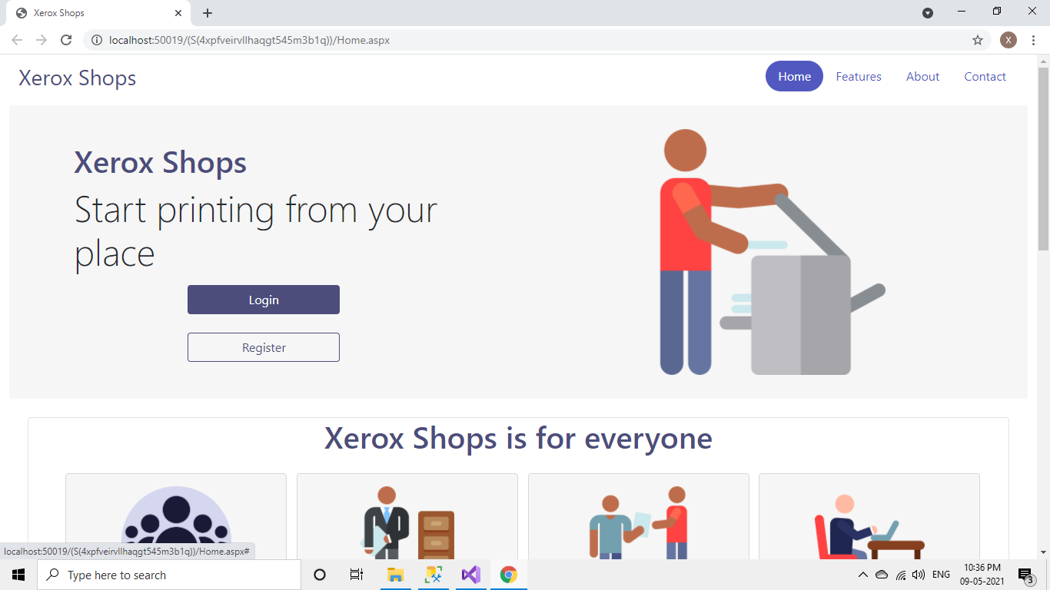

1. **Customer Registration**

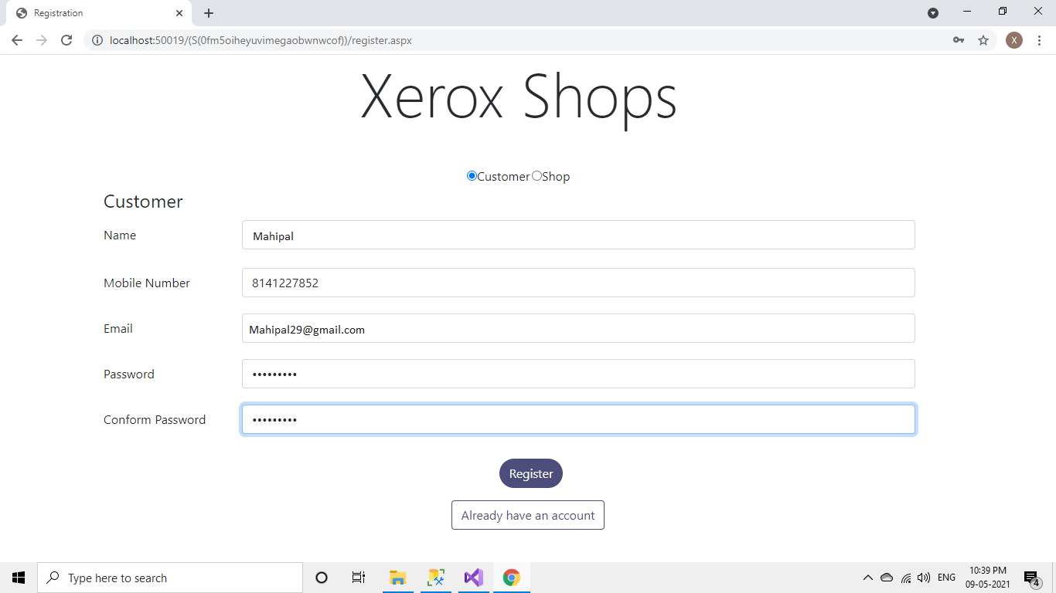

1. **Customer E-mail Authentication**

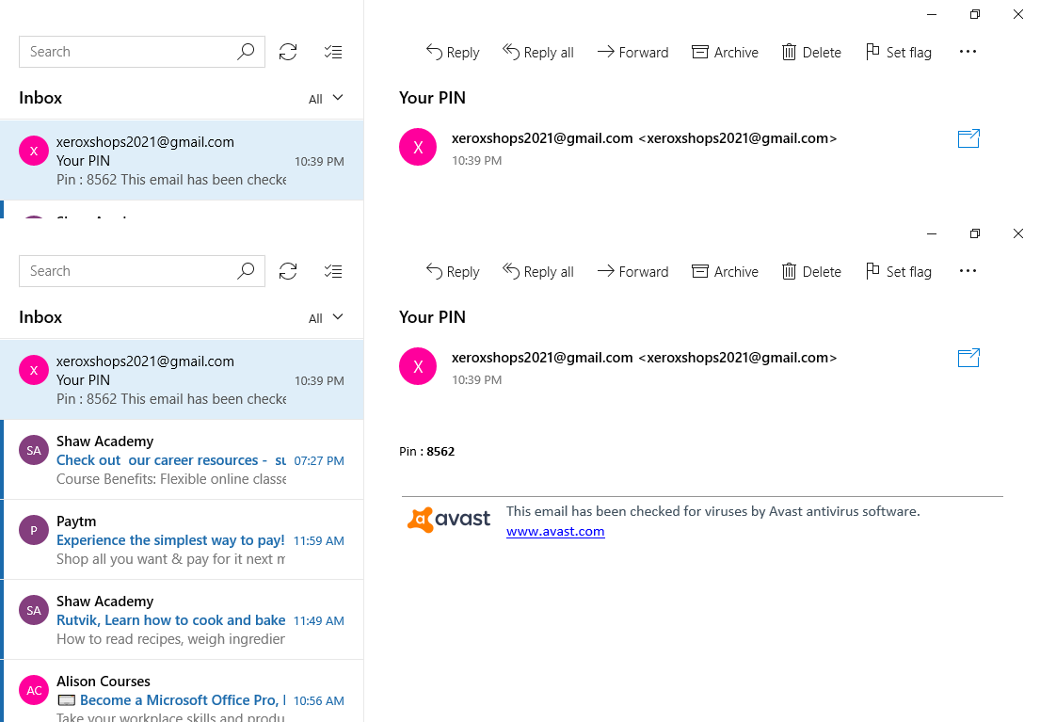

1. **Fore Registering Pin is Required Screen**

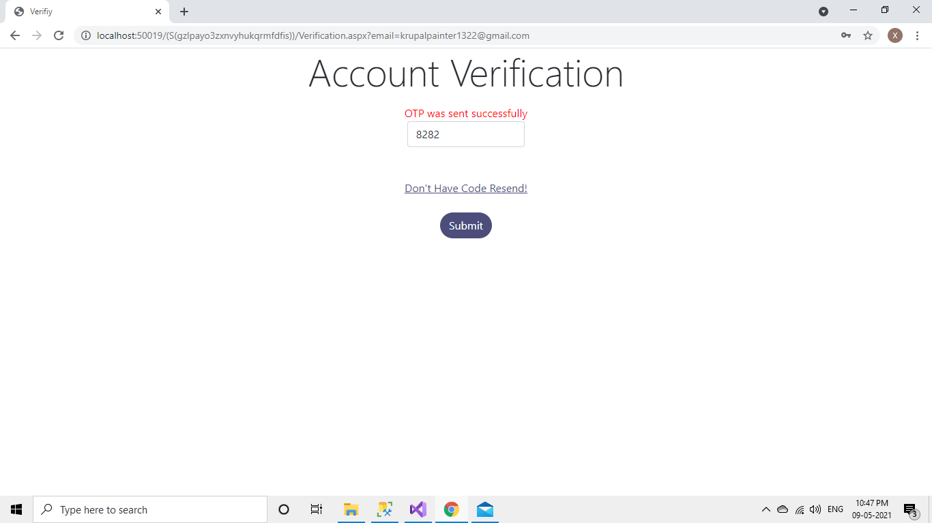

1. 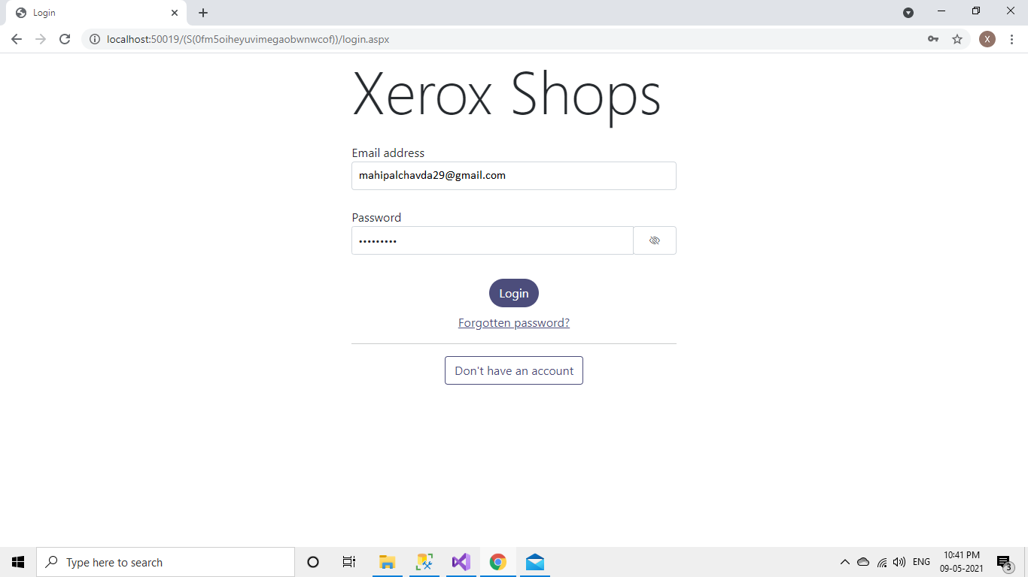**Login Screen**
2. **Shops Page (finding shops by city)**

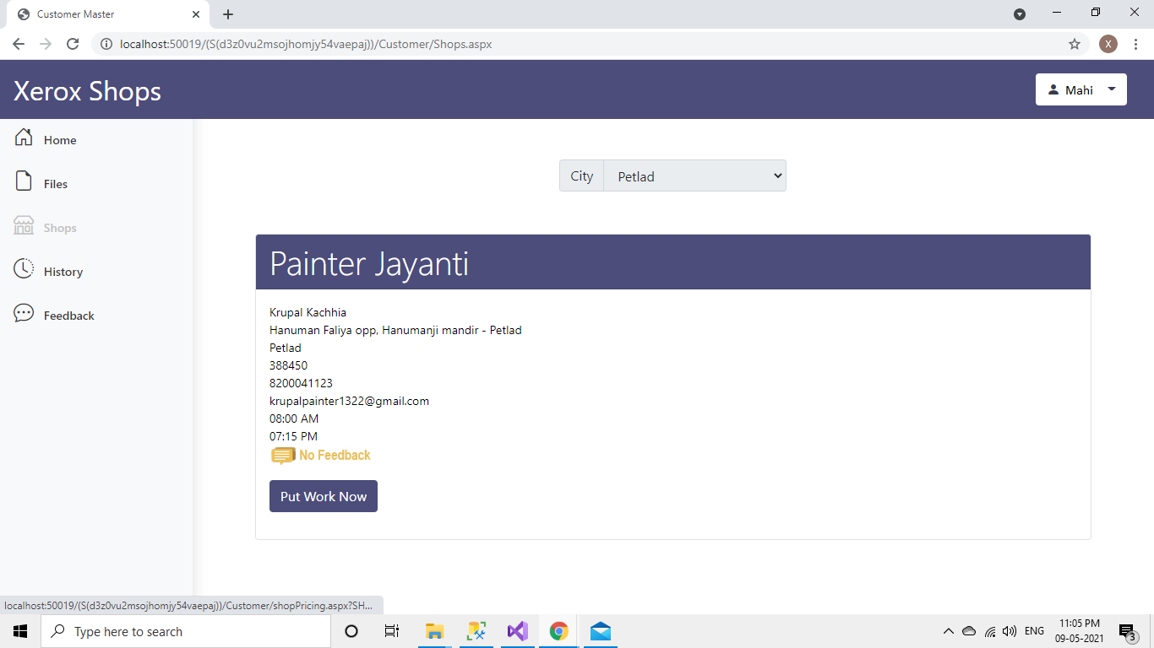

1. **Register Shop**



1. **Verification for shop**

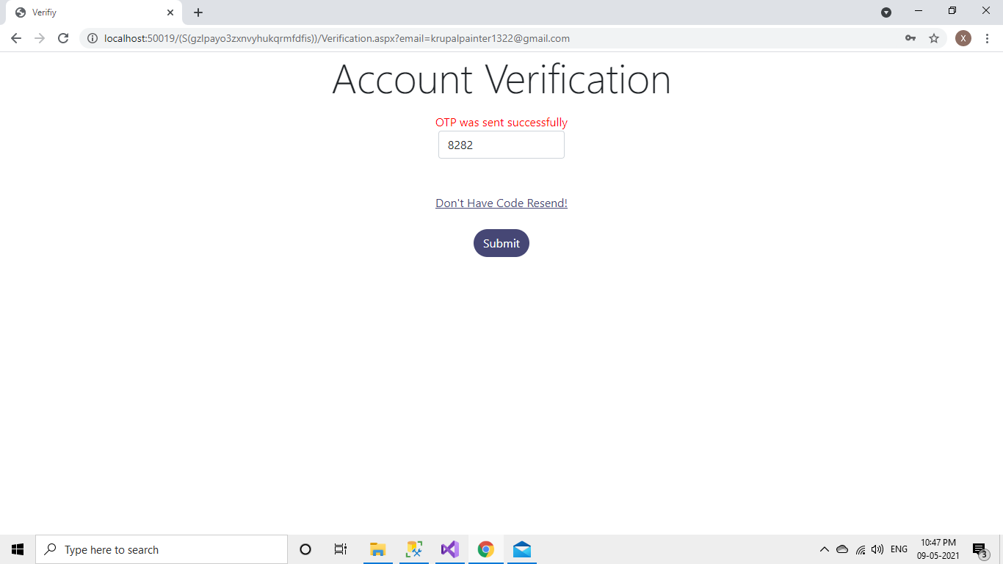

1. **Email Verification for shop:**



1. **Adding Xerox Type**

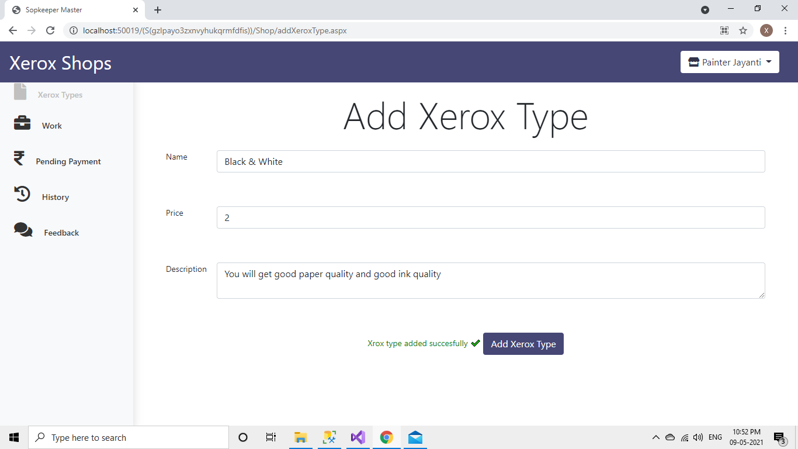

1. **Edit Page for shop**

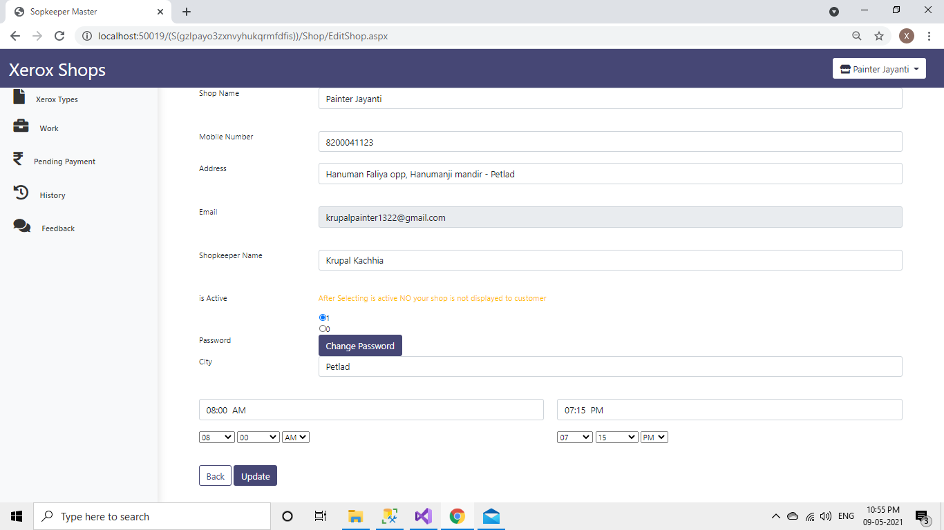

**11) Customer Side shop selection   
  
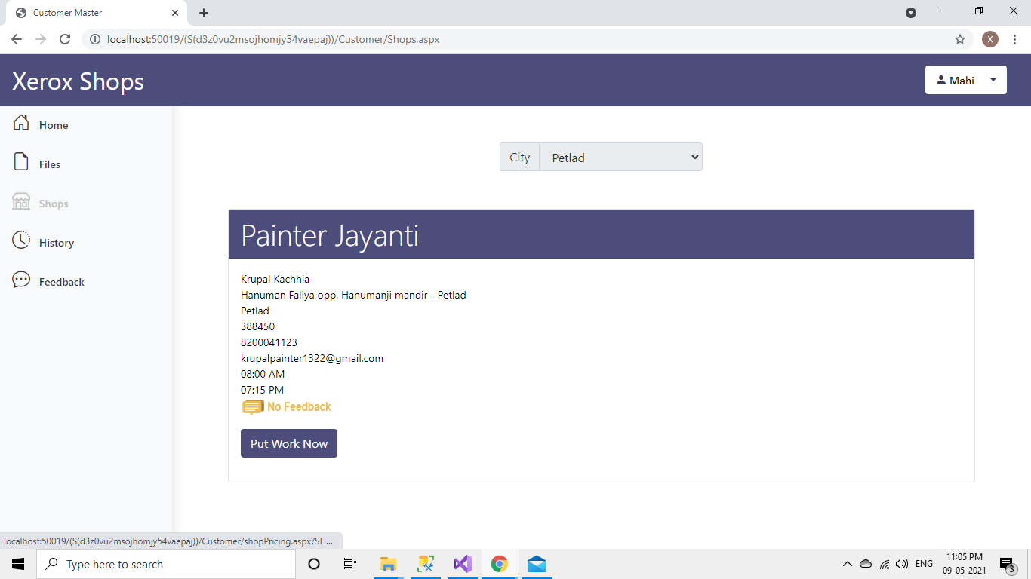**

1. **Pricing of shops**

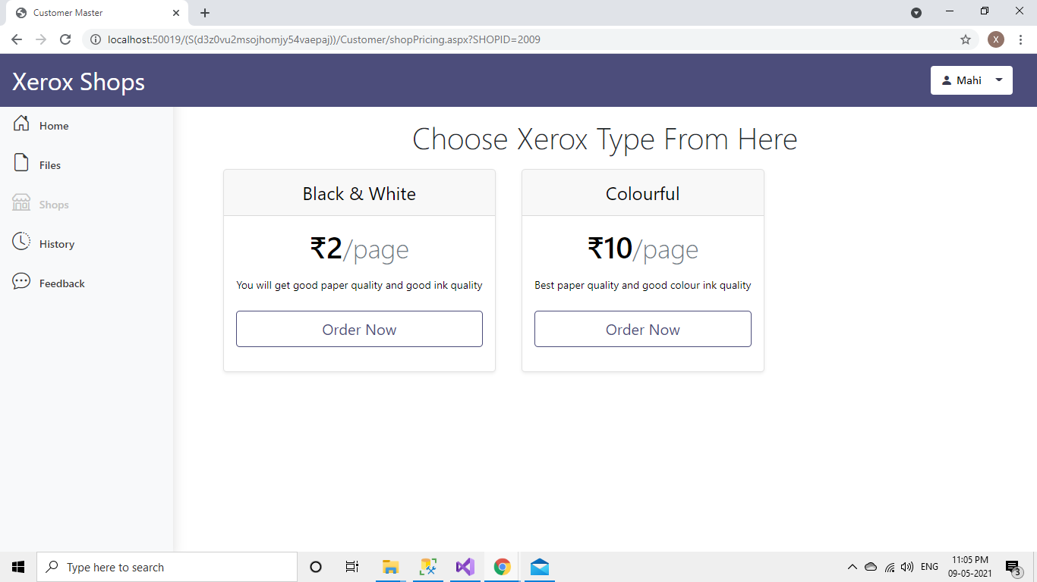

1. **Selecting Xerox Type**

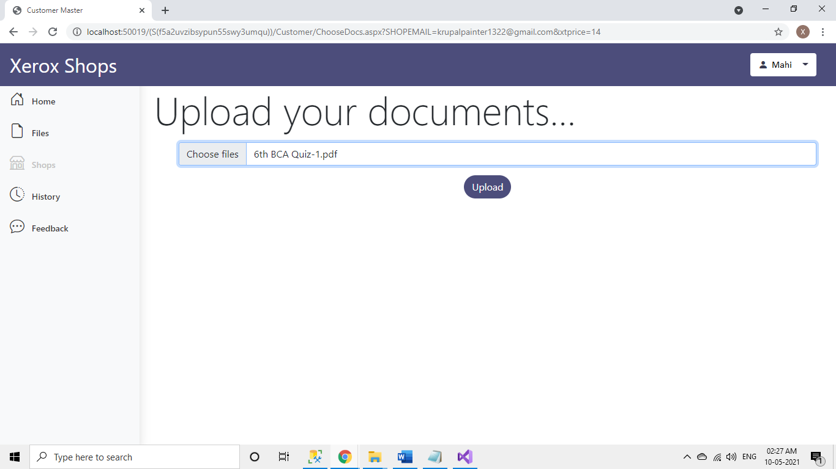

1. **Final Checking of files**

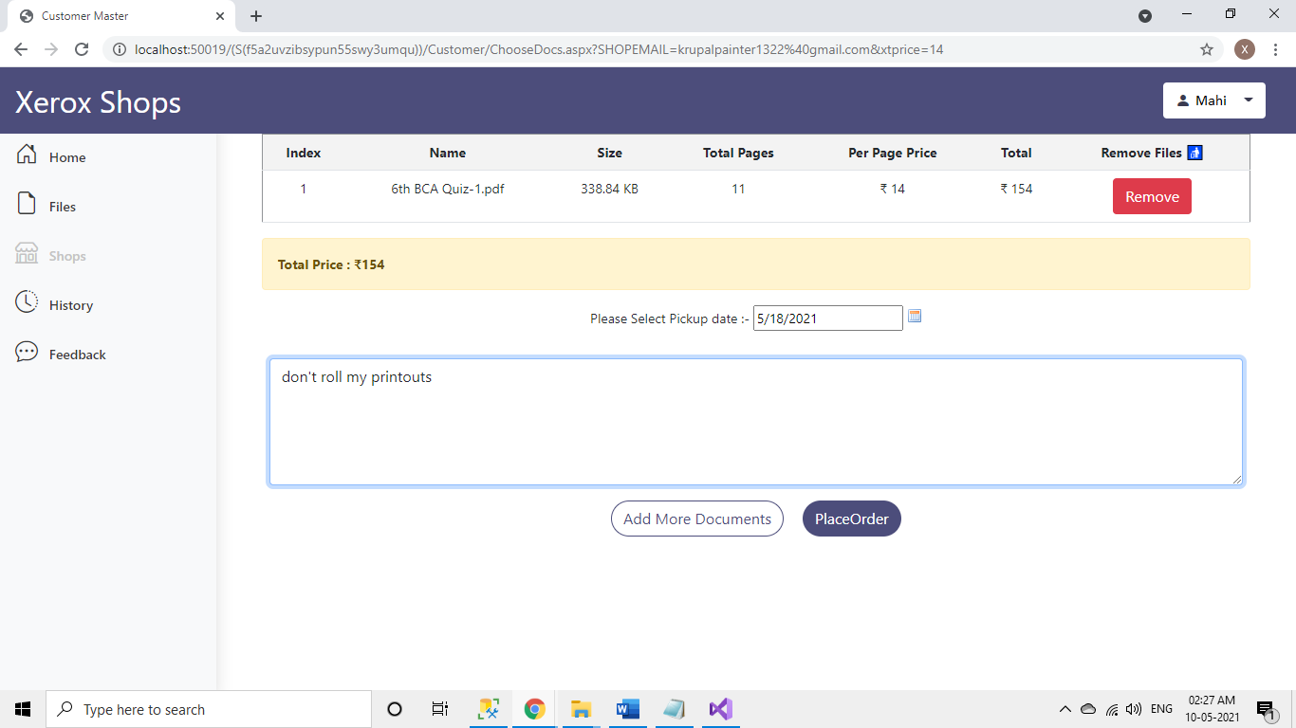

1. **Payment Page**

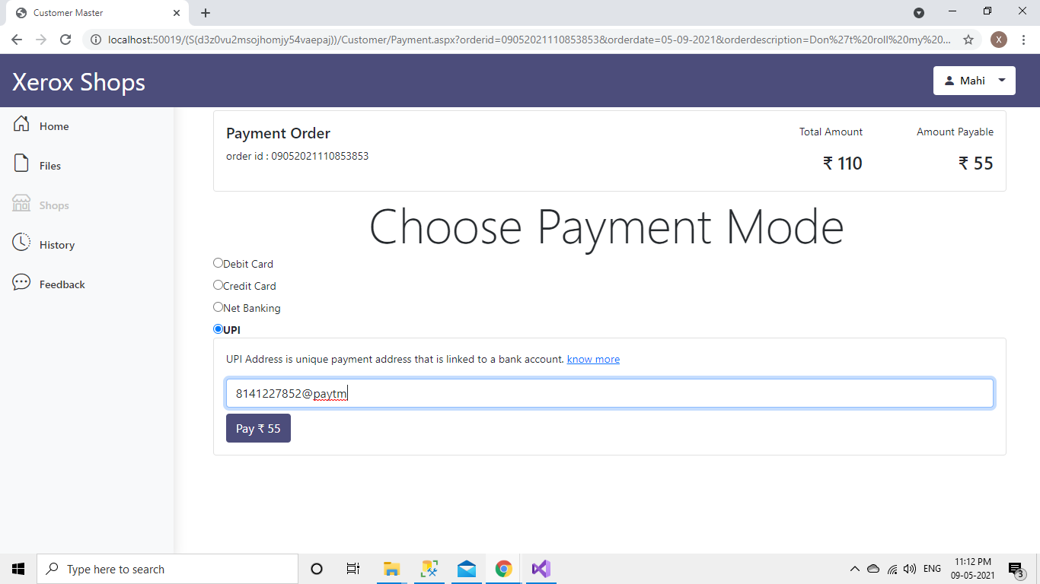

1. **Invoice Page**

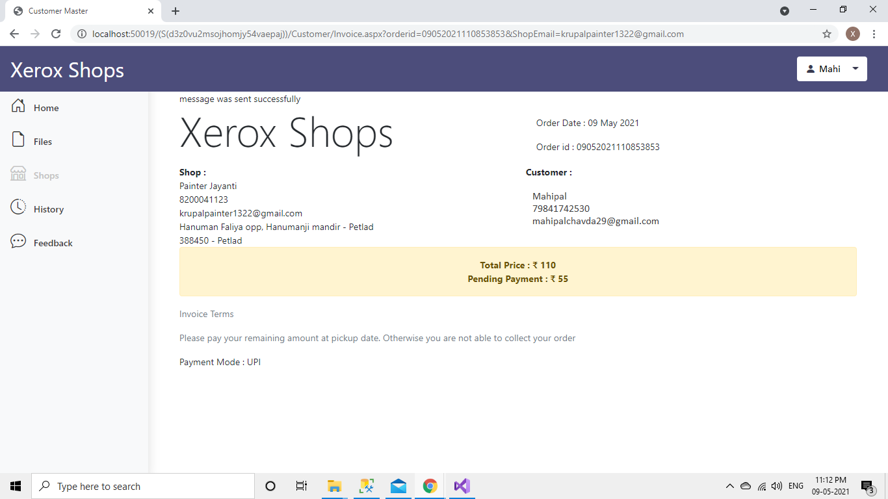

1. **Customer side Saved Files**

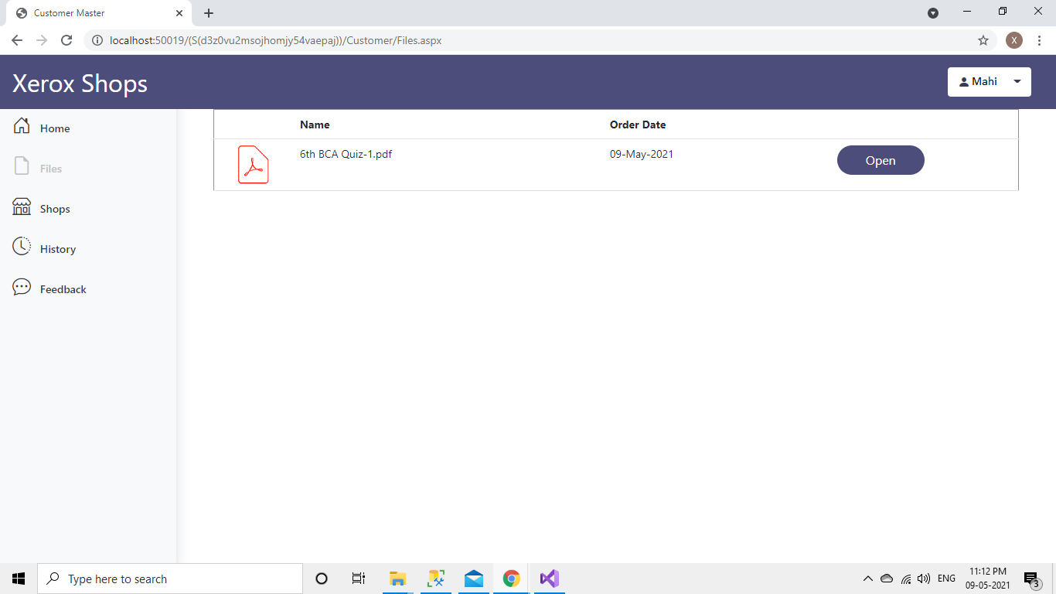

1. **List of shops at feedback page  
     
   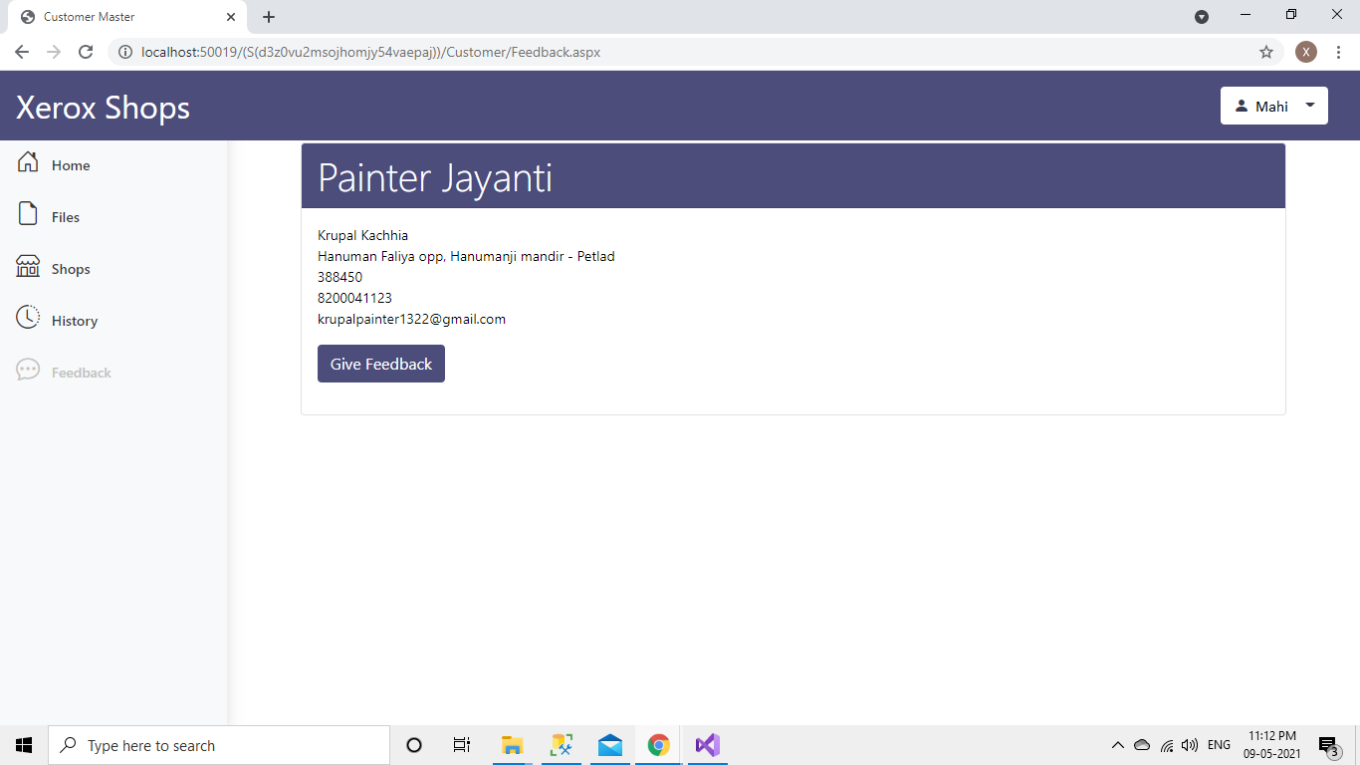**
2. **Feed back Submission**

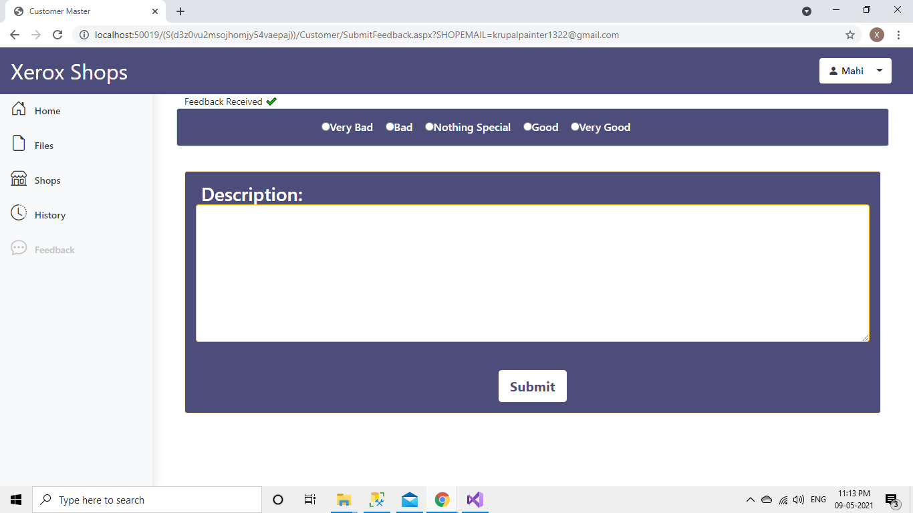

1. **Order Details(Files)**

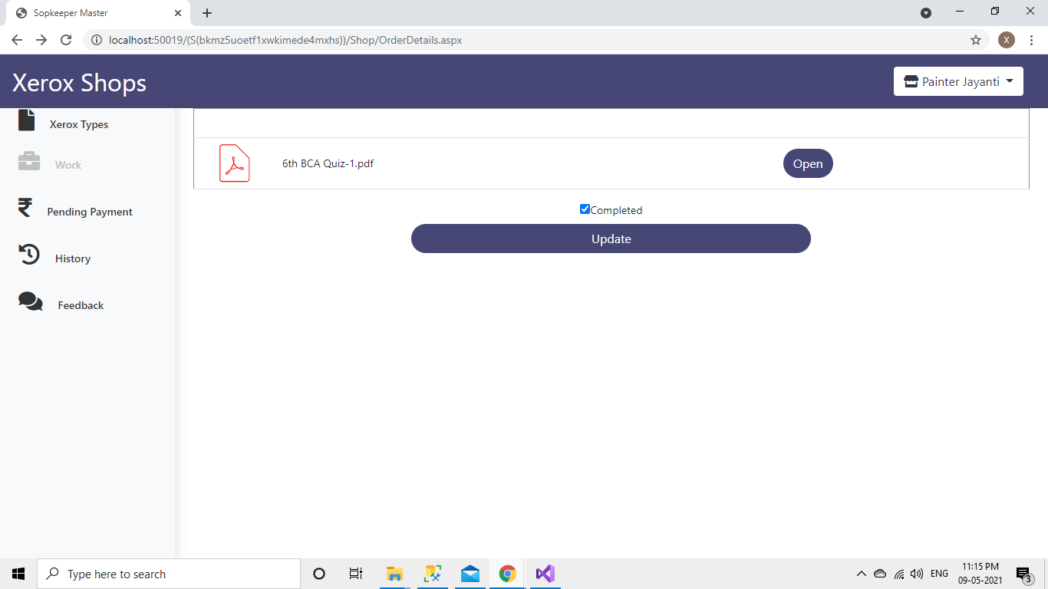

1. **Pending Payments  
     
   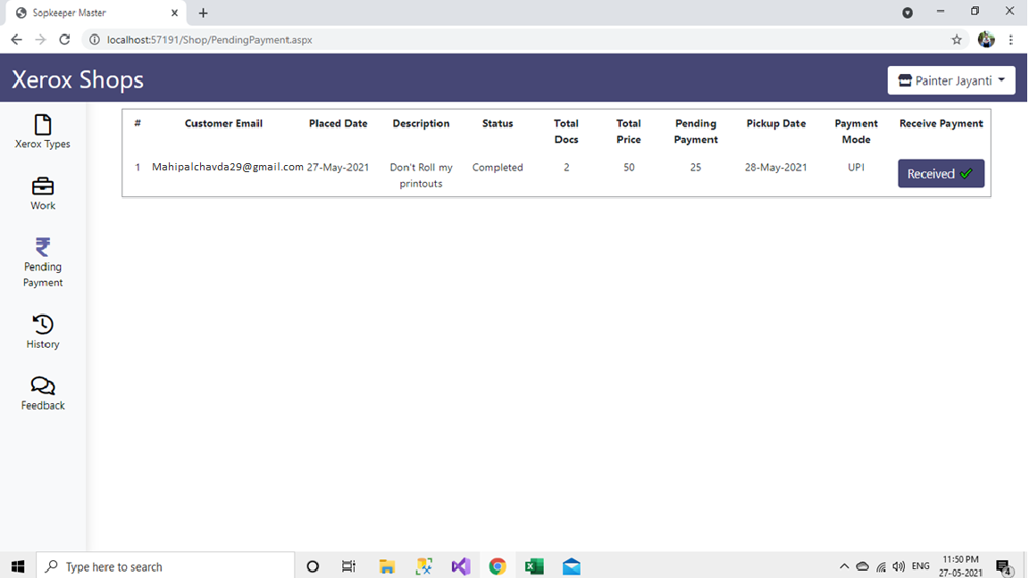**
2. **History page for shopkeepers  
     
   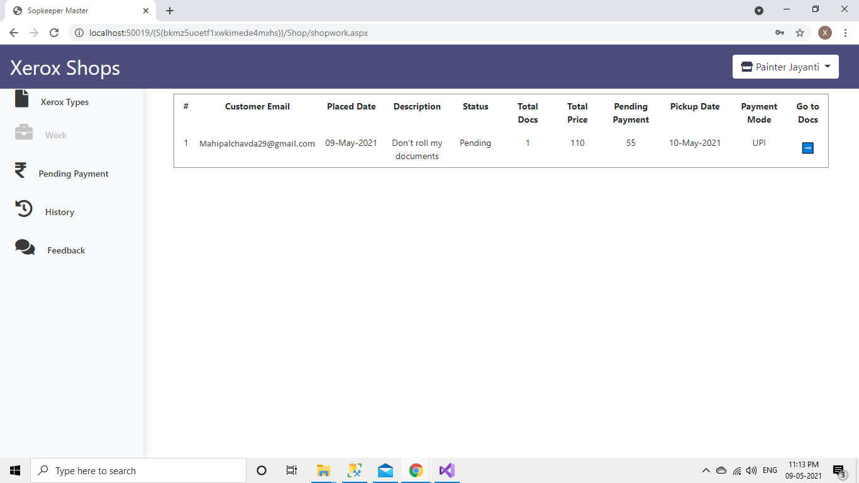**
3. 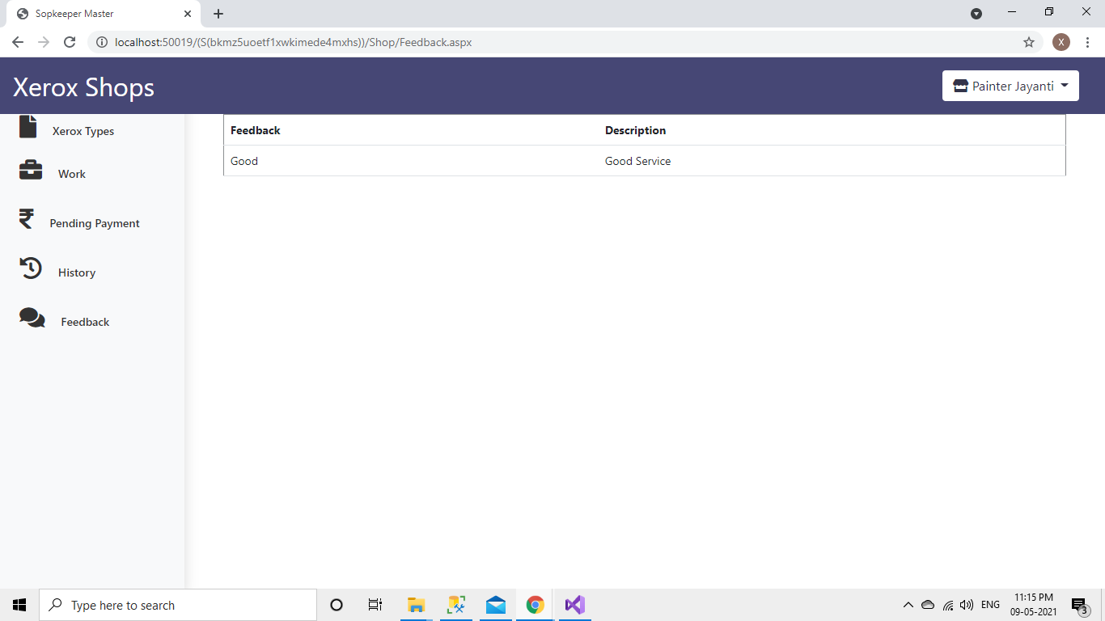**Feedback Received Page**
4. 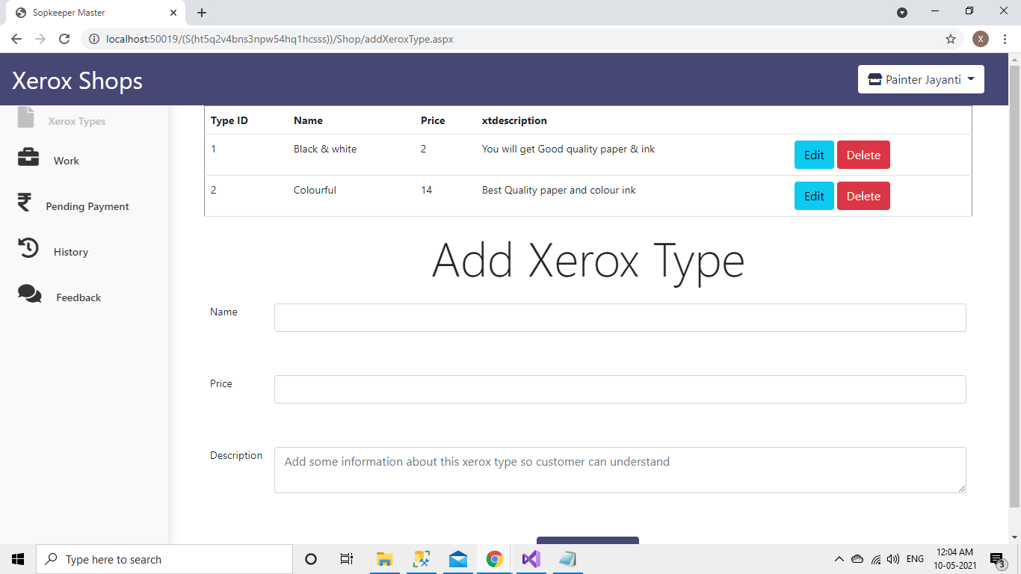**After Adding Xero Types**
5. **Order Received**

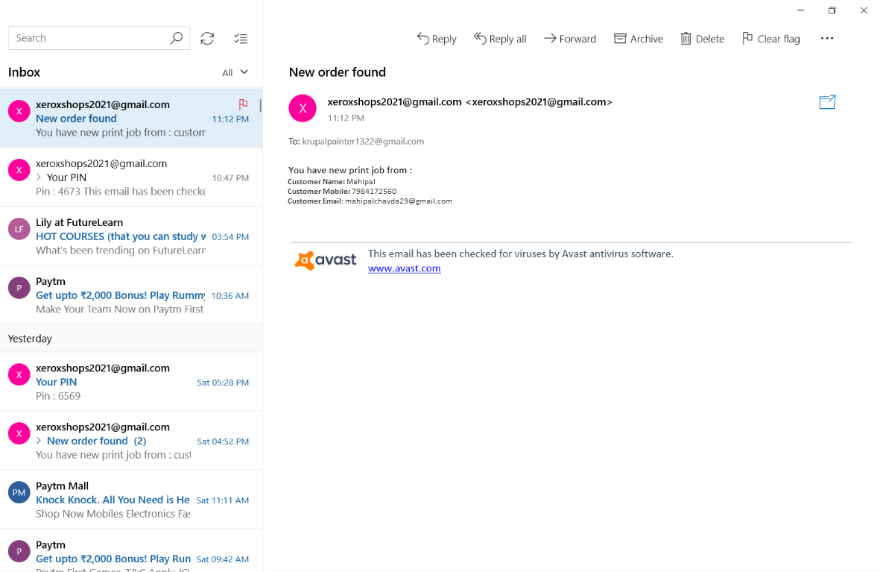

**6.3 Reports:**

* + Shops Report (Customer): Customer can check the shops status by seeing the rating to particular shop.
  + Feedback Report (Shopkeeper): Shopkeeper can check feedbacks that are given by customers. So, shopkeeper can decide how to improve.
  + Orders Report (Shopkeeper): Shopkeeper can check orders by date so shopkeeper will know how much papers & inks and other stuff they have to add in their shop.
  + History Report (Customer): Customer can check their History (Transactions) so he/she can check that how much they are spending for printout work.
  + Xerox Types (Report) (Shopkeeper): Shopkeeper can check the Xerox Types so shopkeeper will know which types of xeroxes shop is providing.
  + Files Report (Customer): Customer can check & download files that they have placed for printing.

7.System Testing

* **7.1 Testing Strategies:**
  + Unit testing:
    - Unit testing carried out in this application to check that each unit of the application works without error, which was successful.
  + System testing:
    - The entire application is tested to check that the application meets the requirements which is mentioned in this document, which was successful.
  + Integrating testing:
    - This testing check that each program module is connected with the respective actor, which was successful,

**7.2 Test Cases:**

* Customer & Shop side test cases

|  |  |  |  |  |  |
| --- | --- | --- | --- | --- | --- |
| Index | Field | Actual value | Expected outcome | Actual outcome | Remarks |
| 1 | Name | - | It should generate error message | It has been generated an error | Successful |
| 2 | Name | ‘Mahipal’  &  ‘Painter Jayanti’ | Checks the length and registered successfully | Allowed to register | Successful |
| 3 | Mobile Number | 1234 | It should generate error message | It has been generated an error | Successful |
| 4 | Mobile Number | 8141227852 | Checks the length and registered successfully | Allowed to register | Successful |
| 5 | Address | - | It should generate error message | It has been generated an error | Successful |
| 6 | Address | ‘B2, Tulsi park society opp vishram gruh’ | Checks the length and registered successfully | Allowed to register | Successful |
| 7 | Email | ‘Mahipal’ | It should generate error message | It has been generated an error | Successful |
| 8 | Email | ‘Mahipalchavda29@gmail.com’ | Checks the email and registered successfully | Allowed to register | Successful |
| 9 | Password | ‘R8141’ | It should generate error message | It has been generated an error | Successful |
| 10 | Password | ‘Mahipal@27’ | Checks the password and registered successfully | Allowed to register | Successful |
| 11 | Conform Password | - && ‘Rut8080’ | It should generate error message | It has been generated an error | Successful |
| 12 | Conform Password | ‘Mahipal@27’’ | Checks the password and registered successfully | Allowed to register | Successful |
| 13 | City | Not Selected | It should generate error message | It has been generated an error | Successful |
| 14 | City | Selected ‘Anand’ | No error will be displayed | Allowed to register | Successful |
| 15 | Shop Timing | - | It should generate error message | It has been generated an error | Successful |
| 16 | Shop Timing | 07:15 AM | No error will be displayed | Allowed to register | Successful |
| 17 | File Upload | File with extension.pptx, .jpeg, .jpg | It should generate error message | It has been generated an error | Successful |
| 18 | File Upload | File with extension .docx, .doc, .pdf | No error will be displayed | Allowed to submit file | Successful |
| 19 | Add More file (Duplicate) | File that is already selected | It should generate error message | It has been generated an error | Successful |
| 20 | Add More File  (Different) | File that is not selected | No error will be displayed | Allowed to submit file | Successful |
| 21 | Pickup date | Pick up date with yesterday date | It should generate error message | It has been generated an error | Successful |
| 22 | Pickup date | Pick up date with Tomorrow date | No error will be displayed | Allowed to submit file | Successful |
| 23 | PIN | Entered pin is NOT same as that in the email | It should generate error message | It has been generated an error | Successful |
| 24 | PIN | Entered pin is same as that in the email | No error will be displayed | Allowed to change password | Successful |
| 25 | Xerox Type Price | Xerox type price less than1 rupee | It should generate error message | It has been generated an error | Successful |
| 26 | Xerox Type Price | Xerox type price more than1 rupee | No error will be displayed | Allowed to change password | Successful |

8.Future enhancement

* **Future Enhancement:**
* Payment gateway
* Proper notifications (Status)
* By paper size pricing
* Add different item other than page
* One file multiple xeroxes
* Permanently Disable Shop

9.bibliography/

references

* Web reference:
* <https://stackoverflow.com/> [For Solution of quires]
* <https://www.c-sharpcorner.com/> [For Solution of quires]
* <https://getbootstrap.com/> [For Designing]
* <https://fontawesome.com/> [For icons]
* <https://www.e-iceblue.com/Introduce/word-for-net-introduce.html#.YKaVLugzbIU> [For Counting Pages]