# Experiment 5

Mahi S. Palimkar 231071036

SY BTech CE Batch B

## What is Open Source? What is the Workflow behind open source projects?

Open-source projects are collaborative software projects where the source code is made publicly available, allowing anyone to view, modify, and distribute it. These projects foster a community-driven development model that encourages transparency, peer review, and collective improvement. Open-source projects span a wide range of applications, from operating systems (e.g., Linux) and web servers (e.g., Apache) to libraries for machine learning, data processing, and more.

#### Key Components of Open-Source Projects

1. **Source Code Accessibility**: The code is accessible to everyone, often hosted on platforms like GitHub, GitLab, or Bitbucket.
2. **Community Contributions**: Contributors, ranging from developers to testers and documenters, can propose changes, fix bugs, and suggest enhancements.
3. **Open Licensing**: Open-source licenses (e.g., MIT, GPL) outline the rules for using, modifying, and distributing the code.
4. **Documentation**: Thorough documentation ensures users understand how to use and contribute to the project.

#### Workflow of Open-Source Projects

1. **Project Initialization**
   * **Defining Scope**: Identify the problem the project will solve or the functionality it will provide.
   * **Selecting a License**: Choose an open-source license that specifies how others can use and contribute to the project.
   * **Setting Up the Repository**: Create a repository on a version control platform, such as GitHub, and upload the initial code, README, and documentation.
2. **Core Development and Maintenance**
   * **Feature Development**: Implement core features and functionalities, aiming for a minimally viable product (MVP) that demonstrates the project's primary use case.
   * **Documentation**: Update documentation for installation, usage, and contribution. Documentation often includes a README, code comments, and, in some cases, wiki pages or dedicated documentation sites.
   * **Creating Issues and Milestones**: Project maintainers outline issues or bugs and define milestones to track progress and organize upcoming features.
   * **Setting Up Testing Pipelines**: Automated tests, CI/CD pipelines, and code quality checks are established to ensure stability as contributions increase.
3. **Community Engagement and Contribution**
   * **Onboarding Contributors**: Define guidelines for contributions (CONTRIBUTING.md) and code of conduct (CODE_OF_CONDUCT.md) to set community expectations.
   * **Assigning Roles**: Maintainers, contributors, and reviewers are assigned specific roles, ensuring efficient code reviews and decision-making.
   * **Communicating through Issues and Pull Requests**: Contributors often start by creating an issue to propose a change or report a bug. Once they’ve implemented a solution, they open a pull request (PR).
   * **Reviewing and Merging Pull Requests**: PRs are reviewed by maintainers or other contributors to verify the code’s quality, adherence to style guidelines, and proper functionality.
   * **Testing and Validation**: Automated tests run for each PR, helping catch issues early. Any bugs or errors are discussed, and the contributor is usually asked to fix them before merging.
4. **Release Management**
   * **Versioning**: Most projects follow a versioning system like semantic versioning (e.g., v1.0.1) to track releases and communicate changes.
   * **Changelog**: A changelog summarizes new features, bug fixes, and updates in each release.
   * **Tagging Releases**: Once the changes are validated, they’re tagged as a release. Documentation and dependencies are updated to reflect the latest stable release.
5. **Ongoing Maintenance and Support**
   * **Bug Fixes and Updates**: Maintainers and contributors address issues reported by the community and regularly update the code to stay compatible with external dependencies.
   * **Community Management**: Building an engaged community around the project is essential. This often involves responding to questions, supporting users, and guiding new contributors.
   * **Periodic Cleanup and Refactoring**: As the project evolves, refactoring code, improving efficiency, and removing obsolete sections help maintain code quality.
6. **Scaling and Expanding the Project**
   * **New Features and Modules**: As the community grows, so do ideas for extending functionality. Contributors often take ownership of specific areas, working on new modules or extensions.
   * **Documentation and Tutorials**: Extensive documentation, tutorials, and sometimes even community forums or chat groups (like on Discord or Slack) support continued adoption.
   * **Sponsorship and Funding**: Some projects seek funding through donations, sponsorships, or platforms like GitHub Sponsors, which can provide resources for sustained development.

#### Tools Commonly Used in Open-Source Project Workflows

* **Version Control Systems**: Git is the most popular choice, managed via platforms like GitHub, GitLab, or Bitbucket.
* **CI/CD Pipelines**: Tools like GitHub Actions, Jenkins, or Travis CI automate testing and deployment.
* **Issue Trackers**: Integrated with version control platforms, these allow for organized issue management, labeling, and assigning.
* **Discussion Boards/Forums**: Platforms like Discourse or Reddit, and real-time chat on Slack, Discord, or Gitter, facilitate communication within the community.

#### Benefits and Challenges of Open-Source Development

* **Benefits**: Transparency, collaboration, cost savings, peer review, flexibility, and community-driven innovation.
* **Challenges**: Coordinating contributions, handling conflicts, ensuring code quality, managing community expectations, and sustaining long-term maintenance.

Open-source projects are a collaborative approach that embodies the spirit of community innovation, providing a robust, transparent, and scalable framework for software development.

## My Contributions

I contributed in several open source projects and repositories recently.

### I also completed hacktoberfest, which is a month long celebration of all things open source where you have to make 4 successful Prs in repos tagged hacktoberfest and also get them merged.

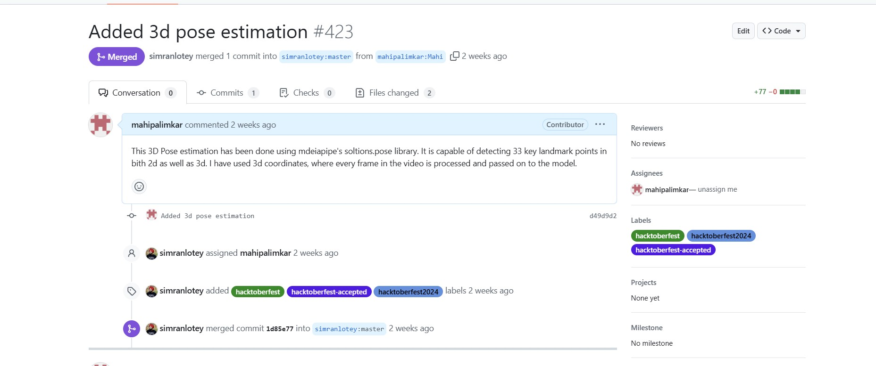**1st Contribution**

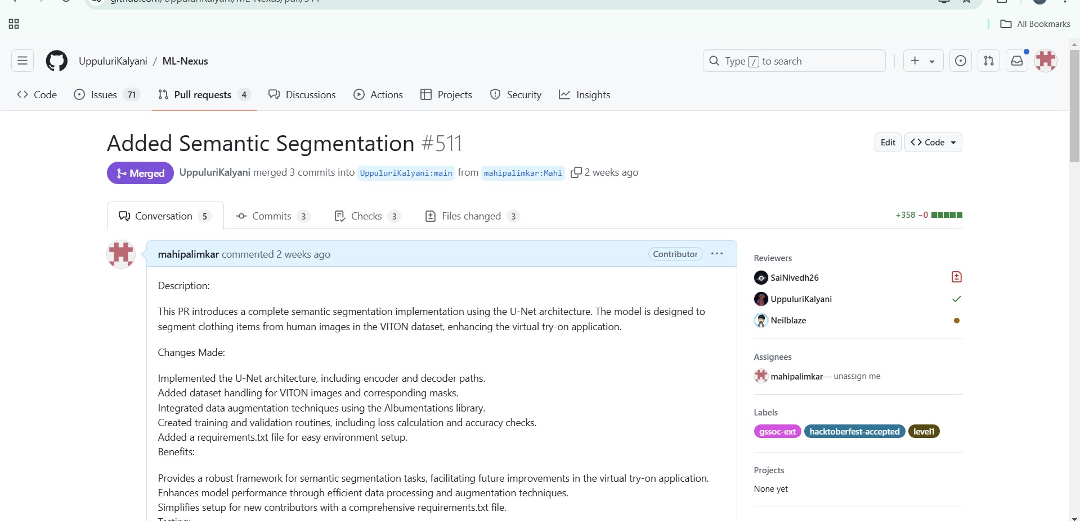**2nd contribution**

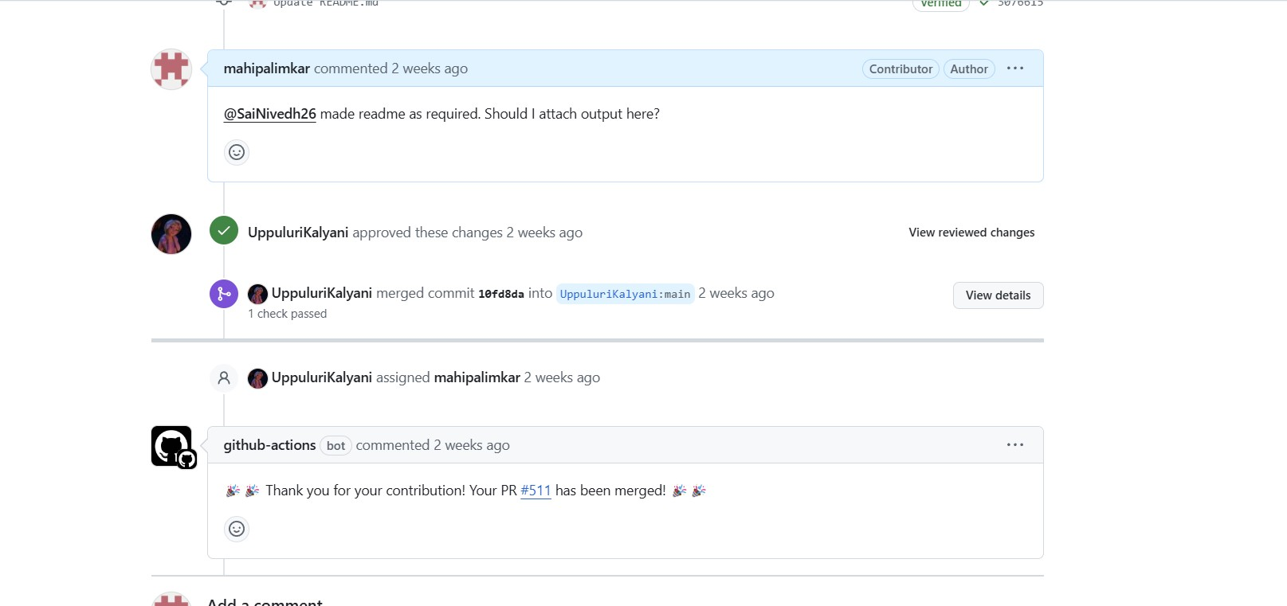

### 3rd Contribution

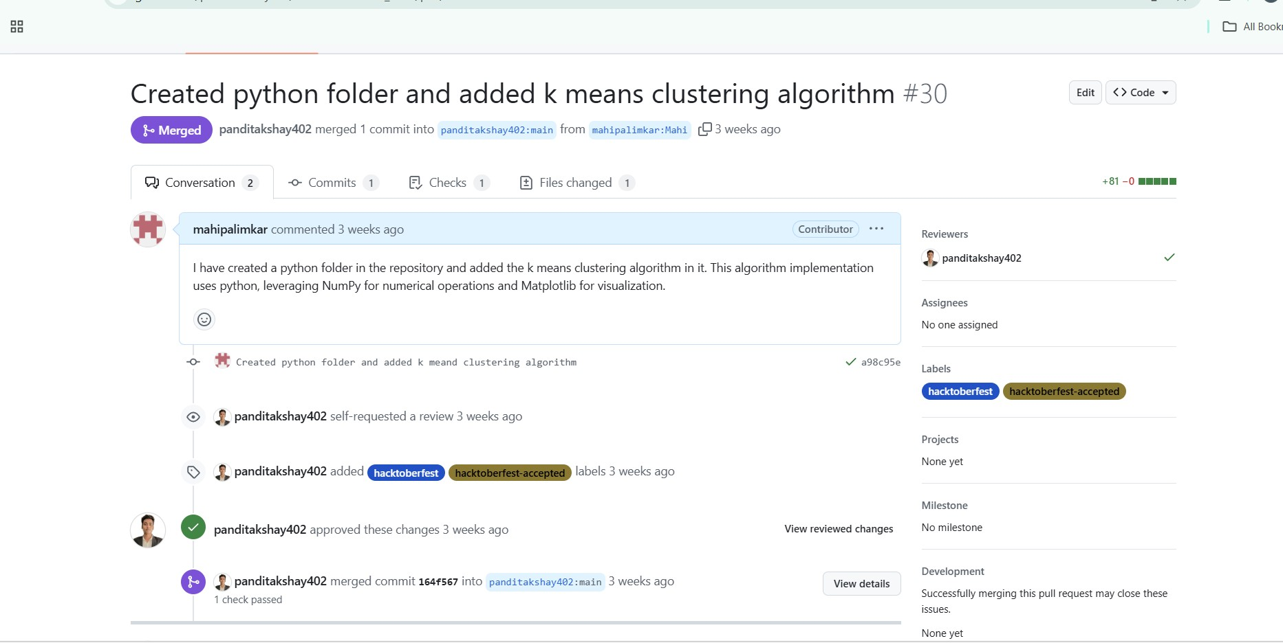**4th Contribution**

# Case Study of Successful Open source softwares

OST LAB ASSIGNMENT

Case study of a successful open source software Mahi S. Palimkar

231071036

SY BTech CE Batch B

**Brief Introduction to Open Source**

**Open source** refers to software whose source code is freely available for

anyone to view, modify, and distribute. This model promotes collaboration, transparency, and innovation. Developers from around the world can contribute to the improvement and development of open-source software, allowing the software to evolve rapidly and cater to a wide variety of needs.

Open-source projects are typically managed by communities, which can consist of individuals, organizations, or a combination of both. Unlike proprietary software, which is controlled by a single entity, open-source projects thrive on community contributions and collective decision-making.

#### Examples of Popular Open-Source Applications

1. **Linux**: An open-source operating system that powers everything from personal computers to enterprise servers and mobile devices.
2. **Apache HTTP Server**: One of the most popular open-source web servers used to host websites on the internet.
3. **Mozilla Firefox**: A widely used open-source web browser.
4. **VLC Media Player**: An open-source, cross-platform multimedia player that supports various audio and video formats.
5. **LibreOffice**: An open-source office suite that provides similar functionality to Microsoft Office, including word processing, spreadsheets, and presentations.
6. **WordPress**: An open-source content management system (CMS) used by millions of websites.
7. **GIMP**: An open-source image editing software comparable to Photoshop.

**Why I Chose Python for the Case Study**

Python was chosen as a case study for open-source success for several

reasons:

1. **Widely Adopted**: Python has become one of the most popular and widely adopted programming languages across industries, including technology, finance, education, healthcare, and research.
2. **Community-Driven Development**: Python’s development and evolution are driven by its global open-source community. Contributions from thousands of developers, educators, and organizations have helped it grow rapidly while maintaining high standards of code quality and readability.
3. **Versatility**: Python’s ability to support multiple programming paradigms (object-oriented, procedural, and functional programming) and its extensive library ecosystem make it ideal for a wide range of applications, from web development and automation to data science and machine learning.
4. **Beginner-Friendly**: Python’s clear and easy-to-read syntax makes it a popular choice for beginners learning to program, as well as for educational institutions teaching computer science.
5. **Impact on Emerging Fields**: Python has played a significant role in the growth of cutting-edge fields such as **data science**, **artificial intelligence**, and **machine learning**. Libraries like TensorFlow, PyTorch, and Scikit-learn are built on Python and are crucial tools in modern AI and data-driven industries.
6. **Open Source Leadership**: As an open-source project governed by the **Python Software Foundation (PSF)**, Python sets a strong example of how collaborative and community-driven efforts can result in the development of software that is both robust and widely supported.

**Python as a Successful Open-Source Story**

Python, one of the most popular programming languages in the world, is a

remarkable success story in the open-source software community. From its inception in the late 1980s to its widespread adoption across industries and academic fields today, Python’s journey highlights the power of open-source development, collaborative communities, and adaptability to modern technology needs.

**1. Background and History of Python**

**Python** was created in the late 1980s by **Guido van Rossum**, a Dutch

programmer, while working at Centrum Wiskunde & Informatica (CWI) in the Netherlands. Guido sought to design a language that would be easy to read and write while also being powerful enough to handle a wide range of tasks. The idea was to build a language that bridged the gap between simplicity (for learners) and sophistication (for professionals).

* **First Release (Python 1.0)**: Python was first released publicly in **1991** as version 1.0. Right from its inception, Python was distributed under an open-source license, allowing anyone to view, modify, and redistribute the code.
* **Python Software Foundation (PSF)**: In 2001, the **Python Software Foundation (PSF)** was established to manage the ongoing development and promotion of Python. The PSF maintains Python’s open-source license and plays a crucial role in guiding the language's evolution, including governance, documentation, and supporting the broader Python ecosystem.

**2. Why Python Thrived as an Open-Source Language**

#### Community-Driven Development

One of the defining features of Python's growth has been its active and diverse **community**. The Python community consists of developers, educators, researchers, students, and businesses from all over the world who

collaborate to improve the language, build new tools, and ensure that Python continues to evolve to meet modern needs.

* + **Python Enhancement Proposals (PEPs)**: Python’s development is guided by **PEPs (Python Enhancement Proposals)**. These proposals suggest new features, improvements, or changes to the language. PEPs are open to discussion and revision by the community. One of the most famous PEPs is **PEP 8**, which establishes the coding style guidelines that developers should follow when writing Python code.
  + **Inclusive Governance**: Python has a unique form of governance in which the **Benevolent Dictator For Life (BDFL)**—Guido van Rossum—had the final say on important decisions. However, in 2018, Guido stepped down as BDFL, and Python transitioned to a more democratic governance model, with the **Python Steering Council** overseeing its development.
  + **Diverse Contributions**: Contributions come from individuals, companies, and organizations globally. Developers contribute code, libraries, documentation, tutorials, and more. The open nature of the project has fostered innovation, with contributions from both large companies like Google and small individual developers.

#### Versatility and Flexibility

Python’s versatility is one of the key reasons for its widespread adoption across different industries.

* + **General-Purpose Language**: Python is a **general-purpose programming language**, meaning it can be used for almost anything, from web development to scientific research. Its ability to handle both simple scripts and large-scale applications makes it suitable for various use cases, such as:
    - **Web development**: Python is used in web frameworks like

**Django** and **Flask**.

* + - **Data science**: Python has become the go-to language for data science, with libraries like **pandas**, **NumPy**, and **SciPy**.
    - **Machine learning and AI**: Python powers many machine learning projects, thanks to libraries like **TensorFlow**, **PyTorch**, and **Scikit-learn**.
    - **Automation and scripting**: Python is commonly used for writing scripts that automate repetitive tasks.
    - **Game development**: Game development frameworks like

**Pygame** allow developers to build 2D games using Python.

* + **Cross-Platform Support**: Python runs on a wide variety of operating systems, including **Windows**, **macOS**, and **Linux**, ensuring that it is accessible to developers regardless of their environment.
  + **Rich Ecosystem of Libraries and Frameworks**: Python’s open-source package index, **PyPI**, contains over 400,000 packages that extend the language’s functionality. These libraries enable Python to be used in virtually every field, from web scraping to data visualization and from bioinformatics to AI research.

#### Beginner-Friendly Syntax and Readability

Python’s simple and readable syntax makes it particularly beginner-friendly. Its philosophy emphasizes **readability** and **clarity**, allowing developers to write clean and concise code.

* + **Syntax Design**: Python’s design is often described as "executable pseudocode," meaning that it is close enough to plain English that even beginners can understand what the code does. For example, Python eliminates the need for semicolons or braces, and relies on indentation to define code blocks, making it cleaner and more intuitive.
  + **First Programming Language**: Python’s ease of learning has made it the go-to language for teaching programming in schools, universities, and coding bootcamps. Platforms like **Codecademy**, **Coursera**, and **edX** offer introductory courses in Python due to its simplicity.

#### Industry Adoption

Python’s open-source nature, combined with its flexibility, has led to widespread adoption across a range of industries. From tech giants to startups, Python is used by some of the most innovative companies in the world.

* + **Tech Companies**: Companies like **Google**, **Facebook**, **Instagram**, **Dropbox**, **Spotify**, and **Netflix** rely heavily on Python for their backend development, automation, and data science needs. For example, YouTube is largely written in Python.
  + **Data Science and AI**: Python has become the standard language in the world of **data science**, **machine learning**, and **artificial intelligence**. Popular ML and AI libraries, such as **TensorFlow**, **Keras**, and **PyTorch**,

are all built using Python, making it the go-to language for AI research and development.

* + **Scientific Computing**: Python is used extensively in the academic and research communities, especially for **scientific computing** and **data analysis**. Libraries like **SciPy**, **Matplotlib**, and **Jupyter Notebooks** are used in fields like astronomy, biology, physics, and more.

**3. The Role of the Python Software Foundation (PSF)**

The **Python Software Foundation (PSF)**, formed in 2001, is a non-profit

organization that manages the open-source licensing for Python and supports the development of the language. The PSF plays a crucial role in maintaining Python’s status as free and open-source, as well as promoting its use in education, research, and industry.

* + **Funding**: The PSF provides grants to Python projects and supports events like **PyCon**, a global conference for Python developers. The PSF also ensures that Python remains freely available to everyone and that its license remains compatible with open-source standards.
  + **Community Building**: The PSF helps foster the global Python community by organizing events, promoting inclusion and diversity in the tech world, and encouraging collaboration across different sectors.

**4. Challenges and Solutions**

Python’s journey has not been without challenges, but its open-source nature

has allowed it to continuously adapt and improve.

#### Performance Issues

Python has faced criticism for its relatively slower performance compared to languages like C++ or Java. This is primarily due to its interpreted nature and the presence of the **Global Interpreter Lock (GIL)**, which limits

multi-threading in CPU-bound applications.

* + **Solutions**: The Python community has developed several performance-enhancing solutions, such as:
    - **CPython**: The default and most widely used implementation of Python, which includes many optimizations.
    - **PyPy**: A fast, compliant alternative to CPython, using just-in-time (JIT) compilation to speed up execution.
    - **Cython**: A compiler that converts Python code into C, allowing for significant performance improvements.

#### Concurrency and Scalability

Python’s **GIL** limits true parallelism, especially for CPU-bound tasks. However, this issue is mitigated in I/O-bound applications through Python’s **asyncio** library and the use of multiprocessing.

* + **Concurrency Libraries**: Python offers libraries like **asyncio** and **multiprocessing**, which help with concurrency and parallelism in Python applications.

**5. Global Impact of Python as Open Source**

Python has not only become a dominant force in software development but

has also made a significant impact on the world at large:

* + **Education**: Python is now one of the first languages taught in many computer science programs worldwide. Its accessibility and simplicity make it an ideal language for beginners, ensuring that the next generation of developers starts their journey with Python.
  + **Job Market**: Python’s popularity has led to high demand for Python developers. Many companies, including some of the largest tech companies in the world, are constantly hiring Python experts. Python ranks highly on surveys like Stack Overflow’s **Most Loved Programming Languages**, and is frequently among the top programming languages in job postings.
  + **Open Science and Research**: Python’s role in scientific research cannot be understated. Tools like **Jupyter Notebooks** allow scientists to create reproducible research and share their work with others in an interactive format.
  + **Supporting Startups and Enterprises**: Python's flexibility, ease of integration, and rapid development cycle have made it a favorite among startups and enterprises alike. Many businesses use Python for prototyping and quickly scaling their applications.

**6. Conclusion: Python’s Open-Source Success Story**

Python’s journey from a hobby project to a globally dominant programming language is a testament to the power of **open-source development**. By embracing transparency, collaboration, and community-driven growth, Python has become a versatile, widely adopted language that powers some of the most advanced technological innovations in the world today.

Its thriving community, strong governance through the **Python Software Foundation**, and ability to adapt to modern computing challenges make Python one of the most successful open-source projects ever created.

Whether it’s helping beginners learn to code, supporting cutting-edge research, or driving the development of AI, Python stands as a shining example of what can be achieved through open collaboration and the free exchange of ideas.

Python’s open-source success story continues to inspire developers and organizations around the world and will likely remain a cornerstone of software development for years to come.