**PRACTICAL: 3**

**AIM:**

Create a React page that displays a Welcome message with the current local date and time which changes every second. Use the React JSX concept.

Note: Use the setInterval function to update the time.

**THEORY:**

In React, we use **JSX** to display dynamic content like the current date and time. The **useState** hook stores the time, and **useEffect** sets up a **setInterval** to update it every second. This causes the component to re-render with the new time, creating a real-time clock. The **Date** object provides local date and time formatting.

**CODE:**

|  |
| --- |
| **App.js**  import React, { useState, useEffect } from 'react';  function App() {    const [currentTime, setCurrentTime] = useState(new Date());    useEffect(() => {      const timer = setInterval(() => {        setCurrentTime(new Date());      }, 1000);      // Cleanup interval on unmount      return () => clearInterval(timer);    }, []);    return (      <div style={styles.container}>        <h1>Welcome to CHARUSAT!!!!</h1>        <h2>It is {currentTime.toLocaleDateString()}</h2>        <h2>It is {currentTime.toLocaleTimeString()}</h2>      </div>    );  }  const styles = {    container: {      fontFamily: 'Arial',      textAlign: 'center',      marginTop: '100px',    },    time: {      fontSize: '23px',      color: '#333',    }  };  export default App;  **App.css**  .App {    text-align: center;  }  .App-logo {    height: 40vmin;    pointer-events: none;  }  @media (prefers-reduced-motion: no-preference) {    .App-logo {      animation: App-logo-spin infinite 20s linear;    }  }  .App-header {    background-color: #282c34;    min-height: 100vh;    display: flex;    flex-direction: column;    align-items: center;    justify-content: center;    font-size: calc(10px + 2vmin);    color: white;  }  .App-link {    color: #61dafb;  }  @keyframes App-logo-spin {    from {      transform: rotate(0deg);    }    to {      transform: rotate(360deg);    }  } |

**OUTPUT:**

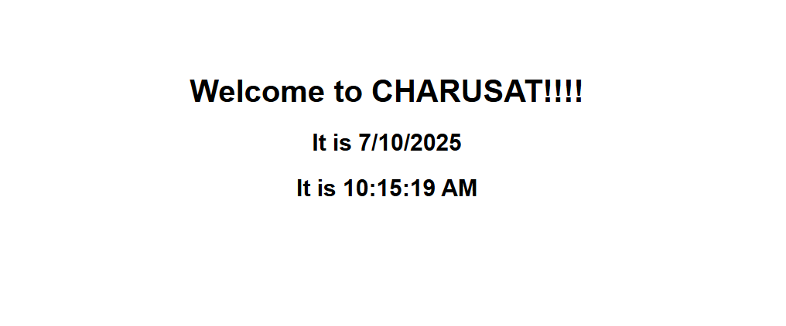

This project is a simple React application that displays a Welcome message along with the current local date and time, which updates automatically every second. It uses JSX for UI rendering, useState to manage time state, and setInterval within useEffect to refresh the time dynamically. The goal is to demonstrate real-time updates in a React component using modern React hooks. This project helps understand core React concepts like state management, lifecycle methods, and handling time-based updates.

**LATEST APPLICATIONS:**

* Dashboard Interfaces – Displays current time to align real-time data logs and user activities.
* Online Booking Systems – Validates and restricts user actions based on live date and time.
* Productivity Tools – Helps users manage tasks and timers with real-time tracking.
* Attendance or Check-in Apps – Records accurate check-in time for users or employees.

**LEARNING OUTCOME:**

* Understand how to use **JSX** to render dynamic content in React.
* Learn to manage state using the **useState** hook.
* Apply **useEffect** for handling side effects like timers.
* Implement **setInterval** to update components in real time.
* Gain experience working with **JavaScript Date and Time** functions.

**REFERENCES:**

1. React Official Documentation –  
   <https://reactjs.org/docs/getting-started.html>
2. MDN Web Docs – setInterval() –  
   <https://developer.mozilla.org/en-US/docs/Web/API/setInterval>