E-COMMERCE SALES & CUSTOMER SEGMENTATION
SUMMARY REPORT

Business problem
Identify high-value and at-risk customers using RFM-style features and clustering-based segments (champions, loyalists, hibernators, whales) to drive retention, reactivation, and revenue growth for an online gift-ware retailer with a meaningful wholesale customer base.

Process flow

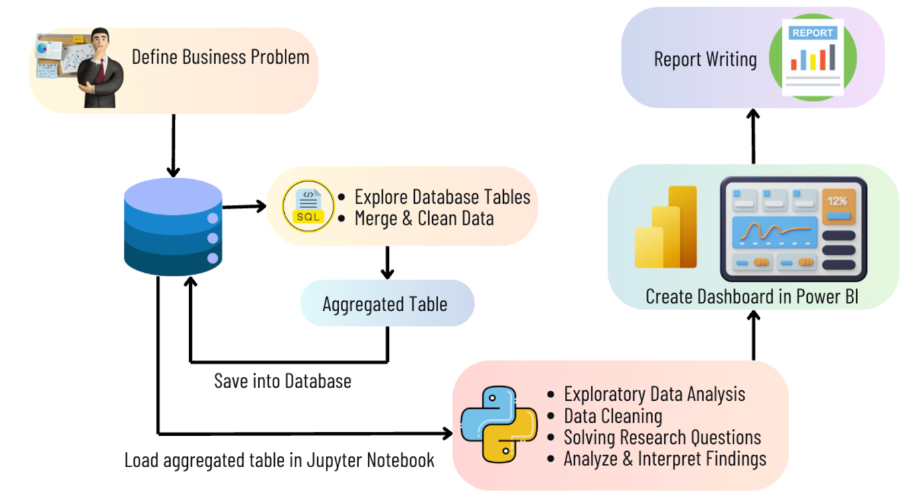

EXPLORATORY DATA ANALYSIS(EDA)

Price vs Quantity Distribution
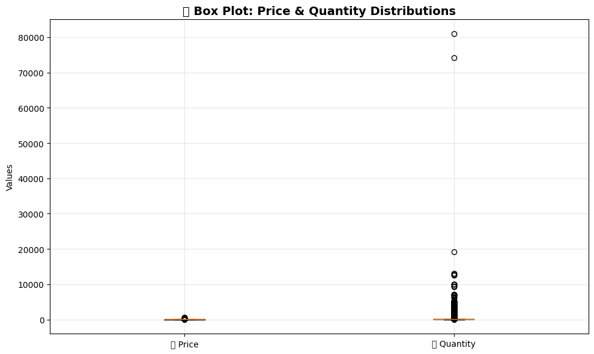

Monthly Unique Sales
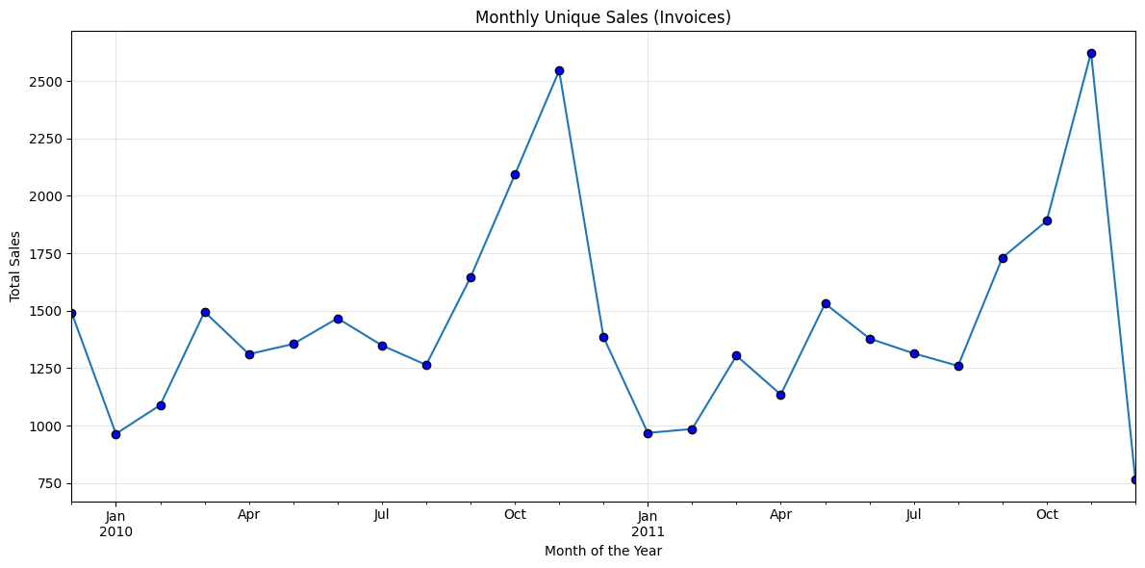

Monthly Active Customers
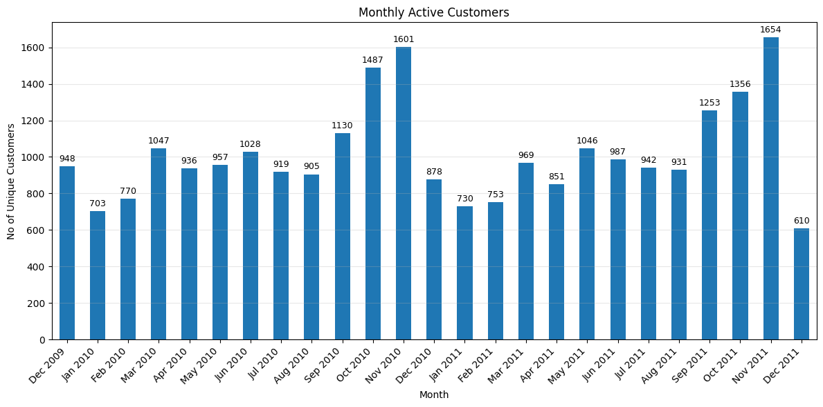

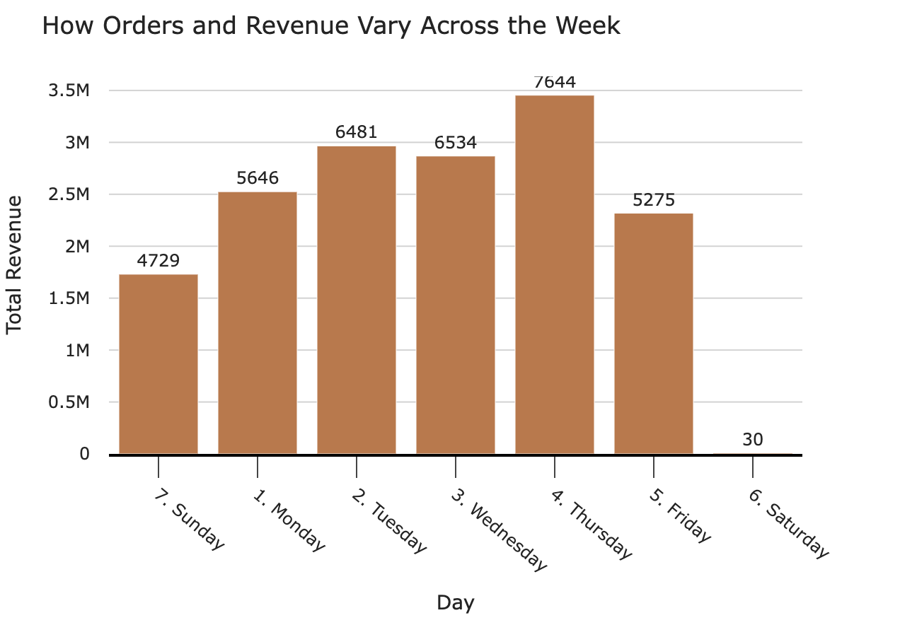


Top Countries by Revenue
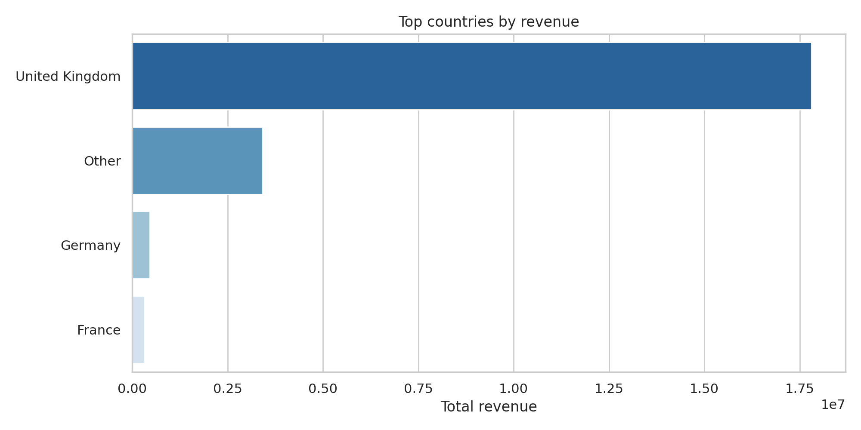

BUSINESS FINDINGS AND KEY INSIGHTS

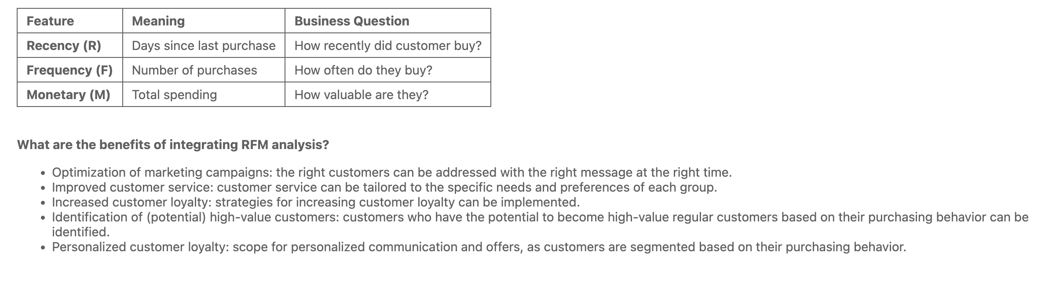
ACTIONABLE INSIGHTS

The analysis reveals clear differences in customer value and activity. Not all customers contribute equally to revenue, so sales and marketing resources should be focused on top customers (champions) and growth segments (occasional buyers), while churn risk customers should be selectively reactivated or deliberately given less attention.

Cluster 0 – Champions / High Value & Loyal Customers

- Very low recency → recently purchased

- Highest purchase frequency

- Highest sales

- Above-average RFM scores

- Key revenue drivers with high customer lifetime value

Business significance

- Highest customer lifetime value

- Most important segment for stability and growth

- Drives a large portion of total revenue

- Low churn risk

Recommended measures

- VIP and loyalty programs

- Exclusive offers & early access

- Focus on customer retention instead of acquisition

- Referral programs

Cluster 1 – Occasional Buyers / Growth Potential

- Medium recency

- Low to medium purchase frequency

- Medium to low sales

- RFM scores close to average

- Can be reactivated with targeted measures

Business significance

- Important growth candidates

- Not yet a core segment, but with potential

- Efficient use of marketing measures possible

- Growth lever for future champions

Recommended measures

- Personalized product recommendations

- Reminder and reactivation campaigns

- Cross-selling and upselling

- Entry into loyalty programs

Cluster 2 – Low Value / Churn Risk Customers

- High recency → no purchase for a long time

- Very low purchase frequency

- Lowest sales

- Below-average RFM scores

- Some were previously good customers

Business significance

- High churn risk

- Low profitability

- Selective approach required

Recommended measures

- Win-back & reactivation campaigns

- Discount campaigns for win-back

- Cost-efficient communication

- In some cases, deliberately not focusing further

📌 Management Takeaways

✔ Customer value highly heterogeneous – segmentation essential

✔ Retention is more profitable than new customer acquisition

✔ Develop growth segments in a targeted manner

✔ Allocate marketing budgets based on data

Overall conclusion
RFM analysis enables data-based segmentation according to customer value and activity:

- Champions secure revenue today
- Occasional buyers offer growth potential
- Churn risk segments require targeted or reduced investment

👉 Strategic recommendation

Prioritize marketing budget on:

1️⃣ Champions (retention & upselling)

2️⃣ Growth segments (activation)

3️⃣ Selective reactivation for churn risk

