NAME : RABARI MAHI ALPESHBHAI
ID NO : 25CE095
CE : DIV 2
BATCH : A2
PRACTICAL 1 :
- A simple C program that displays your name on the screen .
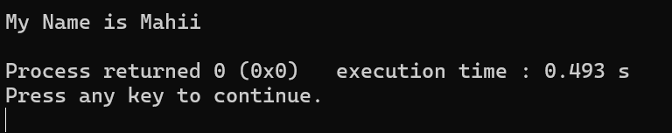
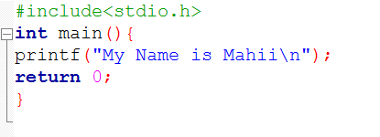
PRACTICAL 2:

- calculate the area and perimeter to finalize blueprint.
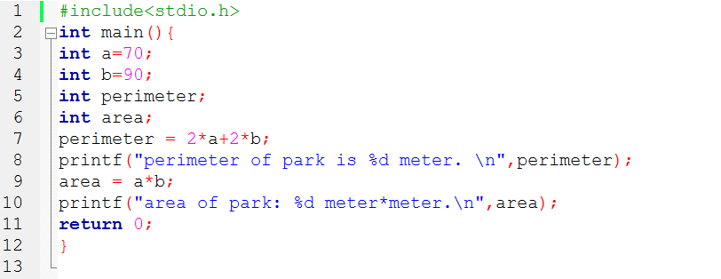
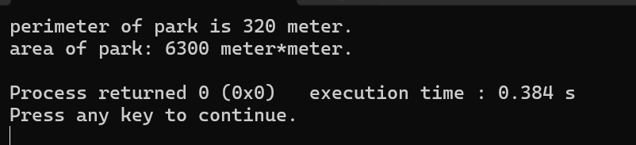
PRACTICAL 3:
- Efficient tool to calculate BMI.
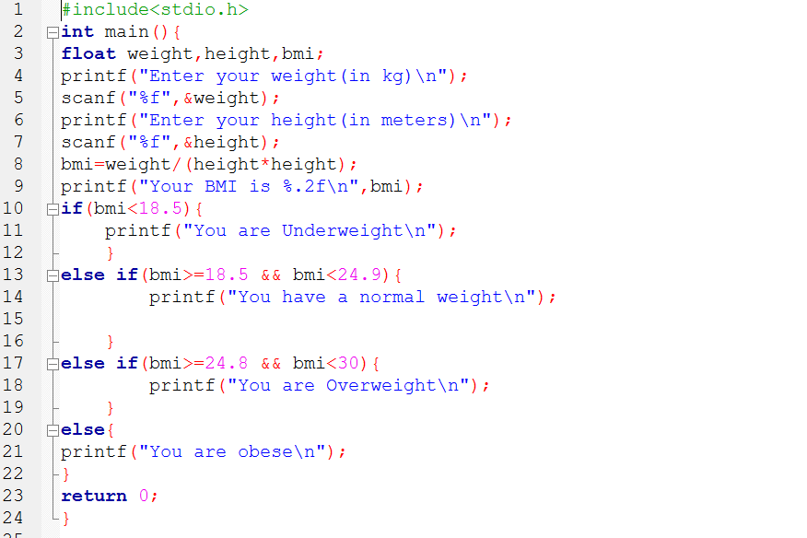
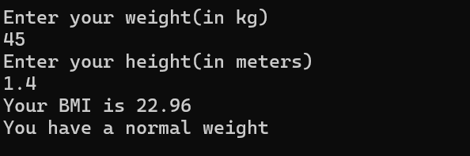
PRACTICAL 4:
- data types and their ranges!
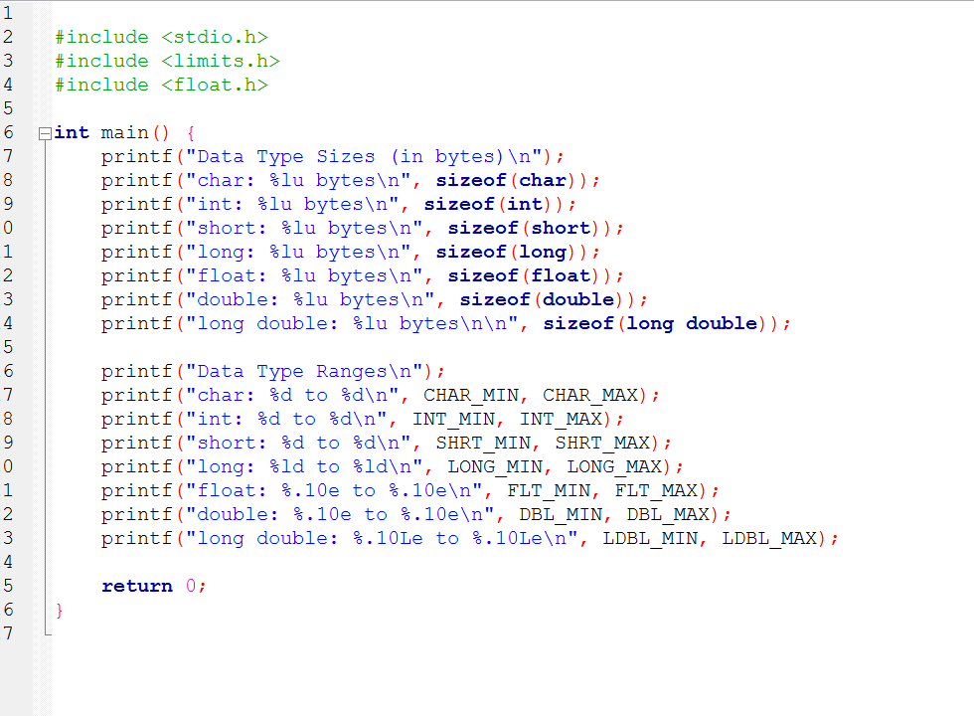
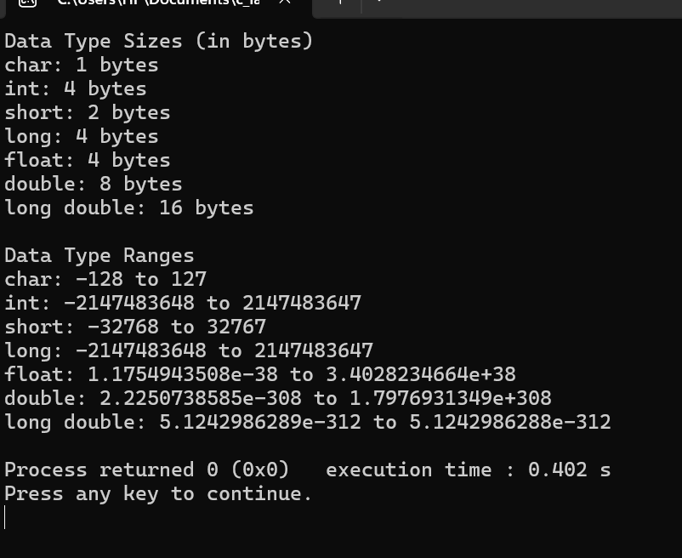
PRACTICAL 5:
- compute the count of illiterate men and women using these statistics.

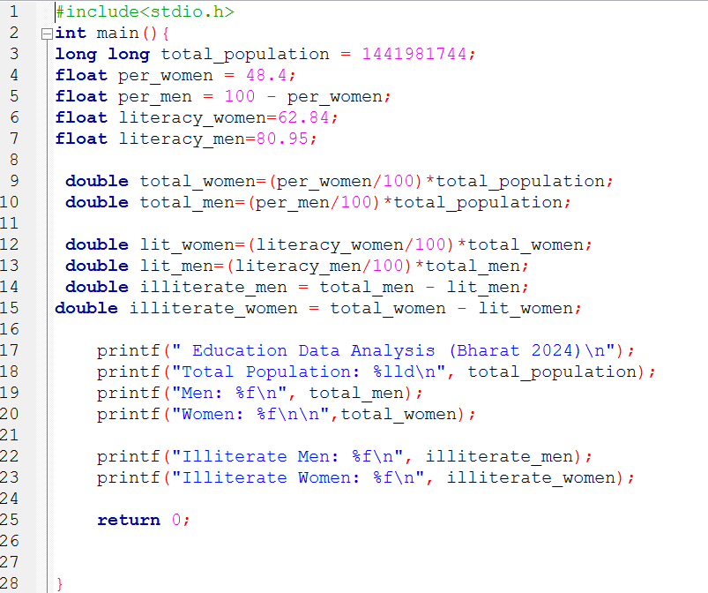
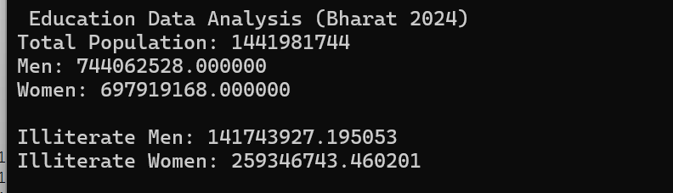
PRACTICAL 6:
- A program to do conversions to Fahrenheit.

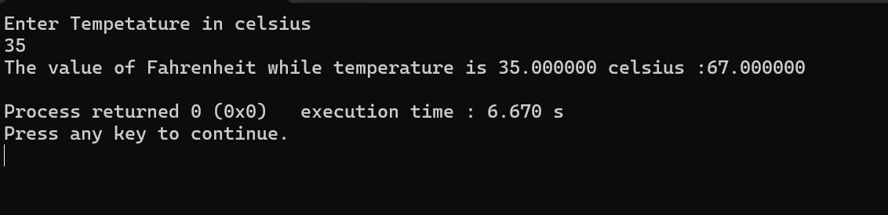
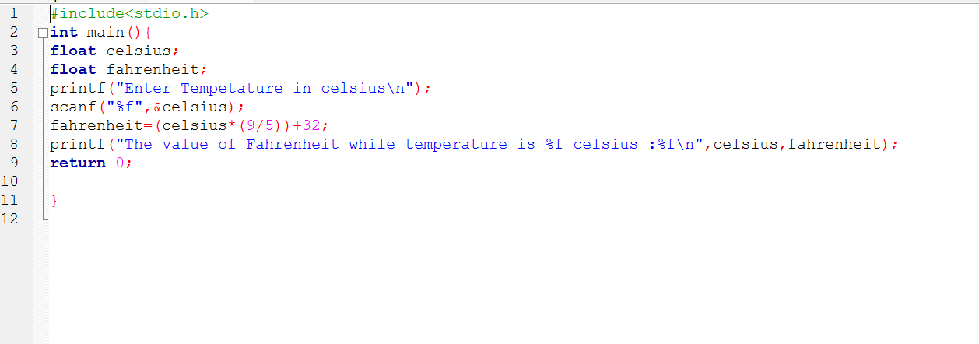
PRACTICAL 7:
- an automated ticketing system to reduce wait times at entry gates. The system needs to decide whether a visitor should be charged for entry or not.
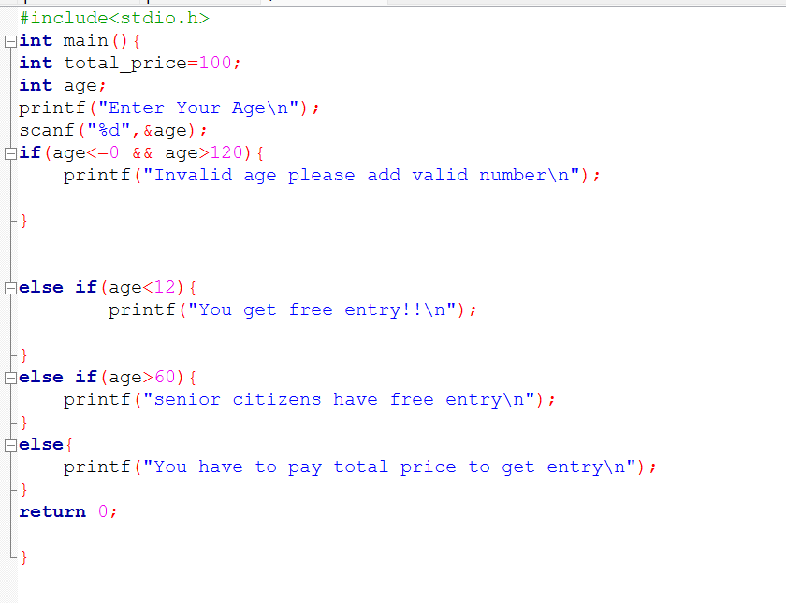
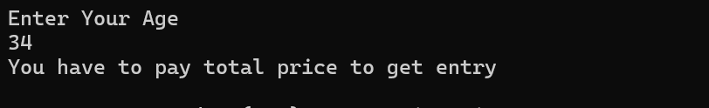
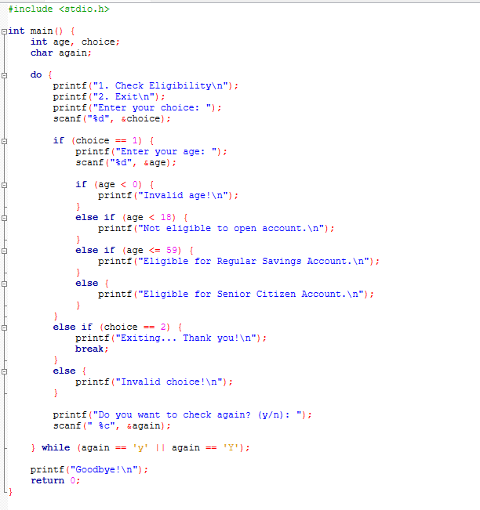
PRACTICAL 8:
- An eligibility checker at their branches.
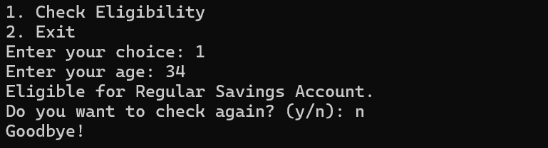

PRACTICAL 9: A budding developer, with designing the logic for the discount system.
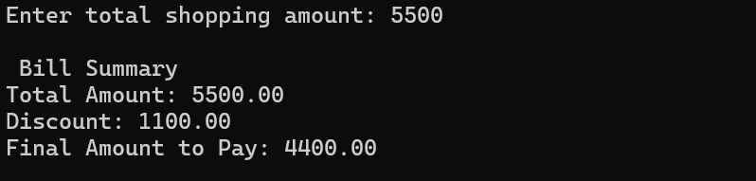
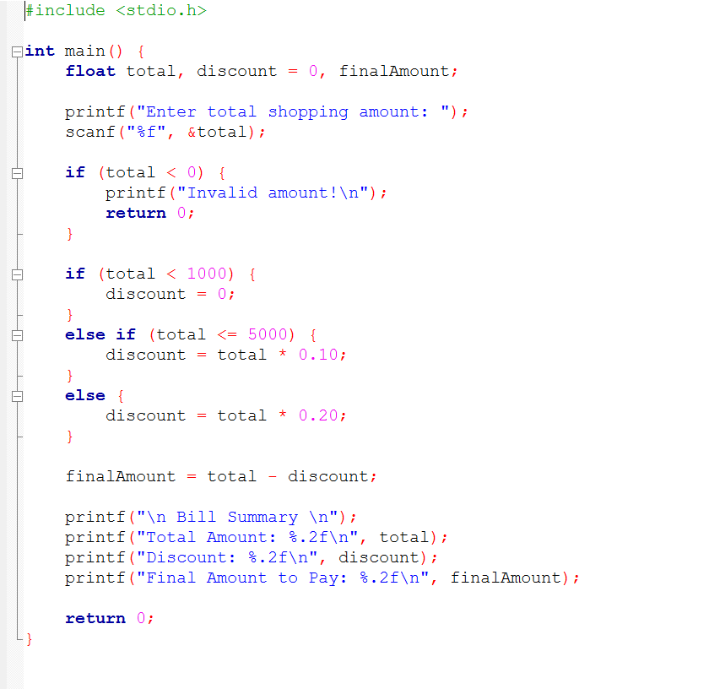
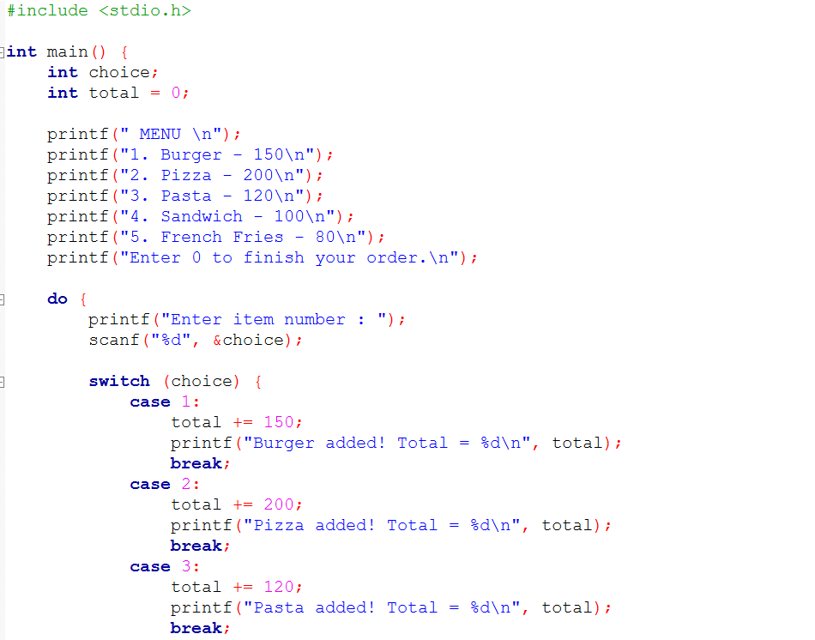
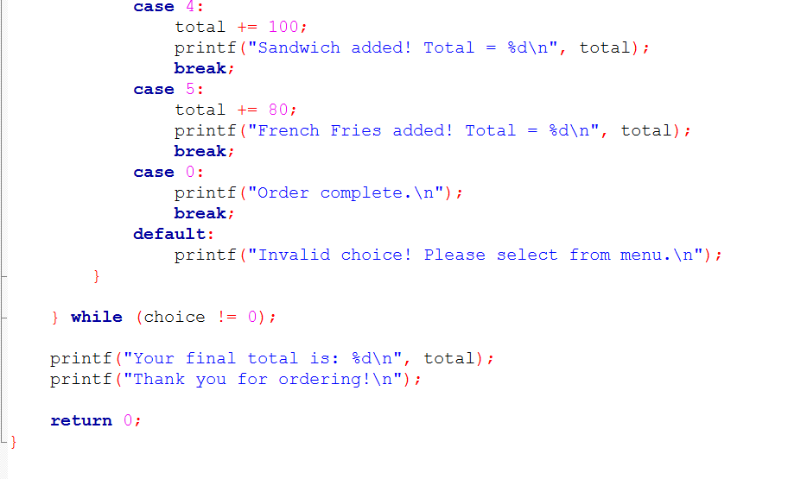
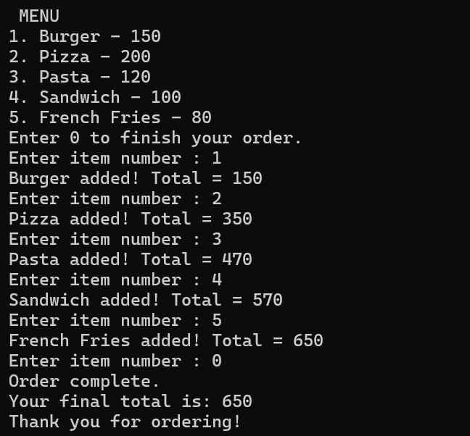
PRACTICAL 10 :
- MENU USING SWITCH CASE
PRACTICAL 11 : Take student’s marks as input and display the corresponding grade as output according to the following criteria:
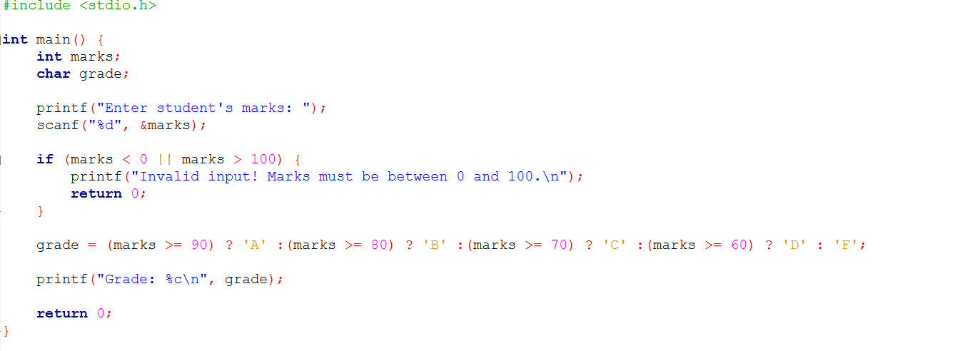
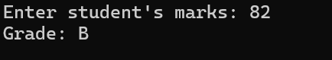
PRACTICAL 12: Displays each book ID on a new line and highlights special editions with a clear note next to their ID.
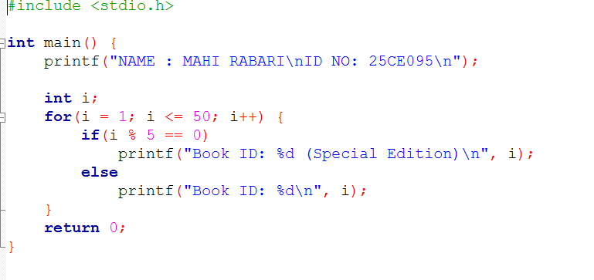
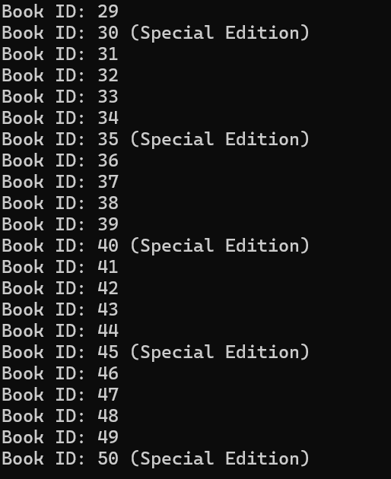
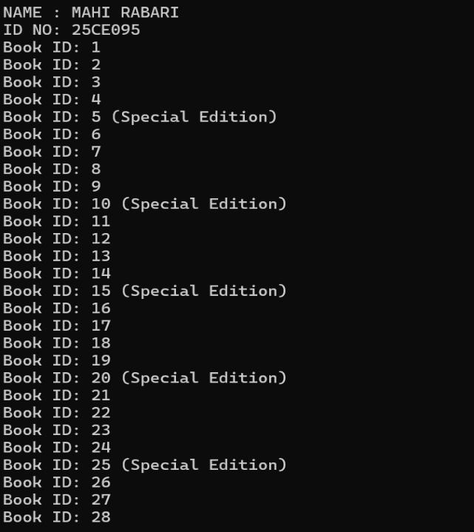
PRACTICAL 13: This system starts refilling an empty tank (initially at 0 liters) until it reaches its maximum capacity of 100 liters.
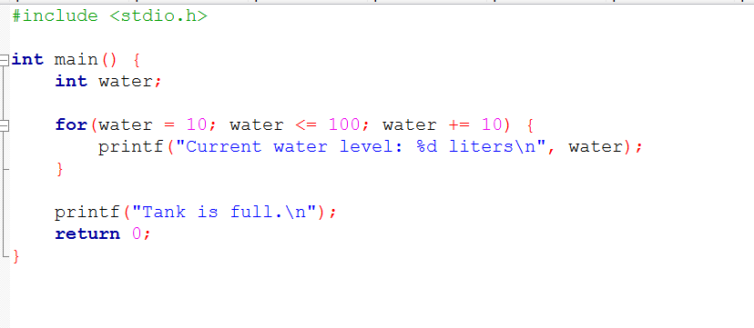
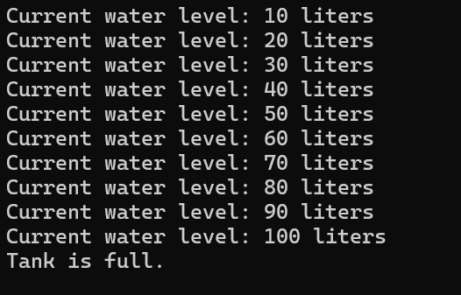
PRACTICAL 14: ATM SYSTEM
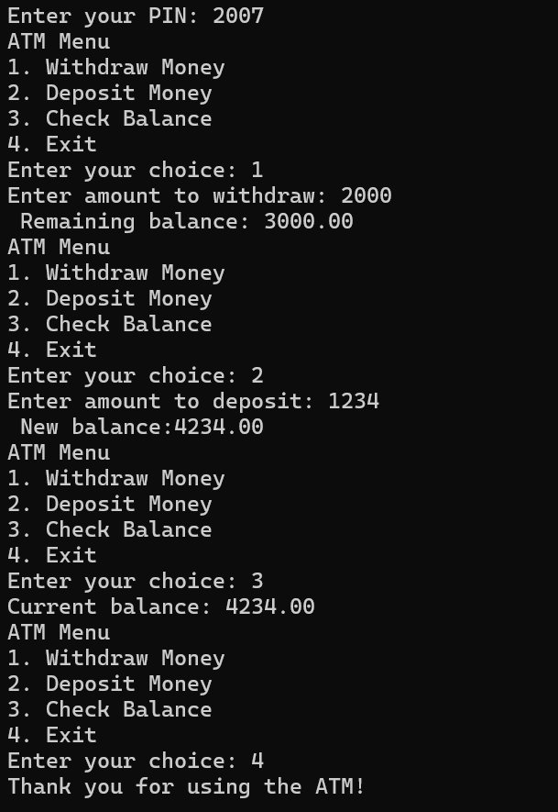
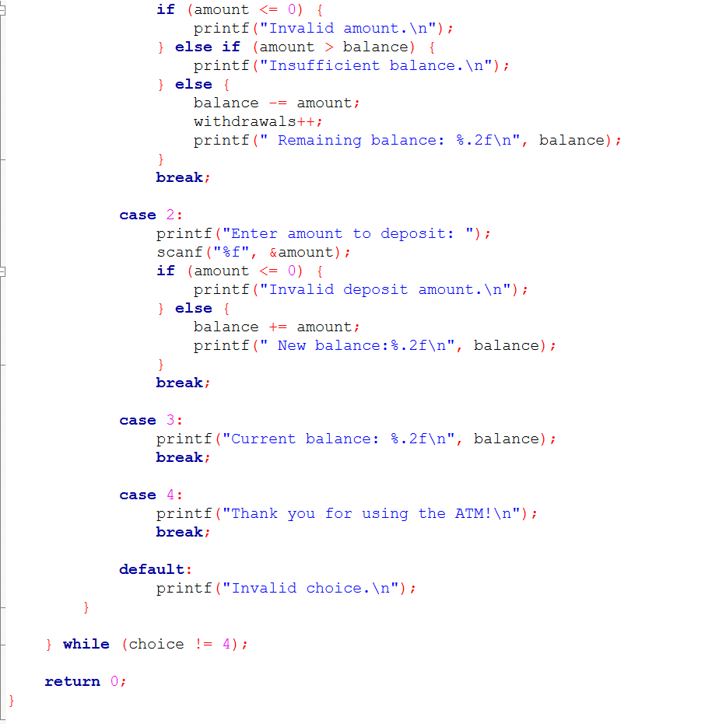
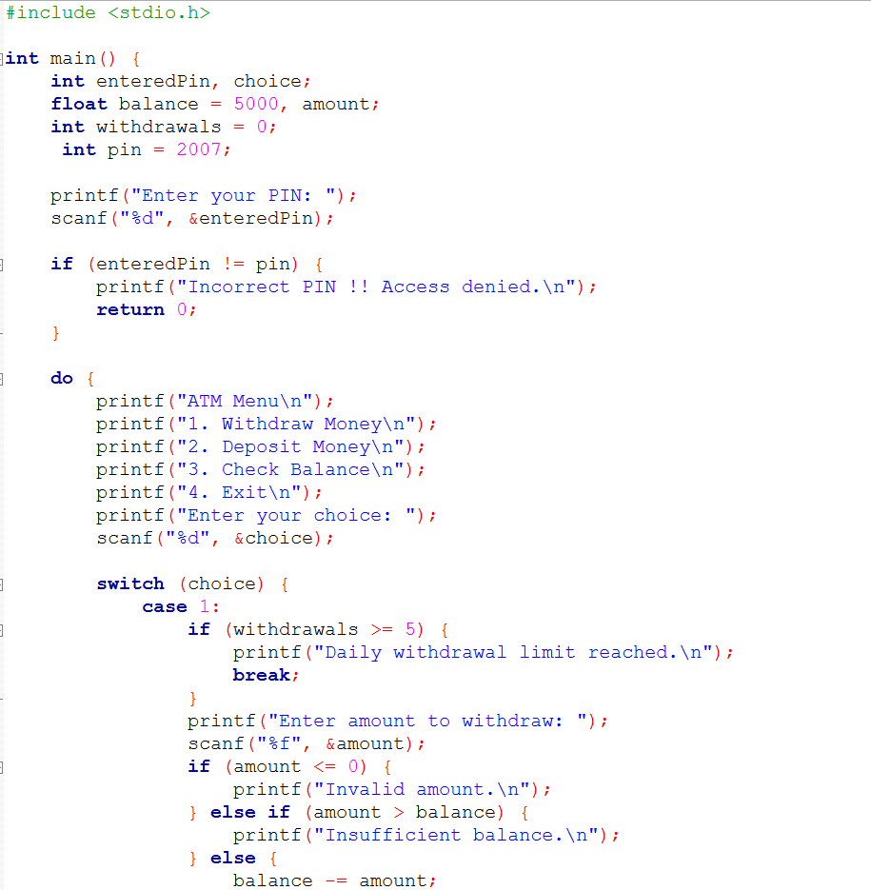
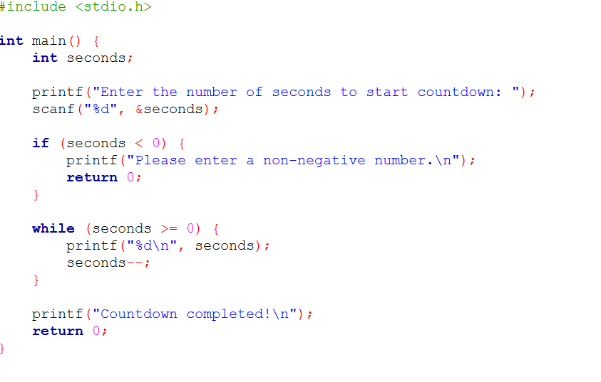
PRACTICAL 15 : Allows user to set a starting number of seconds and then count down to zero, displaying each second as it decrements.
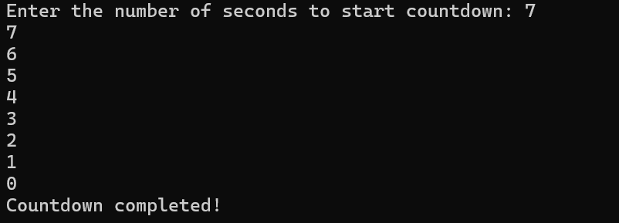
PRACTICAL 16 : A matchstick game between the user and the computer.
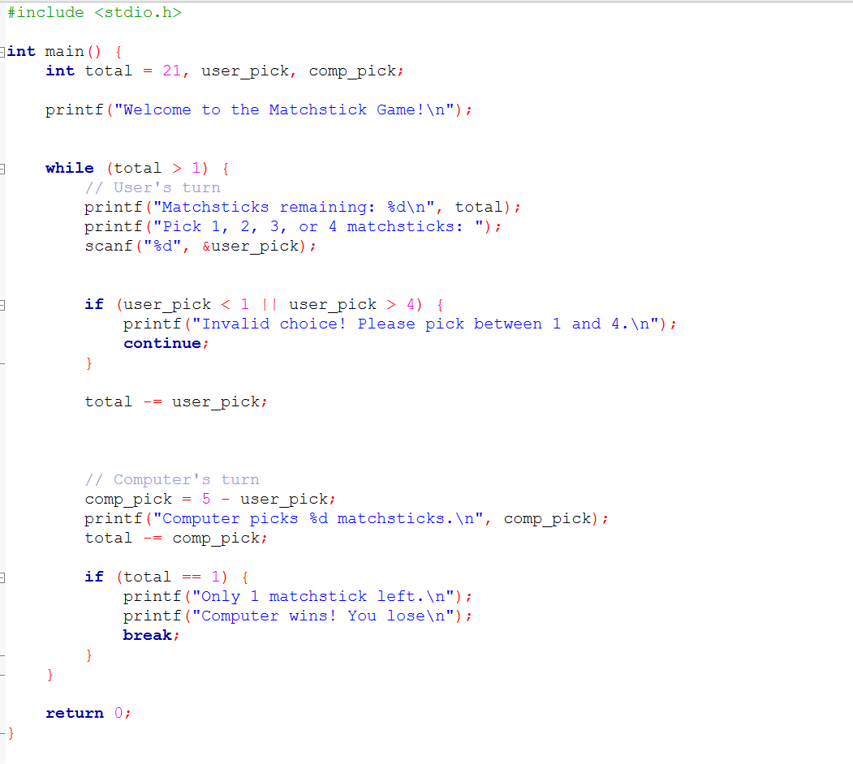
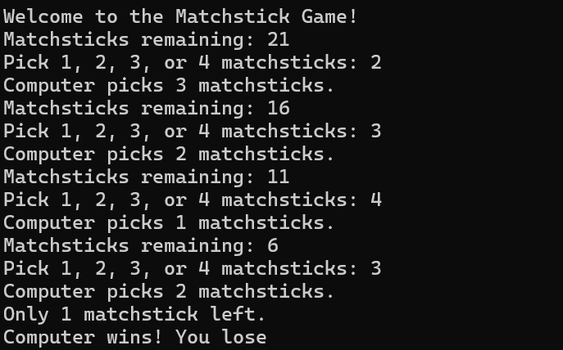
PRACTICAL 17: A program to simulate the distance tracking.
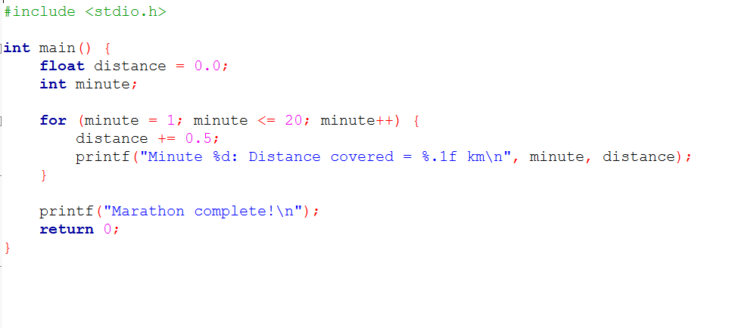
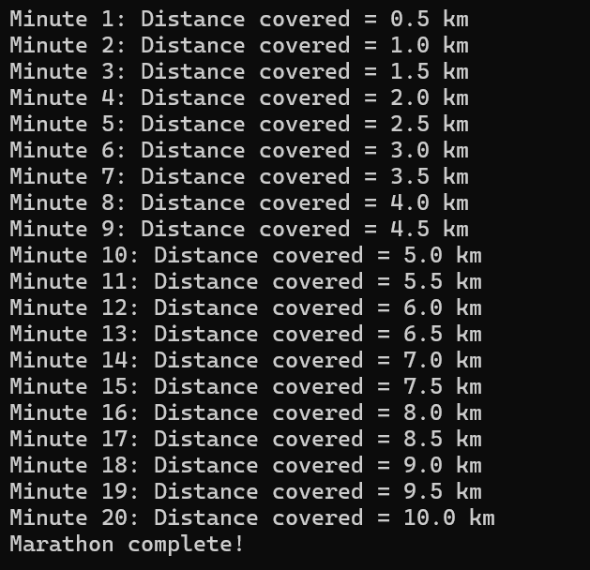
PRACTICAL 18: Display a multiplication table based on user input
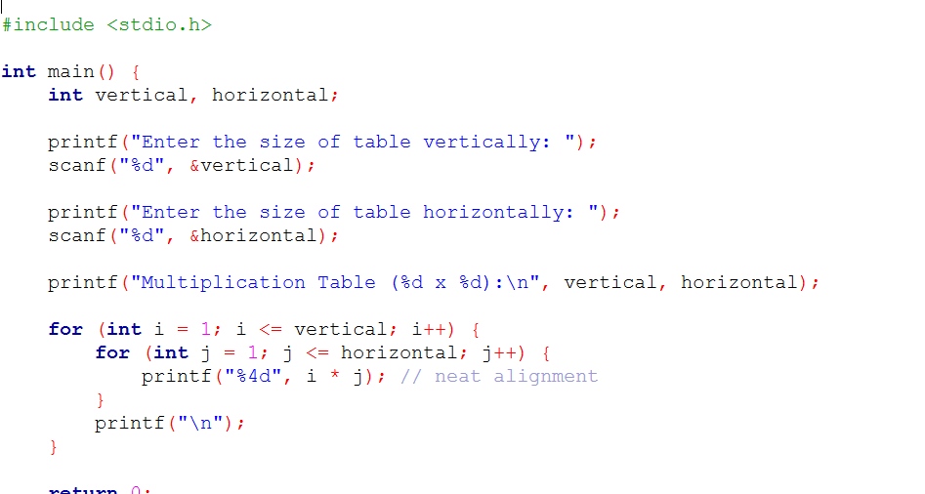
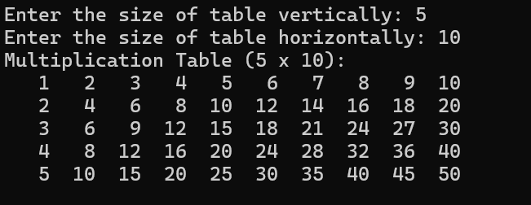
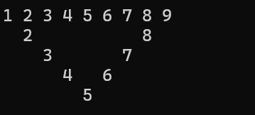
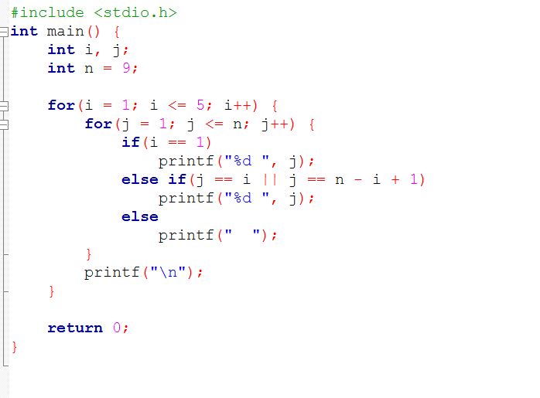
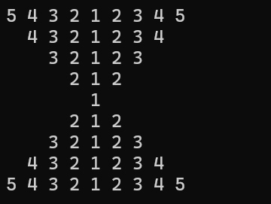
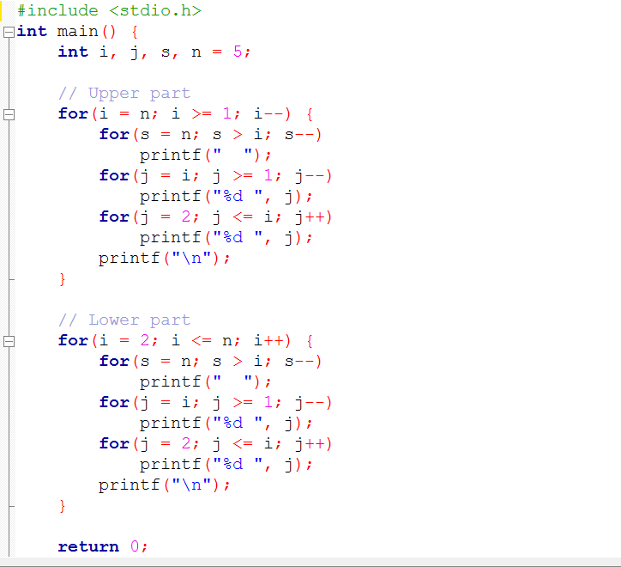
PRACTICAL 19:PATTERNS
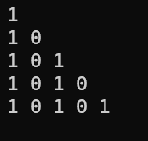
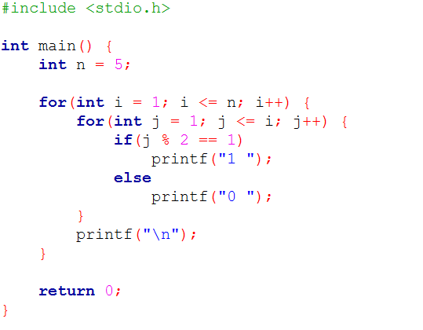
PRACTICAL 20:FIND MISSINF ID
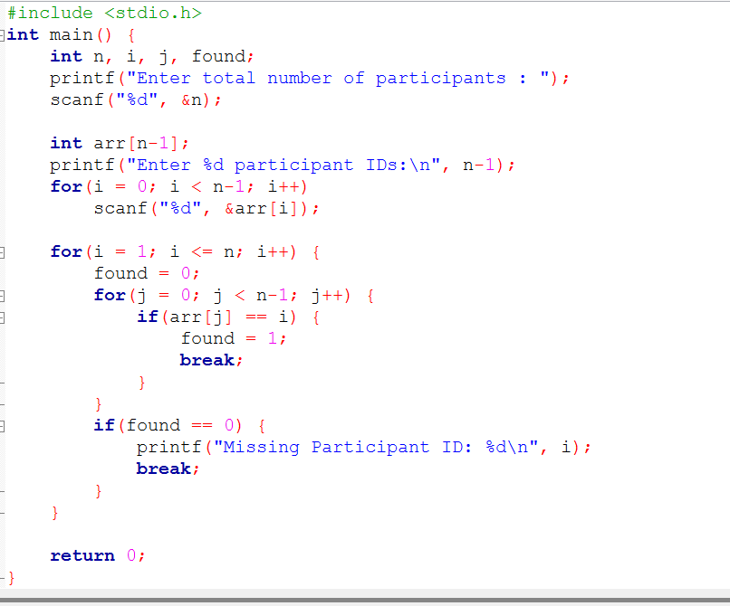
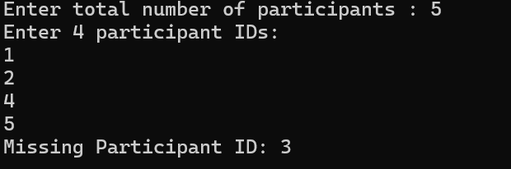
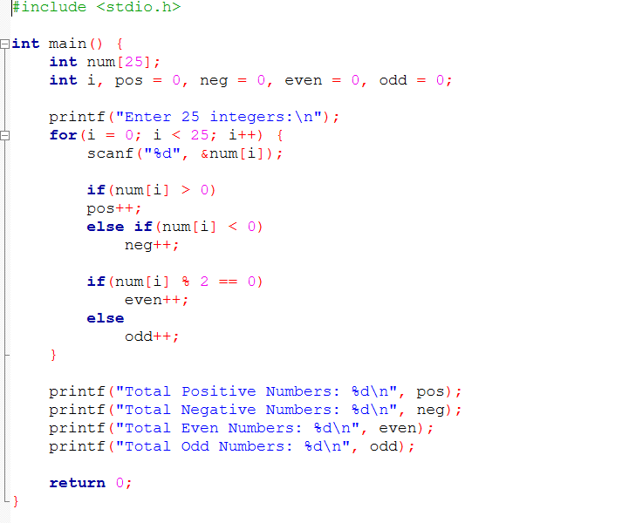
PRACTICAL 21: C based console application that assists operators in understanding the nature of the numbers they enter.

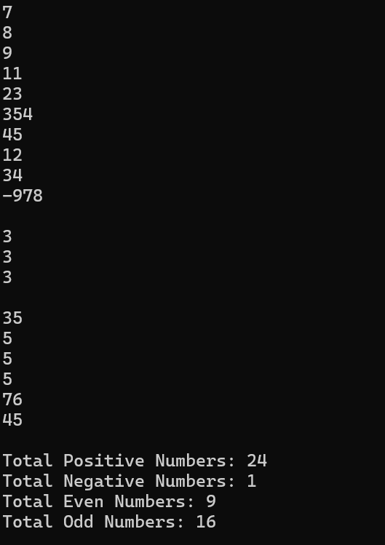
PRACTICAL 22:THEATRE SEAT BOOKING
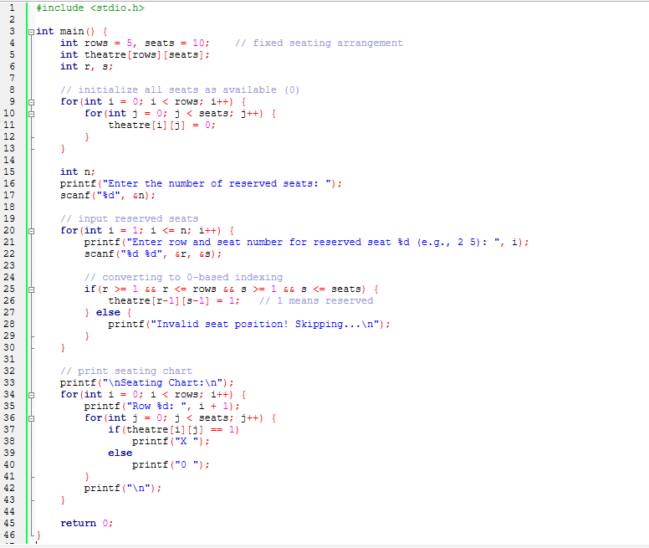
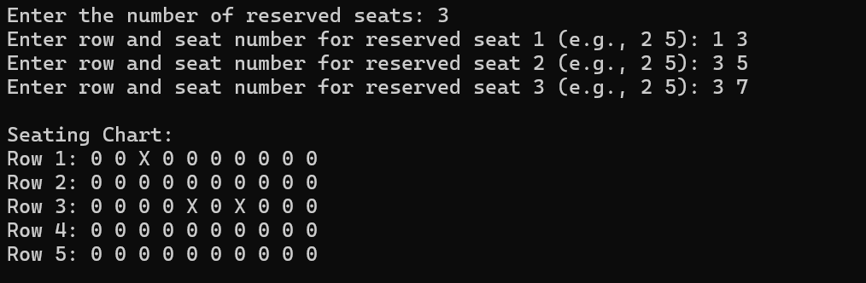
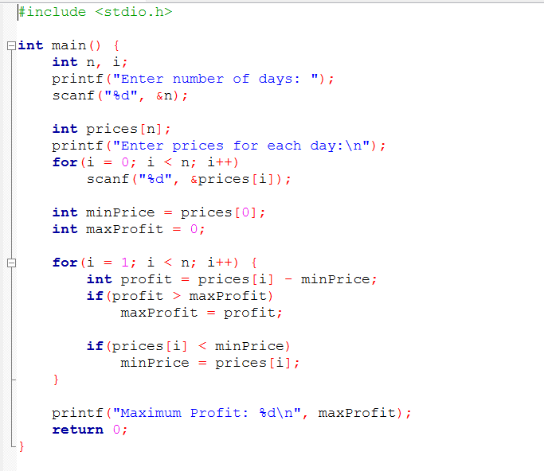
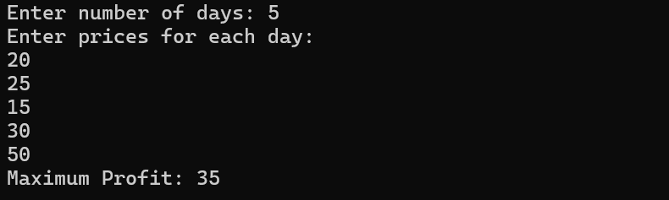
PRACTICAL 23: C to determine the maximum profit you can achieve from this transaction. If no profit is possible (i.e., the fruit price only decreases or stays the same), return 0.
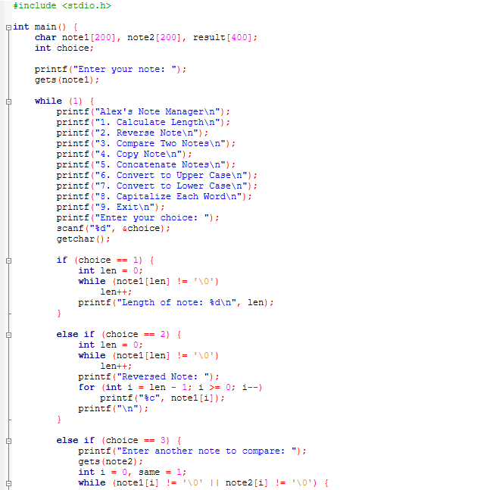
PRACTICAL 24: Manage notes and perform the following operations manually (without using built-in string manipulation functions from ):
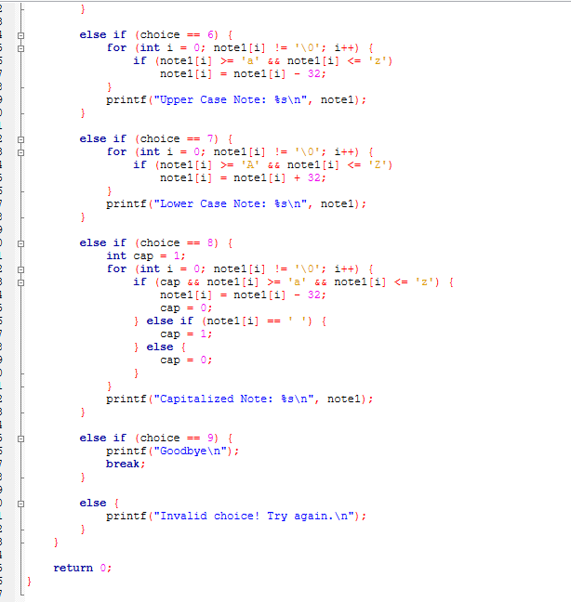
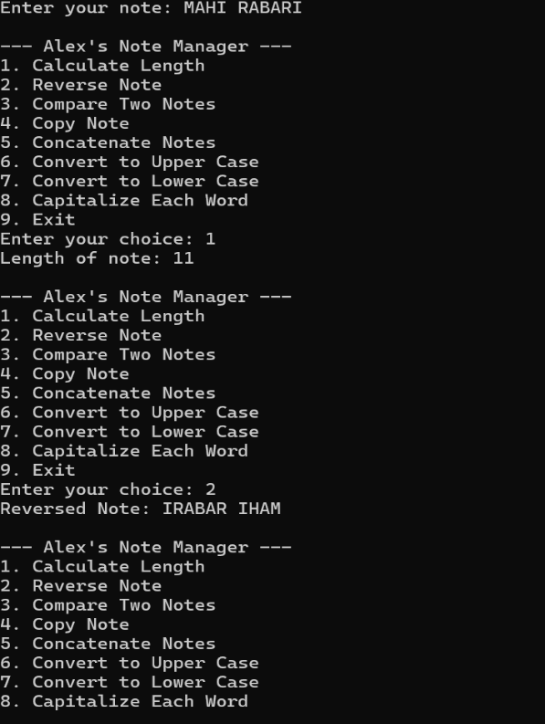
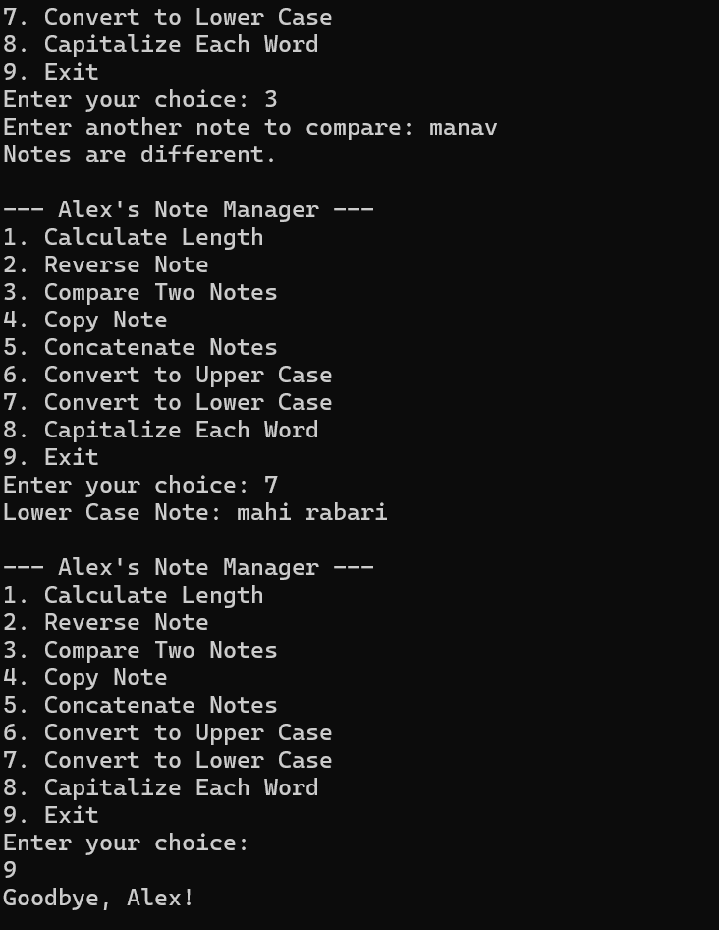
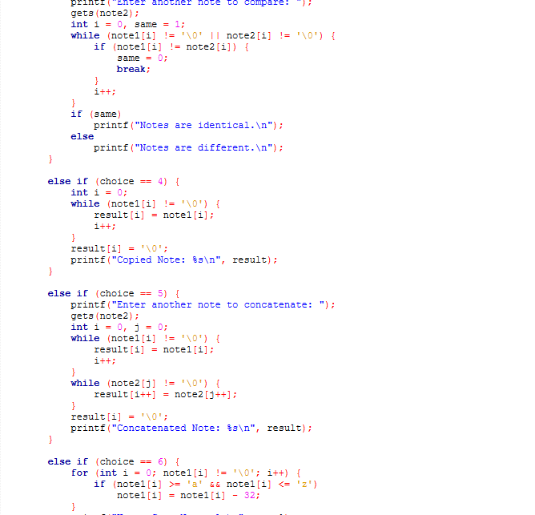
PRACTICAL 25: library management
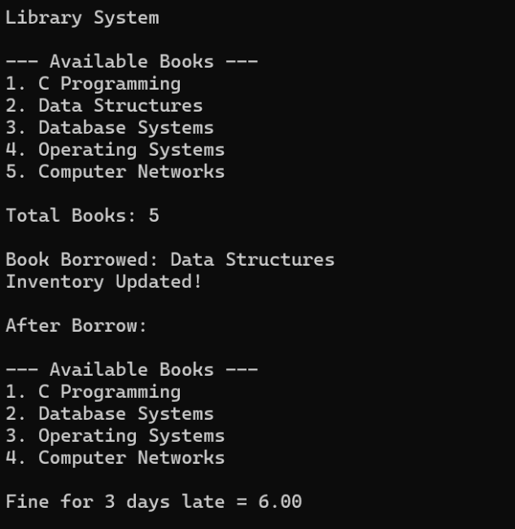
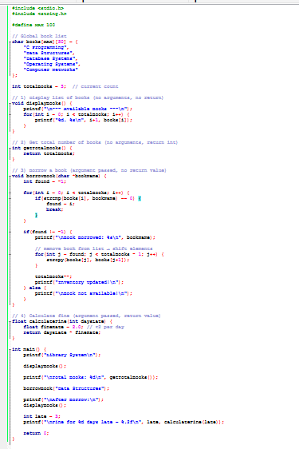
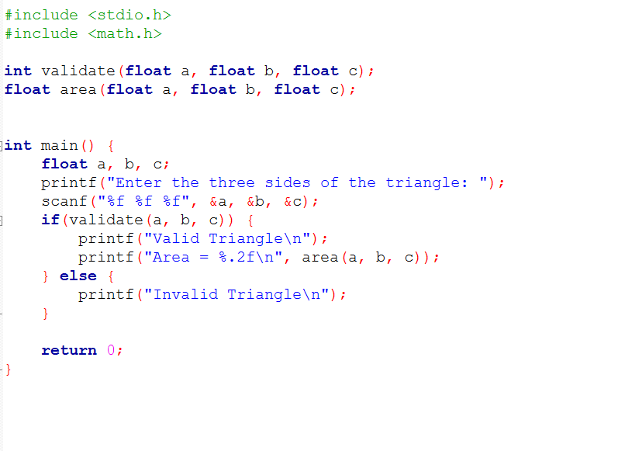
PRACTICAL 26: Creating a program to assist the architech.
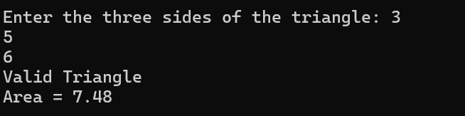

PRACTICAL 27: The amount saved in a given month is often influenced by the sum of the savings from the two previous months. This growth pattern is similar to the Fibonacci series.

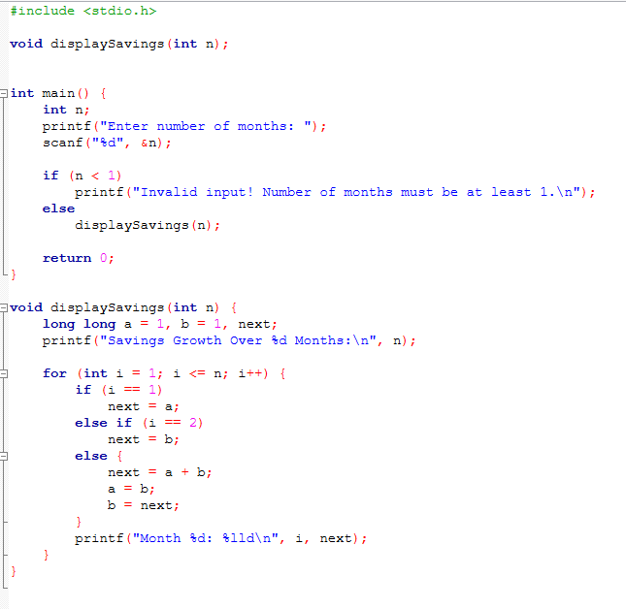
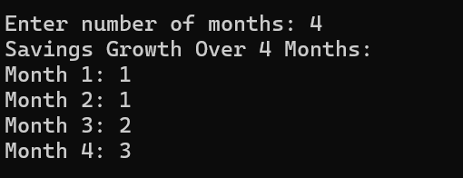
PRACTICAL 28 : Library management system
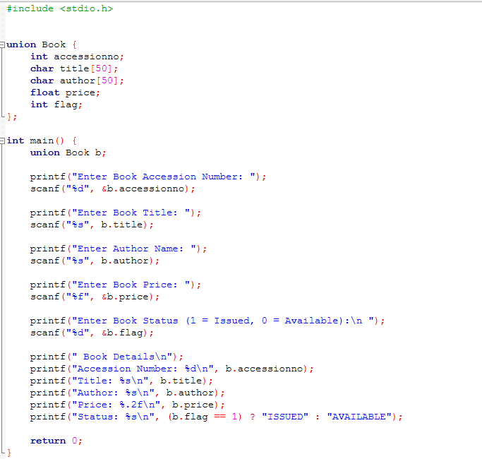
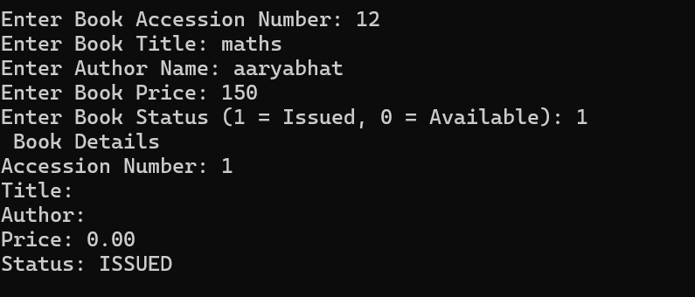
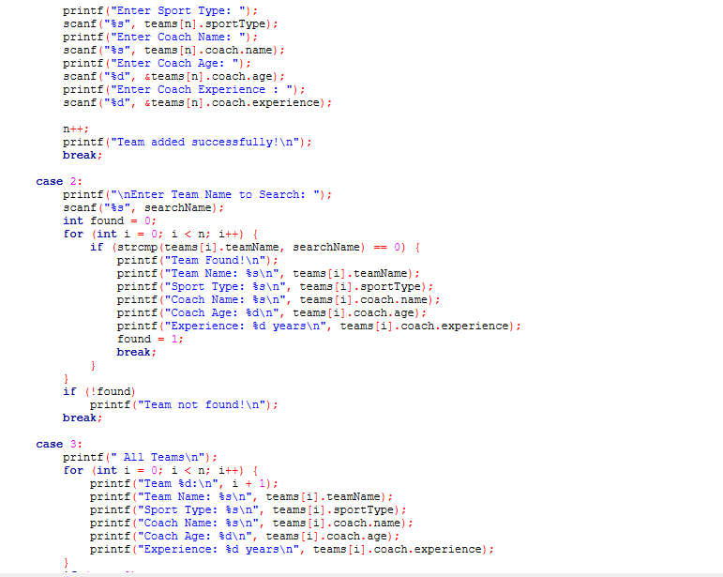
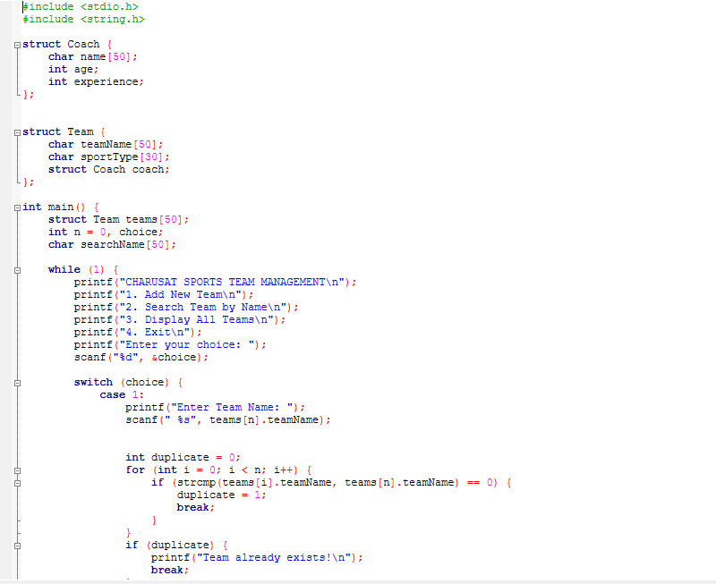
PRACTICAL 29 : C programming, where the team structure includes a sub-structure for coach information.
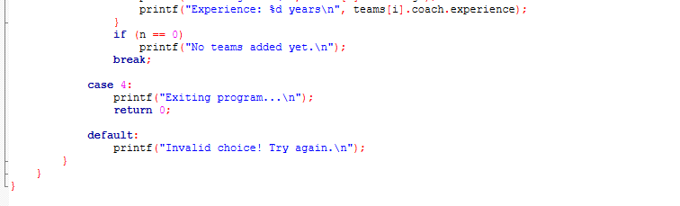
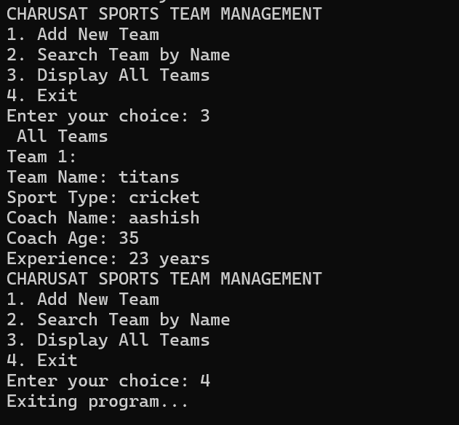
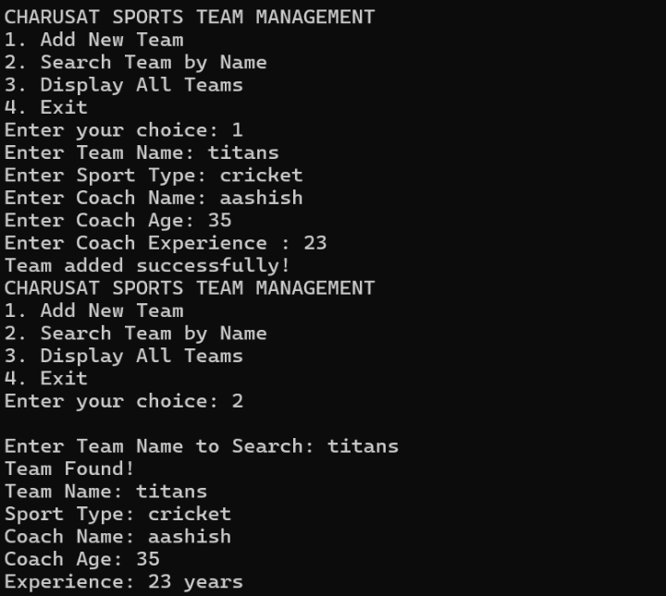
PRACTICAL 30 : C program to assist with this task using pointers.
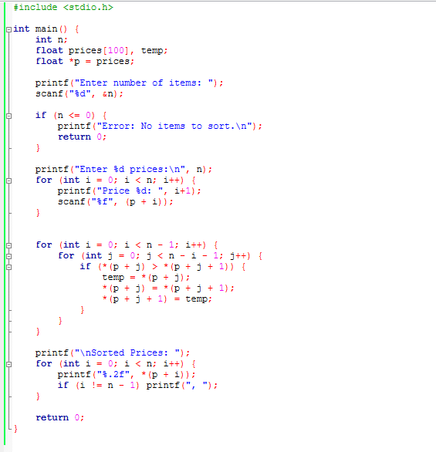
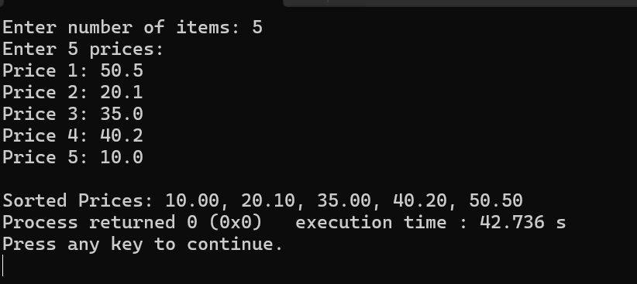
PRACTICAL 31 : The system must dynamically adjust the memory allocation to accommodate the longer text.
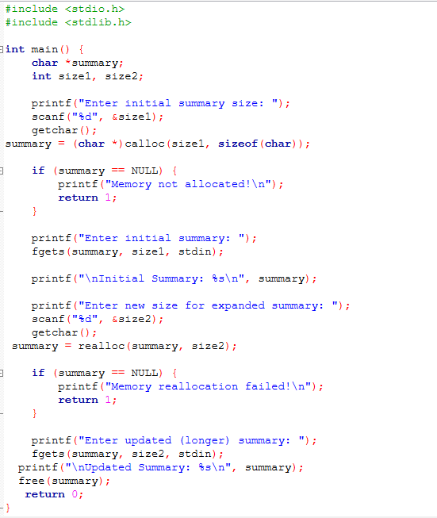
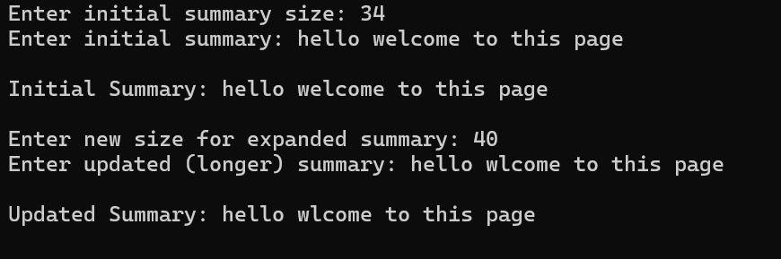
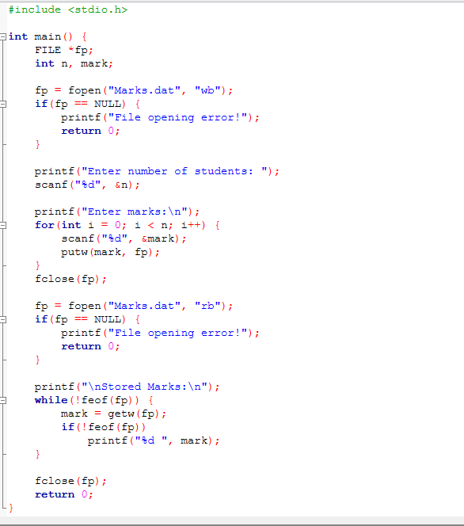
PRACTICAL 32 :
