**WEBSITE FOR COLLEGE PARKING LOT**

**Aim** - Create a website for your college parking lot. The goal of this website would be to see if there are any vacant spots in the parking lot to park the student’s vehicle. If there are any, where in the parking lot is that spot (imaginary spots/marking/maps). There will also be some kind of dashboard to see summary. For example: 10 OPEN, 110 Booked, 1 HANDICAP, 30 FACULTY. The student clicks on 10 OPEN spots and finds the spot closest to him.

**Tools used** – Notepad, HTML, CSS

**Steps**:

1. Fetch the files available in the repository (Github).
2. Make sure all the files are stored in the same folder.
3. Open “Homepage.html” through Google Chrome or Internet Explorer. The following is the Homepage of the website.

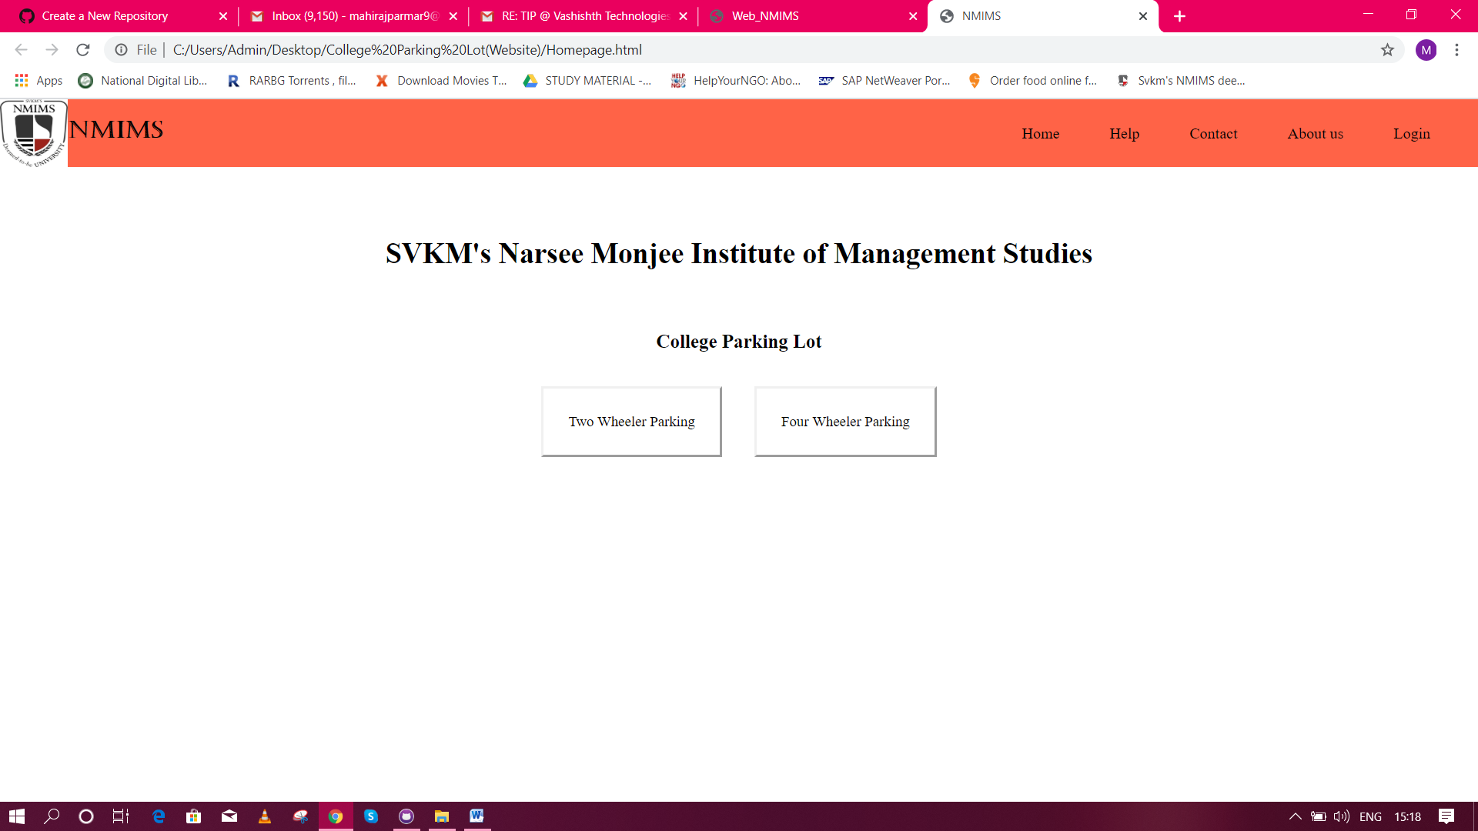

1. The top bar contains options like

* Home – To come back to the homepage
* Help – One can clear all their queries through help
* Contact – The address and contact details of the NMIMS University are mentioned here
* About Us – A brief introduction about the institute is mentioned here
* Login – A faculty member or a student can login here through their SAP ID and password.

**Help**

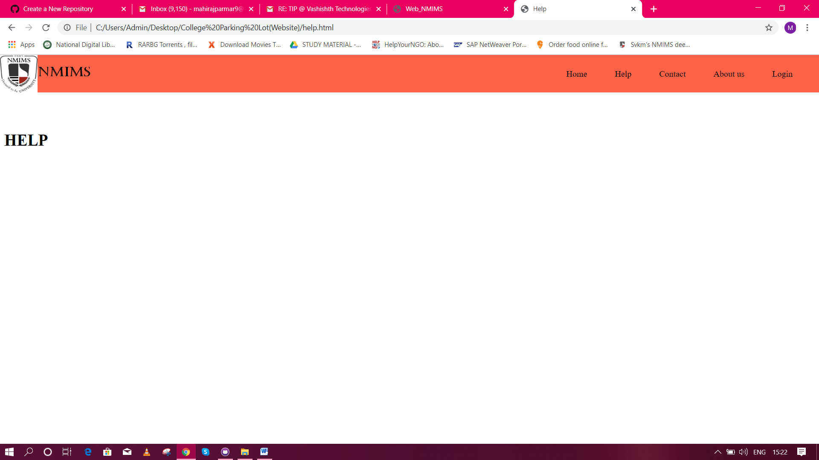

**Contact**

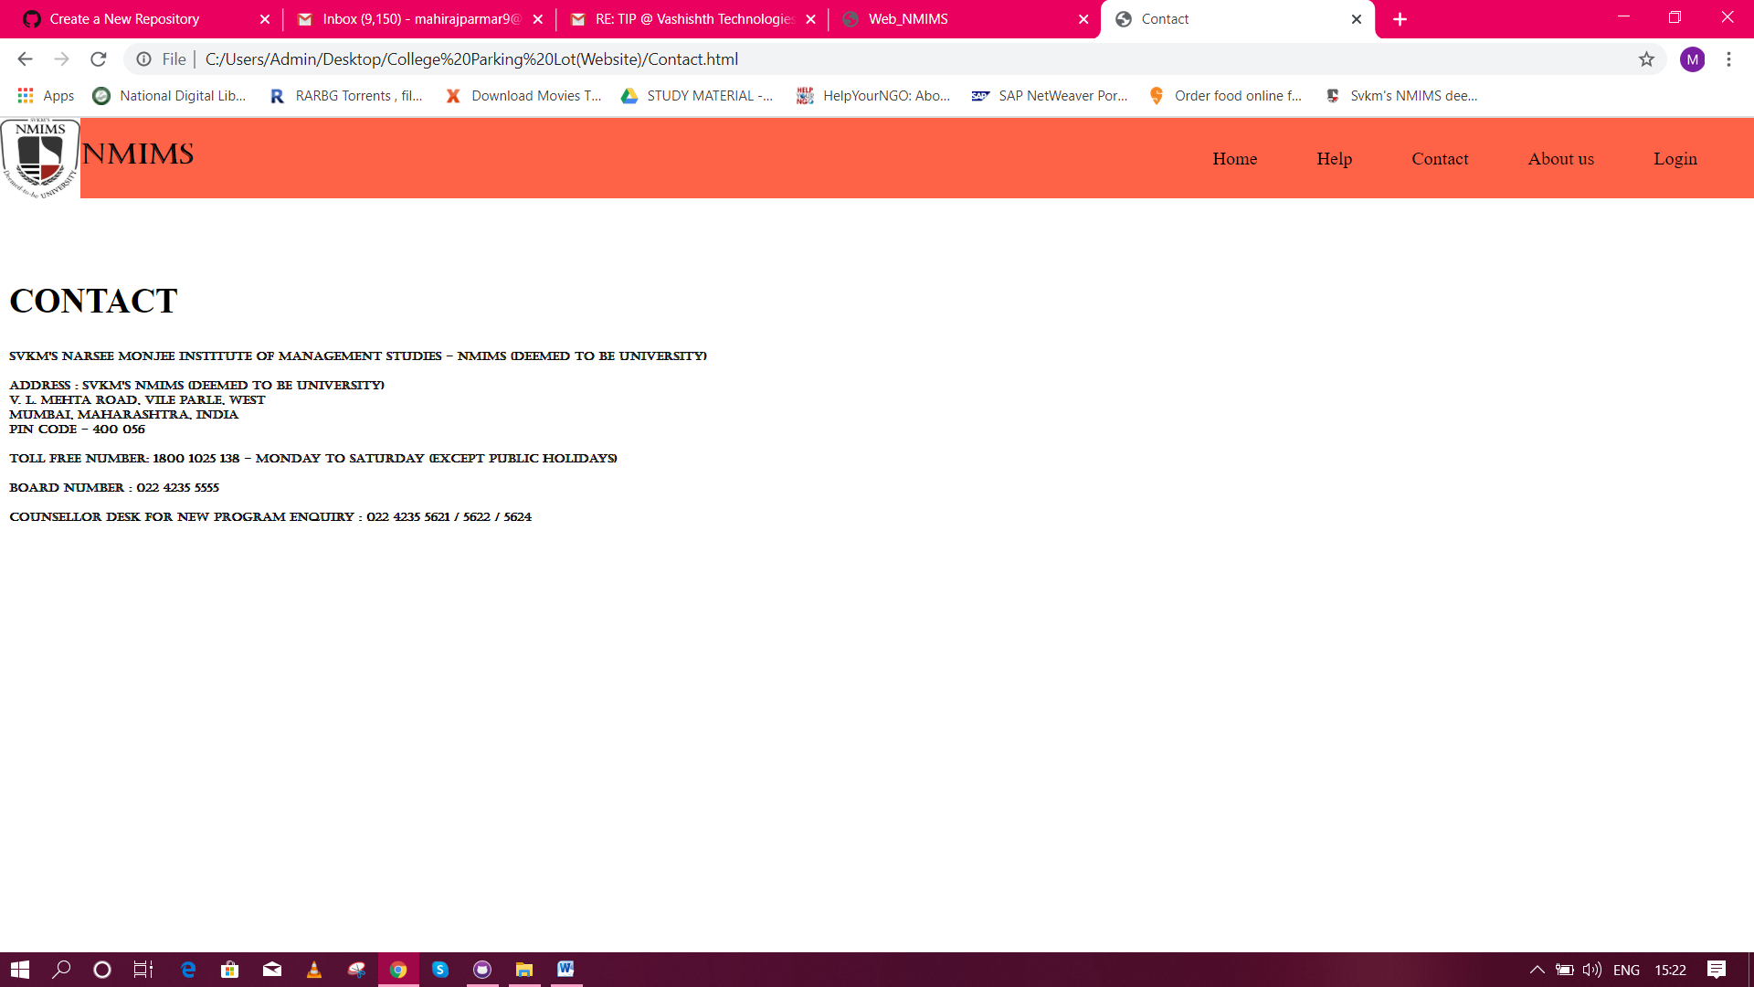

**About Us**

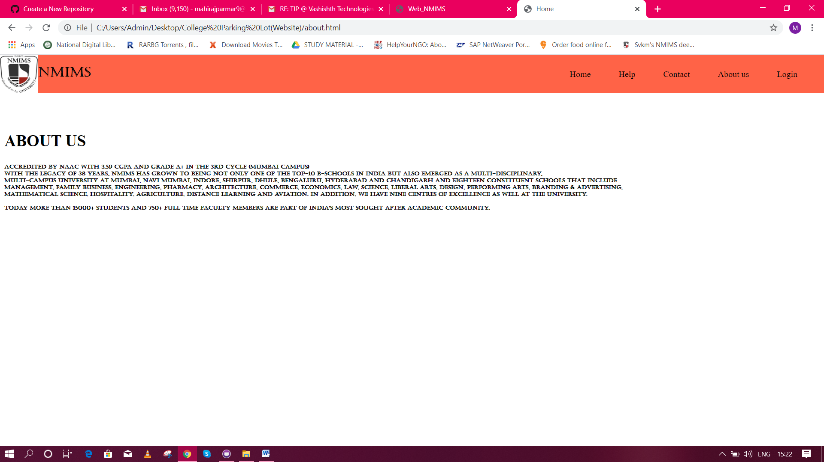

**Login**

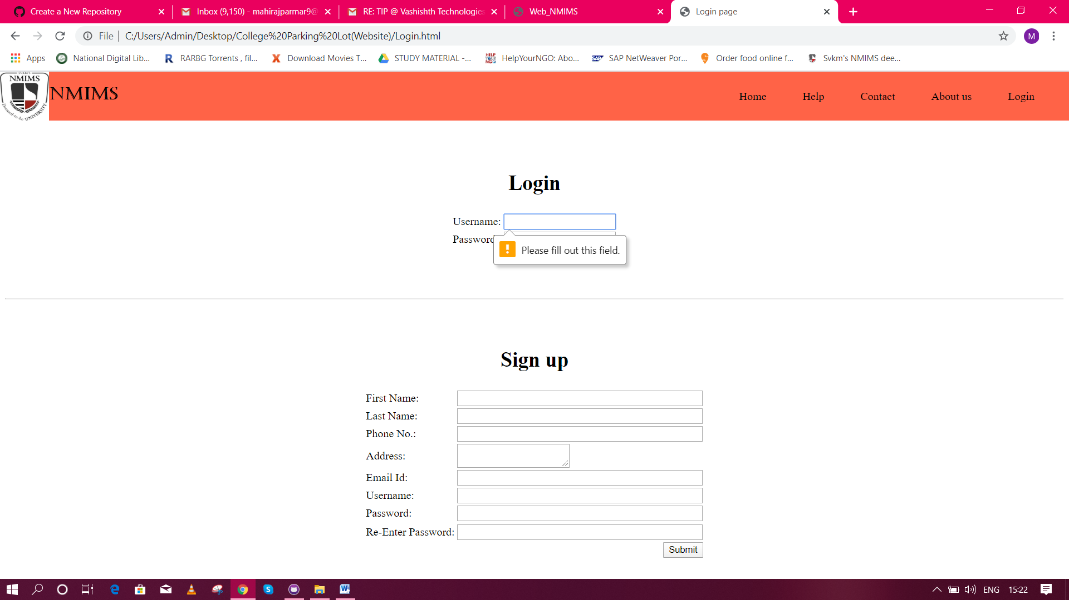

1. Click on “Two Wheeler Parking” or “Four Wheeler Parking” for further procedure.
2. After clicking the same, the individual will be directed to Parking information where one can view whether the slot is available or not.

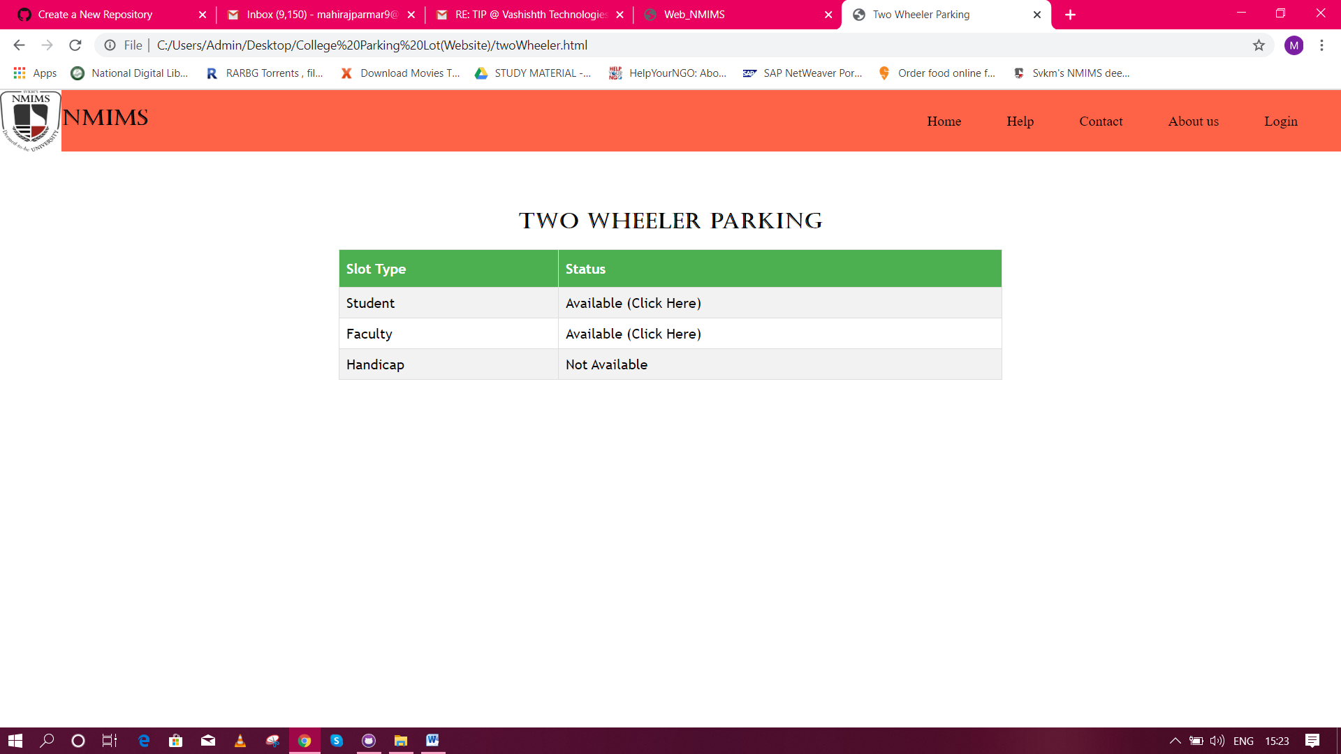

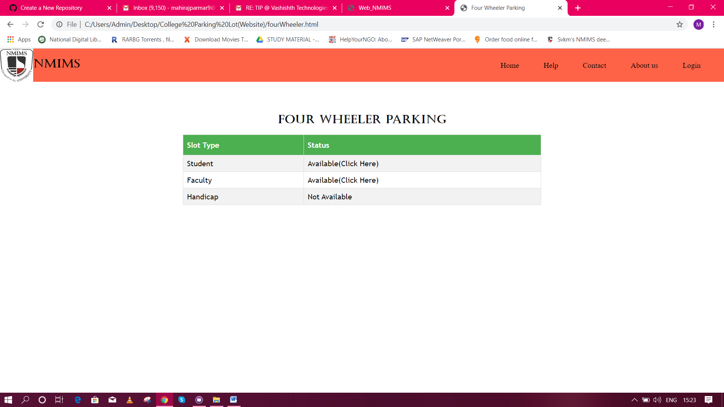

1. If the slot is available, click on “Click Here” for the next step.

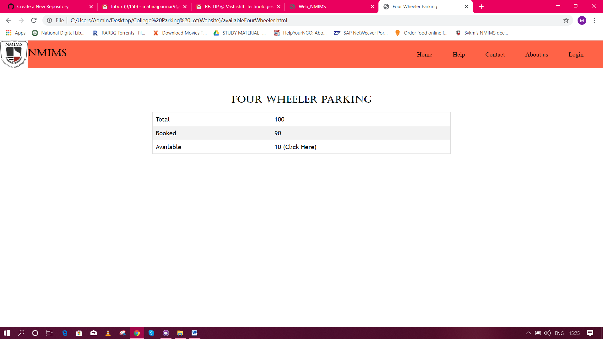

1. The following page will show the number of slots available for parking the vehicle. If one wants to see the location of these available spots, click on “Click Here”.

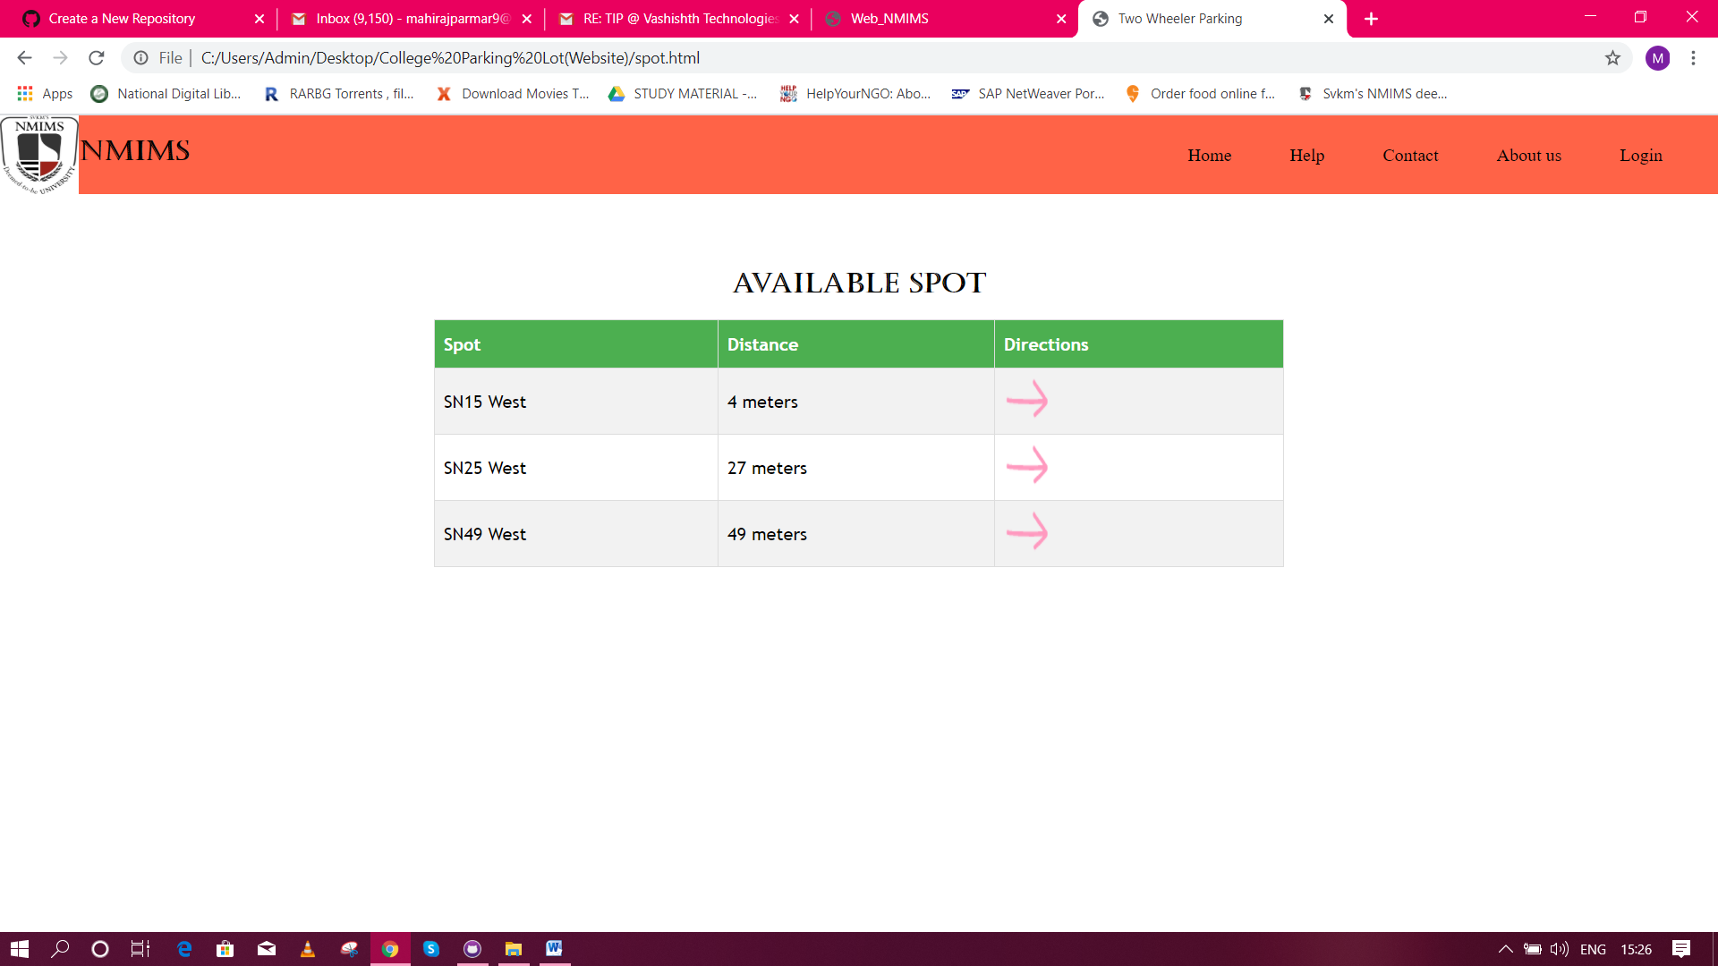

1. The available spots along with the distance are shown in the following page.
2. For the exact location, click on the arrow.
3. This page will redirect the individual to Google Maps for accurate location trace.

