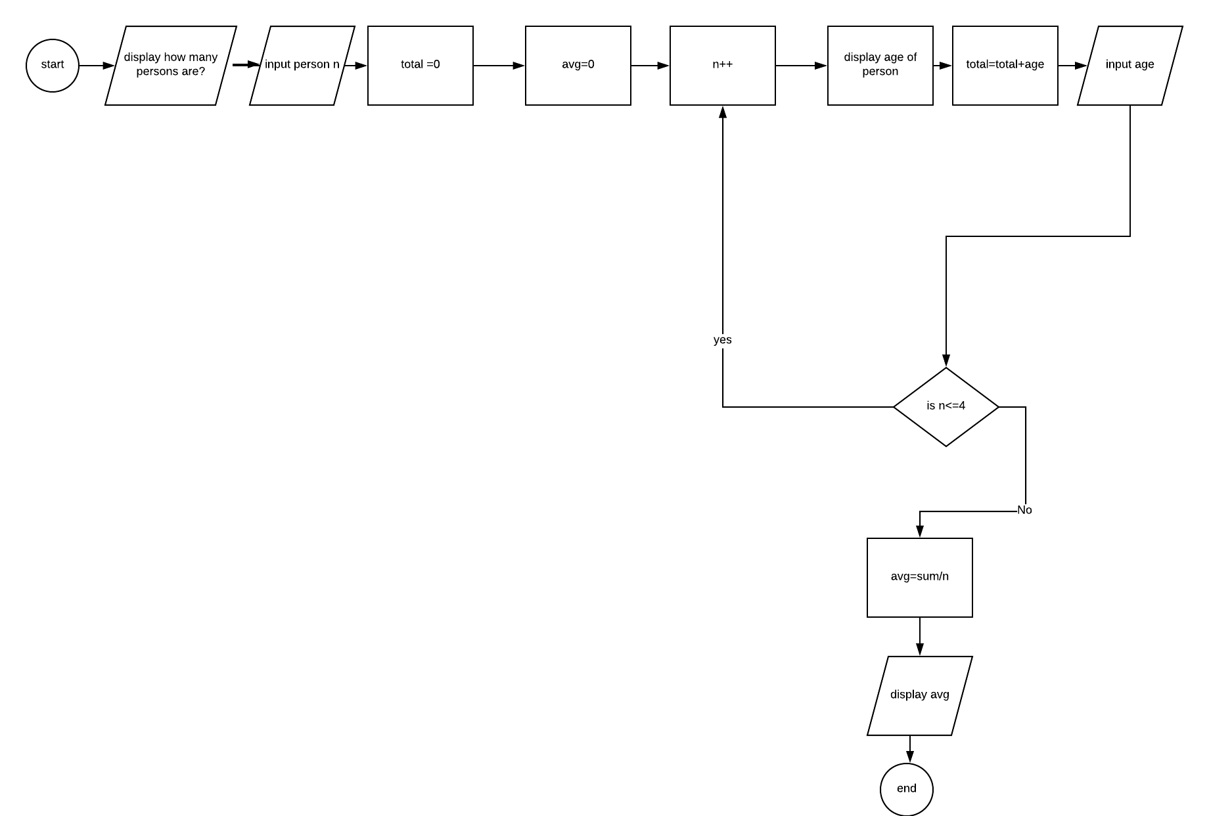

Pseudo code:

1.declare n

2.declare total

3.declare avg

4.declare age

5.ouput how many persons

6.input person n

7. display the age of person

80.total=total+age

9.avg=0

10.if n<=4 the

11.n++

12.Input age

13else

4.avg=sum/n

15.loop

16.output avg

17.end

Assignmnet 9 traces

|  |  |  |  |  |  |  |
| --- | --- | --- | --- | --- | --- | --- |
| Line number | Input buffer | Person count | Salestotal | Person age | Anotherperson | Output buffer |
| 1. | - | - | X | X | X | X |
| 2. | - | - | X | X | X | X |
| 3. | - | - | - | X | X | X |
| 4. | - | - | - | - | - | - |
| 5. | - | 1 | - | - | - | - |
| 6. | - | 1 | 0 | - | - | - |
| 7 | - | 1 | 0 | - | Y | - |
| 8 | - | 1 | 0 | - | Y |  |
| 9 | - | 1 | 0 | - | Y | 1 |
| 10 | - | 1 | 0 | - | Y | How old are you? |
| 11 | 12 | 1 | 0 | 12 | Y | - |
| 12 | 12 | 1 | - | 12 | Y | - |
| 13 | 12 | 1 | 15 | 12 | Y | - |
| 26 | 12 | 1 | 15 | 12 | Y | Count 1 |
| 27 | 12 | 1 | 15 | 12 | Y | Total 15 |

|  |  |  |  |  |  |  |
| --- | --- | --- | --- | --- | --- | --- |
| Line number | Input buffer | Person count | Salestotal | Person age | Anotherperson | Output buffer |
| 1. | - | - | X | X | X | X |
| 2. | - | - | X | X | X | X |
| 3. | - | - | - | X | X | X |
| 4. | - | - | - | - | - | - |
| 5. | - | 1 | - | - | - | - |
| 6. | - | 1 | 0 | - | - | - |
| 7 | - | 1 | 0 | - | N | - |
| 8 | - | 1 | 0 | - | N |  |
| 9 | - | 1 | 0 | - | N | 1 |
| 10 | - | 1 | 0 | - | N | How old are you? |
| 11 | 30 | 1 | 0 | 30 | N | - |
| 15 | 30 | 1 | 45 | 30 | N | - |
| 16 | 30 | 1 | 45 | 30 | N | - |
| 26 | 12 | 1 | 15 | 12 | N | Count 1 |
| 27 | 12 | 1 | 15 | 12 | N | Total 45 |

|  |  |  |  |  |  |  |
| --- | --- | --- | --- | --- | --- | --- |
| Line number | Input buffer | Person count | Salestotal | Person age | Anotherperson | Output buffer |
| 1. | - | - | X | X | x | X |
| 2. | - | - | X | X | X | X |
| 3. | - | - | - | X | X | X |
| 4. | - | - | - | - | - | - |
| 5. | - | 1 | - | - | - | - |
| 6. | - | 1 | 0 | - | - | - |
| 17 | - | 1 | 0 | - | “ “ | - |
| 18 | - | 1 | 0 | - | !=Y and !=N | - |
| 19 | - | 1 | 0 | - | - | Another person? |
| 20 | Y | 1 | 0 | - | Y | - |
| 22 | Y | 2 | 0 | - | Y | - |
| 23 | Y | 2 | 0 | - | Y | - |
| 26 | Y | 2 | 0 | - | Y | Count 2 |
| 27 | Y | 2 | 0 | 12 | Y | Total 45 |