SUMMER INTERNSHIP PROJECT REPORT | COSMOS
First In, First Out (FIFO) Improvement
Low-cost physical stock separation for spares, bulky extrusion materials and other material categories

1. Workstream Title and Executive Summary
This section documents the First In, First Out (FIFO) improvement initiative undertaken during the Summer Internship Project (SIP) at COSMOS. FIFO is reported here as a stand-alone workstream.
Situation. Before the intervention, operators identified stock age largely by visual judgement: material with dust was treated as old stock and material without dust as new stock. This depends on the appearance of the material rather than on a clearly demarcated old-stock and new-stock arrangement.
Intervention. A practical, low-cost physical FIFO arrangement was designed around the factory’s actual space and capital constraints. For spares in bins (both factories), waste GI sheet pieces form a divider that creates a front old-stock compartment and a rear new-stock compartment within the same bin. For bulky extrusion materials, a red/green colour-coded arrangement is used, with red-designated stock issued first and green-designated stock issued afterwards. The FIFO concept was also applied to actuators, spigote and DCV, ArmaSound, ArmaFlex, coils and blowers.
Evidence status. The report presents the process design, qualitative AS-IS and TO-BE analysis, and the operator time observations recorded during the internship. Those observations are not before-and-after measurements of FIFO, a method for validating the improvement is recommended in Sections 8 and 9.

2. Project Background and Objective
The objective was to introduce a practical, low-cost physical FIFO arrangement that:
- Separates old stock from new stock clearly.
- Makes visible the stock that is to be issued first.
- Supports consistent stock rotation.
- Minimises unnecessary material rearrangement and handling.
- Reuses available storage bins and waste GI sheet pieces wherever feasible.
- Avoids additional bins and expensive conventional two-bin arrangements where space and capital constraints make them impractical.
The design was developed around the factory’s actual operational and storage constraints rather than adapted from a standard template.

3. Existing FIFO Process and Operational Gap
In the existing method, the Stores operator approached the material, judged its age by dust accumulation, selected the material on that basis and retrieved it for issue. Material with dust was treated as old stock; material without dust was treated as new stock.
The operational limitation is that a visual indicator based on dust may not provide a consistent and systematic way of distinguishing old and new stock. Dust accumulation depends on storage location, packaging, handling and time on the shelf, and the described method had no clearly demarcated old-stock and new-stock arrangement. This report does not claim that material was issued incorrectly or that inventory losses occurred, as no supporting evidence is presented.

4. AS-IS Swimlane Diagram
Figure 1 shows the existing process in two lanes: the Stores operator’s actions and the state of the physical stock.
STORES OPERATOR | STEP 1  Approach material storage | → | STEP 2  Visually inspect the material | → | STEP 3  Use dust accumulation as indicator of old stock | → | STEP 4  Select material based on this visual judgement | → | STEP 5  Retrieve material for issue
PHYSICAL STOCK / FIFO ARRANGEMENT | STATE A  Material stored in its existing location | → | STATE B  Older and newer material distinguished informally by dust / no-dust appearance |  |  |  |  | → | STATE C  No clearly demarcated old-stock and new-stock compartments in the described method
 | LIMITATION: the operator relies on a visual indicator (dust) rather than a defined physical stock-separation arrangement.
Figure 1: AS-IS Dust-Based FIFO Identification Process
In the existing process the operator moves directly from inspection to selection, using dust as the only indicator of stock age. The physical stock has no defined old-stock and new-stock positions, so the selection for issue rests on the operator’s visual judgement. This is the gap the TO-BE design addresses.

5. Proposed FIFO Design

5.1 Spares — Both Factories
For spare materials stored in bins, a physical compartment system was introduced using waste GI sheet pieces available within the factory. Each applicable bin is divided into two sections:
- Old stock — front compartment: stock designated for issue first.
- New stock — rear compartment: newly received or replenishment stock, kept behind the old stock.
The operating cycle is as follows:
- The operator approaches the bin and identifies the old-stock compartment.
- The operator retrieves material from the old-stock compartment first.
- When the old stock is exhausted, the operator removes or lifts the GI-sheet divider as required by the design.
- The remaining new stock, positioned behind the old stock, is brought forward into the old-stock position.
- The empty new-stock compartment becomes available for the next replenishment.
- New material is placed in the new-stock compartment behind the material currently designated for issue.
- The cycle repeats.
The divider is not removed at every issue. It is lifted or removed only when the old-stock section is exhausted, and the stock arrangement needs to be reset.

5.2 Extrusion — Bulky Materials
For bulky extrusion materials, a colour-coded physical FIFO arrangement was introduced using waste GI sheet pieces:
- Red: old stock, designated for issue first.
- Green: new stock, designated for issue after the red-designated stock is exhausted.
The operator issues the red-designated stock first and then shifts to the green-designated stock. As the cycle progresses, newly received stock is assigned to the appropriate new-stock position. The colour coding gives a visual distinction between the two stock groups without requiring an additional bin for every material, and each colour is accompanied by an Old/New label so that identification does not depend on colour alone.

5.3 Difference Between the Two Arrangements
The two implementations follow the same principle but are physically different. Spares use a compartment-based design, with a GI-sheet divider separating front and rear sections inside a bin. Bulky extrusion materials use a colour-coded arrangement, and it is not stated or implied that every extrusion material uses the same divider design as the spare-parts bins.

6. TO-BE Swimlane Diagram
Figure 2 shows the TO-BE cycle, including the decision point and the replenishment loop.
STORES OPERATOR | STEP 1  Approach designated material bin / storage area | → | STEP 2  Identify old-stock section (GI-sheet divider or red code) | → | STEP 3  Retrieve old stock first | → | DECISION  Is the old-stock section empty? | Yes  → | STEP 4  Lift / remove divider where applicable; bring remaining new stock forward and reset positions | → | STEP 5  Continue issuing from the newly designated old-stock section | → | STEP 6  Place next receipt in the rear / green replenishment position
STORES OPERATOR |  |  |  |  | ← NO: continue issuing old stock (return to Step 3) |  |  |  | ↺ Replenishment cycle: next issue starts again from Step 2
PHYSICAL STOCK / FIFO ARRANGEMENT | OLD + NEW SEPARATED  Old stock at front (spares) or red (extrusion); new stock behind or green | → | OLD STOCK (ISSUE FIRST)  Old-stock section is the one designated for first issue | → | OLD STOCK DEPLETES  Old stock reduces as it is issued; new stock stays in position | → | OLD SECTION EMPTY  Old-stock section becomes empty | → | NEW → OLD POSITION  Remaining new stock shifts into the old-stock position | → | REAR SECTION FREE  Rear / new-stock section available for the next receipt | → | NEW STOCK (BEHIND)  New stock placed behind stock designated for issue; FIFO cycle repeats

SPARES (BINS, BOTH FACTORIES)  OLD STOCK = front compartment; NEW STOCK = rear compartment; separated by a waste GI-sheet divider. | BULKY EXTRUSION MATERIALS  RED = OLD STOCK, issued first; GREEN = NEW STOCK, issued after red is exhausted. Labels accompany colours.
Figure 2: TO-BE Physical FIFO Stock Rotation Process
The operator identifies the old-stock section by the divider or the red code and issues from it. When the old-stock section is empty, the divider is lifted or removed where applicable, the remaining new stock moves into the old-stock position, and the freed rear or green position receives the next replenishment. If the old-stock section is not empty, the operator continues issuing from it. The cycle therefore covers replenishment as well as a one-time issue.

7. Material-Category Coverage
The FIFO workstream covers the categories below. The common principle in every category is to distinguish old stock from new stock and to issue the old stock first.
Material category | Common FIFO principle | Physical configuration
Spares (both factories) | Old stock in front compartment, new stock behind; old issued first | GI-sheet divider within bin
Extrusion (bulky materials) | Red-designated old stock issued first, then green-designated new stock | Red/green colour-coded identifiers (GI sheet pieces)
Actuators | Distinguish old and new stock; issue old first | Red/green colour-coded identifiers (GI sheet pieces) also left to right
Spigote and DCV | Distinguish old and new stock; issue old first | Red/green colour-coded identifiers (GI sheet pieces)
ArmaSound | Distinguish old and new stock; issue old first | Red/green colour-coded identifiers (Spray)
ArmaFlex | Distinguish old and new stock; issue old first | Red/green colour-coded identifiers (Spray)
Coils | Distinguish old and new stock; issue old first | Red/green colour-coded identifiers (GI sheet pieces)
Blowers | Distinguish old and new stock; issue old first | Red/green colour-coded identifiers (GI sheet pieces)
The exact physical configuration may differ by material, so a uniform implementation method is not assumed. The configuration details for the categories marked “To be confirmed” should be verified with the Stores team before final submission.

8. Time Study and Operator Material-Handling Observations
The following operator time observations were recorded during the internship.
Material / Spare | Recorded time
Rod | 1.5–2 minutes
Corner | 2 minutes
Screw | 2 minutes
R/D rod | 1 minute
Rivets | 4–5 minutes
Side spacer | 5 minutes

Interpretation. These figures are operator time observations associated with the relevant material-handling activities. The available information does not establish that they are before-and-after measurements of the FIFO implementation. They are therefore not reported as time saved by FIFO, no percentage reduction is calculated, and no productivity improvement is claimed.
Limitation. The precise activity measured for each material (for example, locating, retrieving or issuing) is not documented. The observation method should be confirmed before the figures are used for any comparison.

9. Motion Study and Physical Material Flow
This section is a qualitative motion analysis of operator movement and stock rotation. It is not a quantified motion study.

Existing Method
The operator approaches the material, visually judges whether it is old or new based largely on dust accumulation, identifies the material to issue and retrieves it. The number of movements, handling steps and travel distances in the existing process was not measured, and no record confirming them is available.

Method — Spare-Parts Bins
- The operator approaches the designated bin.
- The operator identifies the front old-stock compartment.
- The operator retrieves the required material from the old-stock compartment.
- The operator repeats the retrieval while old stock remains.
- Once the old-stock compartment is empty, the operator lifts or removes the divider as required.
- The operator moves the remaining stock from the rear compartment into the front position.
- The now-available rear compartment is used for the next incoming stock.
- Subsequent replenishment is placed behind the stock designated for issue first.

Method — Bulky Extrusion Materials and Others
- The operator approaches the designated material storage area.
- The operator identifies the red-designated old stock.
- The operator issues the red-designated stock first.
- After the red-designated stock is exhausted, the operator moves to the green-designated stock.
- Stock positions are reset as required for the next replenishment cycle.

Motion-Study Interpretation
The design replaces reliance on dust-based visual judgement with a defined physical stock-selection method. The potential operational implications are:
- More consistent identification of the stock to be issued first.
- Less ambiguity in distinguishing old and new stock.
- A defined replenishment sequence for new receipts.
- Reduced need for separate bins, where the compartment system is feasible.
- Potential reduction in unnecessary searching or rearrangement.
These are expected effects of the design. Operator walking distance, handling motions and total movement time have not been measured, and no reduction in them is claimed. If a quantified assessment is required, the following should be recorded: operator travel distance, number of handling actions, divider-reset time and total retrieval time.

10. Space and Capital Constraints — Design Rationale
Conventional two-bin arrangements are used in many inventory systems. COSMOS faced space constraints and capital-budget limitations that made separate bins for all applicable spare items impractical. The solution therefore used existing bins and waste GI sheet pieces to create two stock positions within a single bin. A conventional two-bin system was not implemented; the solution was adapted to limited space and capital.
- Space efficiency: two stock groups can be accommodated within the same bin where dimensions permit.
- Low incremental material cost: waste GI sheet pieces already available in the factory were reused.
- Practical implementation: the physical separation is straightforward for Stores operators to understand.
- Visual management: colour-coded red/green identifiers support quick recognition in the applicable bulky-material storage areas.
- Operational adaptability: the arrangement can be adapted to different material categories and storage constraints.
Cost savings, space savings and return on investment are not quantified, as measured space and cost data are not available.

11. AS-IS vs TO-BE Comparison
Dimension | AS-IS | TO-BE
Stock-age identification | Dust/no-dust visual judgement | Physical compartment or colour-coded identification
Old/new stock separation | No clearly demarcated separation in the described method | Defined old-stock and new-stock positions
Selection for issue | Based largely on visual judgement | Old-stock section designated for first issue
Spare-parts arrangement | Existing bin arrangement | Front and rear compartments separated by a GI-sheet divider
Bulky extrusion materials | Existing stock arrangement | Red-designated old stock followed by green-designated new stock
Replenishment | Existing method to be documented | New stock placed in the designated replenishment position
Space requirements | Existing storage constraints | Uses existing bins where feasible
Capital requirement | Conventional additional-bin arrangement considered impractical | Reuses available waste GI sheet pieces
Time impact | Baseline to be established from comparable observations | Requires before-and-after validation
Motion impact | Exact movement data not established | Defined stock-selection and replenishment sequence

12. Expected Benefits and Limitations

Expected Benefits
The following benefits are expected from the design and have not been measured:
- Consistent, visible identification of the stock to be issued first.
- Reduced ambiguity between old and new stock compared with dust-based judgement.
- A defined replenishment sequence that keeps new receipts behind stock designated for issue.
- Low incremental cost through reuse of existing bins and waste GI sheet pieces.

Limitations
- No quantified baseline: time, motion, space and cost effects of the change have not been measured.
- Time observations: the recorded figures are not before-and-after measurements, and the activity measured for each is not documented.
- Qualitative motion analysis: movement counts, travel distances and divider-reset time are not recorded.
- Dimension dependence: the compartment design applies where bin dimensions permit two stock positions.
- Discipline dependence: the arrangement works only if operators place receipts in the designated position and reset the divider at the right time.
- Other categories: the physical configuration for actuators, spigote and DCV, ArmaSound, ArmaFlex, coils and blowers is yet to be confirmed.

13. Implementation Controls and Recommendations
- Clear identification of old-stock and new-stock positions, using labels as well as colours.
- Consistent placement of newly received stock in the replenishment section.
- Operator training to issue old stock first.
- Periodic checks of the stock arrangement.
- Safe handling of GI-sheet dividers, including removal and replacement.
- Damage and hazard checks: dividers must not damage materials or create handling hazards, for example from sharp edges.
- Accurate records: keep material identity and stock records accurate.
- Design adaptation for materials with different shapes, dimensions and handling requirements.
- Batch or receipt information used where necessary to confirm stock age.
FIFO applies to eligible stock. It must not override quality holds, rejected-material controls or other restrictions.

14. Photographic and Video Evidence
The photographs and video below show the FIFO arrangements on the shop floor.
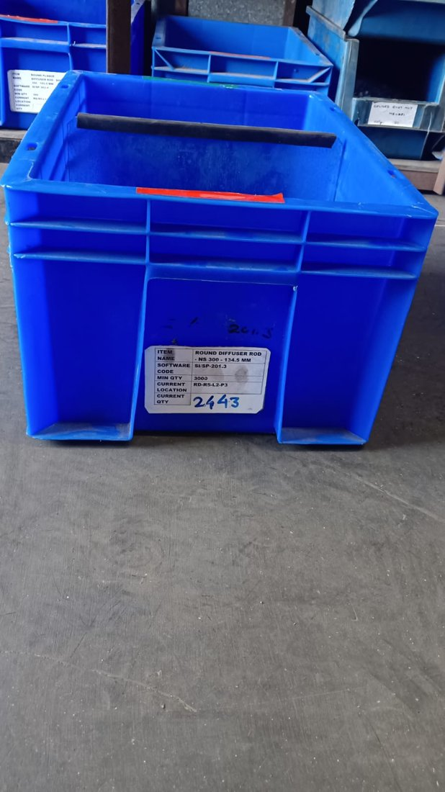
Figure 3: GI-Sheet Divider for Old and New Spare Stock
A spare-parts bin (Round Diffuser Rod, software code Si/SP-201.3) with the top edge of the divider visible across the bin and a red marker on the front rim. The bin label records the item name, software code, minimum quantity, current location and current quantity.
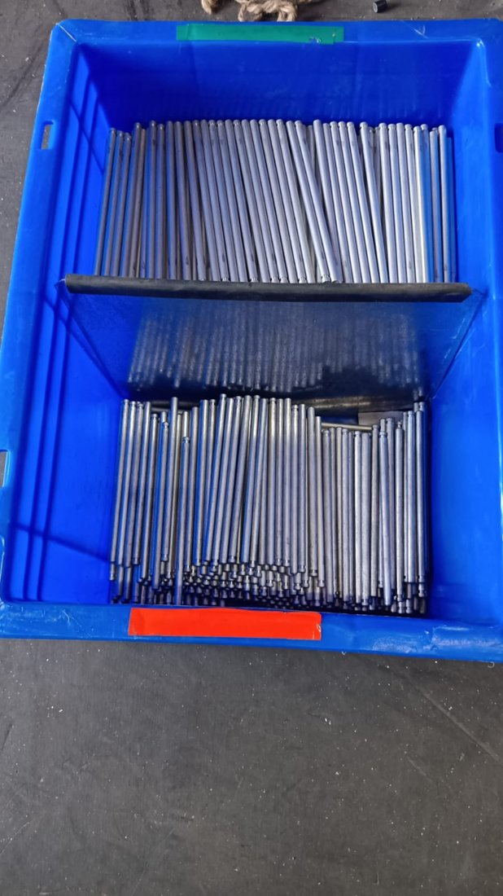
Figure 4: Physical FIFO Arrangement for Spare Parts
The same type of bin seen from above. The divider separates two groups of rods, with a red marker on the near rim and a green marker on the far rim, consistent with the front (old) and rear (new) compartments described in Section 5.1.
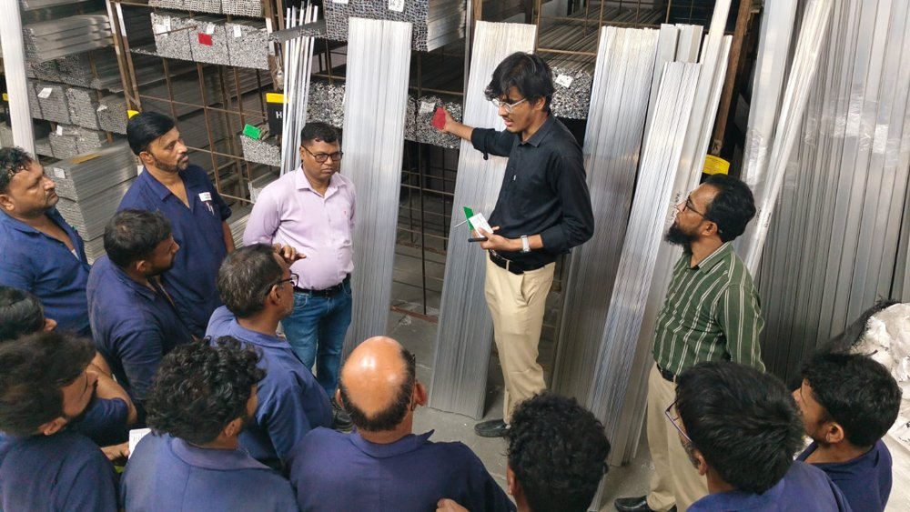
Figure 5: Red/Green Stock Identification for Bulky Extrusion Materials
Stores staff being briefed on red and green stock identification at the extrusion racks; the presenter holds a red tag and a green tag. The video below walks along the extrusion racks, where red and green tags are fixed on the stacked bundles. Double-click the video to play it in Word.
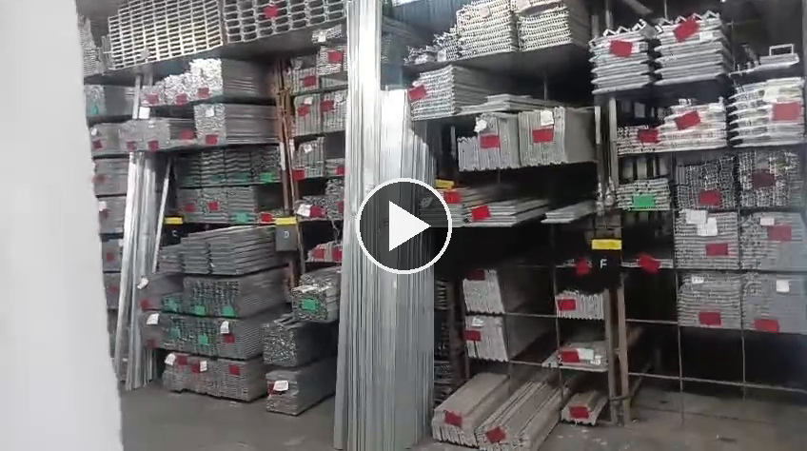
Figure 5 (video): Extrusion Rack Walkthrough Showing Red and Green Stock Tags
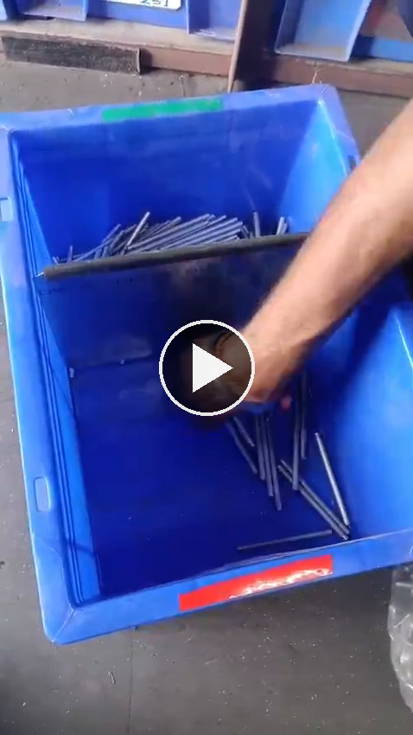
Figure 6: FIFO Stock Rotation and Replenishment Sequence (video)
Operator working through a spare-parts bin: stock is issued from the front compartment, the divider is handled, and the bin returns to a two-compartment arrangement with stock on both sides of the divider. Double-click the video to play it in Word.
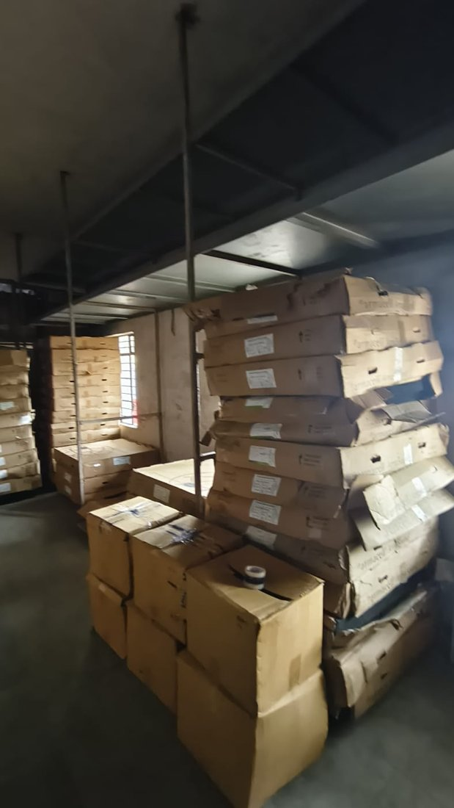 | 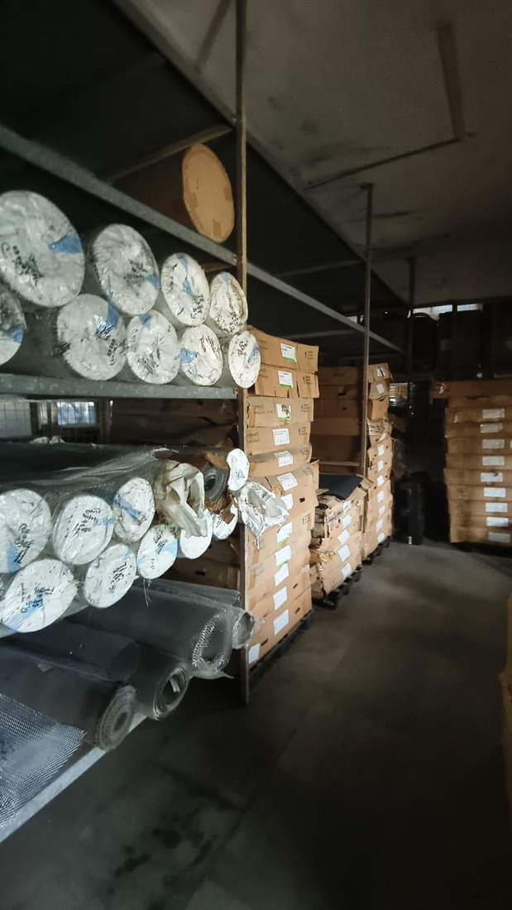 | 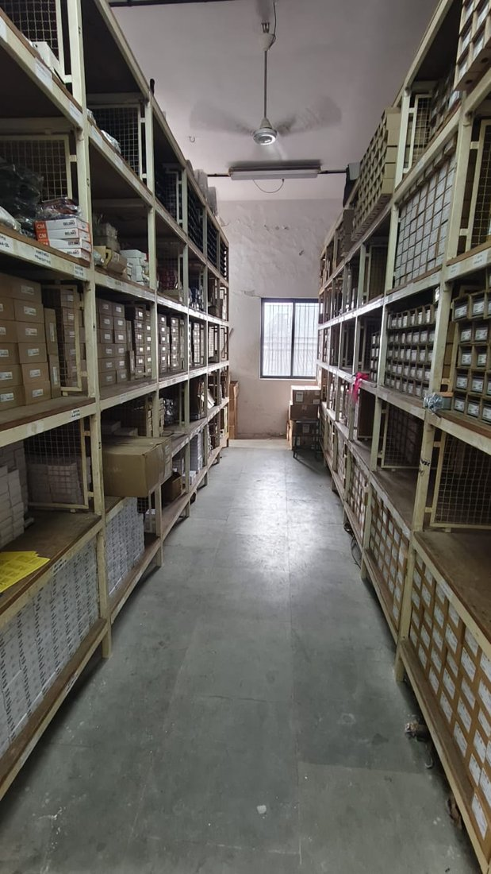
Figure 7: Physical FIFO Arrangement for Other Material Categories
Storage areas for other material categories: carton stock (left), wrapped rolls on racks beside carton stacks (centre) and shelved boxed items in an aisle (right). The category and FIFO marking arrangement for each area are to be confirmed.

15. Conclusion
At COSMOS, FIFO identification relied on dust-based visual judgement. In response, a low-cost physical FIFO arrangement was designed using existing bins and waste GI sheet pieces. Spares use a front/rear compartment system separated by a GI-sheet divider, bulky extrusion materials use red/green identification with red issued first, and the FIFO concept was applied to six further material categories.
The design gives a defined way of selecting stock for issue and a defined replenishment sequence. The operator time observations recorded during the internship are not before-and-after measurements, and the motion analysis is qualitative, so no time, motion, space or cost benefit is claimed. A structured time and motion validation, as set out in Sections 8 and 9, would quantify the improvement.

