SUMMER INTERNSHIP PROJECT | COSMOS
Binning, Labeling & Storage Location Optimization – COSMOS
Department-wise storage organization, rack and bin identification, and visual quantity control
Report by | Company | Programme
Mahir Valani | Cosmos Air Distribution Products | MBA – Summer Internship Project

1. Executive Overview
During the Summer Internship at Cosmos Air Distribution Products (COSMOS), an organized, department-wise storage system was established for the store racks. The work combined three integrated elements: binning, storage location allocation, and labeling. Suitable bins were selected for the existing racks, each rack was assigned to one department, materials were placed by weight and accessibility, and every rack and bin was given a consistent identity.
Labeling was the foundation of the system. A physical arrangement can only be used reliably when each rack, bin and material carries a consistent identification. Each bin label therefore links the material to its item name, software code, minimum quantity, storage location and displayed current quantity.
The design intent was to make material retrieval easier, improve operator accessibility and reduce unnecessary movement. The average time to retrieve a material is reported to have reduced from about 4–5 minutes to about 2–3 minutes (Section 11). These are approximate reported averages and not formal time-study records.

2. Objective and Scope
The objective was to establish an organized, department-wise storage system by selecting suitable bins for existing racks, assigning materials to specific locations, standardizing rack and bin identification, and enabling operators to identify materials and update displayed quantities easily.
Element | Scope of work
Binning | Selecting suitable bin dimensions to utilize the available rack space
Storage location allocation | Assigning racks to departments, placing materials in designated positions, organizing by weight and accessibility
Labeling | Identifying racks, bins, materials, storage locations, minimum quantities and displayed current quantities

3. Binning and Labeling Methodology
The work followed a seven-step sequence, from physical measurement through to a manually updated quantity display.
Rack measurement and bin selection
▼
Department-wise rack allocation
▼
Weight-based material placement
▼
Rack, level and position coding
▼
Standardized rack and bin labels
▼
Label generation using Word and Excel
▼
Writable quantity field

4. Rack Measurement and Bin Selection
The dimensions of the existing racks were assessed first. Based on the usable rack space, suitable bin sizes were selected and ordered so that the available dimensions could be utilized efficiently and the maximum practical number of bins accommodated.
- Assess rack length, breadth/depth and usable height.
- Identify suitable bin dimensions.
- Evaluate how the bins fit within the available rack space.
- Consider practical accessibility and material handling.
- Finalize bin sizes and quantities for procurement.
The selected sizes and order quantities are tabulated in Appendix A. Bin dimensions (length, breadth, height) are distinct from the order quantity, which is the number of bins of that size.

5. Department-wise Rack Allocation
Every rack was designated for one specific department. Materials were organized by department so that, when a production job or requirement arose, the operator could go directly to the corresponding rack instead of searching across unrelated storage areas.
Operational logic: Department-specific rack allocation → clearer storage organization → less searching across racks → potentially lower retrieval time and unnecessary operator movement.
This was an intentional part of the storage design and not merely a labeling exercise.

6. Weight-based Material Placement
After the bins arrived and storage locations were assigned, materials were arranged vertically according to weight and handling requirements.
Rack level | Material placed | Purpose
Upper levels | Lighter materials | Easier reach and handling at elevated positions
Lowest levels | Heavier materials | Avoids lifting heavy items from elevated positions, subject to safe handling practices

The purpose was to improve accessibility, reduce unnecessary handling effort and make retrieval more practical for operators. This supports the time-and-motion objective: operators can access materials more conveniently, spend less time handling or repositioning items, and avoid unnecessary movement while retrieving materials.

7. Rack, Level and Position Coding System
A structured location identification system identifies the department and the exact physical position of each bin.
Structure: Department Prefix – Rack Number – Level Number – Position Number
Code segment | Meaning in the example RD-R5-L2-P2
RD | First two letters identifying the department
R5 | Rack number 5
L2 | Level 2 of the rack
P2 | Position 2 on that level

The code lets the operator navigate from the department to the rack and then to the exact level and position, reducing ambiguity and supporting consistent identification across the store.
Each rack level also carries an index board listing the item names and software codes stored at that level (Rack No. 5, Levels 1 to 3, in Figure B2c). On the Level 2 board the Round Diffuser Rod NS 225 – 97 mm (SI/SP-201.2) is the second entry, consistent with Position 2 in the example code.
Software code vs. location code: the software code (for example SI/SP-201.2) identifies the item in the system. The location code (for example RD-R5-L2-P2) identifies where the bin is physically stored. The two are separate fields on every label.

8. Standardized Label Design
Every rack was labeled for its designated department, and each bin received an individual label with five fields: Item Name, Software Code, Minimum Quantity, Current Location and Current Quantity.
Field | Round Diffuser Rod | Linear Grille Frame
Item name | Round Diffuser Rod – NS 225 – 97 mm | Linear Grille Frame – 16 mm – EE
Software code | SI/SP-201.2 | SI-EX-10.1
Minimum quantity | 500 | 6000
Current location | RD-R5-L2-P2 | —
Current quantity | 791 (handwritten) | —
The quantity 791 is the value visible in the photograph and is not a claim about current inventory.
Standardized labels connect the physical material to its item code, designated location, minimum quantity and displayed current quantity. Photographs of both labels are provided in Appendix B.

9. Word–Excel Label Generation Process
A compact standardized label template was created in Microsoft Word on an A4 page and connected to an Excel file holding the material information. The exact commands used are not recalled; the probable method is Microsoft Word Mail Merge with Excel as the data source.
- Maintain material information in structured Excel columns.
- Create the label layout in Word.
- Connect Word to the Excel data source.
- Insert the relevant merge fields.
- Preview the labels and check data alignment.
- Generate and print the labels.
- Attach each label to the correct bin after verifying the material and location.
The workflow is shown in Appendix C.

10. Writable Quantity-Update Mechanism
Each printed label includes a writable quantity field. A white magnetic-sheet surface attached to a GI sheet/surface allows the store operator to write the current quantity with a marker, erase the old value and enter the revised quantity.
Category | Fields | How maintained
Fixed identification | Item name, software code, minimum quantity, current location | Printed once through the label template
Manually updated | Current quantity | Written and erased by the operator on the magnetic surface

This allows the displayed quantity to change without reprinting the whole label whenever stock changes. The field is a manual visual-control mechanism and is not synchronized automatically with ERP, Excel or any other digital inventory system.

Illustrative quantity-update example
The following example is illustrative and is not an actual stock transaction from the photographs.
Transaction | Quantity
Opening stock | 1,200 units
Issued to production | 350 units
Received into stock | 150 units
Closing stock | 1,000 units
Closing stock = Opening stock − Issues + Receipts: 1,200 − 350 + 150 = 1,000 units
After recording the transactions through the applicable store procedure, the operator would update the writable field to display 1,000. Assuming an illustrative minimum quantity of 500 units, the displayed stock is above the minimum. The handwritten quantity is a visual reference and should be reconciled with physical stock and the applicable inventory records.

11. Time Study, Motion Study and Operator Movement
The storage arrangement was designed to make the operator’s work easier and reduce unnecessary movement and retrieval time. Two industrial engineering concepts frame this intent.
Concept | Definition | Relevance to this work
Time study | Measuring the time required to complete an activity, such as locating and retrieving a material | Retrieval time is the activity the design aims to shorten
Motion study | Examining the movements performed during an activity to identify unnecessary movement and handling | Searching, walking between racks and lifting from elevated positions are the movements the design aims to reduce

Design decision | Intended effect on the operator
A. Department-wise rack allocation | Operator identifies the relevant storage area quickly for a department-specific job
B. Clear rack and bin identification | Rack labels, location codes and bin labels identify the rack, level, position and material systematically, reducing searching across locations
C. Weight-based vertical arrangement | Lighter items above and heavier items at the lowest level reduce retrieval of heavy items from elevated positions and ease routine handling
D. Bin standardization | Bins selected to rack dimensions create a structured arrangement and make individual locations easier to define

E. Integrated operational logic
Rack measurement and suitable bin selection
▼
Department-wise rack allocation
▼
Weight-based material placement
▼
Rack, level and position identification
▼
Standardized bin labeling
▼
Easier material identification and retrieval
▼
Potential reduction in unnecessary operator movement and retrieval time

Worked example: retrieval cycle for one material
The cycle below starts when a Material Requisition Slip (MRS) reaches the store and ends when the displayed quantity is updated. It is the activity that a time study would measure and a motion study would analyse.
Stage | Before the arrangement | After the arrangement
1. MRS reaches the store | Operator reads the required material | Operator reads the required material
2. Go to the respective department | Search across storage areas to reach the right rack | Goes directly to the rack dedicated to that department
3. Identify the material | Look through bins to find the material | Location code, level board and bin label identify rack, level, position and item
4. Take the material | Material taken once found | Lighter items reached on upper levels, heavier items on the lowest level
5. Update quantity | Quantity updated after issue | Operator rewrites the current quantity on the writable label
Average time per material | Approx. 4–5 minutes | Approx. 2–3 minutes

Indicative saving: on the midpoints of the reported ranges (4.5 and 2.5 minutes), the saving is about 2 minutes per material, or roughly 40–45 percent. The range of the two estimates is 1 to 3 minutes. This is derived from approximate reported averages.
Illustration only | Before | After
MRS with 10 materials (assumed) | 40–50 minutes | 20–30 minutes
This illustration assumes 10 materials per MRS and is not an actual COSMOS record.
Time study view: stage 1 to stage 5 are timed from MRS receipt to quantity update, giving the 4–5 and 2–3 minute averages. Motion study view: stages 2 to 4 are examined for walking between racks, searching bins, and reaching or lifting. Department-wise racks shorten stage 2, coding and labels shorten stage 3, and weight-based levels ease stage 4.
The times are approximate averages reported from store operations. They are not stopwatch records, so a recorded before-and-after time study over a sample of MRS transactions would confirm them.

12. Operational Benefits and Limitations

Benefits
- Systematic use of rack space through suitable bin selection
- Clearer department-wise storage organization
- Easier identification of the correct rack and bin
- More practical access to materials through weight-based vertical placement
- Reduced need to search across unrelated storage locations
- Potential reduction in retrieval time, unnecessary movement and handling effort
- Improved visual availability of displayed stock quantities
- More consistent material identification through standardized labels

Limitations
- Before-and-after times (4–5 and 2–3 minutes per material) are approximate reported averages and it can vary
- Displayed quantities are updated manually and depend on operator discipline and reconciliation with inventory records

13. Conclusion
The binning, labeling and storage location work gave the store a structured system: bins matched to racks, racks dedicated to departments, heavier materials placed low and lighter materials high, a four-part location code, and standardized bin labels with a writable quantity field. Together these elements were designed to make materials easier to identify and retrieve and to reduce unnecessary operator movement. The average retrieval time per material is reported to have fallen from about 4–5 minutes to about 2–3 minutes; a recorded before-and-after time study would confirm this.

Appendix A — Bin Dimensions and Order Quantities
Bin sizes and quantities as recorded in the handwritten sheets (Figures B1a and B1b), with the CC and CH prefixes as written. Unit of measurement to be confirmed.
S. No. | Prefix | Length | Breadth | Height | Quantity (bins)
1 | — | 275 | 400 | 400 | 72
2 | — | 295 | 400 | 400 | 24
3 | — | 345 | 400 | 400 | 16
4 | — | 540 | 360 | 400 | 12
5 | CC | 300 | 200 | 200 | 36
6 | CC | 400 | 300 | 320 | 30
7 | CH | 540 | 360 | 400 | 12
8 | CH | 650 | 450 | 315 | 15
Total bins ordered: 217

Appendix B — Actual Rack and Bin Label Photographs
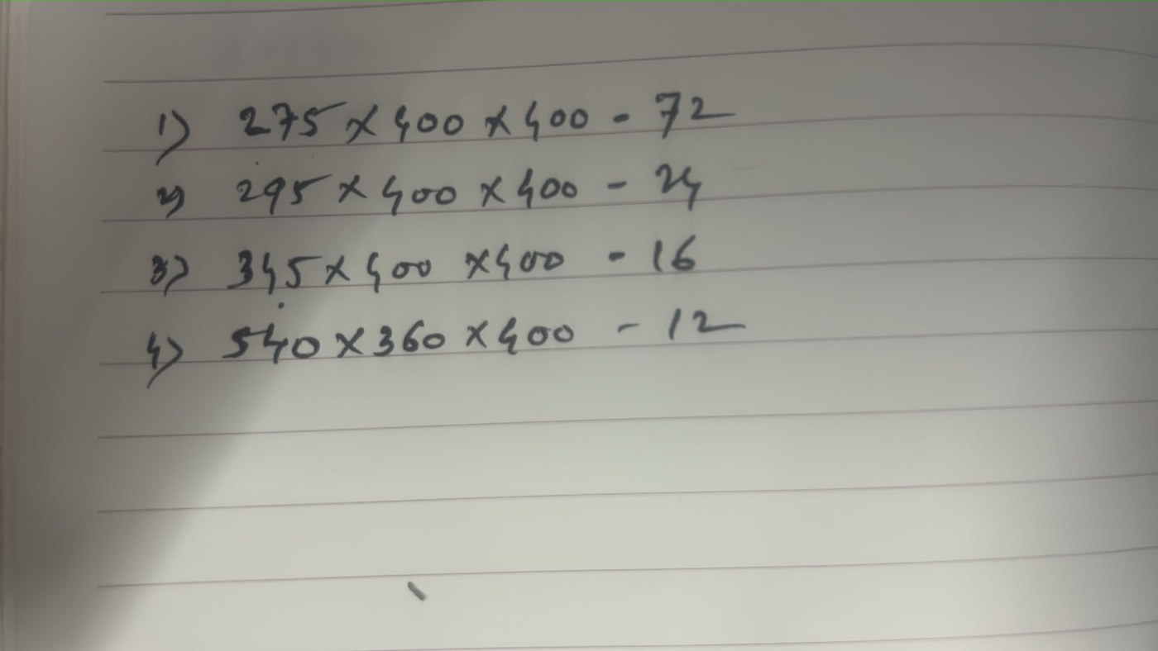
Figure B1a: Handwritten bin dimensions and order quantities (sheet 1)
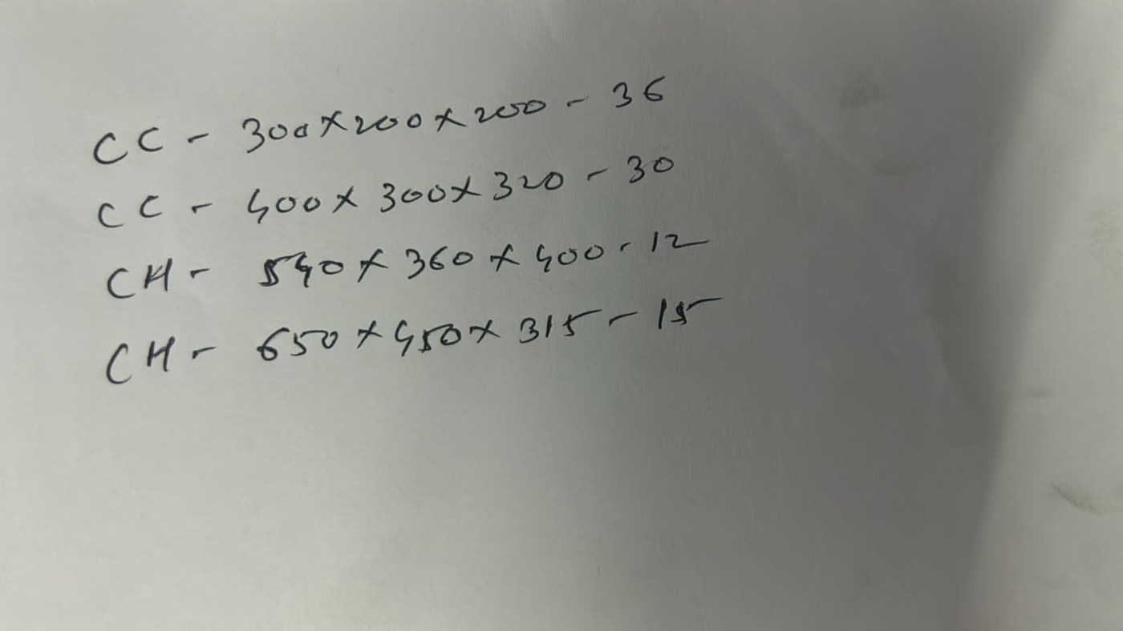
Figure B1b: Handwritten bin dimensions and order quantities with CC and CH prefixes (sheet 2)

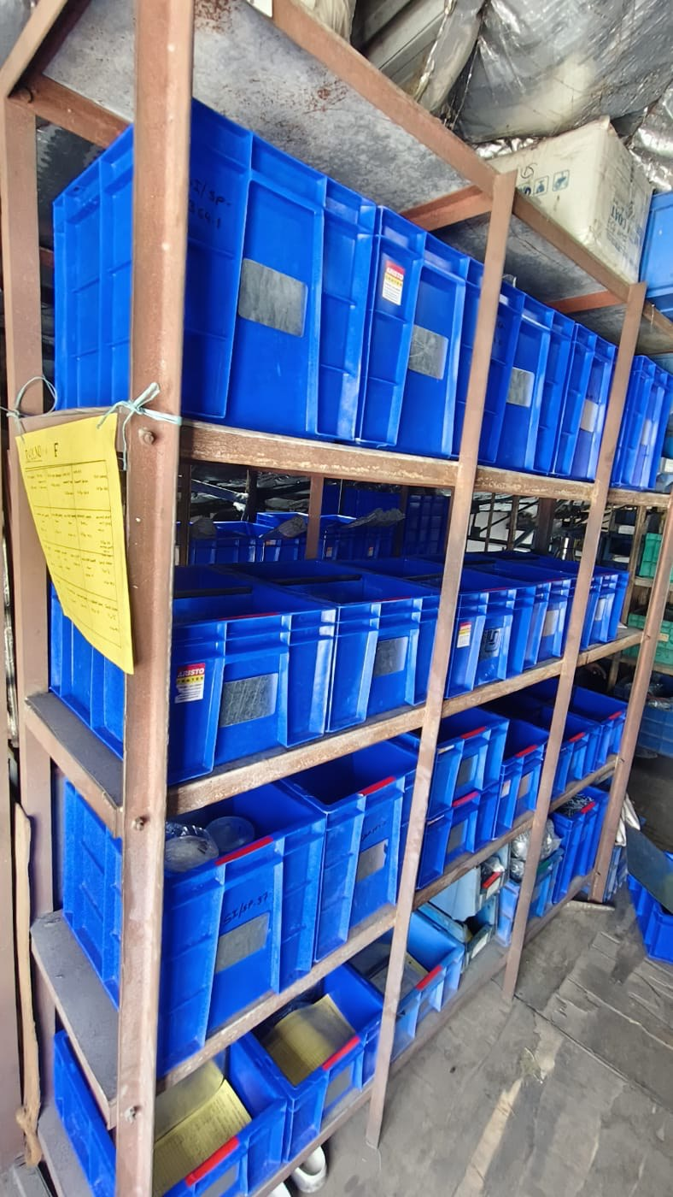  Figure B2a: Blue bins arranged within the rack | 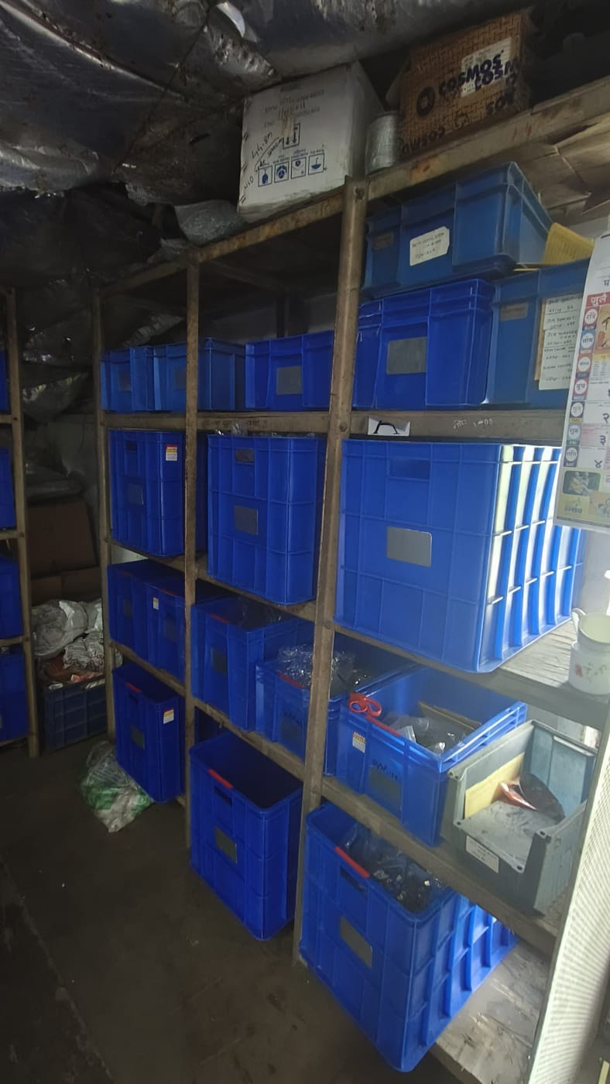  Figure B2b: Blue bins arranged within the racks, second view | 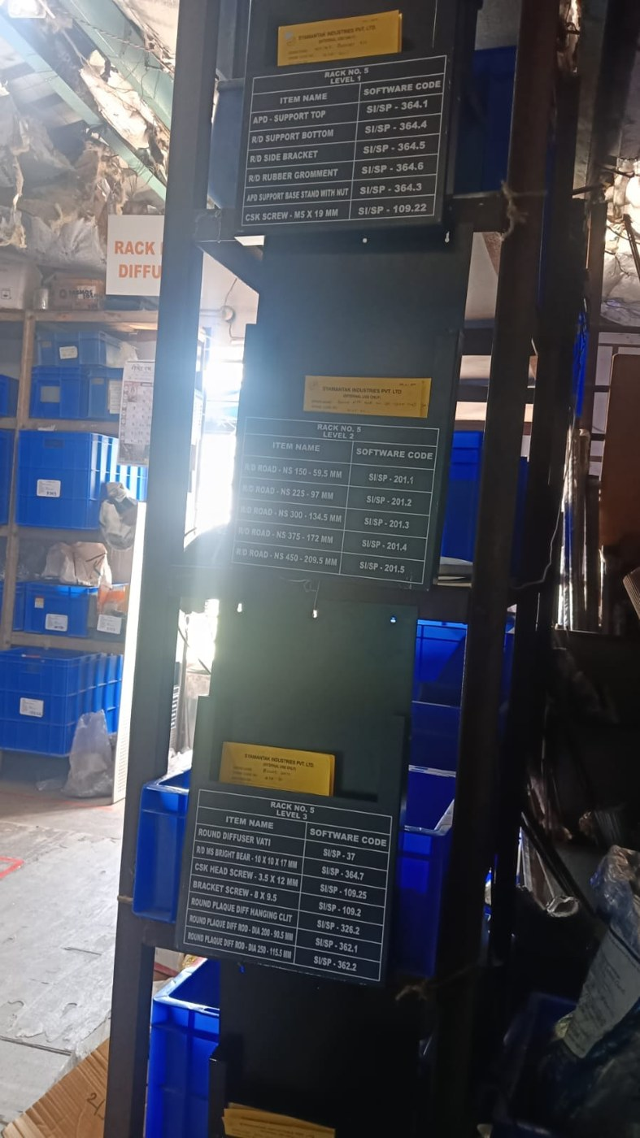  Figure B2c: Rack No. 5 level index boards (Levels 1 to 3)
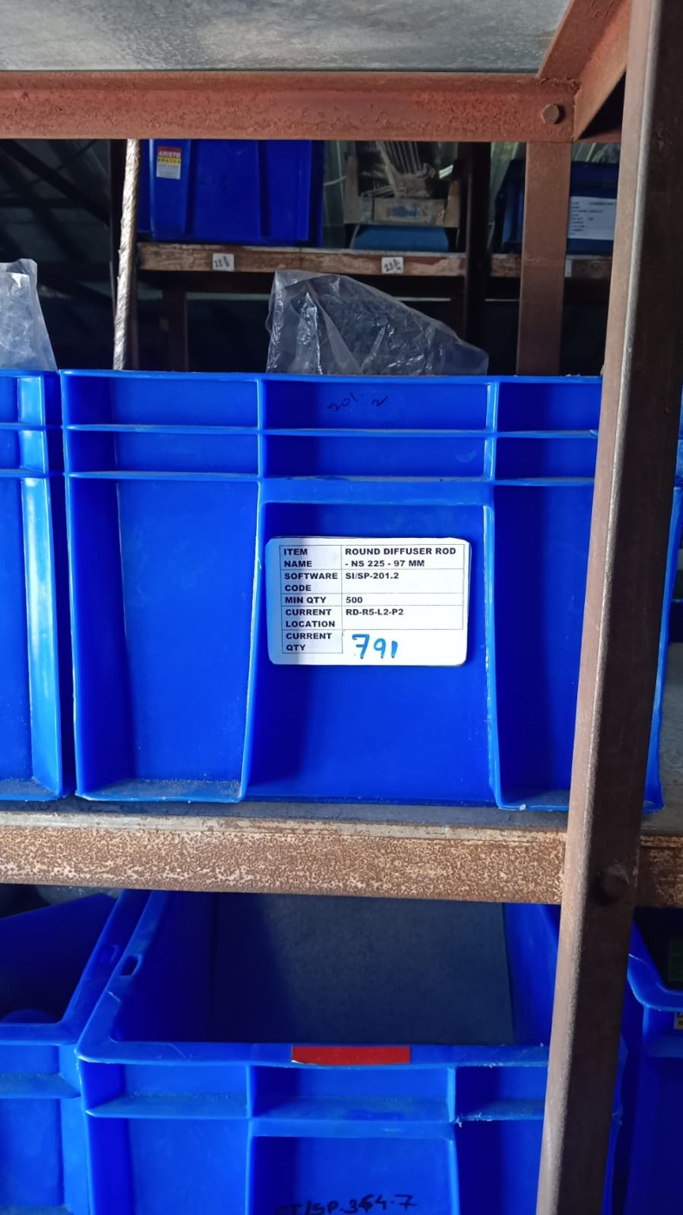
Figure B3: Round Diffuser Rod bin label (RD-R5-L2-P2, current quantity 791 handwritten)

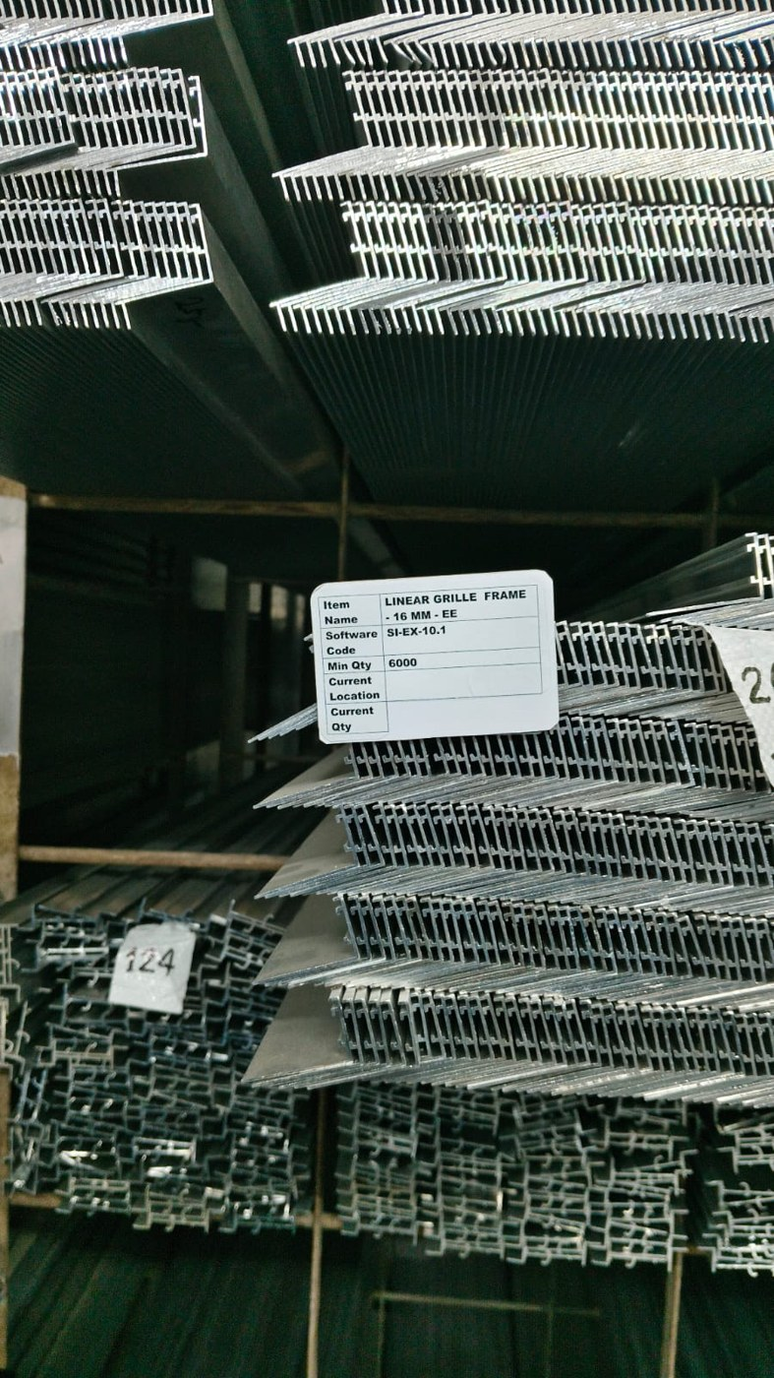  Figure B4a: Linear Grille Frame material with its label | 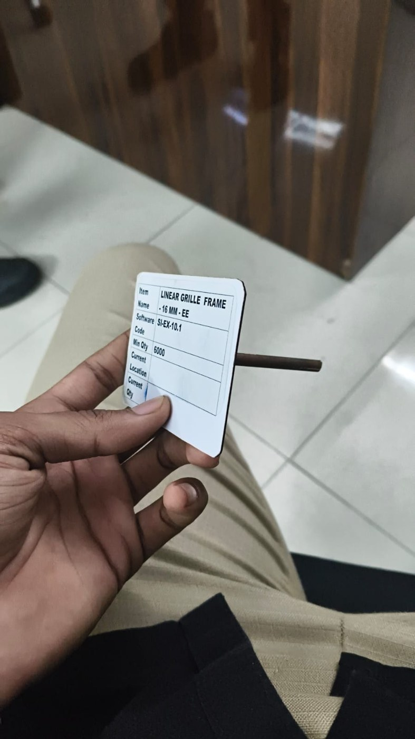  Figure B4b: Linear Grille Frame label, close view

Appendix C — Label Generation Workflow
1. Maintain material data in structured Excel columns
▼
2. Create the label layout in Word (A4)
▼
3. Connect Word to the Excel data source
▼
4. Insert the merge fields
▼
5. Preview labels and check data alignment
▼
6. Generate and print the labels
▼
7. Verify material and location, then attach label to bin

