SUMMER INTERNSHIP PROJECT REPORT | COSMOS
Kanban-Based Inventory Replenishment
Visual management, replenishment communication, time study and motion study

1. Workstream Title and Executive Summary
This section documents the Kanban implementation undertaken during the Summer Internship Project (SIP) at COSMOS (Syamantak Industries Pvt. Ltd.). It is a distinct intervention within a broader Stores improvement effort that also covered material classification, storage-space and rack design, and binning and labelling.
Problem. The factory reportedly experienced approximately one to two raw-material stockout incidents per month, meaning Production was ready to manufacture but the required raw material was unavailable. Separately, an internal Stores audit found the physical raw-material quantity to be lower than the quantity reflected in the records.
Approach. Replenishment communication was improved in three phases: (1) an interim email-based (Gmail) process between the Stores Assistant Manager, Stores Manager and Purchase team; (2) a physical Store Kanban Control Board with department-wise rows and green, yellow, red and blue status columns, supported by individual Kanban cards; and (3) a planned transition to a digital Kanban.
Reported outcome. Zero stockouts were reported during the subsequent observation period. The duration of that period has not been specified and the result has not been independently audited, so it is presented as a reported observation. Moving a card and the associated communication takes approximately 2–5 minutes (reported estimate), against a reported procurement lead time of approximately 20 days.
Evidence status. No annual saving, production-loss avoidance or percentage improvement is calculated, and the Kanban process is not credited with the whole of the improvement in inventory accuracy.

2. Business Background and Problem Statement
Two related but distinct problems were identified before the intervention:
- Material availability: required raw material was not always available when Production needed it, creating a risk of production disruption. The reported frequency was approximately one to two stockout incidents per month.
- Inventory accuracy: an internal Stores audit identified differences between recorded stock and physically available stock, with the physical quantity lower than the recorded quantity.
The assignment was to help improve the Stores process through better inventory organisation, visibility, replenishment communication and control mechanisms. The Kanban workstream is one part of that effort; improvements arising from classification, rack design and binning and labelling are not attributed to Kanban.

3. Project Objectives
The Kanban initiative aimed to:
- Establish a visible mechanism for identifying stock that requires replenishment.
- Compare current quantities against the applicable minimum or reorder levels.
- Trigger replenishment communication before material becomes unavailable.
- Identify critical and fast-moving items requiring priority attention.
- Track the status of replenishment orders.
- Improve coordination between Stores and Purchase.
- Reduce raw-material stockouts and support uninterrupted production.
- Establish a physical Kanban process that can eventually be transitioned to digital Kanban.

4. The Physical Store Kanban Control Board
The reference implementation is the Store Kanban Control Board, titled “Syamantak Industries Pvt. Ltd. — Store Kanban Control Board — Visual Replenishment & Inventory Control”. Exhibit A shows the board.
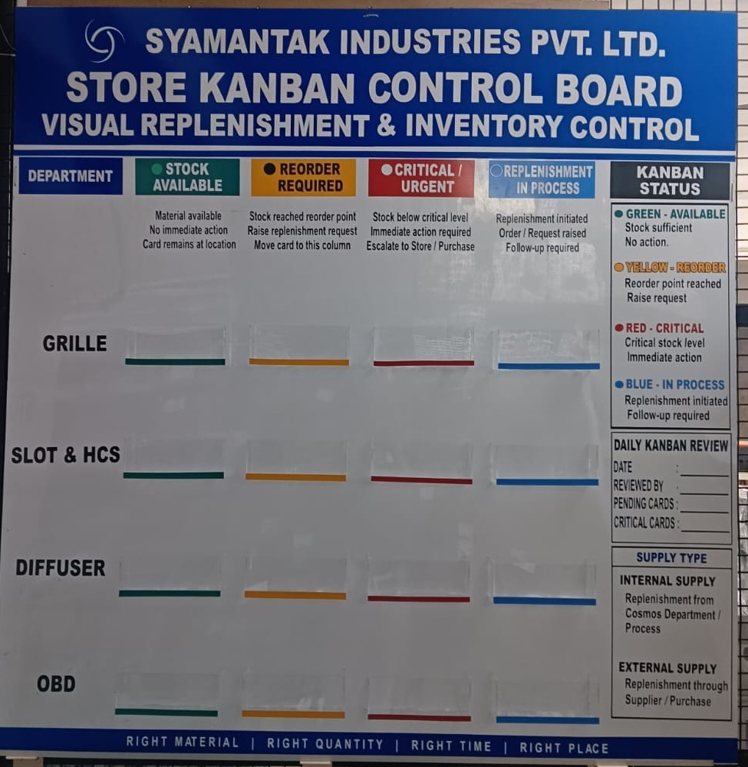
Exhibit A: Store Kanban Control Board (reference implementation)
The board has a department column and four operational status columns, with a card pocket for each department in each status column. Its footer carries the principle that governs the design: Right Material | Right Quantity | Right Time | Right Place.
Board column | Colour | Board wording | Operational meaning
STOCK AVAILABLE | Green | Material available. No immediate action. Card remains at location. | Material is available and no immediate action is needed.
REORDER REQUIRED | Yellow | Stock reached reorder point. Raise replenishment request. Move card to this column. | Replenishment request needs to be raised; the card moves to this column.
CRITICAL / URGENT | Red | Stock below critical level. Immediate action required. Escalate to Store / Purchase. | Critical or urgent condition; immediate action and escalation. A priority designation, not a mandatory stage for every card.
REPLENISHMENT IN PROCESS | Blue | Replenishment initiated. Order / Request raised. Follow-up required. | Order or request has been raised; follow-up continues until the material arrives.

Green, yellow, red and blue are replenishment statuses. Red is a critical or urgent designation and is not a stage that every card must pass through.
The board also includes three supporting panels:
- Kanban Status legend: green (available), yellow (reorder), red (critical) and blue (in process), each with a short action note.
- Daily Kanban Review: fields for Date, Reviewed By, Pending Cards and Critical Cards.
- Supply Type: Internal Supply (replenishment from Cosmos Department / Process) and External Supply (replenishment through Supplier / Purchase).
This board is the reference implementation. It is not claimed that every Stores area already has a board.

5. Department-Wise Visual Management
The board has a separate row for each of four departments: GRILLE, SLOT & HCS, DIFFUSER and OBD. Each row has its own positions for the green, yellow, red and blue columns, so operators and Stores personnel can go straight to the relevant category instead of searching a single undifferentiated list.
The intended operational advantages of this arrangement are:
- Faster visual identification of the relevant department’s cards.
- Easier identification of pending replenishment requirements.
- Better visibility of critical items.
- Less need to search through unstructured information.
- Clearer daily review of pending and critical cards.
- More standardised communication between operators and Stores management.
These are the design’s intended benefits and have not been measured. The same department-wise approach is intended to be prepared for the other Stores areas, with cards selected according to their materials, departments, locations and suppliers. That extension is not yet complete.

6. Kanban Card Standardisation and Material Identification
Each material has an individual Kanban card. The card register supplied with this workstream contains 112 cards in a common template. Each card carries a “Kanban Card” heading with its supply type, the Syamantak Industries Pvt. Ltd. name and COSMOS branding, and the following fields: Material Name, Software Code, Rack Location, Department and Supplier. Most cards also show a profile drawing of the extrusion.
Together these fields link a specific material to its identity, department, storage location and supplier. This supports reliable identification and replenishment coordination. The drawing supports visual identification of the component only; it is not evidence of stock quantity or reorder quantity. All 112 cards in the register are marked External Supply.
Exhibits B1 to B3 reproduce three representative cards from different departments and suppliers.
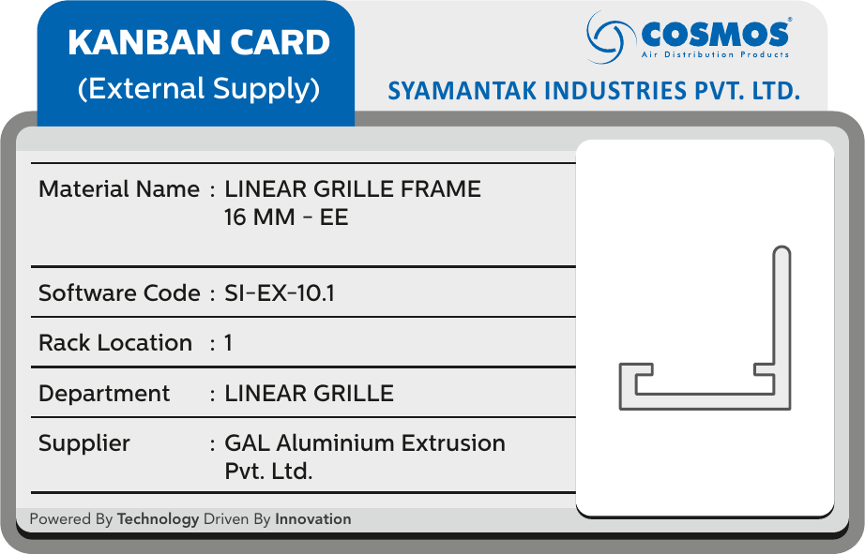 | Exhibit B1. Card 1 of the register  Material Name: LINEAR GRILLE FRAME 16 MM - EE  Software Code: SI-EX-10.1  Rack Location: 1  Department: LINEAR GRILLE  Supplier: GAL Aluminium Extrusion Pvt. Ltd.
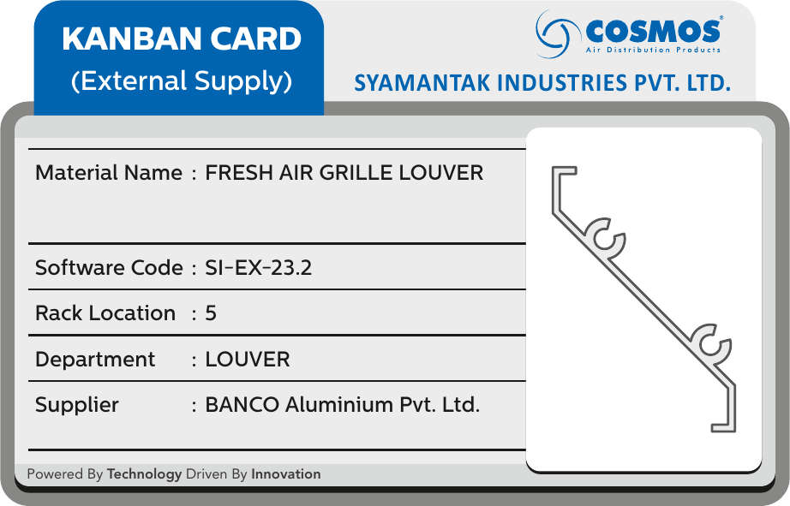 | Exhibit B2. Card 30 of the register  Material Name: FRESH AIR GRILLE LOUVER  Software Code: SI-EX-23.2  Rack Location: 5  Department: LOUVER  Supplier: BANCO Aluminium Pvt. Ltd.
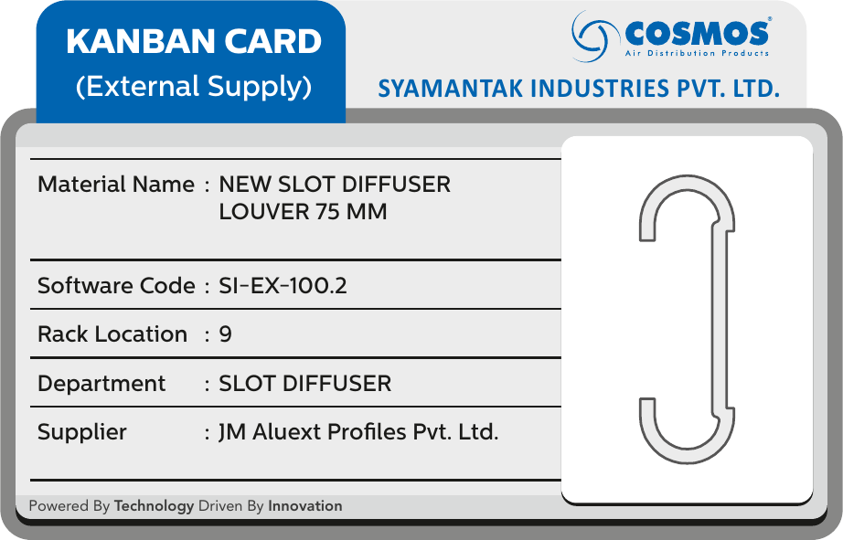 | Exhibit B3. Card 60 of the register  Material Name: NEW SLOT DIFFUSER LOUVER 75 MM  Software Code: SI-EX-100.2  Rack Location: 9  Department: SLOT DIFFUSER  Supplier: JM Aluext Profiles Pvt. Ltd.
The complete 112-card register is maintained separately as supporting documentation (Appendix A summarises its contents). The card template does not include a minimum or reorder-level field, so the thresholds against which stock is compared are held outside the card.

7. AS-IS Process — Before the Intervention
The historical process is documented only to the extent it was reported:
- Operators and Stores personnel relied on the existing stock-information and replenishment practices.
- Stockouts occurred approximately one to two times per month, according to the reported historical experience.
- Production could be ready to manufacture while the required raw material was unavailable.
- An internal audit identified discrepancies between recorded stock and physically available stock.
- A more structured mechanism was required to make low-stock requirements visible and to communicate replenishment needs.
Figure 1 presents this situation across four lanes. The detailed sequence of approvals, communications and purchase-order updates in the existing process was not documented and is not reconstructed here.

7.1 AS-IS Swimlane Diagram
PRODUCTION | STEP 1  Requires raw materials | → | STEP 2 — OBSERVED PROBLEM 1  May be unable to proceed when the required material is unavailable |  | OBSERVED PROBLEM 1: RECURRING STOCKOUTS  Reported at approximately one to two raw-material stockout incidents per month. Production was ready to manufacture but the required raw material was unavailable.
STORES OPERATOR | STEP 1 — OBSERVED PROBLEM 2  Checks or updates stock information through the existing process | → | STEP 2  Identifies material unavailability or insufficient stock when it occurs  ▼ to Stores Management
STORES MANAGEMENT |  |  | STEP 3  Coordinates material availability and replenishment using the existing process  ▼ to Purchase Team |  | OBSERVED PROBLEM 2: RECORDED vs PHYSICAL STOCK  An internal Stores audit found the physical raw-material quantity to be lower than the quantity reflected in the records.
PURCHASE TEAM |  |  | STEP 4  Handles procurement through the existing process, where applicable
Figure 1: AS-IS Raw-Material Availability and Replenishment Process
Production requires raw material and may be unable to proceed when the material is unavailable (Problem 1). Stores Operators check or update stock information through the existing process; the audit later found recorded and physical quantities to differ (Problem 2). Stores Management and the Purchase Team handle availability and procurement through existing processes whose detailed steps are not documented.

8. Interim Improvement — Email-Based Communication (Phase 1)
Before the physical Kanban process was implemented, an interim email-based (Gmail) communication process was introduced to improve visibility and coordination while the physical system was being established. The sequence was:
- The Stores Assistant Manager compiles current stock quantities and identifies items requiring reorder.
- The Assistant Manager emails the stock and reorder information to the Stores Manager.
- The Stores Manager communicates the requirements to the Purchase team.
- The Purchase team processes the order according to the applicable procurement procedure.
- Stores follows up until the material arrives.
The process was manual and was not automated. It improved the structure of replenishment communication; no claim is made that the email process alone eliminated stockouts.

9. TO-BE Process — Physical Kanban System (Phase 2)

9.1 Stock Monitoring
The operator updates the relevant stock quantity on the material label and compares it with the applicable minimum or reorder level. When the quantity falls below the applicable threshold, the replenishment process is triggered. Reorder quantities, safety-stock levels and consumption rates are not specified in this report.

9.2 Kanban Card Status
The material’s Kanban card is moved to the appropriate status column:
- Green: stock available; no immediate replenishment action.
- Yellow: reorder required; the reorder point has been reached or the relevant threshold requires action.
- Red: critical or urgent stock condition requiring immediate action and escalation. For critical, fast-moving items, red provides additional visibility and priority. It is not a compulsory step for every material.
- Blue: replenishment is in process; the request or order has been raised and follow-up is required. The card moves to blue only when the request or order has actually reached that stage.

9.3 Communication and Replenishment Sequence
- The operator updates the stock quantity.
- Stock is compared against the applicable minimum or reorder level.
- When replenishment is required, the card moves from green to yellow.
- If the item is critical, the card is placed in red for urgent attention.
- Stores personnel compile and communicate the replenishment requirement.
- The Stores Manager coordinates with the Purchase team.
- Once the replenishment request or order is processed, the card moves to blue.
- The order is followed up while the material is in transit.
- When the material arrives and is available in Stores, the card returns to green.
Physical card movement, communication, purchase-order processing and material receipt are separate events. The card status should reflect the actual stage reached. Figure 2 shows the process across six lanes.

9.4 TO-BE Swimlane Diagram
PRODUCTION | STEP 1  Requires raw material | → | STEP 2  Uses material for manufacturing  ▼ |  |  |  |  |  |  |  |  |  |  |  | PRODUCTION CONTINUES  Continues production subject to material availability
STORES OPERATOR |  |  | STEP 3  Updates stock quantity | → | STEP 4  Compares quantity with minimum / reorder level; makes Kanban status visible | → | DECISION  Has stock reached the reorder trigger?  Yes ▼ | No  → | NO  Continue normal monitoring; card remains GREEN if stock is sufficient |  |  |  |  |  | ▲
STORES OPERATOR |  |  |  |  |  |  | YES — YELLOW  Move card to YELLOW; initiate replenishment communication  ▼ | → | IF CRITICAL — RED  Highlight card RED and escalate for immediate action |  |  |  |  |  | ▲
STORES ASSISTANT MANAGER |  |  |  |  |  |  | STEP 5  Compiles current stock quantities and reorder requirements | → | STEP 6  Sends interim email to Stores Manager (where this process applies)  ▼ |  |  |  |  |  | ▲
STORES MANAGER |  |  |  |  |  |  |  |  | STEP 7  Reviews requirements | → | STEP 8  Coordinates with Purchase  ▼ |  | BLUE — IN PROCESS  Follows replenishment; card status reflects actual order status |  | ▲
PURCHASE TEAM |  |  |  |  |  |  |  |  |  |  | STEP 9  Receives replenishment requirement | → | ▲  STEP 10  Processes purchase order per procurement procedure  ▼ |  | ▲
MATERIAL RECEIPT / STORES STOCK |  |  |  |  |  |  |  |  |  |  |  |  | STEP 11  Receives replenishment material | → | ▲  GREEN — AVAILABLE  Updates stock information; returns card to GREEN when material is available

GREEN — STOCK AVAILABLE  Material available; no immediate action. | YELLOW — REORDER REQUIRED  Reorder point reached; raise replenishment request. | RED — CRITICAL / URGENT  Stock below critical level; immediate action; not a compulsory stage. | BLUE — REPLENISHMENT IN PROCESS  Order / request raised; follow-up required.
Figure 2: TO-BE Physical Kanban Replenishment Process
The Stores Operator updates the quantity and tests it against the reorder trigger. If the trigger has not been reached, monitoring continues and the card stays green. If it has, the card moves to yellow (or red if critical) and the requirement passes through the Assistant Manager and Stores Manager to Purchase. The Stores Manager keeps the card status in line with the order status (blue), and receipt of material returns the card to green. The up-arrows in the right-hand column show that replenished material allows production to continue.

10. Time Study — Kanban Card Movement and Replenishment Communication
The reported estimate for moving the Kanban card through the relevant steps, together with the associated communication, is approximately 2–5 minutes. This is an approximate reported process time and not a measured reduction in procurement lead time.
Activity | Time | Evidence / Status
Stock quantity update and identification of reorder requirement | Separate time not provided | Requires separate measurement
Physical card movement | Separate time not provided | Requires separate measurement
Replenishment communication and related steps | Included in the reported overall estimate where applicable | Detailed breakdown unavailable
Overall card movement and associated communication | Approximately 2–5 minutes | Reported estimate
Procurement and material-arrival lead time | Approximately 20 days | Reported lead time

No times are assumed for the individual activities. A future time study should observe multiple reorder events, record start and end times for each step, and compare comparable pre- and post-intervention processes where data is available.

11. Motion Study — Physical Kanban and Replenishment Workflow
This is a qualitative description of the operator and Stores workflow. It is not a quantified motion study.
- Approach or identify the material storage location.
- Check or update the material’s stock quantity.
- Compare current stock with the applicable minimum or reorder level.
- Locate the Kanban board.
- Move the card to the appropriate status column.
- Communicate, or support communication of, the reorder requirement.
- Track the card’s progress as the order is processed.
- Return the card to green once replenishment has arrived and the material is available.
Physical relationship. Each card records a rack location, which ties the material to its storage position, while the board gives one central place where status is shown for all departments. The operator’s movement is therefore between the storage location and the board. The board’s department rows and colour-coded pockets mean that, once at the board, the operator goes directly to the right row and column.
Opportunities. Card handling can be standardised through one card per material and fixed pockets for each department and status. Unnecessary searching can be reduced through the department-wise rows and the Daily Kanban Review fields. Replenishment communication can be simplified by using the card’s fields (software code, rack location, supplier) as the common reference.
Operator walking distances, step counts, travel times and motion reductions have not been measured. If a quantified assessment is required, future observations should record distance between storage locations and the board, the number of handling actions, and the time for each movement.

12. Replenishment Lead Time
The reported replenishment lead time is approximately 20 days from ordering until the raw material arrives at the factory. Timely identification of reorder requirements is therefore essential. The Kanban mechanism is intended to trigger replenishment early enough to reduce the risk of material unavailability while the order is processed and transported.
This 20-day procurement lead time is distinct from the 2–5 minute card-movement and communication estimate. No evidence is presented that Kanban shortens the supplier lead time.

13. Operational Results and Reported Impact

Operational Impact of the Kanban Intervention
- Before the intervention, approximately one to two raw-material stockout incidents per month were reported.
- After implementation, zero stockouts were reported during the subsequent observation period.
- The internal Stores audit had previously identified differences between recorded and physically available quantities.
- The interim email process improved the structure of replenishment communication.
- The physical board provided a visible method of tracking stock status, critical items and replenishment progress.
- Department-wise grouping was intended to improve ease of use for workers and Stores personnel.
The observation period for the zero-stockout result has not been specified, and the result has not been independently audited. No annual savings, production-loss avoidance or percentage improvement is calculated, because validated supporting data is not available.
Improvement in inventory accuracy cannot be attributed to Kanban alone. Physical stock reconciliation and accurate quantity updates remain necessary controls, and the broader Stores improvements (classification, rack design, binning and labelling) contributed in their own right.

14. Three-Phase Implementation Roadmap
Phase | Mechanism | Status | Description
Phase 1 | Email-based (Gmail) communication | Introduced as interim control | Stores Assistant Manager compiles stock and reorder information and emails the Stores Manager, who communicates requirements to Purchase.
Phase 2 | Physical Kanban control board and cards | Implemented on the reference board | Department-wise board with green, yellow, red and blue status columns; individual material cards; Daily Kanban Review.
Phase 3 | Digital Kanban | Planned | Transition of the physical process to digital Kanban, carrying over its statuses, card fields and review routine.

Phase 2 is designed so that its statuses, card fields (material name, software code, rack location, department, supplier) and thresholds can carry over to a digital Kanban. Before the digital transition, the minimum and reorder levels for each material should be defined and recorded in a form that can be used digitally.

15. Limitations and Items for Verification
- Observation period: the period for the zero-stockout result is unspecified and not independently audited.
- Time data: individual activity times are not available; only the overall 2–5 minute estimate and the 20-day lead time are reported.
- Motion data: distances, step counts and travel times are not measured.
- Board coverage: the board is the reference implementation; extension to other Stores areas is not complete.
- Green column wording: the board reads “Card remains at location” for Green, whereas the process description refers to the card remaining in the green column. Confirm which describes actual practice.
- Departments: the board has four department rows (Grille, Slot & HCS, Diffuser, OBD), while the 112 cards carry fifteen department labels and none reads OBD. The mapping of card departments to board rows should be confirmed.
- Software codes: six codes appear on two cards each (SI-EX-27.2 on pages 8 and 64; SI-EX-77.4 on pages 44 and 45; SI-EX-50.1 on pages 46 and 90; SI-EX-100.2 on pages 60 and 62; SI-EX-105.1 on pages 68 and 88; SI-EX-106.1 on pages 72 and 89). The cards are preserved as supplied and should be checked.
- Page 67: the card for LINEAR DIFFUSER ‘T’ SECTION -2.5 (SI-EX-37.3) carries an added note that the section was not found and listing SI-EX-37.1 and SI-EX-37.2. It is preserved as supplied and should be verified.
- Board photograph: the photograph shows the card pockets without cards. A photograph with cards in place, if available, would show the board in use.

16. Conclusion
The Kanban workstream responded to two linked problems: recurring raw-material stockouts and a gap between recorded and physical stock. Replenishment communication was structured first through an interim email process, then through a physical, department-wise Kanban board with a standard card for each material, and a digital Kanban is planned as the next phase.
Zero stockouts were reported after implementation, over an observation period that has not been specified. The card movement and communication estimate of 2–5 minutes is a reported figure, and the 20-day procurement lead time is unchanged by the evidence presented. A structured time and motion study across multiple reorder events, and a defined observation window for stockouts, would allow the benefit to be quantified.

Appendix A: Kanban Card Register — Summary
The complete register of 112 Kanban cards is maintained separately as supporting documentation. All cards are marked External Supply. The cards by supplier and by department label are summarised below.
Supplier (as printed on cards) | Cards
GAL Aluminium Extrusion Pvt. Ltd. | 54
JM Aluext Profiles Pvt. Ltd. | 30
BANCO Aluminium Pvt. Ltd. | 23
RALCO Extrusion Pvt. Ltd. | 5
Total | 112

Department (as printed on cards) | Cards
SLOT DIFFUSER | 25
HCS DIFFUSER | 18
LINEAR GRILLE | 12
LOUVER | 12
GRILLE | 9
DIFFUSER | 8
FLOOR GRILLE | 8
DAMPER | 4
DOOR GRILLE | 4
LINEAR DIFFUSER | 4
DUCT DAMPER | 3
FILTER | 2
EGG GRILLE | 1
DUCT DIFFUSER | 1
HEPA BOX | 1
Total | 112

