SUMMER INTERNSHIP PROJECT REPORT | COSMOS
Additional Kaizen Initiatives and Operational Improvements
Projects 11–16: weight-based counting, bilingual SOPs and audit checklist, layout redesign, bin-box visualisation, worker recognition and mezzanine-floor safety

Chapter Overview
This chapter documents six smaller Kaizen initiatives undertaken alongside the primary Stores Optimization workstreams. They are reported separately and are not merged into those workstreams. Each project follows the same structure: background, AS-IS, root cause and constraint, improvement, TO-BE, diagram, time and motion analysis, benefits and status, and evidence with recommendations. Completed improvements are distinguished from proposals, and reported figures are kept at the scope in which they were reported.
No. | Initiative | Implementation status | Reported result and qualification
11 | Weight-based counting | Implemented; standardised across Factory 1 and Factory 2 Stores for bulk hardware categories | 14 min 58 sec to 7 min 53 sec for a batch of three MRS transactions (approximately 47%); stopwatch records supplied. Not an individual-MRS figure.
12 | Bilingual SOPs and Store audit checklist | Work instructions VWI-01 (FIFO) and VWI-02 (Kanban) issued in English and Marathi; Daily Store Audit Checklist developed | No compliance percentage or error reduction is claimed; no records supplied.
13 | VAV assembly line relocation | Implemented; line moved from second floor to first floor | 18% reduction in material-handling time (reported); 120 minutes saved per day out of a 480-minute working day (stated). Observation sheets to be attached.
14 | Bin-box visualisation | Implemented; rack-level material boards in place | 2–3 minutes less search time per MRS (reported estimate; no formal before-and-after study).
15 | Worker Kaizen recognition | Introduced (prizes and Worker of the Month announced) | Two Kaizen ideas received: a month-end monetary reward for Kaizen contributions and an Operator of the Month award in each department (early outcome; not a quantified benefit).
16 | Mezzanine-floor safety | Implemented; wooden flooring replaced with steel flooring for worker safety | No quantified safety outcome; steel specification to be confirmed.

Evidence is drawn from the weight-based counting report, the FIFO and Kanban visual work instructions, the Daily Store Audit Checklist, the first-floor, second-floor and ground-floor layout drawings, a walk-through video of the racks, floor marking and mezzanine, and photographs of the mezzanine flooring. Where evidence was not supplied, a labelled placeholder marks the item needed.

Project 11: Manual Counting Time Reduction Through Weight-Based Counting

Background and Problem Statement
During Material Requisition Slip (MRS) preparation, small spare parts such as screws, bushes, spacers, aluminium rods and grille hardware were counted manually, one piece at a time. The initiative replaced this with weight-based counting using a digital weighing machine already available in the Stores.

AS-IS
- Counting method: manual, piece by piece, for each MRS transaction.
- Time behaviour: counting time increased with the number of pieces demanded.
- Effort and risk: the work was repetitive for the operator and carried a risk of miscounting, particularly in high-volume batches such as grille hardware requisitions.

Root Cause and Constraint
The root cause was that the count was obtained by handling every piece, so the time and effort scaled directly with quantity. The constraint was that no additional capital was to be spent, so the solution had to use equipment already in the Stores.

Improvement Implemented
A Gill Real Weigh digital weighing machine (stated in the source report to be ISO 9001:2015 certified, with a capacity of 4 kg) was used in its piece-count mode. A precisely counted sample of 10 pieces is weighed to establish the reference unit weight for each applicable spare type. The operator then places the required batch on the scale and the machine displays the count calculated from the batch weight. The method was standardised across Factory 1 and Factory 2 Stores for applicable bulk hardware categories.

TO-BE
Counting is a single weighing step per batch, supported by a one-time reference-weight setup for each spare type. Figure 11.1 compares the two processes.
AS-IS | STEP 1  MRS transaction requires spares | → | STEP 2  Pick the required batch of spares | → | STEP 3  Count manually, one piece at a time | → | STEP 4  Issue against the MRS
TO-BE | STEP 1  MRS transaction requires spares | → | STEP 2  Pick the required batch of spares | → | ▲  STEP 3  Place batch on scale in piece-count mode | → | STEP 4  Read the displayed count | → | STEP 5  Issue against the MRS
ONE-TIME SETUP PER SPARE TYPE | SETUP 1  Count exactly 10 pieces | → | SETUP 2  Weigh the 10-piece sample | → | ▲  SETUP 3  Reference unit weight established
Figure 11.1: AS-IS versus TO-BE Counting Process

Reference-Weight Calibration Method
- Select the spare type and count exactly 10 pieces by hand.
- Weigh the 10-piece sample to establish the reference unit weight.
- Place the batch to be issued on the scale; the machine calculates the quantity from the batch weight and the reference unit weight.
The method depends on an appropriate reference sample and on consistent part characteristics. If the pieces in a batch differ in weight from the sample, the displayed count will not be reliable. The 4 kg capacity of the machine also limits the batch size that can be weighed in one placement.

Recorded Time Study
The study used stopwatch records across three live MRS batches. Figure 11.2 reproduces the stopwatch readings.
  Before: 14 min 58 sec |   After: 7 min 53 sec
Figure 11.2: Stopwatch Records for Three MRS Transactions, Before and After
Parameter | AS-IS | TO-BE | Outcome
Time for three MRS transactions | 14 min 58 sec | 7 min 53 sec | 7 min 05 sec saved
Cycle-time reduction | — | Approximately 47% | Reported
Additional capital investment | — | Nil, using existing equipment | No new equipment

The comparison is for a batch of three MRS transactions, not for an individual MRS. The three transactions recorded are listed below and their slips appear in Figure 11.4.
MRS number | PPBOM reference | Date
SI/MRS/2026-27/1196 | PPBOM_15292 | 28/05/2026
SI/MRS/2026-27/1239 | PPBOM_15335 | 30/05/2026
SI/MRS/2026-27/1265 | PPBOM_15361 | 01/06/2026

AS-IS (manual) |  | 14 min 58 sec
TO-BE (weight-based) |  | 7 min 53 sec
Figure 11.3: Before-and-After Time Comparison for Three MRS Transactions (bar length proportional to time)
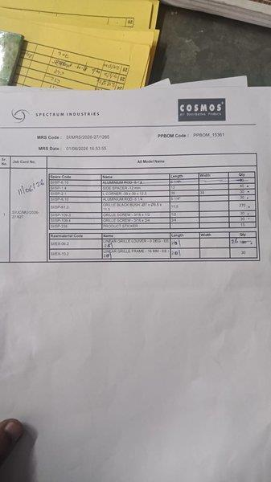 | 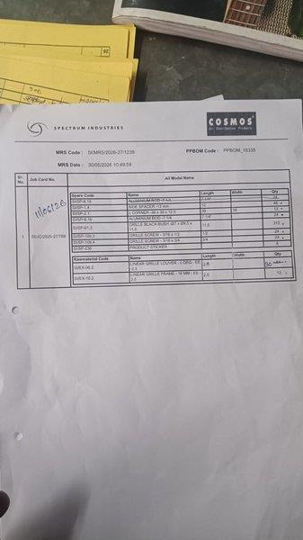 | 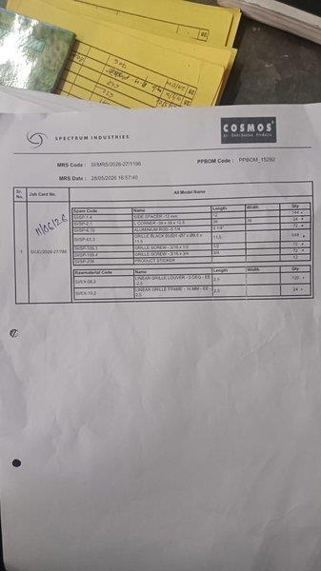
Figure 11.4: MRS Slips Used in the Time Study (SI/MRS/2026-27/1196, /1239 and /1265)
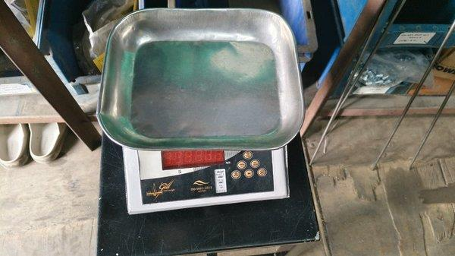
Figure 11.5: Gill Real Weigh Digital Weighing Machine Used in the Stores

Lean Analysis
Lean lens | Observation | Effect of the change
Repetitive processing | Piece-by-piece counting is a non-value-added step repeated for every MRS | Replaced by one weighing step per batch
Operator effort | Repetitive manual counting, increasing with quantity | Reduced; effort no longer scales with piece count
Miscount risk | Manual counting carried a risk of error in high-volume batches | Machine count expected to lower the risk; no error-rate data supplied

Benefits, Limitations and Status
Status: implemented and standardised across Factory 1 and Factory 2 Stores for bulk hardware categories. The measured benefit is the time saving recorded for the three-MRS batch. Reported qualitative benefits are lower operator effort, more consistent counting and a method that can be extended to other spare categories. A measured reduction in error rate is not claimed, because no numerical error-rate data is provided. The result rests on one set of three transactions, so it should not be extrapolated to all MRS types.

Evidence and Recommendations
- Evidence: the source report, the stopwatch photographs, the weighing-machine photograph and the three MRS slips.
- Recommend: repeat the study on more MRS batches, record the reference unit weight for each spare type, check the sample periodically, and record count discrepancies to allow an error-rate comparison.

Project 12: Bilingual SOPs and Store Audit Checklist

Background and Problem Statement
Stores activities such as FIFO stock rotation and Kanban replenishment depend on every worker applying the same method. Standardised visual work instructions, in English and Marathi, and a structured daily audit were developed to support that consistency.

AS-IS
The source material establishes the standard that was introduced but does not document the arrangement that preceded it. The baseline SOP position and the compliance gaps therefore require confirmation, and no gap is assumed here.

Root Cause and Constraint
A standard written only in English may not be equally usable by all Stores workers. The instructions were therefore issued in English and Marathi and in visual form, so that the procedure can be followed without relying on long text. Whether language was a documented cause of earlier non-compliance is not established by the source.

Improvement Implemented
- VWI-01 FIFO and VWI-02 Kanban, each issued as a visual work instruction in English and in Marathi.
- Daily Store Audit Checklist with 15 checkpoints, an audit summary, a corrective-action table, remarks, comments and sign-off fields.

FIFO Work Instruction (VWI-01)
The instruction carries the COSMOS and Syamantak Industries Pvt. Ltd. identity, with Department: Stores, Document No.: VWI-01 and Revision: 01. The effective date is 01/07/2026, the same on the English and Marathi versions. It sets out the following.
Section | Content of the instruction
1. What is FIFO | First In First Out: the material received first is issued first. This keeps stock rotating, reduces inventory ageing and prevents obsolete stock.
2. Colour identification | Red magnet (Issue First): marks the oldest material; always issue from the red magnet location. Green magnet (New Stock): marks the newly received material; place it on the latest stock stored on the shelf.
Rule | After the red-marked material is completely consumed, move the red magnet to the next oldest stock and place the green magnet on the newest stock.
3. Standard FIFO procedure | (1) Verify the material before storing. (2) Store the new material in the designated FIFO sequence. (3) Place the green magnet on the newly received material. (4) Ensure the red magnet identifies the oldest available material. (5) Always issue from the red magnet location. (6) After issuing, reposition the magnets to maintain FIFO. (7) Report any damaged or unidentified material to the supervisor.
4. Visual example | Correct: before issuing, red (Issue First) on the older stock and green (New Stock) on the newer stock; after issuing, move red to the next oldest and place green on the newest. Incorrect: issuing from the green location; storing new material in front of old material; not maintaining the magnets.
5. Do’s | Issue from the red magnet location; keep the green magnet on the newest stock; keep material labels visible; follow the designated storage sequence; inform the supervisor if FIFO cannot be maintained.
5. Don’ts (as numbered on the sheet) | Do not issue material marked with the green magnet; do not remove or interchange magnets without authorisation; do not mix different material batches; do not store new material in front of old material; do not remove identification labels.
6. Responsibility | Foreman: maintains the FIFO sequence and updates the red and green magnets. Assistant Manager: verifies FIFO compliance during daily inspections.

Kanban Work Instruction (VWI-02)
VWI-02 (Kanban, Visual Reorder System), Revision 01, Department: Stores, has the effective date 01/07/2026, the same on the English and Marathi versions. It carries the following content.
Section | Content of the instruction
Colour identification | Green (Available): stock is available; no action required. Yellow (Reorder Level): stock has reached the minimum level; inform the Purchase Department; the replenishment process should start. Red (Urgent Reorder): stock is below the minimum level; immediate replenishment is required; follow up with the supplier on priority.
Standard Kanban procedure | (1) Check stock level daily. (2) Compare current quantity with the minimum quantity on the label. (3) If stock reaches the minimum quantity, move the indicator or card to yellow. (4) Inform the Purchase Department. (5) If stock continues to reduce and reaches the critical level, move the indicator or card to red. (6) After new material arrives, move the indicator or card back to green. (7) Update the current quantity on the Kanban label.
Workflow | Normal stock (status green) → minimum level reached (move card to yellow and inform Purchase) → critical level (move card to red and follow up with supplier) → material received (move card back to green and update current quantity).
Note on the sheet | Do not wait for stock to reach zero. Act at the yellow stage to avoid production delay.
Board example | Green, yellow and red tables list item name, code, current quantity and minimum quantity. The example entries appear to be illustrative.
Do’s and Don’ts | Do: check stock daily; follow the Kanban colour guidelines; inform Purchase at the yellow stage; update the current quantity on the label; keep the Kanban board clean, updated and visible. Don’t: ignore the yellow indication; wait until stock becomes zero; remove or misplace Kanban cards or labels; change the minimum quantity without approval; hide damaged or expired material.
Responsibility | Foreman / Store Keeper: checks stock daily, updates current quantity on labels, moves the Kanban card or indicator as per status, informs Purchase at the yellow stage. Assistant Manager: verifies Kanban status during daily inspection, ensures timely replenishment and follow-up, reviews Kanban compliance regularly.
Benefits stated on the sheet | Prevents stock-outs; ensures timely replenishment; reduces production delays; improves inventory visibility; reduces emergency purchases; improves overall operational efficiency. These are stated benefits and are not measured here.

Marathi Content of the Work Instructions
Both work instructions are also issued in Marathi (Devanagari script), with the same layout, icons and photographs. The Marathi sheets follow the English structure but are not word-for-word translations. The table gives the principal terms as they appear on the sheets.
English | Marathi as shown on the sheet
Visual Work Instruction | दृश्य कार्य सूचना
FIFO (First In First Out) | पहिले आलेले साहित्य – पहिले वापरा
Red magnet (oldest material) | लाल मॅग्नेट – सर्वात जुने साहित्य दर्शवितो
Green magnet (newly received) | हिरवा मॅग्नेट – नवीन आलेल्या साहित्यावर लावा
Rule: move red to next oldest, green to newest | नियम: लाल मॅग्नेट असलेला स्टॉक पूर्ण संपल्यानंतर लाल मॅग्नेट पुढील जुन्या स्टॉकवर हलवा आणि हिरवा मॅग्नेट नवीन स्टॉकवर लावा.
Correct practice / Incorrect practice | योग्य पद्धत / चुकीची पद्धत
Responsibility: Foreman, Assistant Manager | जबाबदारी: फोरमन, सहाय्यक व्यवस्थापक
Kanban (Visual Reorder System) | कानबन (दृश्य पुनर्भरण प्रणाली)
Green (Available) | हिरवा (उपलब्ध)
Yellow (Reorder Level) | पिवळा (पुनर्भरण स्तर)
Red (Urgent Reorder) | लाल (तातडीचे पुनर्भरण)

Visual instructions support consistent execution because the same colour, icon and photograph convey the action at a glance, the correct and incorrect practices are shown side by side, and the language of the sheet matches the language of the worker. The full sheets are reproduced as Figures 12.4 to 12.7 at the end of this project.

Daily Store Audit Checklist
The Daily Store Audit Checklist is titled “FIFO Compliance, Stock Update & Machine Counting” and is used for daily and weekly audits. The header records Date, Store / Location, Audited By and Designation. Each of the 15 checkpoints is marked Yes or No, with a Remarks column. The checkpoints, as worded on the sheet, are listed below and the sheet is reproduced in Figure 12.1.
Sr. | Audit checkpoint | Sr. | Audit checkpoint
1 | FIFO followed during material issue | 9 | Machine counting completed for newly received stock
2 | New stock stored behind existing stock | 10 | New stock quantity verified before storage
3 | Red & Green magnetic labels correctly updated | 11 | Kanban board updated wherever minimum stock reached
4 | Current Quantity updated on magnetic sheet | 12 | No unidentified or loose material found
5 | Current Location updated correctly | 13 | Store area clean and organized (5S)
6 | Material stored in designated rack/location | 14 | Damaged materials identified and segregated
7 | Rack labels are visible and readable | 15 | Any stock discrepancy reported to Assistant Manager
8 | Item labels are properly attached

Below the checkpoints the sheet provides:
- Audit Summary: Total Checkpoints (15), Complied, Non-Complied and Compliance %.
- Corrective Actions: a table with Issue Identified, Action Taken, Responsible Person and Target Date.
- Store Assistant Manager Comments: a free-text box.
- Sign-off: Signature and Date for the Store Foreman / Auditor and for the Assistant Manager (Stores).
Several checkpoints tie back to the standards above: checkpoints 1 to 4 to VWI-01 (FIFO and the red and green magnets), checkpoint 11 to VWI-02 (Kanban) and checkpoints 9 and 10 to the weight-based counting method in Project 11. The sheet carries no audit results, so no compliance percentage is reported here.
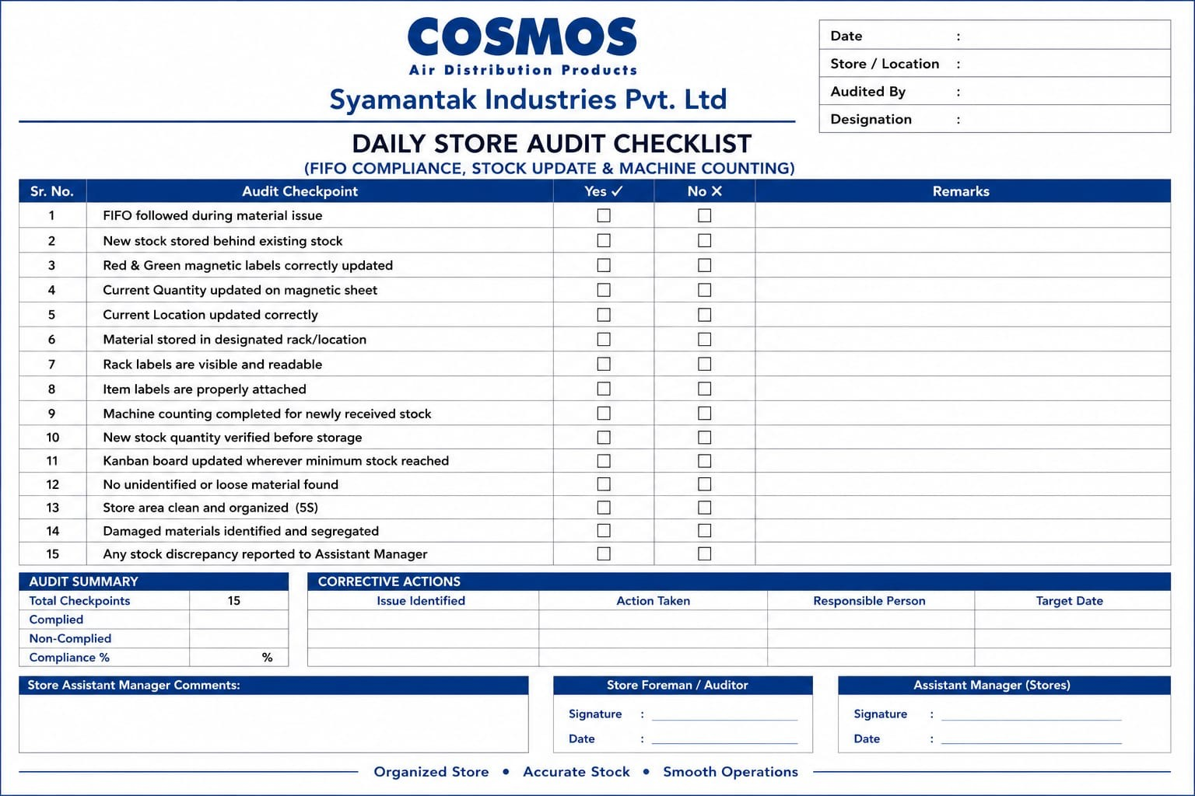
Figure 12.1: Daily Store Audit Checklist

TO-BE
Bilingual visual instructions define the method. A structured daily checklist verifies it. Responsibility is defined between the Store Foreman and the Assistant Manager. Observations, corrective actions and sign-off are recorded on the checklist.
1 DEFINE  Standard procedure defined (VWI-01 FIFO, VWI-02 Kanban) | → | 2 ISSUE  Issued as English and Marathi visual work instruction | → | 3 USE  Applied by the Store Foreman in daily work | → | 4 VERIFY  Checked by the Assistant Manager through daily inspection and checklist | → | 5 CORRECT  Non-compliance recorded with corrective action | → | 6 REVIEW  Reviewed and revised under revision control
Figure 12.2: SOP Creation, Use and Compliance Cycle
The daily audit workflow and the split of responsibility between the Store Foreman / Auditor and the Assistant Manager are shown in Figure 12.3. The sheet assigns the audit and the first sign-off to the Store Foreman / Auditor, and the comments and second sign-off to the Assistant Manager (Stores).
STORE FOREMAN / AUDITOR | STEP 1  Performs daily FIFO and Kanban tasks (magnets, quantity, card) | → | STEP 2  Audits the 15 checkpoints; ticks Yes or No with remarks | → | DECISION  Is the checkpoint compliant?  No ▼ | → | YES  Counted as Complied in the audit summary  ▼
STORE FOREMAN / AUDITOR |  |  |  |  | NO  Records issue, action taken, responsible person and target date  ▼ | → | STEP 3  Completes audit summary; signs as Store Foreman / Auditor  ▼
ASSISTANT MANAGER (STORES) |  |  |  |  | STEP 4  Reviews corrective actions and follows up to closure | → | STEP 5  Adds comments; signs as Assistant Manager (Stores)
Figure 12.3: Daily Audit Workflow and Responsibility Flow

Example: From Non-Compliant Checkpoint to Recorded Action
The table shows, for illustration only, how a non-compliant checkpoint should lead to a recorded corrective action. It is not an actual audit record.
Issue Identified | Action Taken | Responsible Person | Target Date
Checkpoint 2: new material found stored in front of old material (incorrect practice in VWI-01) | Move new material behind existing stock; reposition the red and green magnets | Store Foreman | [to be entered]

Benefits, Limitations and Status
Status: VWI-01 and VWI-02 are issued as Revision 01, effective 01/07/2026, and the checklist is developed. The extent and duration of use on the shop floor are not documented. The expected benefit is more consistent execution across workers, a recorded daily verification and a documented route from finding to corrective action. No audit-compliance percentage, error reduction or productivity gain is claimed, because no records were supplied.

Evidence and Recommendations
- Evidence: the four work-instruction sheets (Figures 12.4 to 12.7) and the Daily Store Audit Checklist (Figure 12.1).
- Recommend: keep completed checklists as records, track the number of non-compliant checkpoints and closed actions over time, and review the instructions at each revision.
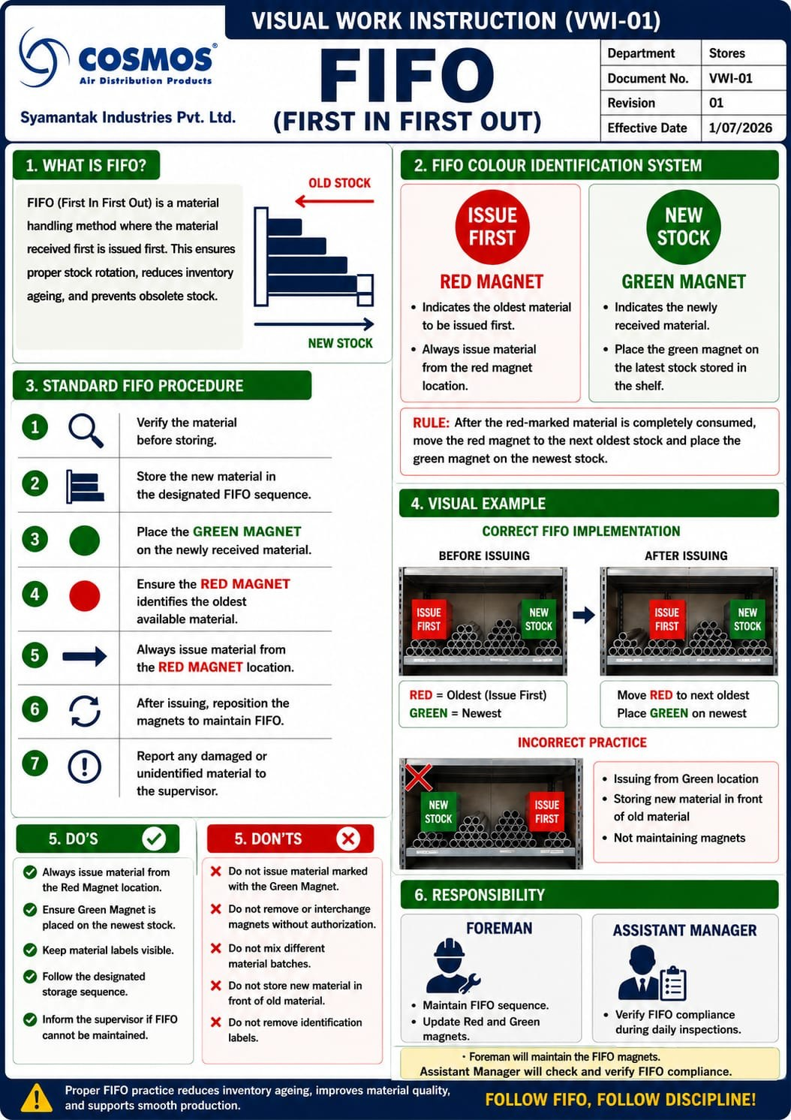
Figure 12.4: Visual Work Instruction VWI-01, FIFO (English)
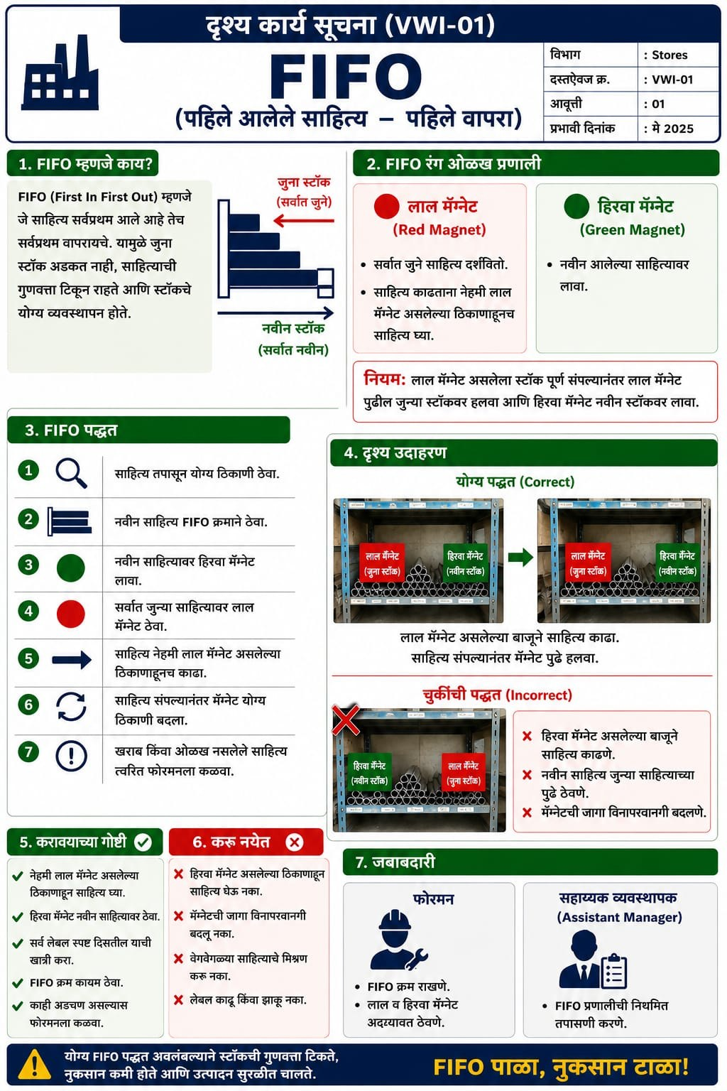
Figure 12.5: Visual Work Instruction VWI-01, FIFO (Marathi)
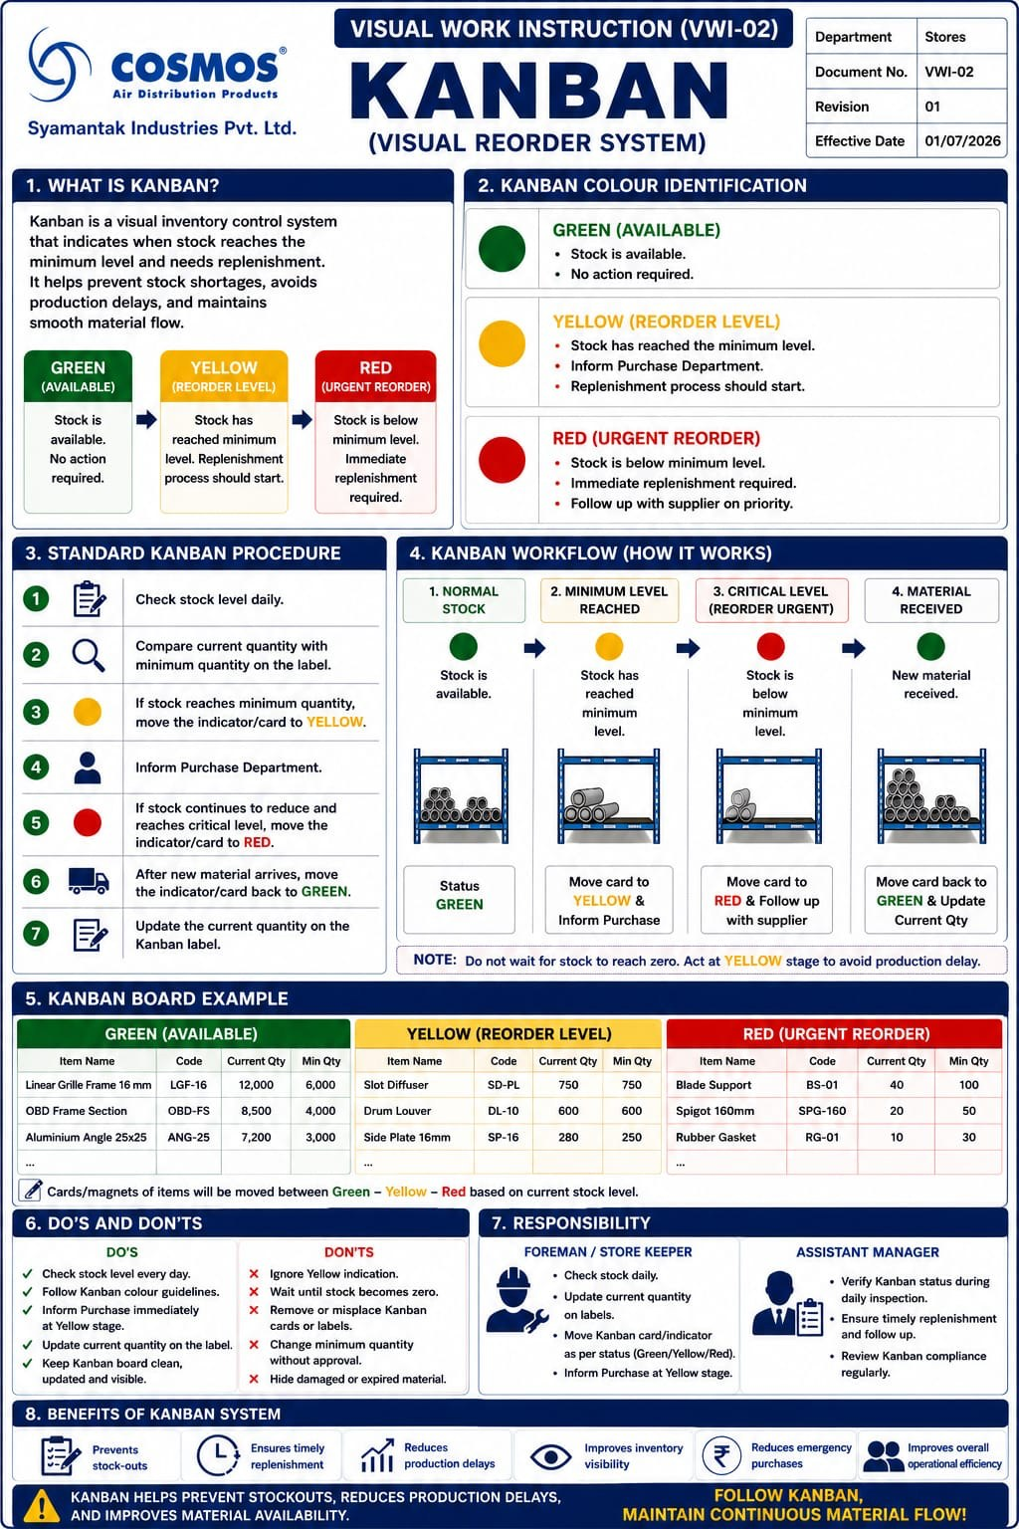
Figure 12.6: Visual Work Instruction VWI-02, Kanban (English)
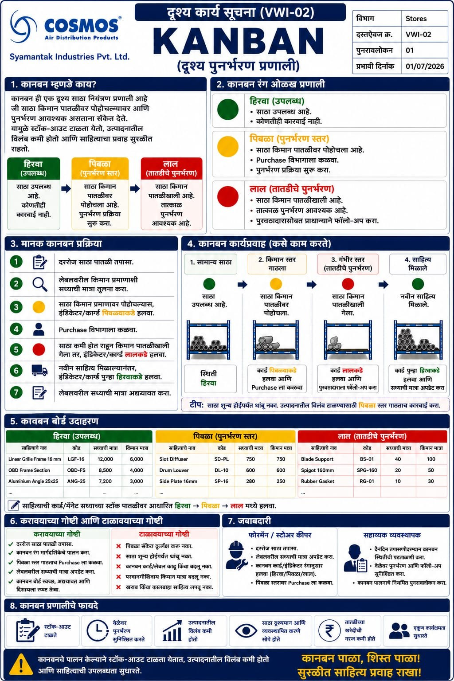
Figure 12.7: Visual Work Instruction VWI-02, Kanban (Marathi)

Project 13: Store Layout Redesign — VAV Assembly Line Relocation

Background and Problem Statement
The layout of the store and production floors involved material movement between several floors before dispatch. The VAV assembly line was relocated from the second floor to the first floor to reduce unnecessary inter-floor movement.

AS-IS
According to the project observations, the previous arrangement involved a route in which material or activity travelled from the ground floor to the second floor, returned to the first floor, and then moved back to the ground floor for dispatch. The original layout drawing was not supplied, so the activities at each location on this route are to be validated against it.

Root Cause and Constraint
The root cause was the position of the VAV assembly line on the second floor, away from the first-floor operations that follow it, which added an upward leg and a return leg to the route. The constraint was that the move had to fit within the existing floor areas and be agreed with the Production team.

Improvement Implemented
The VAV assembly line was relocated from the second floor to the first floor through a layout designed by the intern in collaboration with the Production team using AutoCAD. The redesign aimed to improve process flow and reduce unnecessary inter-floor movement before dispatch.

TO-BE
The first-floor drawing shows the VAV assembly and its related areas on the first floor: body clinching, flange clinching, wiring work and VAV control box assembly, followed by a VAV calibration area, a VAV store area and a final assembly check and packing area, with hand-drawn flow arrows. The second-floor drawing shows damper and diffuser assembly lines. The three drawings are reproduced in Figures 13.4 to 13.6.

Movement Route Comparison
Figure 13.1 shows the AS-IS route from the project observations. Figure 13.2 shows the expected route after relocation. The TO-BE route is derived from the relocation and should be confirmed against the final drawings.
AS-IS ROUTE | STEP 1  Ground floor: start of movement  ▲ to second floor |  | STEP 2  Second floor: VAV assembly line  ▼ to first floor |  | STEP 3  First floor: return  ▼ to ground floor |  | STEP 4  Ground floor: dispatch
Figure 13.1: AS-IS Floor-to-Floor Movement Route
TO-BE ROUTE | STEP 1  Ground floor: start of movement  ▲ to first floor |  | STEP 2  First floor: VAV assembly line (relocated)  ▼ to ground floor |  | STEP 3  Ground floor: dispatch
Figure 13.2: TO-BE Floor-to-Floor Movement Route (expected, to be confirmed against drawings)
Location | AS-IS | TO-BE | Expected operational effect
Second floor | VAV assembly line | VAV assembly line no longer located here | Removes the second-floor leg of the VAV route
First floor | Return leg of the route | VAV assembly line, calibration, store and final check and packing areas | Keeps VAV assembly and following steps on one floor
Ground floor | Start and dispatch | Start and dispatch | Dispatch route to be validated against the drawing

Time and Motion Analysis
The reported result is an 18% reduction in material-handling time following the layout redesign. The saving is stated as approximately 120 minutes per day, taking the standard 480-minute (8-hour) working shift of an operator. The derived figures below follow from those numbers.
Measure | Value per day | Basis
Standard working time per operator per day | 540 minutes (9 hours) | Standard shift
Time saved per day | Approximately 120 minutes (2 hours) | Stated, on the standard shift
Time saved per hour of the shift | 15 minutes | Calculated: 120 ÷ 8
Saved time as a share of the working day | 25% | Calculated: 120 ÷ 475
Reduction in material-handling time | 25.26% | Reported

Benefits, Limitations and Status
Status: implemented (the line was relocated). The expected benefit is a shorter inter-floor route and better flow before dispatch. The 120 minutes per day and the 25,26% are stated and reported figures and are not independently validated.

Evidence and Recommendations
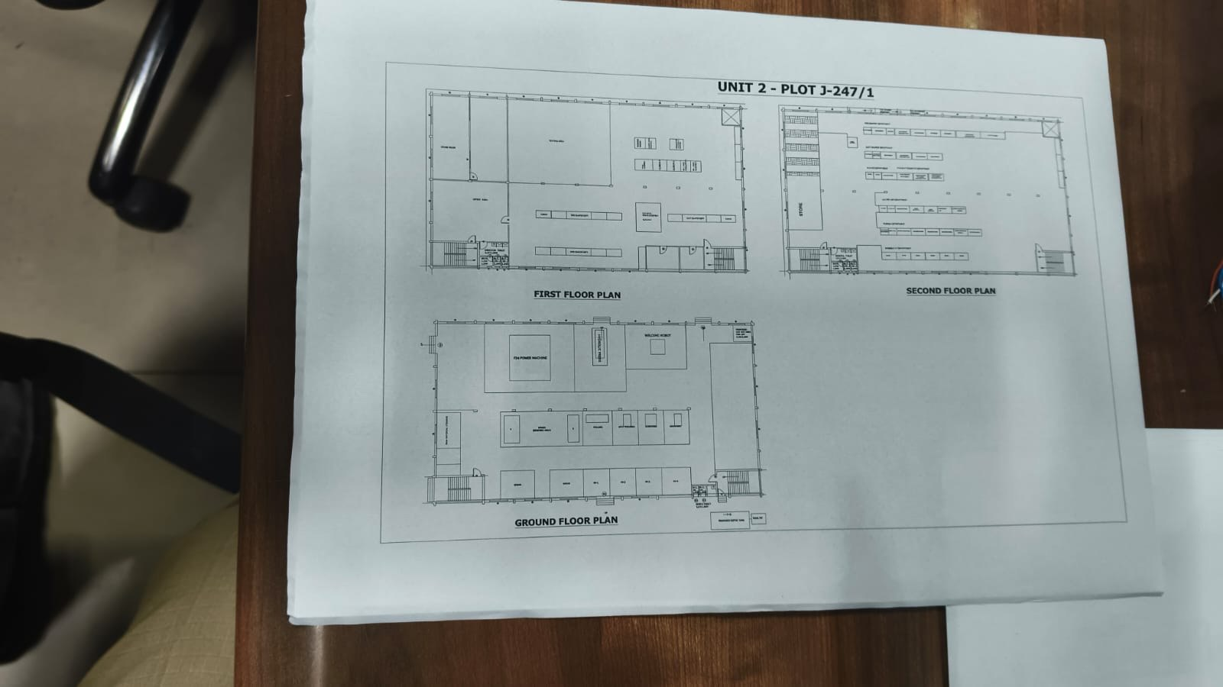
Figure 13.3: AS-IS Layout Drawing (original layout, Unit 2 — Plot J-247/1)
The original layout sheet shows the first-floor, second-floor and ground-floor plans of Unit 2, Plot J-247/1. It is reproduced from a photograph of the printed sheet, and the labels are not legible at this resolution.
- Recommend: attach the observation sheets behind the 120 minutes per day and the 18%, mark the route arrows on the original and revised drawings, and record travel distance and handling time for a sample of VAV orders.

Project 13: Layout Drawings
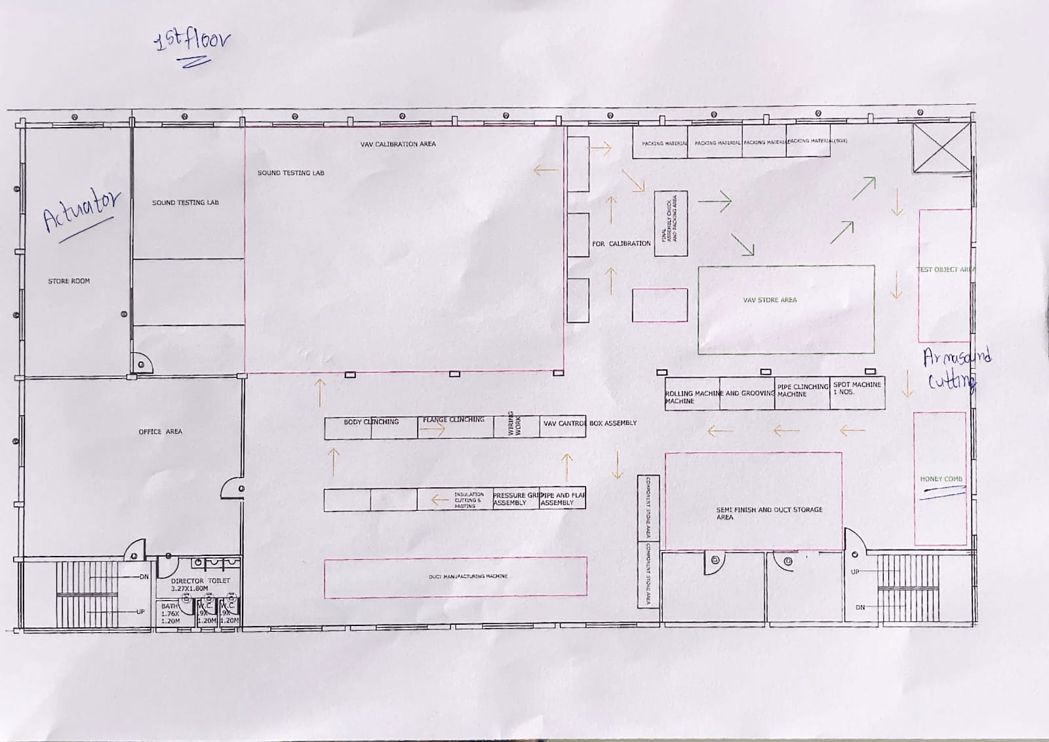
Figure 13.4: First-Floor Layout (VAV assembly line relocated here; hand-drawn flow arrows)

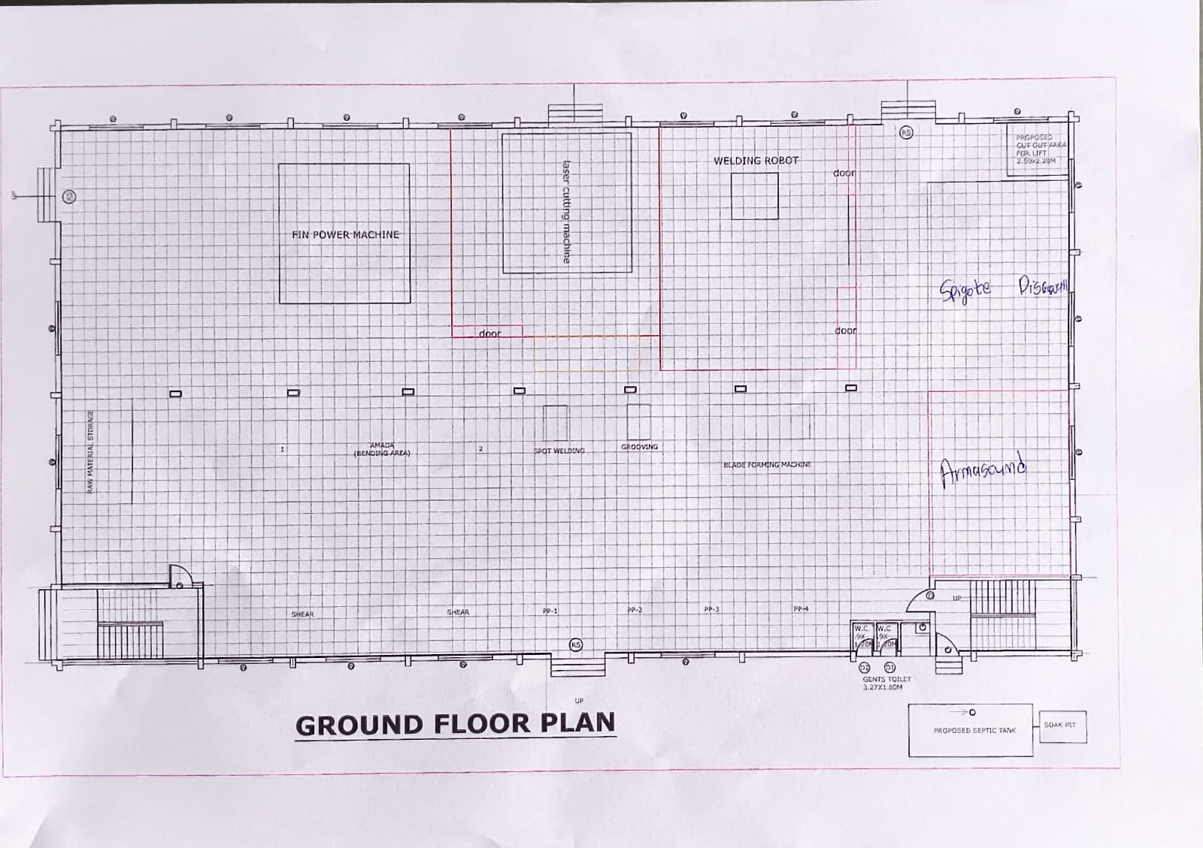
Figure 13.5: Ground-Floor Plan

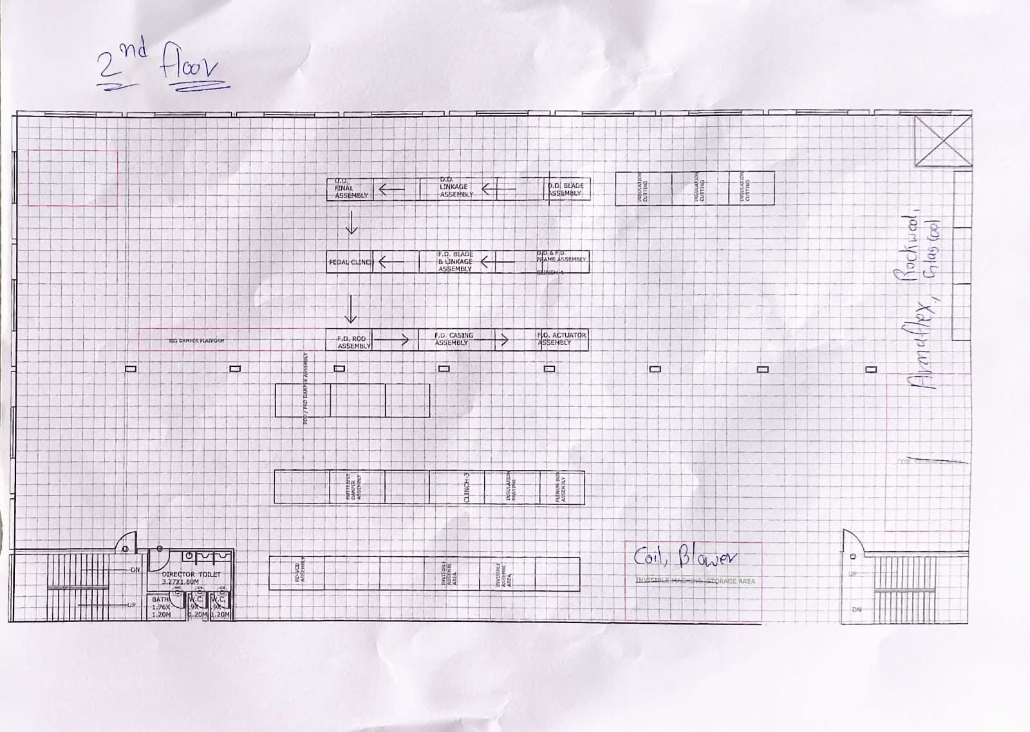
Figure 13.6: Second-Floor Layout

Project 14: Bin-Box Visualisation for Faster Material Retrieval

Background and Problem Statement
Operators filling an MRS need to know which rack, which level and which bin holds each material. A visual rack-and-bin reference was developed so that this can be read at the rack.

AS-IS
Material identification required operators to locate the appropriate rack, level and material information. Where this information was not immediately visible or easy to interpret, operators could spend additional time searching. It is not assumed that every rack lacked labels; the gap addressed was the absence of a consolidated, readable reference of the materials on each rack and level. A photograph of the earlier condition has not been supplied.

Root Cause and Constraint
The material information was not available in one readable place at each rack level, so identification depended on looking through multiple bins and locations. The constraint was the existing racks and blue bins, which were to be used as they are.

Improvement Implemented
A visual reference was created showing the materials associated with each rack and its levels. Each rack carries a rack sign (for example, Rack No. 2, Grille), and each level carries a board headed with the rack number and level, with columns for item name and software code. The supplied walk-through video shows these boards on the racks, together with the white labels on the bins. Stills from the video are reproduced in Figure 14.3.

TO-BE
The operator identifies the rack from its sign, reads the board for the required level, finds the item name and software code, and goes directly to the matching bin. The board and the bin label carry the same software code, which links the reference to the physical storage location.
AS-IS SEARCH | STEP 1  MRS received | → | STEP 2  Locate rack, level and material information | → | STEP 3  Search through multiple locations where information is not visible | → | STEP 4  Retrieve material
TO-BE IDENTIFICATION | STEP 1  MRS received | → | STEP 2  Identify rack from rack sign | → | STEP 3  Read the level board for item name and software code | → | STEP 4  Go to the matching bin and retrieve material
Figure 14.1: AS-IS Material-Search Process versus TO-BE Visual-Identification Process
Rack | Level | Material reference | Bin
Rack No. (sign on rack) | Level No. (board on shelf) | Item name and software code (as listed on the level board) | Bin label carrying the matching code
Figure 14.2: Example Rack → Level → Material Reference
The boards are physical, printed references. They are not stated to update automatically from ERP or any other system, and any link to system records is to be confirmed.
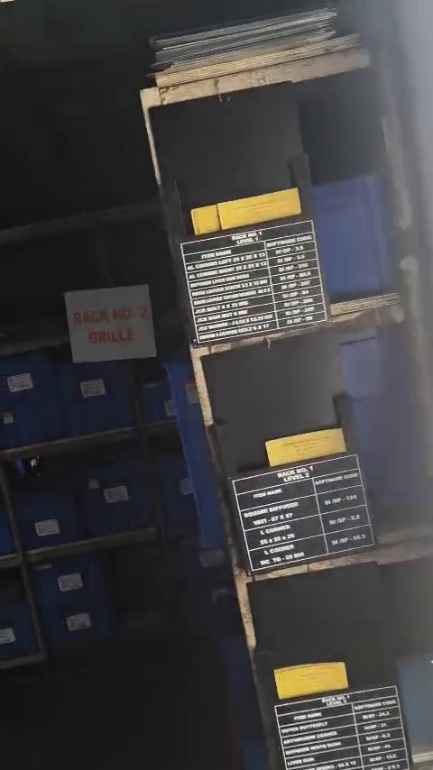 | 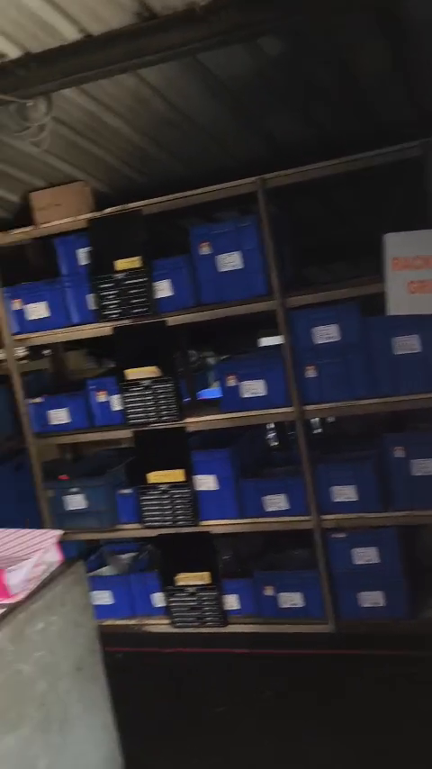 | 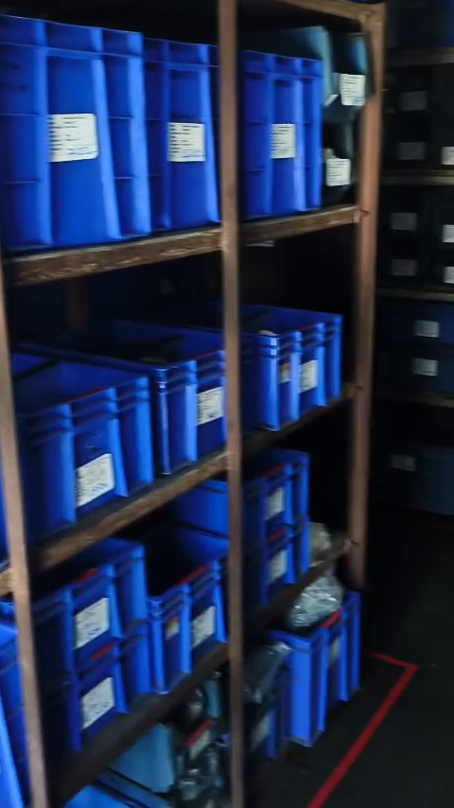
Figure 14.3: Rack-Level Material Boards and Bin Labels (stills from the supplied video)
The first still shows the level boards headed with the rack number and level and the item name and software code columns. The second shows a rack with a board at each level. The third shows bins with white labels. The full walkthrough, which also shows the red-tape floor marking and the mezzanine floor, is embedded in Figure 14.4 and can be played in Word.
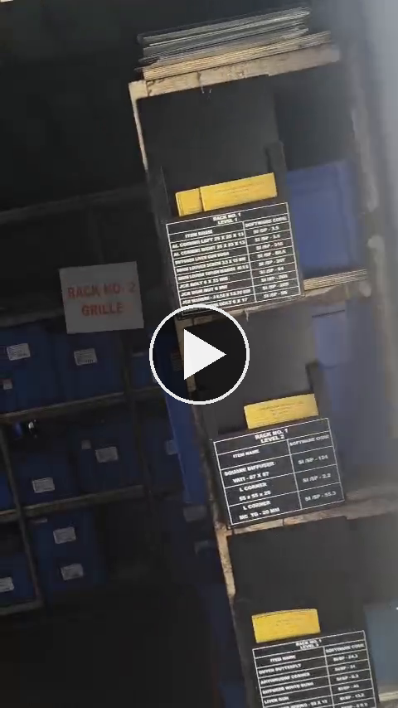
Figure 14.4: Walkthrough Video — Racks, Rack-Level Boards, Red-Tape Floor Marking and Mezzanine Floor (double-click to play)
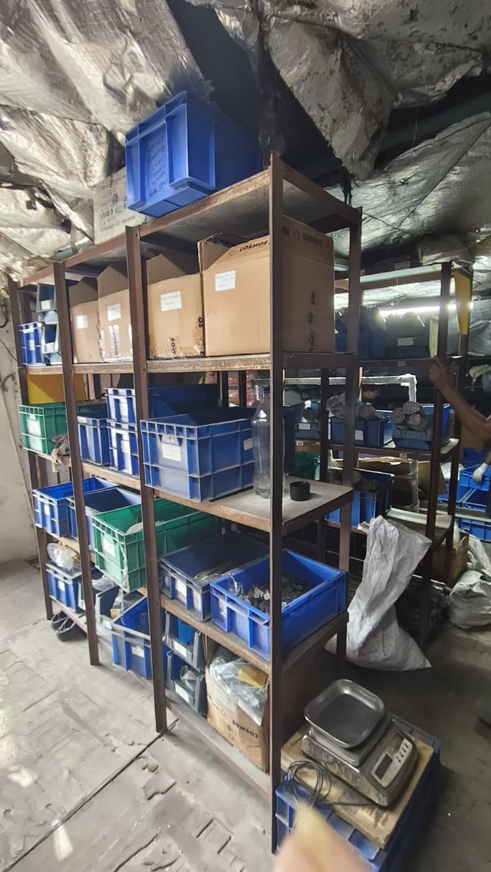
Figure 14.5: Before-Condition Photograph for Comparison
Racks before the rack-level material boards were added: bins and cartons on open shelves, with no level board listing item names and software codes.

Time and Motion Analysis
The reported estimate is a 2–3 minute reduction in search time per MRS. This is the reported estimate, as no formal before-and-after time study was supplied. It is not multiplied by daily MRS volume, because the transaction volume and calculation basis are not available. The motion benefit is qualitative: the operator moves directly from the rack sign and level board to the bin instead of checking several locations.

Benefits, Limitations and Status
Status: implemented. The intended benefit is faster rack, level and material identification. The saving is an estimate and is not validated. Accuracy depends on the boards being kept current when materials or locations change.

Evidence and Recommendations
- Evidence: the walkthrough video and the stills taken from it.
- Recommend: time a sample of MRS retrievals with and without the board, define an owner for updating the boards, and keep the board code and bin label code identical.

Project 15: Increasing Worker Participation Through Kaizen Recognition

Background and Problem Statement
Operational improvement relies on ideas from the people who do the work. Worker-recognition initiatives were introduced to encourage workers to share ideas and take part in improvement activities.

AS-IS
The original participation or suggestion process is not documented in the available project notes, so it is not stated that a suggestion system was absent. The baseline is to be confirmed.

Root Cause and Constraint
The aim was to give workers a visible reason to contribute ideas. No root-cause data on earlier participation levels is available.

Improvement Implemented
Prizes and Worker of the Month awards were announced to encourage workers to share ideas and take part in improvement activities. The intention was to recognise contributions, encourage ownership and build a culture of continuous improvement. The two ideas received were:
Idea | Description | Scope
1. Monetary reward for Kaizen | An operator who makes a Kaizen receives money and a bonus at the end of the month, to encourage good work and add value to the work. | Factory operators; paid monthly
2. Operator of the Month award | An Operator of the Month award is given in each department. | Production, Stores, Factory overall and Dispatch

TO-BE
Workers submit ideas, which are reviewed and, where suitable, recognised. Figure 15.1 shows the process and the change from the earlier cycle.
AS-IS CYCLE | STEP 1  Idea or suggestion process (details not documented)
TO-BE CYCLE | STEP 1  Identify an opportunity | → | STEP 2  Submit an idea | → | STEP 3  Review the idea | → | STEP 4  Recognise suitable contributions (prizes, Worker of the Month) | → | STEP 5  Track implementation
Figure 15.1: AS-IS versus TO-BE Worker-Suggestion Cycle
The table below is a proposed idea-submission card for use in the review step. It contains no entries, as no idea records were supplied.
Field | Entry
Idea title
Area / process
Current situation
Proposed improvement
Expected benefit
Submitted by / date
Review decision and date
Recognition given
Implementation status

Time and Motion Analysis
Not applicable. No timing observations apply to this initiative.

Benefits, Limitations and Status
Status: introduced. Two Kaizen ideas had been received following the initiative. This is an early participation outcome and not proof of a sustained increase in engagement or of any productivity improvement. The amounts of the monetary reward and the stage of implementation of each idea are not documented. No award values, participation rates, savings or worker names are stated.

Evidence and Recommendations
The following are future performance measures, to be tracked once records exist:
- Number of ideas submitted.
- Number of ideas reviewed.
- Number of ideas implemented.
- Time to review an idea.
- Verified benefits from implemented ideas.

Project 16: Mezzanine-Floor Safety Improvement

Background and Problem Statement
The mezzanine floor is used for storage and material handling. The wooden flooring was replaced for the safety of the factory workers.

AS-IS
The original mezzanine flooring was wooden. The later part of the walkthrough video in Figure 14.4 shows the mezzanine floor with red-tape floor marking and blue bins, and Figure 16.1 shows a supplied photograph of the wooden flooring, in which a localised area of the surface is broken and splintered with a gap visible. No inspection record was supplied, so no structural conclusion is drawn about the floor as a whole.
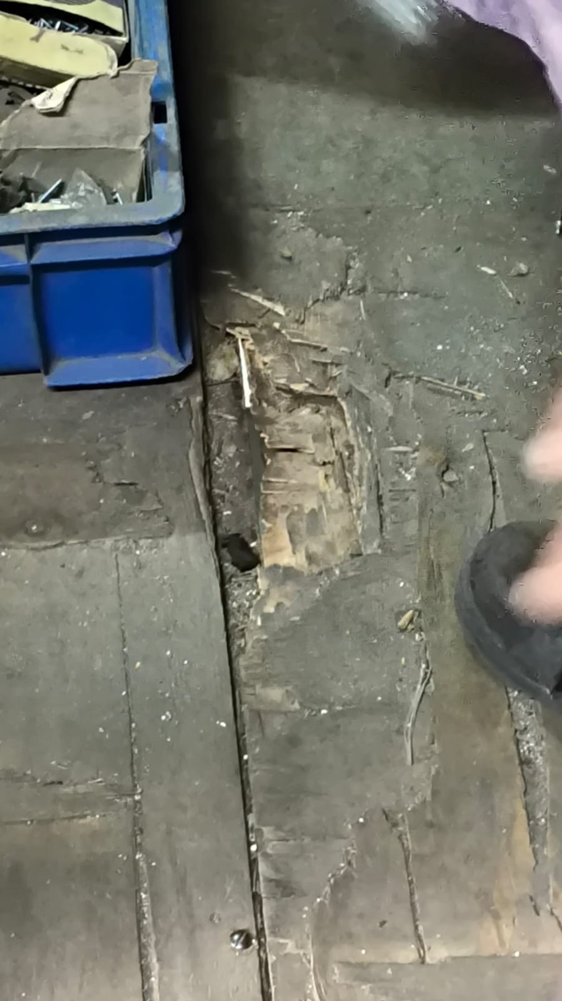  Before: wooden flooring | 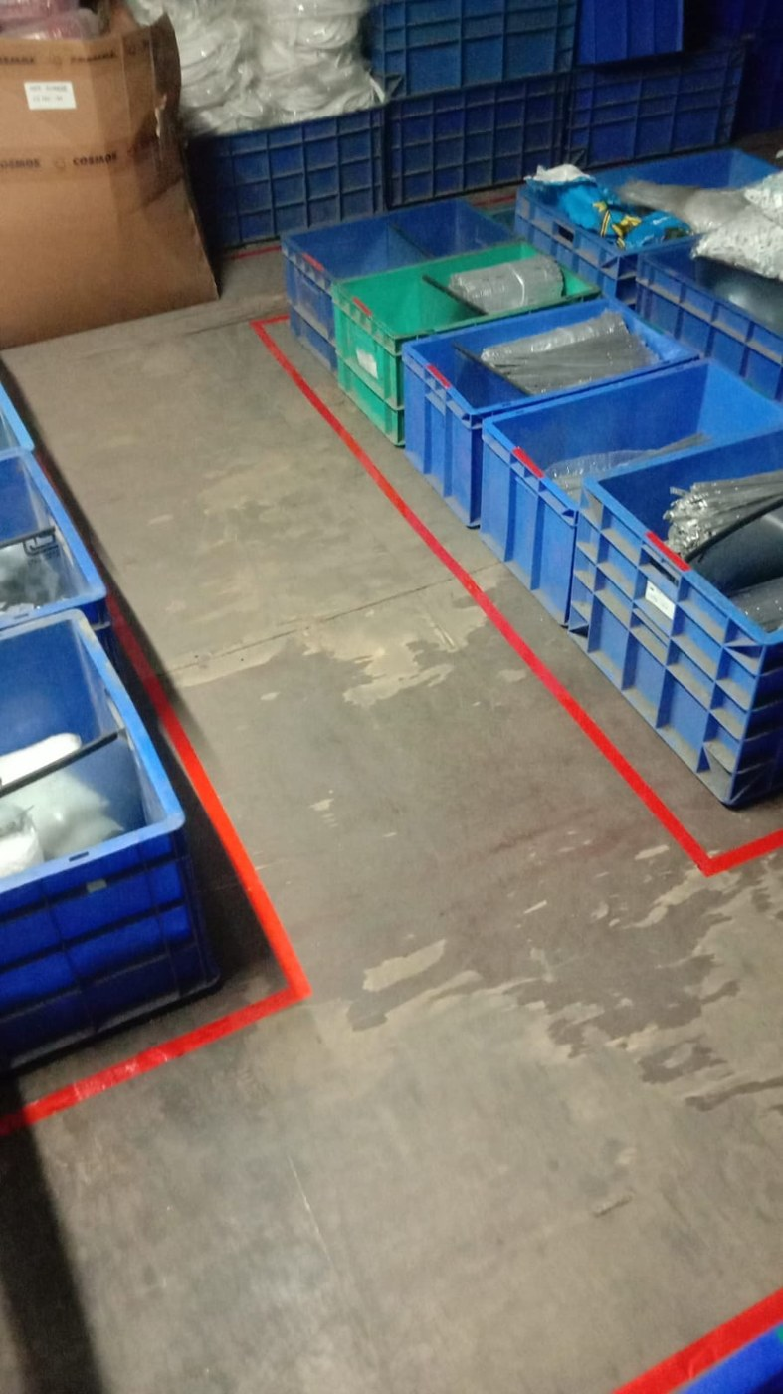  Current: mezzanine floor with red-tape floor marking
Figure 16.1: Mezzanine Flooring, Wooden Floor and Current Floor with Red-Tape Marking

Root Cause and Constraint
The documented concern is the safety of the flooring surface for workers. No inspection record, load assessment or incident record was supplied, so a specific root cause is not stated.

Improvement Implemented
The flooring was changed from wood to a steel flooring material. The exact technical specification is not established by the project notes: [confirm exact steel flooring specification].

TO-BE
The mezzanine has a steel floor in place of the wooden floor, with the intended benefit of a safer working surface. The following technical details are to be taken from the project records.
Item | Status
Material specification | [confirm exact steel flooring specification]
Load rating | To be confirmed from records
Slip resistance | To be confirmed from records
Installation method | To be confirmed from records
Inspection requirements | To be confirmed from records
Engineering or safety approval | To be confirmed from records

Time and Motion Analysis
Not applicable. This is a safety initiative and no timing observations apply. The implementation sequence is not documented in the material supplied.

Benefits, Limitations and Status
Status: implemented; the wooden flooring was replaced with steel flooring for worker safety. The intended benefit is improved worker safety. This is an intended benefit and not a measured safety outcome. No reduction in accidents or independent safety verification is claimed.

Evidence and Recommendations
- Recommend: record the specification, load rating, slip resistance and approval for the steel flooring, add a close-up photograph of the steel flooring and include the floor in periodic inspections.

Items for Confirmation Before Submission
Item | Detail
VWI-01 and the FIFO workstream | VWI-01 uses red and green magnets. The FIFO workstream describes GI-sheet dividers for spares and red and green colour coding for bulky extrusion. Confirm how the magnets relate to those arrangements.
Kanban terminology and examples | VWI-02 refers to the minimum level for yellow, while the Kanban board refers to the reorder point. The board example item codes on VWI-02 (for example LGF-16) are shown as examples and differ from the SI-EX codes on the card register.
Counting study scope | The report states that three live MRS batches were timed under both methods. Confirm whether the same three transactions were used for both readings.
VAV layout | The observation sheets behind the 120 minutes per day and the 18%, including the number of operators, are to be attached. The photographed layout sheet is not legible at this resolution; a clearer copy would allow the VAV line to be marked.
Bin-box | A formal time study would support the 2–3 minute estimate.
Kaizen ideas | The amount of the monetary reward and the implementation status of each of the two ideas.
Mezzanine | Exact steel flooring specification and approvals. The supplied flooring photograph is taken to show the mezzanine; confirm.

