Project 1: E-Commerce Analytics Platform

1. Objective
- To build a complete E-Commerce Analytics Platform using Apache Spark.
- To ingest data from multiple Parquet files.
- To perform data transformation and aggregation using PySpark DataFrames.
- To calculate business metrics such as daily sales, customer lifetime value, and product revenue.
- To generate analytical reports for business decision-making.

2. Procedure
- Create a SparkSession to initialize the PySpark application.
- Read the Orders, Customers, and Products datasets from Parquet files.
- Load the datasets into Spark DataFrames.
- Perform data validation by checking the loaded records.
- Group the Orders dataset by Order Date to calculate Daily Revenue and Order Count.
- Group the Orders dataset by Customer ID to calculate Customer Lifetime Value, Number of Orders, and Average Order Value.
- Group the Orders dataset by Product ID to calculate Total Units Sold and Product Revenue.
- Display the calculated business metrics using Spark DataFrame operations.
- Stop the SparkSession after execution.

3. Screenshots
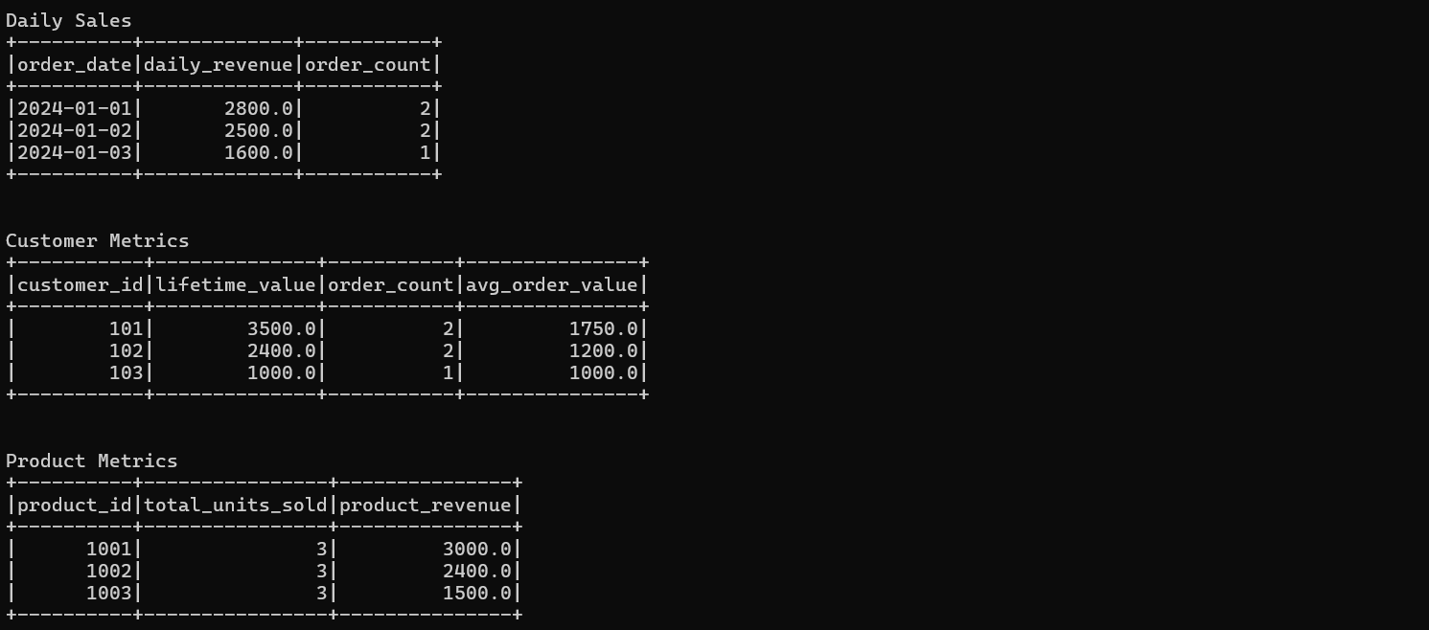

4. Conclusion
The E-Commerce Analytics Platform was successfully implemented using Apache Spark. Multiple datasets were ingested from Parquet files, processed using DataFrame operations, and transformed into meaningful business metrics. The application generated daily sales statistics, customer lifetime values, and product performance reports, demonstrating the effectiveness of PySpark for large-scale e-commerce analytics.

