Project 2: Fraud Detection System

1. Objective
- To build a fraud detection system using Apache Spark and Machine Learning.
- To perform feature engineering on transaction data.
- To train a Random Forest Classifier for fraud prediction.
- To identify suspicious and high-value transactions.
- To analyze user transaction patterns for fraud detection.

2. Procedure
- Create a SparkSession to initialize the PySpark application.
- Create a sample transaction dataset containing transaction details.
- Convert the timestamp column into Timestamp format.
- Perform feature engineering by extracting Hour of Day, Day of Week, and Amount Category.
- Calculate rolling average transaction amount and transaction count using Window functions.
- Create a label column to identify fraudulent transactions based on transaction amount.
- Assemble the selected features into a feature vector using VectorAssembler.
- Split the dataset into training and testing datasets.
- Train a Random Forest Classification model.
- Generate predictions for test transactions.
- Detect potential fraudulent transactions based on prediction results.
- Analyze high-value transactions.
- Identify users with frequent transactions.
- Calculate the average transaction amount for each user.
- Display users with high average spending.
- Stop the SparkSession after successful execution.

3. Screenshots

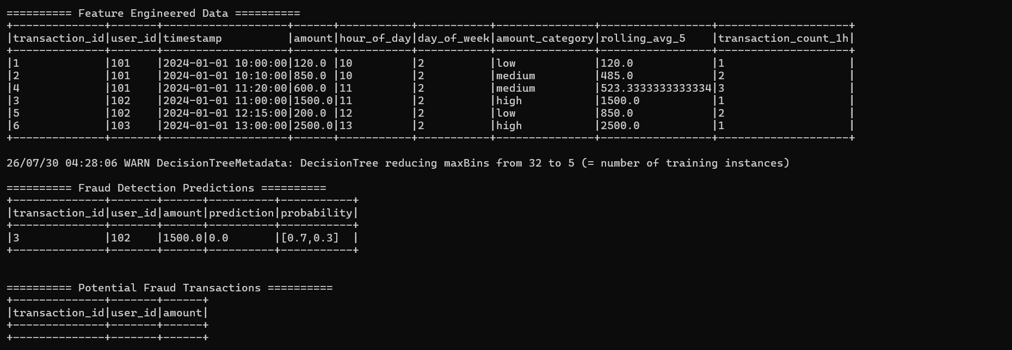
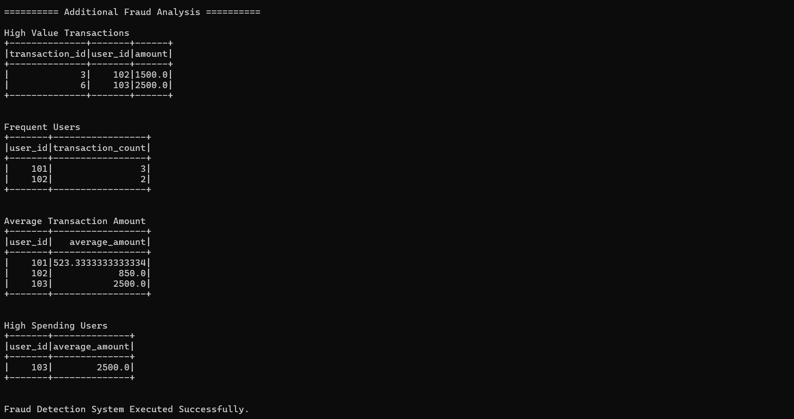

4. Conclusion
The Fraud Detection System was successfully implemented using Apache Spark MLlib. Feature engineering techniques were applied to transaction data, and a Random Forest Classifier was used to detect fraudulent transactions. The system also analyzed user transaction behavior, identified high-value transactions, and generated useful fraud detection insights using PySpark DataFrame operations.

