Hybrid Big Data Processing using Apache Hadoop and Apache Cassandra in WSL

1. Objective
- To install and configure Apache Cassandra using Docker in the WSL environment.
- To create a Cassandra keyspace and tables for storing music streaming analytics data.
- To generate batch music streaming data using Python.
- To upload batch data into Hadoop Distributed File System (HDFS).
- To perform batch analytics using Hadoop Streaming MapReduce.
- To load Hadoop-generated analytical results into Cassandra.
- To execute Cassandra queries for analyzing streaming data.
- To understand the integration of Hadoop for batch processing and Cassandra for real-time NoSQL data storage.

2. Procedure

Step 1: Project Setup
- Created the project directory structure in WSL.
- Created folders for data, scripts, jobs, output, and Cassandra storage.

Step 2: Cassandra Configuration
- Created a docker-compose.yml file.
- Started the Cassandra container using Docker Compose.
- Verified the Cassandra container using docker ps.
- Connected to Cassandra using cqlsh.

Step 3: Database Schema Creation
- Created the keyspace streaming_analytics.
- Created the following Cassandra tables:
  - current_top_songs
  - user_listening_history
  - hourly_stats
  - user_sessions
  - daily_aggregates
  - top_songs_daily
  - user_recommendations

Step 4: Loading Real-Time Data
- Inserted sample music streaming records into Cassandra.
- Updated current top songs and hourly statistics.
- Verified inserted records using CQL queries.

Step 5: Batch Data Generation
- Created a Python program to generate 100,000 music streaming records.
- Saved the generated CSV file inside the data directory.

Step 6: Uploading Data to HDFS
- Created HDFS directories.
- Uploaded the generated CSV file to Hadoop HDFS.
- Verified the uploaded dataset.

Step 7: Hadoop MapReduce Processing
- Developed Mapper and Reducer programs for:
  - Daily Aggregation
  - Top Songs Analysis
- Executed Hadoop Streaming jobs.
- Generated analytical output files.

Step 8: Loading Hadoop Results into Cassandra
- Copied Hadoop output files to the local project directory.
- Executed the Python loader program.
- Inserted batch analytical results into Cassandra tables.

Step 9: Query Execution
- Queried Cassandra tables to verify:
  - Daily aggregates
  - Top songs
  - User listening history
  - User sessions
  - Hourly statistics
- Verified successful data insertion.

3. Source Code
The project contains the following source files:

Configuration Files
- docker-compose.yml
- cassandra_schema.cql
- load_realtime_data.cql

Python Programs
- generate_batch_data.py
- load_hadoop_results.py

Hadoop Streaming Programs
- mapper_daily_aggregate.py
- reducer_daily_aggregate.py
- mapper_top_songs.py
- reducer_top_songs.py

Main Commands Used

Create Project Structure
mkdir -p ~/hadoop-cassandra-exercise/{data,scripts,output,jobs}

Start Cassandra
docker compose up -d

Connect to Cassandra
docker exec -it cassandra cqlsh

Execute Cassandra Schema
docker exec -i cassandra cqlsh < scripts/cassandra_schema.cql

Load Real-Time Data
docker exec -i cassandra cqlsh < scripts/load_realtime_data.cql

Generate Batch Data
python3 scripts/generate_batch_data.py

Upload Data to HDFS
hdfs dfs -put ~/hadoop-cassandra-exercise/data/batch_plays.csv /user/$USER/analytics/input/

Execute Hadoop Streaming Job
hadoop jar $HADOOP_HOME/share/hadoop/tools/lib/hadoop-streaming-*.jar

Load Hadoop Results
python3 scripts/load_hadoop_results.py

Query Cassandra
SELECT * FROM daily_aggregates;
SELECT * FROM top_songs_daily;
SELECT * FROM current_top_songs;
SELECT * FROM hourly_stats;

4. Screenshots

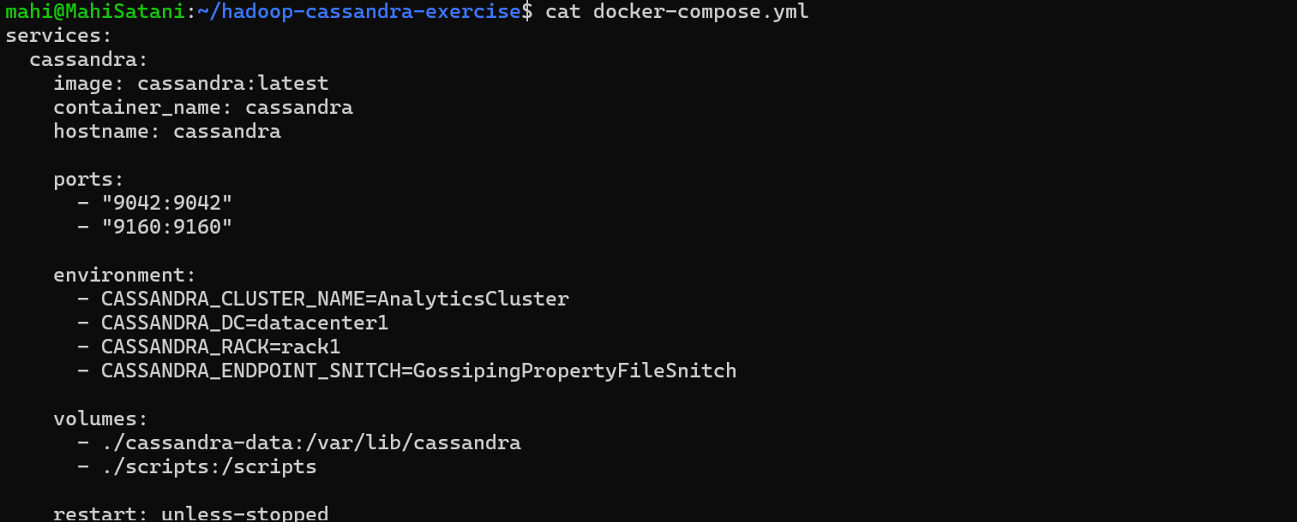
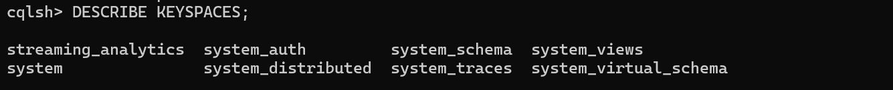
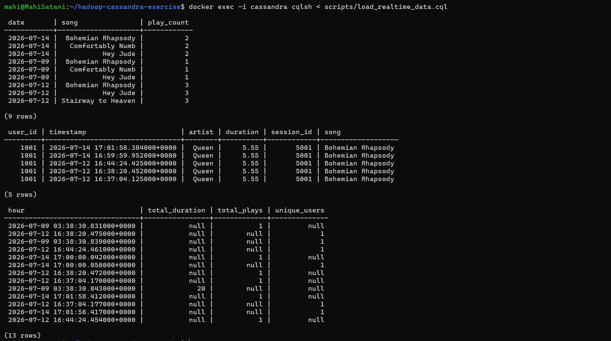
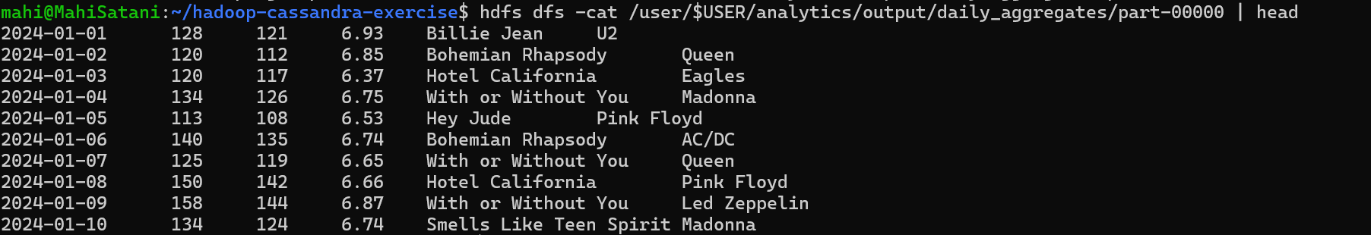
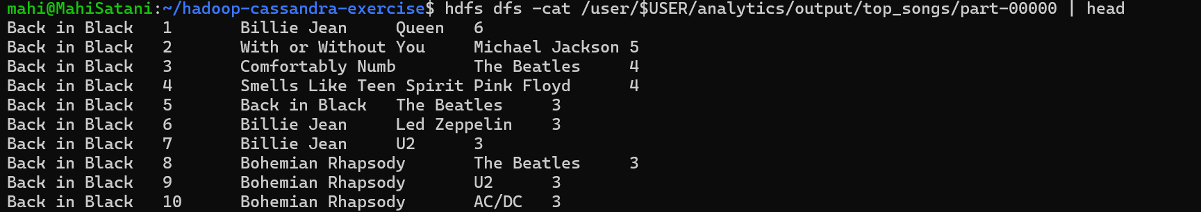
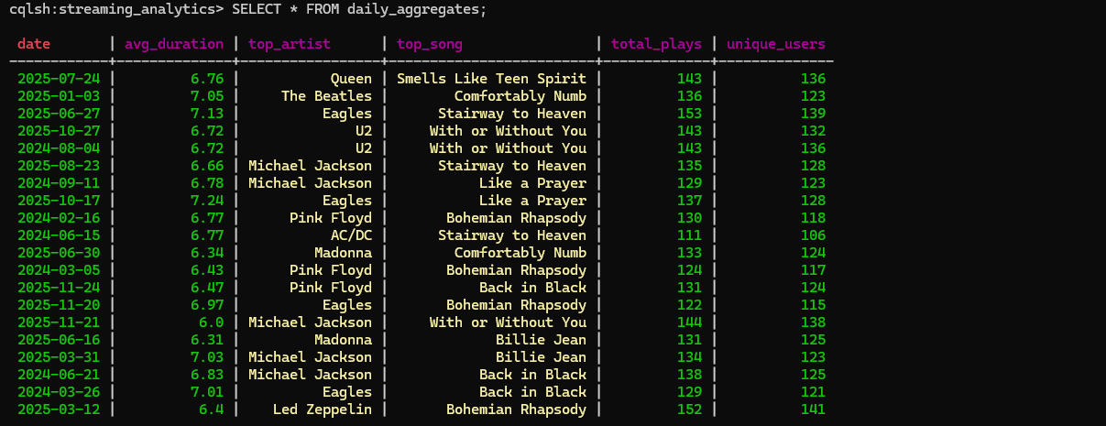

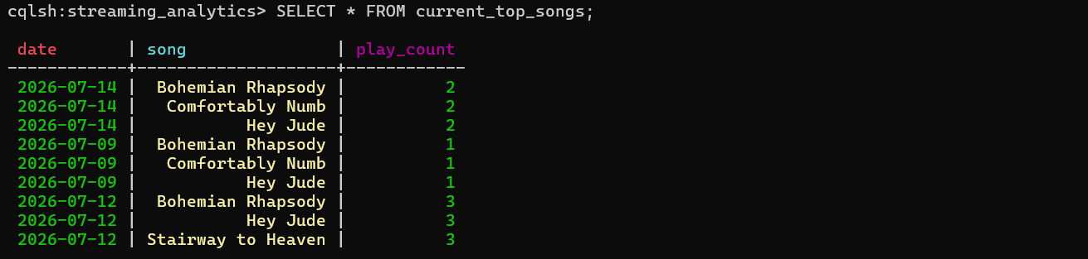
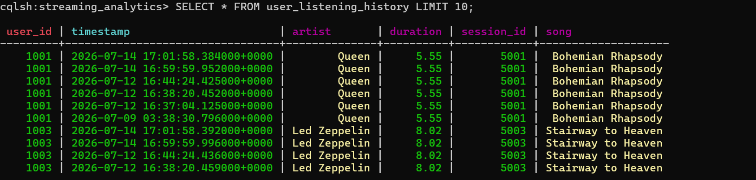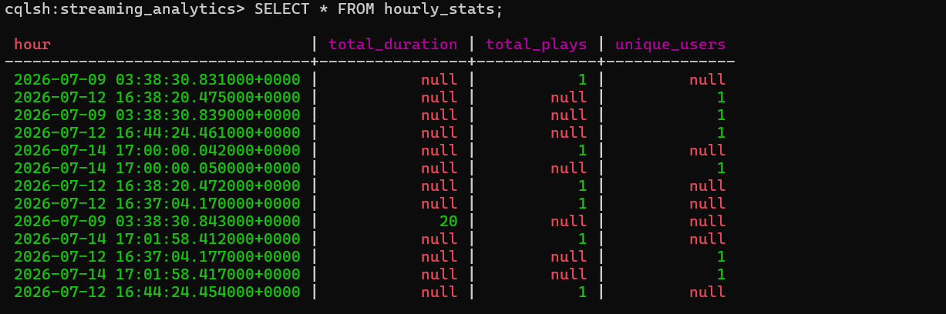
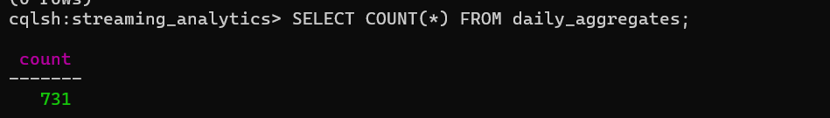
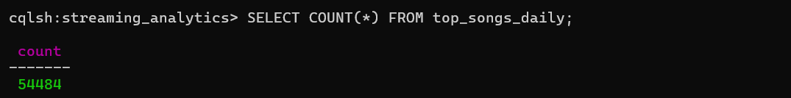

5. Conclusion
The experiment successfully demonstrated the integration of Apache Hadoop and Apache Cassandra in a WSL environment for hybrid big data processing. Apache Cassandra was used to efficiently store and query real-time streaming data, while Hadoop Streaming MapReduce processed large-scale batch datasets to generate daily aggregates and top song statistics. The processed analytical results were successfully loaded back into Cassandra for fast querying and reporting. This experiment provided practical experience in configuring Docker, Cassandra, Hadoop HDFS, MapReduce, and Python scripts to build a scalable big data analytics pipeline capable of handling both batch and real-time workloads.

