Exercise 9: Optimization Techniques

1. Objective
To optimize Apache Spark jobs for better performance and efficient resource utilization using partition tuning, broadcast joins, caching, adaptive query execution, and data skew handling.

2. Procedure
- Create a Spark session.
- Create sample DataFrames.
- Check the number of partitions in the DataFrame.
- Increase partitions using repartition().
- Reduce partitions using coalesce().
- Perform a broadcast join between a large and a small DataFrame.
- Cache the DataFrame using cache().
- Persist the DataFrame using MEMORY_AND_DISK.
- Enable Adaptive Query Execution (AQE).
- Configure shuffle partitions.
- Handle data skew using the salting technique.
- Display the optimized results.

Challenges

Challenge 1: Profile and Optimize a Slow-Running Job
- Create sample data.
- Analyze the execution plan.
- Optimize the job using repartitioning.
- Display the optimized execution plan.

Challenge 2: Handle Data Skew
- Create skewed sample data.
- Apply the salting technique.
- Display the transformed data.

Challenge 3: Use Broadcast Joins
- Create large and small DataFrames.
- Apply a broadcast join.
- Display the joined result.

Challenge 4: Tune Memory and Execution Parameters
- Enable Adaptive Query Execution.
- Configure shuffle partitions.
- Display the optimization settings.

3. Screenshots

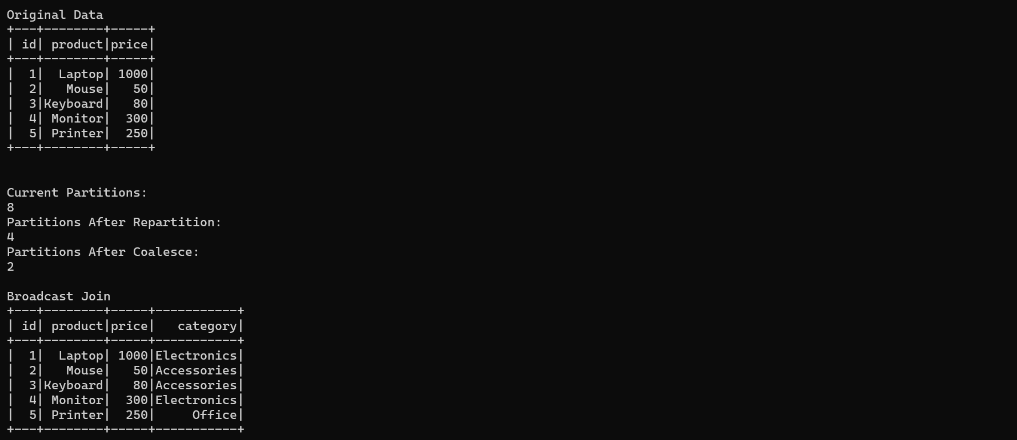
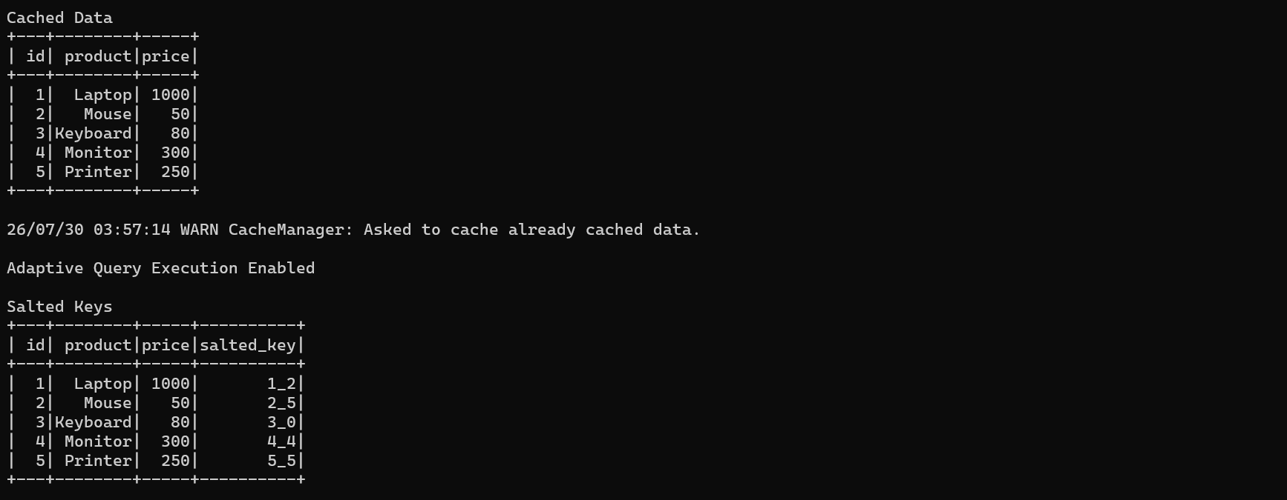
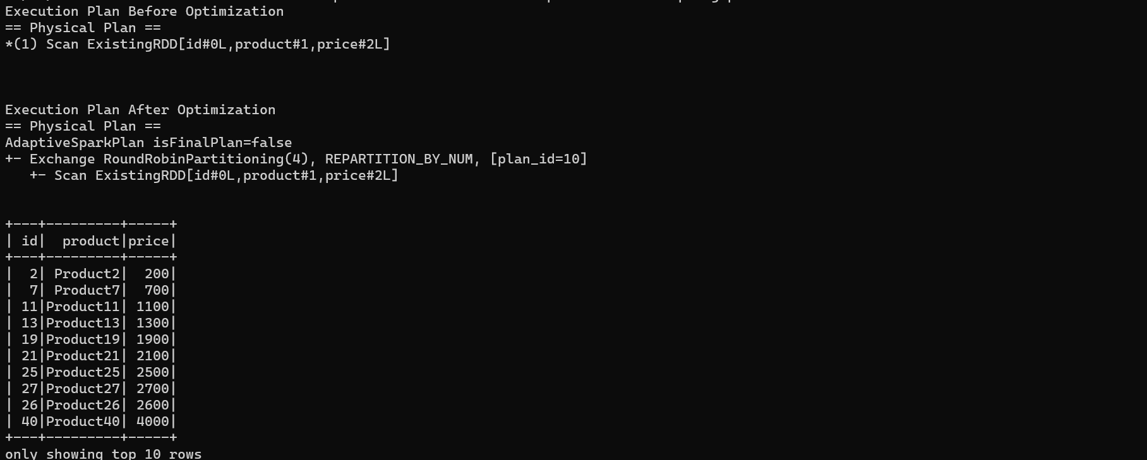
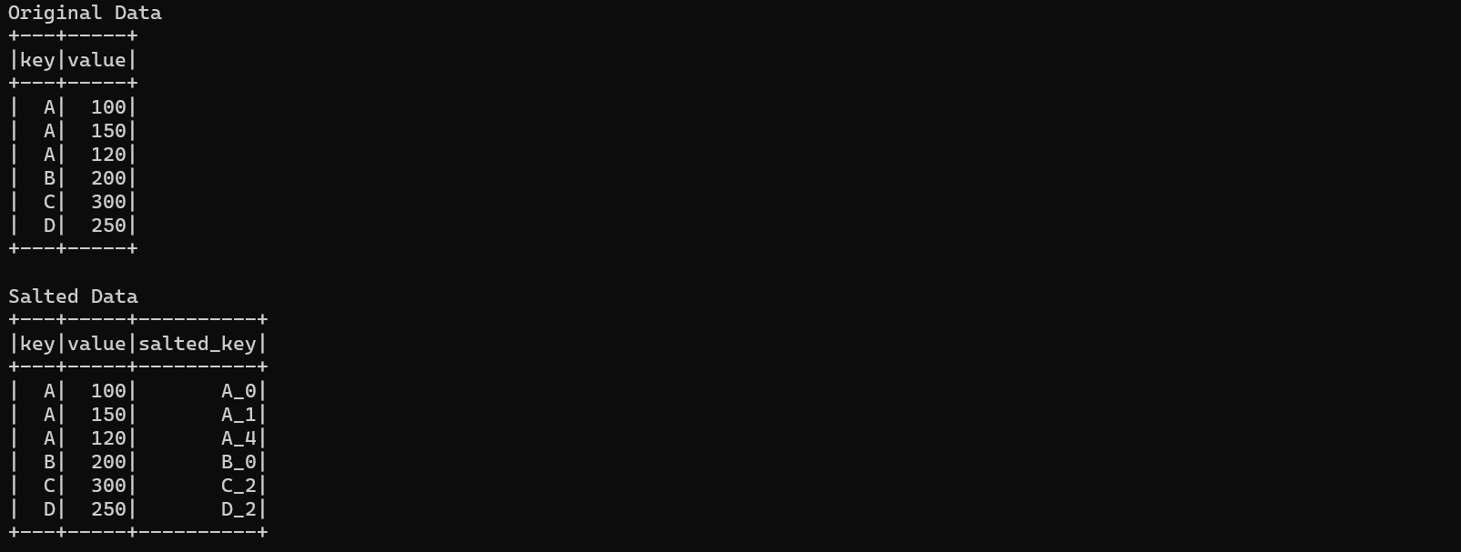


4. Conclusion
The optimization techniques were successfully implemented using Apache Spark. Partition tuning, broadcast joins, caching, adaptive query execution, and data skew handling improved the efficiency and resource utilization of Spark jobs. The challenge programs demonstrated practical optimization methods for building high-performance Spark applications.

