Exercise 10: Complex Event Processing

1. Objective
To analyze event streams using Apache Spark by implementing pattern detection, session aggregation, and complex event processing for stateful analytics.

2. Procedure
- Create a Spark session.
- Define the schema for event data.
- Create sample event records.
- Load the events into a DataFrame.
- Detect login-to-purchase event patterns.
- Identify users who complete a purchase within five minutes of login.
- Perform session aggregation for each user.
- Calculate the number of events and total transaction amount per session.
- Apply a rule engine to identify suspicious transactions.
- Display the pattern detection, session aggregation, and fraud detection results.

3. Screenshots
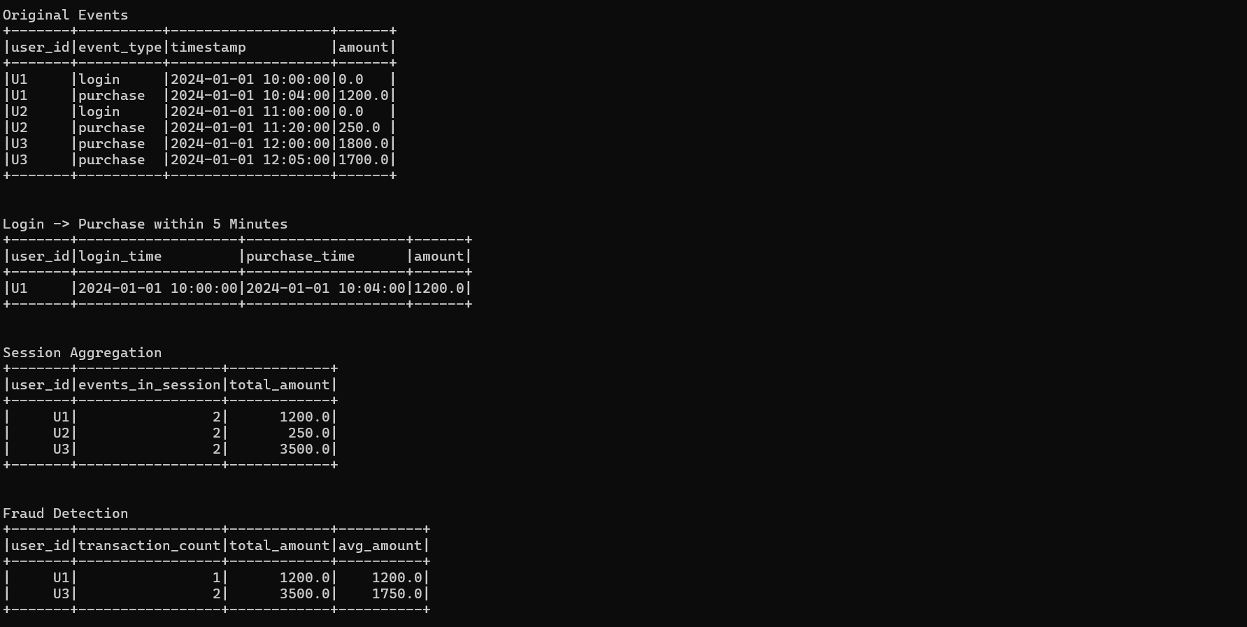

4. Conclusion
The complex event processing application was successfully implemented using Apache Spark. Event patterns, user sessions, and suspicious transactions were analyzed successfully, demonstrating event stream processing and stateful analytics concepts.

