Exercise 5: Streaming Analytics

1. Objective
To process real-time streaming data using Apache Spark Structured Streaming by integrating with Kafka, performing window-based aggregations, applying watermarking for late-arriving data, and generating live analytics.

2. Procedure
- Create a Spark session.
- Define the schema for the incoming streaming data.
- Read real-time data from the Kafka topic.
- Parse JSON messages into structured columns.
- Apply watermarking to handle late-arriving events.
- Perform window-based aggregations on the streaming data.
- Calculate event count, total value, and average value for each event type.
- Write the streaming output to the console.
- Start the streaming query.
- Wait for the streaming query to terminate.

3. Screenshots
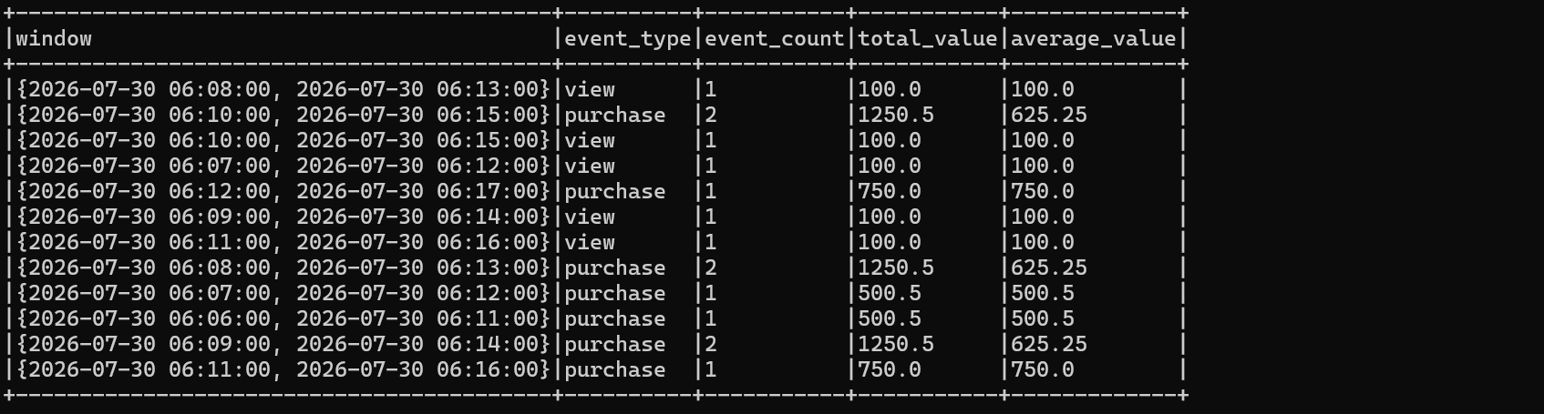

4. Conclusion
The streaming analytics application was successfully implemented using Apache Spark Structured Streaming and Apache Kafka. Real-time data was ingested from Kafka, processed using window-based aggregations and watermarking, and displayed as live analytics. The implementation demonstrated efficient processing of continuous data streams and provided a foundation for building scalable real-time analytics applications.

