Exercise 2: Sales Data Analysis using Apache Spark DataFrame API

1. Objective
- To analyze sales data using the Apache Spark DataFrame API.
- To perform SQL-like operations and aggregations on sales data.
- To calculate product-wise and city-wise revenue.
- To identify sales trends using DataFrame operations.
- To implement additional sales analysis challenges using Spark.

2. Procedure

Exercise 2: Sales Data Analysis
- Create a Spark Session using SparkSession.builder.appName().getOrCreate().
- Read the sales.csv file into a Spark DataFrame.
- Display the sales data using the show() method.
- Create a new column named revenue by multiplying the price and quantity columns.
- Group the data by product and calculate the total revenue and total quantity sold using aggregation functions.
- Display the product-wise sales summary.
- Group the data by city and calculate the total revenue generated from each city.
- Sort the city-wise revenue in descending order.
- Display the final results.
- Stop the Spark Session after successful execution.

Challenge 1: Find the Top 5 Best-Selling Products
- Read the sales data into a DataFrame.
- Group the data by product.
- Calculate the total quantity sold for each product.
- Sort the products in descending order of quantity sold.
- Display the top five best-selling products.
- Stop the Spark Session.

Challenge 2: Calculate Month-over-Month Revenue Growth
- Read the sales data into a DataFrame.
- Convert the date column into Date format.
- Create a revenue column by multiplying price and quantity.
- Group the data by month and calculate the total monthly revenue.
- Create a Window specification ordered by month.
- Calculate the previous month's revenue using the lag() function.
- Compute the month-over-month revenue growth percentage.
- Display the monthly revenue analysis.
- Stop the Spark Session.

Challenge 3: Find Products with Highest Average Order Value
- Read the sales data into a DataFrame.
- Create an OrderValue column by multiplying price and quantity.
- Group the data by product.
- Calculate the average order value for each product.
- Sort the products by average order value in descending order.
- Display the results.
- Stop the Spark Session.

3. Screenshots

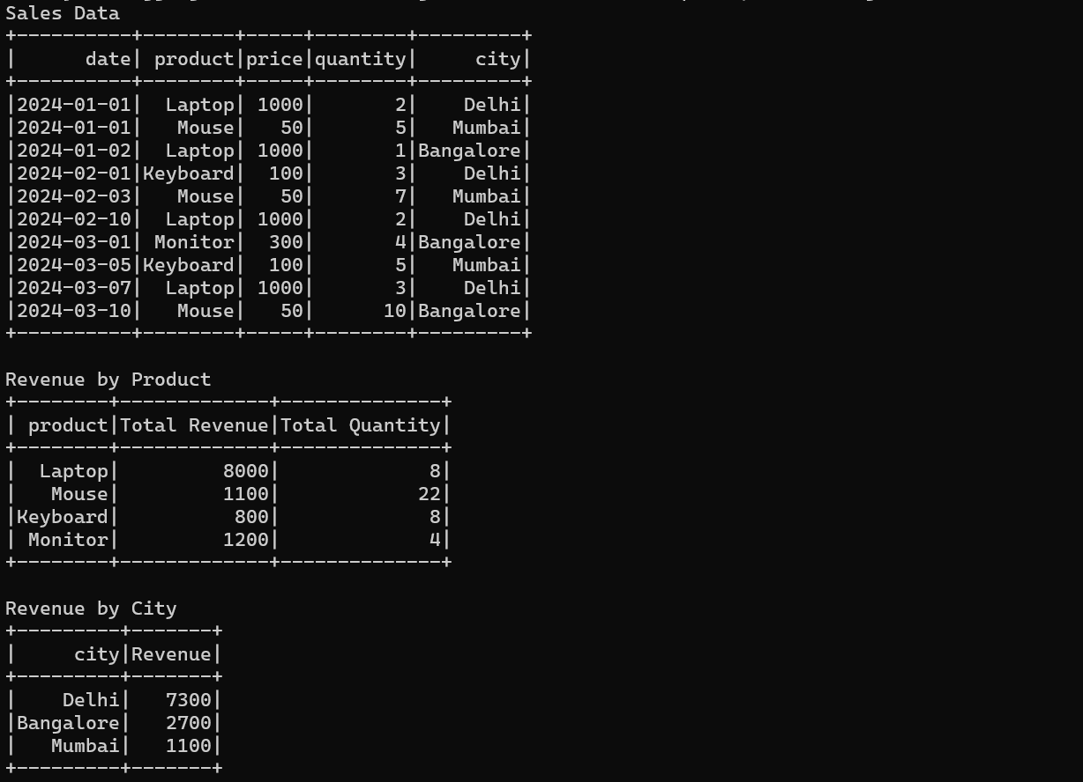

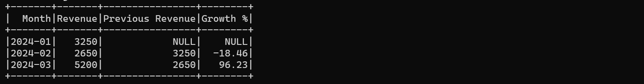
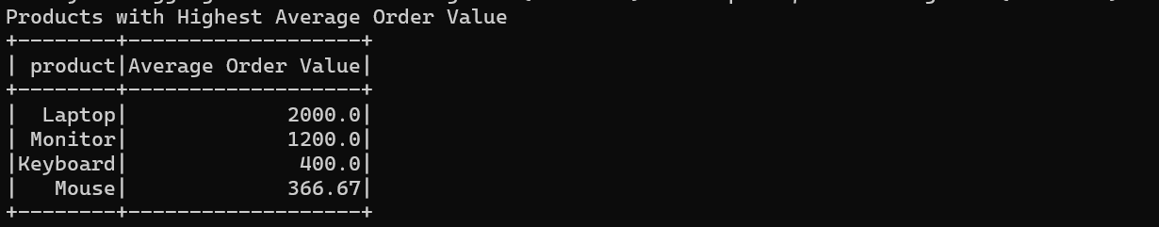

4. Conclusion
The Sales Data Analysis exercise demonstrated the use of Apache Spark DataFrame API for processing and analyzing structured data. The exercise successfully performed product-wise and city-wise revenue analysis using aggregation functions. The challenge tasks further explored DataFrame capabilities by identifying the top-selling products, calculating month-over-month revenue growth, and determining products with the highest average order value. This exercise enhanced the understanding of Spark DataFrames, SQL-like operations, aggregation functions, and window functions for efficient big data analysis.

