Exercise 3: Log Analysis using Apache Spark

1. Objective
- To analyze web server log data using Apache Spark.
- To extract useful information from log entries using Regular Expressions.
- To identify request patterns and server issues.
- To count status codes and IP address requests.
- To implement additional log analysis challenges using Spark.

2. Procedure

Exercise 3: Log Analysis
- Create a Spark Session using SparkSession.builder.appName().getOrCreate().
- Create sample web server log data using Spark RDD.
- Parse each log entry using Regular Expressions to extract IP address, timestamp, request method, requested URL, and status code.
- Store the extracted information in structured records.
- Count the occurrences of each HTTP status code using map() and reduceByKey().
- Count the number of requests made by each IP address.
- Display the parsed log information, status code counts, and IP address counts.
- Stop the Spark Session after successful execution.

Challenge 1: Find the Most Active IP Addresses
- Read the log data into an RDD.
- Extract IP addresses from each log entry using Regular Expressions.
- Count the number of requests from each IP address.
- Sort the IP addresses in descending order based on request count.
- Display the most active IP addresses.
- Stop the Spark Session.

Challenge 2: Calculate Error Rate (4xx and 5xx Responses)
- Read the log data into an RDD.
- Extract the HTTP status code from each log entry.
- Count the total number of requests.
- Filter all client errors (4xx) and server errors (5xx).
- Calculate the error rate as the percentage of error responses.
- Display the total requests, error requests, and error rate.
- Stop the Spark Session.

Challenge 3: Identify the Most Requested URLs
- Read the log data into an RDD.
- Extract the requested URL from each log entry.
- Count the number of requests for each URL.
- Sort the URLs based on request frequency.
- Display the most requested URLs.
- Stop the Spark Session.

Challenge 4: Find Patterns in Failed Login Attempts
- Read the log data into an RDD.
- Filter log entries containing failed login requests.
- Extract the IP addresses associated with failed login attempts.
- Count the number of failed login attempts for each IP address.
- Sort the IP addresses by the number of failed login attempts.
- Display the failed login analysis.
- Stop the Spark Session.

3. Screenshots

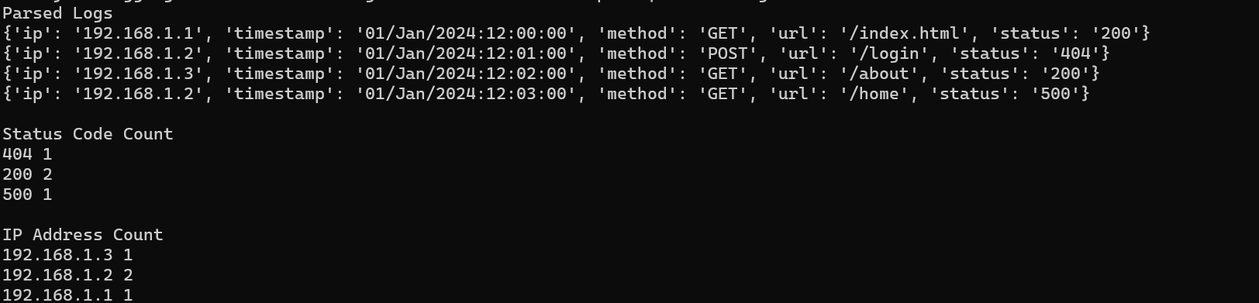

4. Conclusion
The Log Analysis exercise demonstrated the use of Apache Spark RDDs and Regular Expressions for processing and analyzing web server log data. The exercise successfully extracted useful information such as IP addresses, timestamps, request methods, URLs, and HTTP status codes. The challenge tasks further analyzed the log data by identifying the most active IP addresses, calculating the error rate, finding the most requested URLs, and detecting failed login patterns. This exercise enhanced the understanding of distributed log processing, filtering, parsing, and aggregation techniques using Apache Spark.

