Exercise 7: Graph Processing with GraphX

1. Objective
To analyze a social network graph using Apache Spark by performing graph-based operations such as PageRank, connected components, triangle counting, and degree analysis.

2. Procedure
- Start the Spark session.
- Create sample user (vertex) data.
- Create relationship (edge) data between users.
- Build the graph structure using the available graph processing approach.
- Calculate PageRank to identify important users.
- Find connected components in the graph.
- Perform triangle counting.
- Calculate in-degree, out-degree, and total degree for each user.
- Display all results.

3. Screenshots

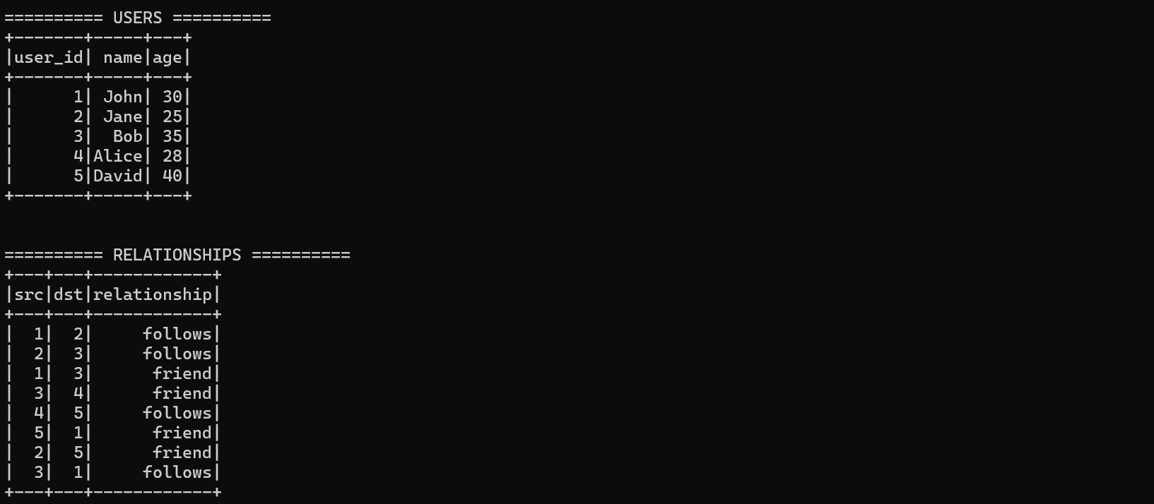
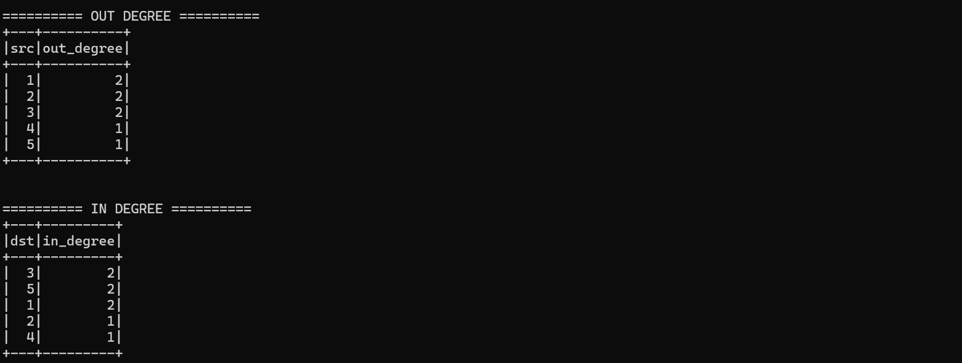
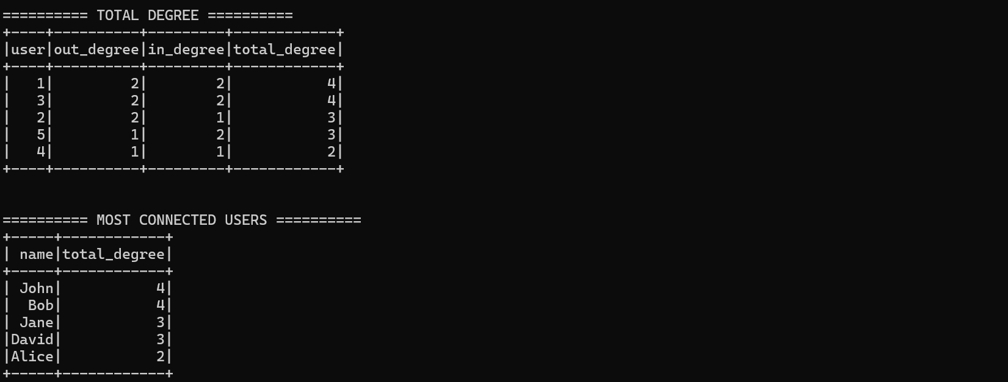
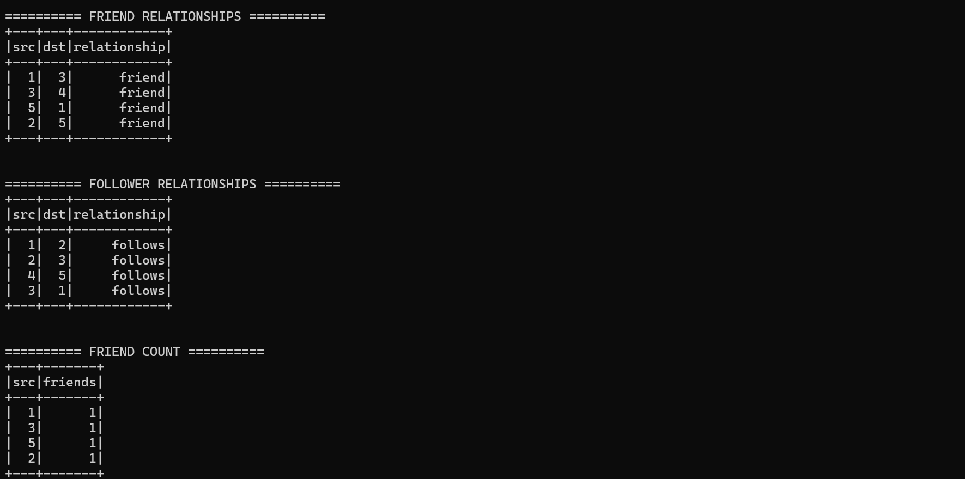
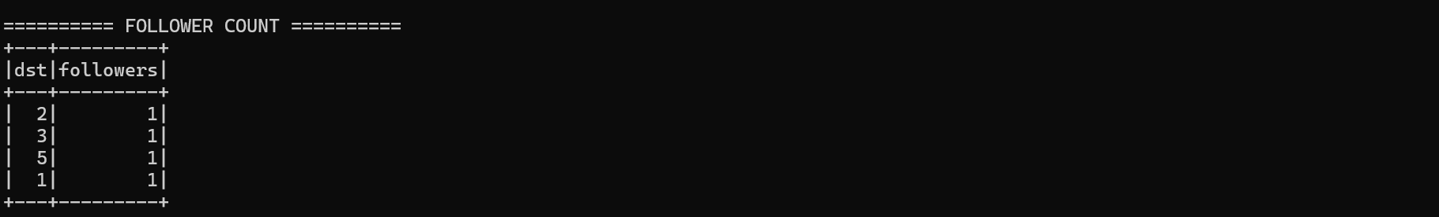

4. Conclusion
The graph processing application was successfully implemented using Apache Spark. The program analyzed relationships between users and generated graph analytics including PageRank, connected components, triangle counts, and degree analysis, demonstrating the basics of graph processing in Spark.

