Spark Word Count Using PySpark DataFrames

1. Objective
The objective of this experiment is to understand the basics of Apache Spark using PySpark by implementing the classic Word Count program. This exercise introduces DataFrames, distributed datasets, transformations, actions, and Spark's lazy evaluation. It also demonstrates how Spark processes large-scale text data efficiently.

2. Procedure

Step 1: Launch PySpark
Open the Ubuntu terminal and start the PySpark shell.
pyspark

If the installation is successful, the Spark logo and Python prompt (>>>) will appear.

Step 2: Verify Spark Version
spark.version

Expected Output
'4.1.2'

Step 3: Create a Distributed Dataset (RDD)
data = spark.sparkContext.parallelize([
("Hello world Hello Spark",),
("Spark is great for big data",),
("Hello Python and Spark",)
])

This creates a distributed dataset (RDD) from local Python data.

Step 4: Convert RDD into DataFrame
df = spark.createDataFrame(data, ["line"])

Step 5: Display the DataFrame
df.show()

Expected Output
+---------------------------+
|line |
+---------------------------+
|Hello world Hello Spark |
|Spark is great for big data|
|Hello Python and Spark |
+---------------------------+

Step 6: Import Required Functions
from pyspark.sql.functions import explode, split, col, desc

These functions are used to split text into words, expand arrays into rows, reference columns, and sort results.

Step 7: Split Each Sentence into Words
words_df = df.select(
explode(
split(col("line"), " ")
).alias("word")
)

Step 8: Display the Words
words_df.show()

Expected Output
+------+
|word |
+------+
|Hello |
|world |
|Hello |
|Spark |
|Spark |
|is |
|great |
|for |
|big |
|data |
|Hello |
|Python|
|and |
|Spark |
+------+

Step 9: Count Word Frequency
word_counts = words_df.groupBy("word").count()

Spark groups identical words together and counts their occurrences.

Step 10: Sort the Results
sorted_word_counts = word_counts.orderBy(desc("count"))

Step 11: Display Final Output
sorted_word_counts.show()

Expected Output
+------+-----+
|word |count|
+------+-----+
|Spark |3 |
|Hello |3 |
|Python|1 |
|world |1 |
|great |1 |
|for |1 |
|big |1 |
|data |1 |
|is |1 |
|and |1 |
+------+-----+

Step 12: Create a Sample Text File
Exit PySpark.
exit()

Create a sample text file.
nano sample.txt

Enter the following text.
Hello Spark
Spark is fast
Hello Python
Spark Spark

Save the file using
CTRL + O
ENTER
CTRL + X

Step 13: Start PySpark Again
pyspark

Step 14: Read the Text File
df = spark.read.text("sample.txt")

Display the contents.
df.show()

Step 15: Perform Word Count on the File
from pyspark.sql.functions import explode, split, col, desc

words = df.select(
explode(
split(col("value"), " ")
).alias("word")
)

counts = words.groupBy("word").count()

counts.orderBy(desc("count")).show()

Expected Output
+------+-----+
|word |count|
+------+-----+
|Spark |4 |
|Hello |2 |
|Python|1 |
|fast |1 |
|is |1 |
+------+-----+

3. Source Code
from pyspark.sql.functions import explode, split, col, desc

# Create RDD
data = spark.sparkContext.parallelize([
("Hello world Hello Spark",),
("Spark is great for big data",),
("Hello Python and Spark",)
])

# Convert RDD to DataFrame
df = spark.createDataFrame(data, ["line"])

# Display DataFrame
df.show()

# Split words
words_df = df.select(
explode(split(col("line"), " ")).alias("word")
)

# Count words
word_counts = words_df.groupBy("word").count()

# Sort descending
sorted_word_counts = word_counts.orderBy(desc("count"))

# Display output
sorted_word_counts.show()

# Read a text file
df = spark.read.text("sample.txt")

# Word Count from text file
words = df.select(
explode(split(col("value"), " ")).alias("word")
)

counts = words.groupBy("word").count()

counts.orderBy(desc("count")).show()

4. Screenshots

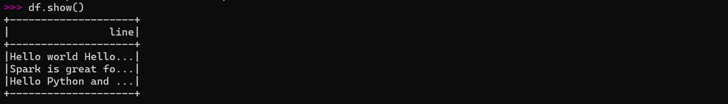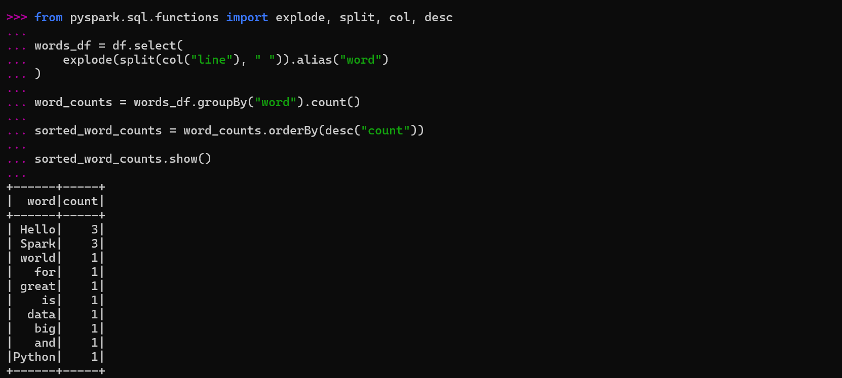
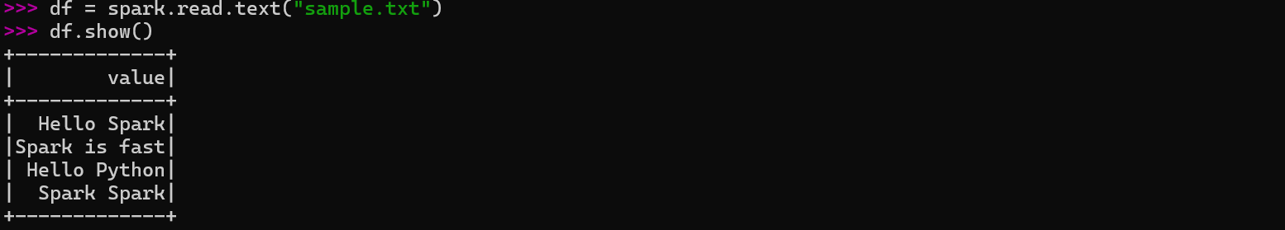
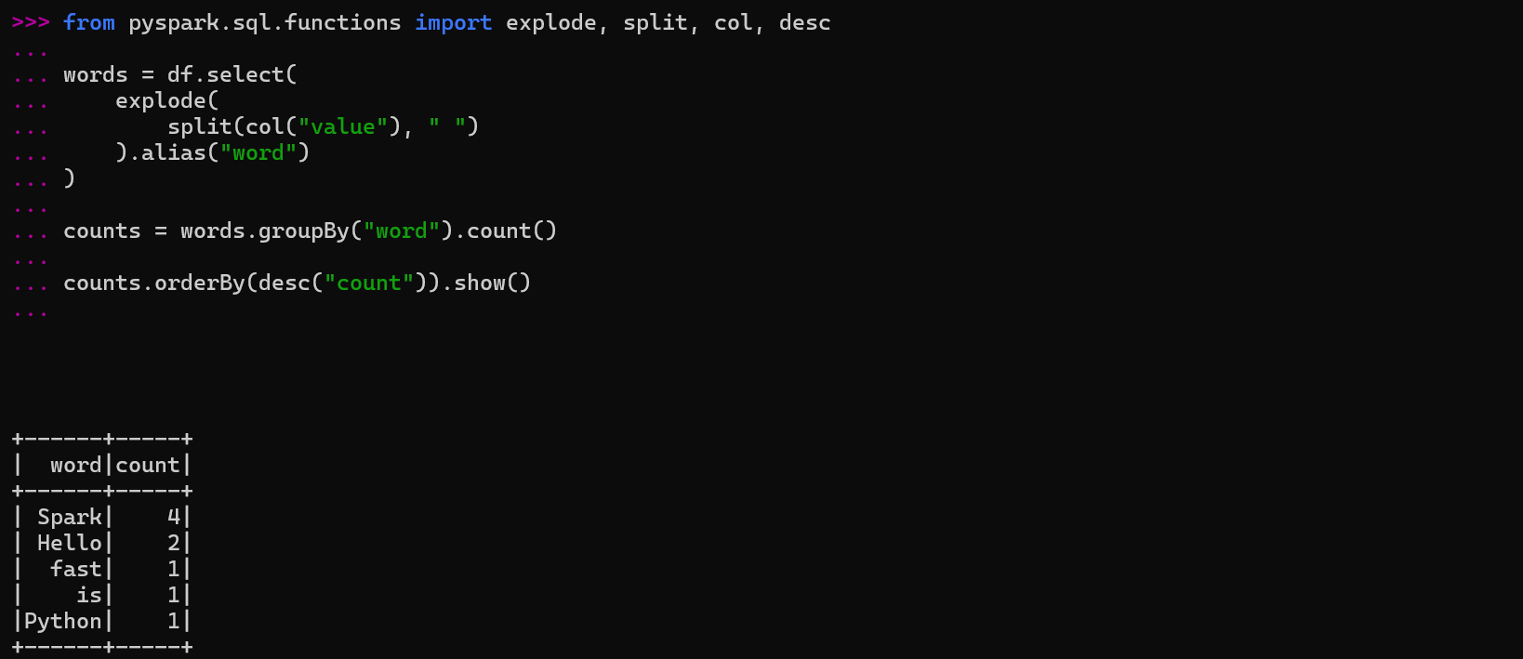

5. Conclusion
In this experiment, Apache Spark was successfully used to perform the classic Word Count program using PySpark DataFrames. The exercise demonstrated how to create distributed datasets, convert RDDs into DataFrames, apply Spark SQL functions such as split(), explode(), groupBy(), and count(), and sort the results based on word frequency. The experiment also introduced reading text files using Spark and highlighted the concepts of distributed data processing, transformations, actions, and lazy evaluation. This exercise provides a strong foundation for performing large-scale data processing and analytics using Apache Spark.

