Exercise 8: Custom Transformers & UDFs

1. Objective
To create custom data transformation functions using Apache Spark UDFs and Pandas UDFs, perform text preprocessing, and build custom feature extraction techniques.

2. Procedure
- Create a Spark session.
- Create a sample DataFrame containing text data.
- Define and apply a Regular UDF to clean text data.
- Define and apply a Pandas UDF for vectorized text processing.
- Display the transformed DataFrame.
- Create a custom feature extraction transformer.
- Implement a custom ML feature.
- Build a text preprocessing pipeline using Tokenizer and StopWordsRemover.
- Optimize processing using a Pandas UDF.
- Display the final outputs.

Challenges

Challenge 1: Create Custom Feature Extraction Transformer
- Create sample text data.
- Clean the text using Spark functions.
- Extract features such as word count.
- Display the extracted features.

Challenge 2: Implement Custom ML Algorithm
- Create sample text data.
- Calculate text length as a custom ML feature.
- Display the generated feature.

Challenge 3: Build Text Preprocessing Pipeline
- Create sample text data.
- Tokenize the text.
- Remove stop words using StopWordsRemover.
- Build and execute the Pipeline.
- Display the processed text.

Challenge 4: Optimize Performance with Pandas UDFs
- Create sample data.
- Define a Pandas UDF.
- Calculate text length using the Pandas UDF.
- Display the optimized output.

3. Screenshots

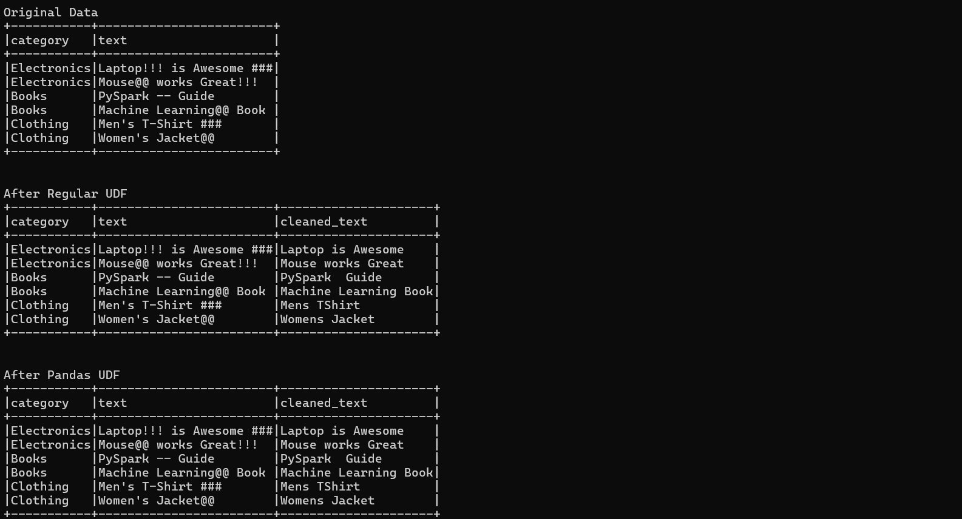
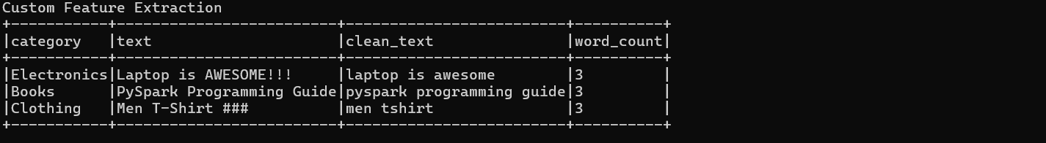
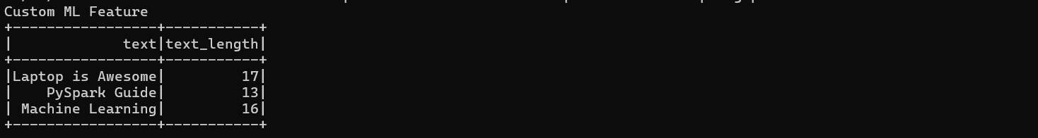
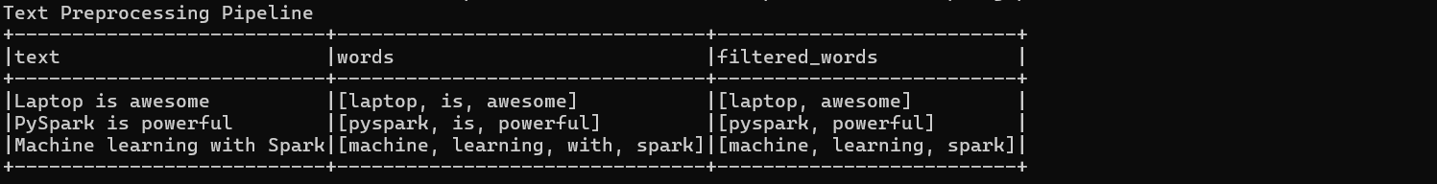
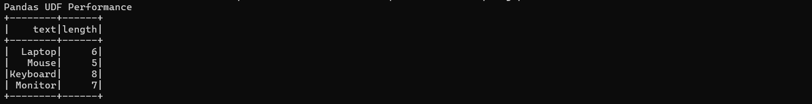

4. Conclusion
The exercise was successfully completed using Apache Spark UDFs and Pandas UDFs. Custom data transformations, feature extraction, text preprocessing, and optimized vectorized operations were implemented successfully, demonstrating efficient text processing techniques in Spark.

