Exercise 6: Machine Learning Pipeline using Apache Spark MLlib

1. Objective
- To build a complete Machine Learning pipeline using Apache Spark MLlib.
- To perform feature engineering using VectorAssembler and StandardScaler.
- To train a Random Forest Classification model.
- To evaluate the model using Cross Validation and Accuracy.
- To implement advanced ML challenges such as Recommendation System, Churn Prediction, Feature Importance Analysis, and REST API deployment.

2. Procedure

Exercise Procedure
- Created a Spark Session.
- Loaded the customer dataset from a CSV file.
- Performed feature engineering using StringIndexer, VectorAssembler, and StandardScaler.
- Split the dataset into training and testing datasets.
- Built a Random Forest Classification model.
- Created a Machine Learning Pipeline.
- Performed hyperparameter tuning using CrossValidator and ParamGridBuilder.
- Trained the model using the training dataset.
- Generated predictions on the testing dataset.
- Evaluated the model using Accuracy.
- Displayed prediction results.

Challenge 1 – Recommendation System using ALS
- Created a sample user-product ratings dataset.
- Trained an ALS Recommendation model.
- Generated product recommendations for each user.
- Evaluated the recommendation model using RMSE.

Challenge 2 – Customer Churn Prediction
- Created a customer dataset.
- Converted input columns into feature vectors.
- Trained a Logistic Regression model.
- Predicted customer churn.
- Evaluated the prediction model.

Challenge 3 – Feature Importance Analysis
- Created a Random Forest Classification model.
- Trained the model using customer data.
- Extracted feature importance scores.
- Displayed the importance of each feature.

Challenge 4 – Deploy Model as REST API
- Built a Flask REST API.
- Loaded and trained the Random Forest model.
- Created a /predict API endpoint.
- Sent prediction requests using JSON input.
- Returned prediction results through the REST API.

3. Screenshots

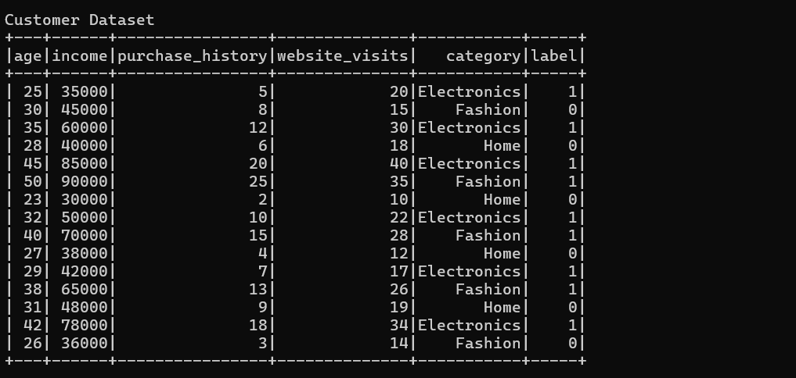
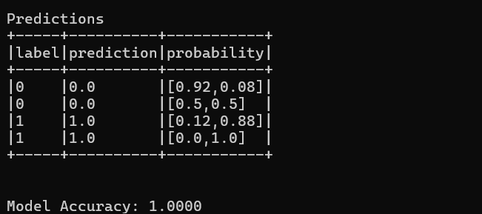
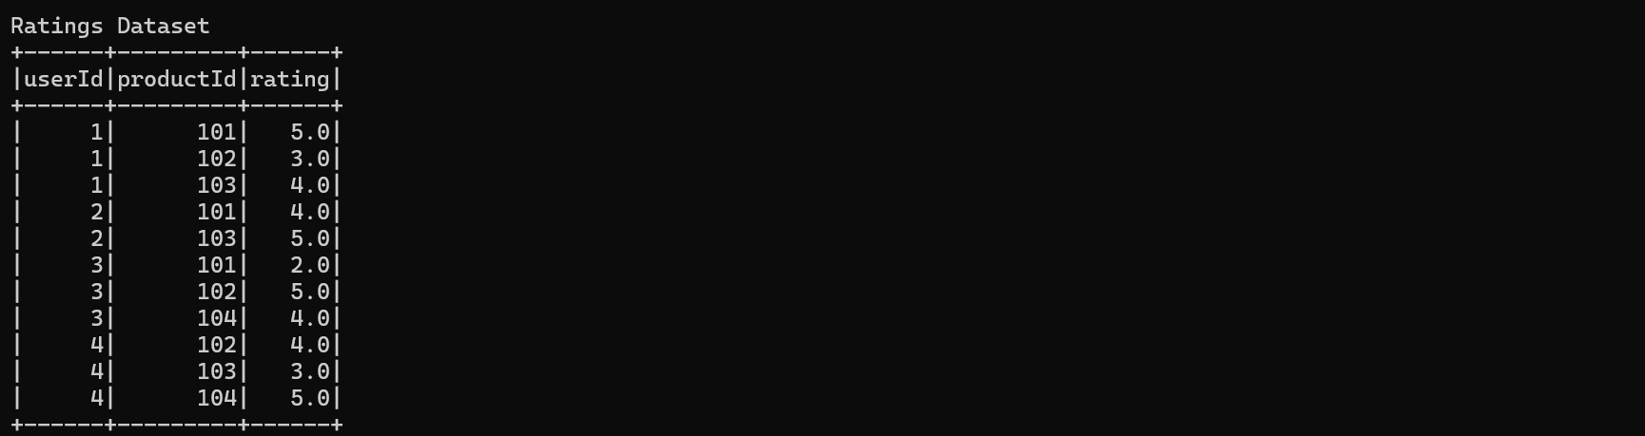
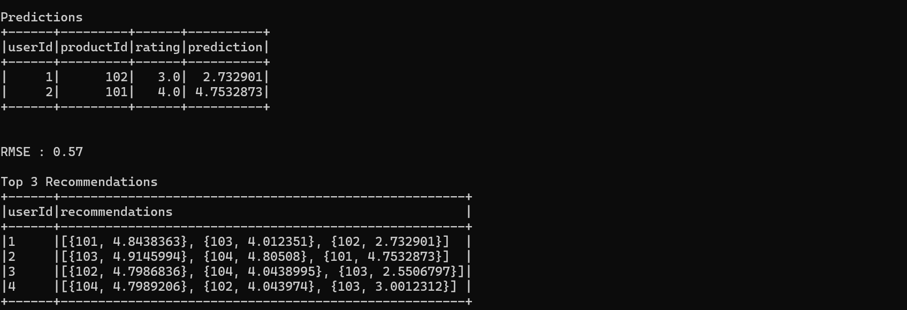
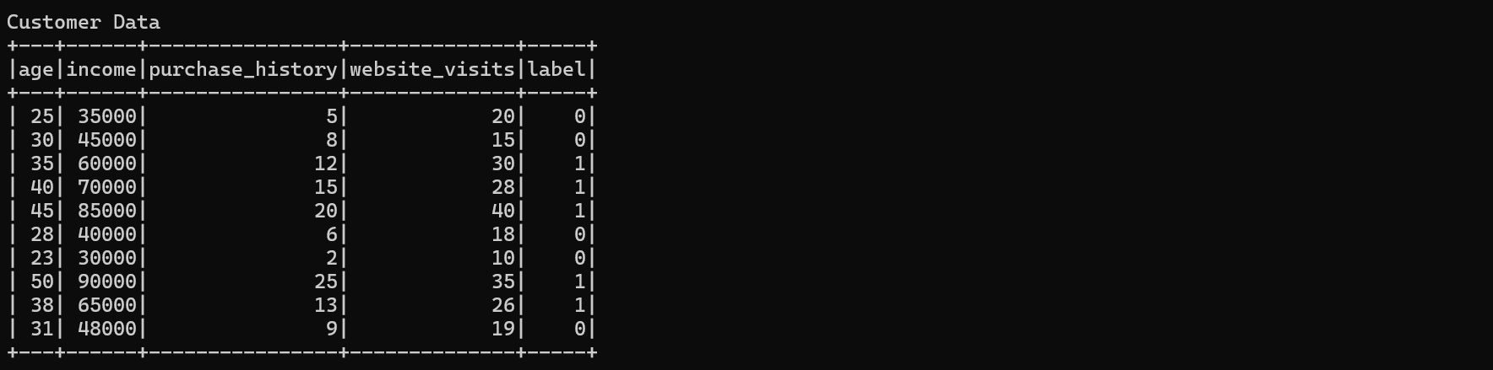
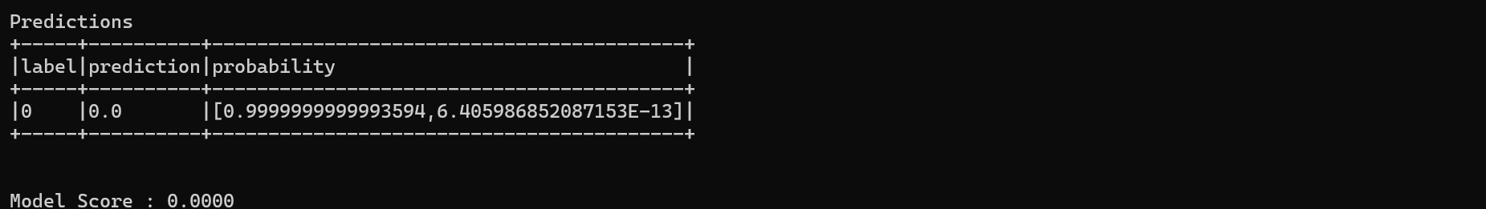
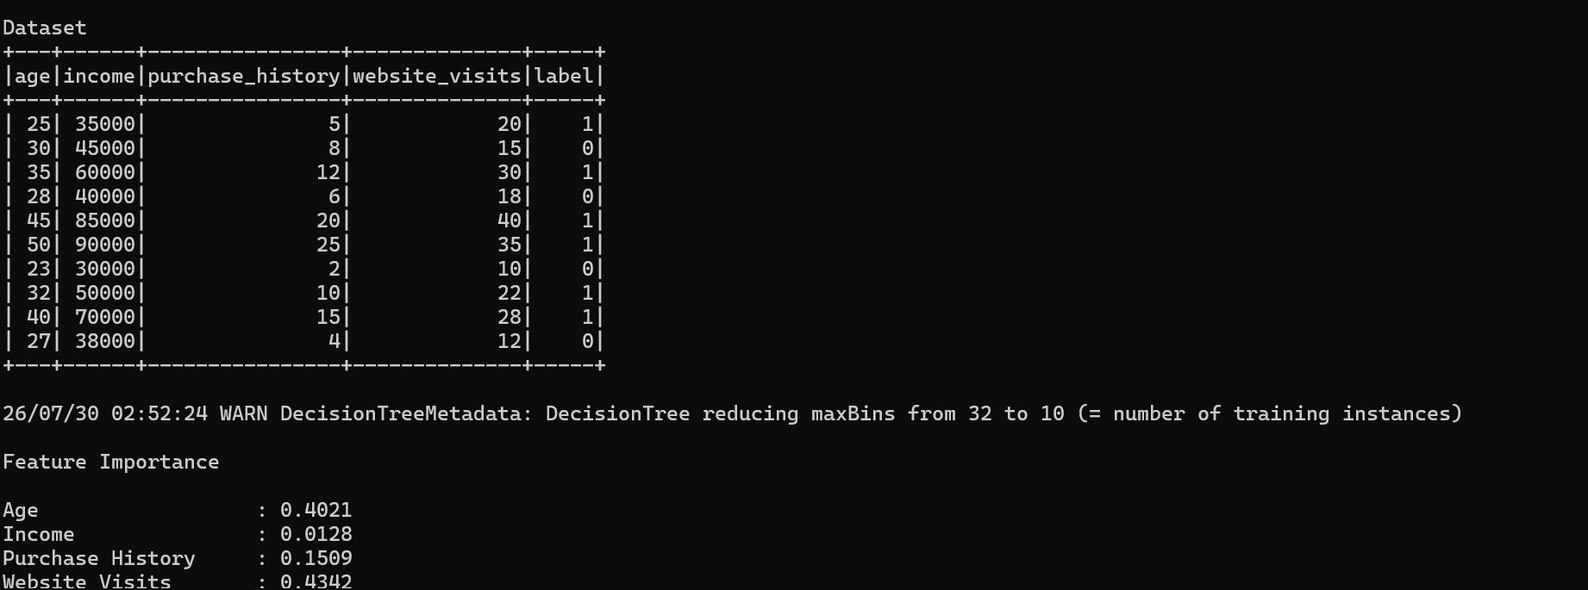

4. Conclusion
A complete Machine Learning pipeline was successfully implemented using Apache Spark MLlib. Feature engineering, model training, hyperparameter tuning, and evaluation were performed successfully. Advanced machine learning applications such as recommendation systems, churn prediction, feature importance analysis, and REST API deployment were also implemented, demonstrating the end-to-end machine learning capabilities of Apache Spark.

