Exercise 1: Word Count using Apache Spark

1. Objective
- To understand the basic concepts of Apache Spark using PySpark.
- To create a Spark application for counting the frequency of words in a text file.
- To learn how to perform RDD transformations and actions.
- To understand the use of flatMap(), map(), reduceByKey(), and collect() operations.
- To execute a Spark program and display the word count results.

2. Procedure

Exercise 1: Word Count
- Create a project folder and place the input text file (sample.txt) inside it.
- Create a Spark Session using SparkSession.builder.appName().getOrCreate().
- Obtain the SparkContext from the Spark Session.
- Read the input text file using the textFile() method.
- Split each line into individual words using the flatMap() transformation.
- Convert each word into a key-value pair (word, 1) using the map() transformation.
- Count the occurrences of each word using the reduceByKey() transformation.
- Display the final word count using the collect() action.
- Stop the Spark Session after successful execution.

Challenge 1: Count Words Longer Than 3 Characters
- Read the input text file.
- Split each line into individual words.
- Filter the words whose length is greater than three characters using the filter() transformation.
- Convert the filtered words into (word, 1) key-value pairs.
- Count the occurrences of each word using reduceByKey().
- Display the filtered word counts.
- Stop the Spark Session.

Challenge 2: Display Top 10 Most Frequent Words
- Read the input text file.
- Split the text into individual words.
- Convert each word into (word, 1) key-value pairs.
- Count the occurrences of each word using reduceByKey().
- Sort the words in descending order based on their frequency using takeOrdered().
- Display the top 10 most frequently occurring words.
- Stop the Spark Session.

Challenge 3: Ignore Stop Words
- Create a set of common stop words.
- Read the input text file.
- Split each line into words using flatMap().
- Remove all stop words using the filter() transformation.
- Convert the remaining words into (word, 1) key-value pairs.
- Count the occurrences using reduceByKey().
- Display the final word counts after removing stop words.
- Stop the Spark Session.

3. Screenshots

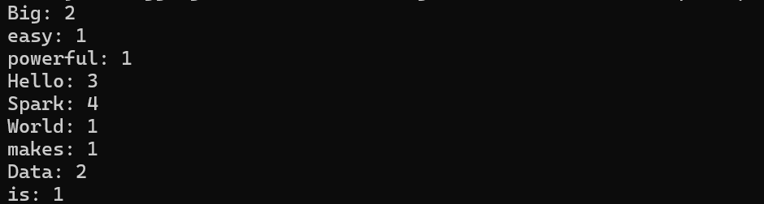

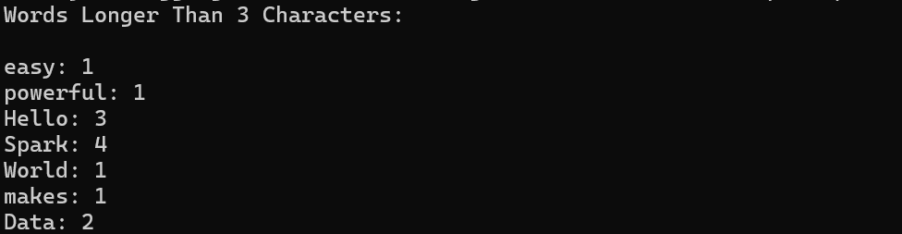
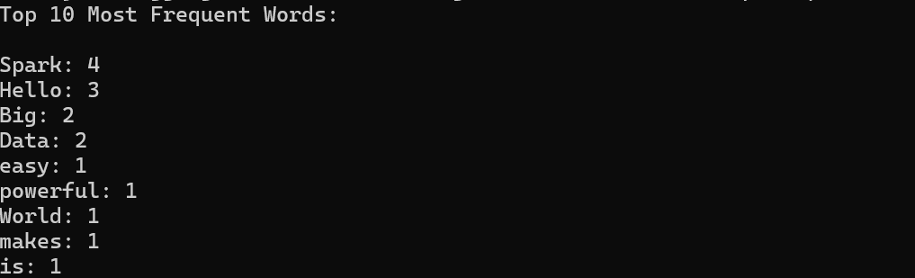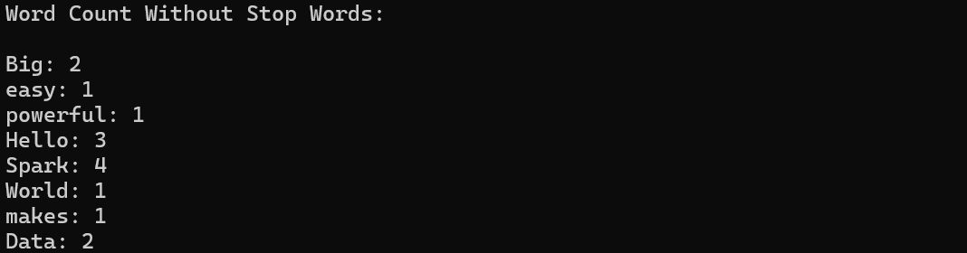

4. Conclusion
The Word Count application was successfully implemented using Apache Spark with PySpark. The program demonstrated how to read a text file as an RDD, transform the data using flatMap() and map(), and aggregate word frequencies using reduceByKey(). The exercise provided practical experience with Spark's distributed data processing model and introduced the fundamental concepts of RDD transformations and actions, forming a strong foundation for more advanced Spark applications.

